Supplementary Information for
Control of Intramolecular Electron Transport Pathways by Varying Localized Electron Distribution
Dahai Zhou^{1†}, Ping Duan^{1†}, Yu Zhou^{1†}, Chuan Li^{2,3,4†}, Yaping Wang¹, Lichuan Chen¹, Jin-Yun Wang^{2,4}, Kai Qu^{2,3,4}, Chun Tang¹, Jia Shi¹, Junyang Liu^{1,*}, Qian-Chong Zhang^{2,*}, Zhong-Ning Chen^{2,4,*}, and Wenjing Hong^{1,*}
¹State Key Laboratory of Physical Chemistry of Solid Surfaces, iChEM, College of Chemistry and Chemical Engineering, Xiamen University, Xiamen 361005, China
²State Key Laboratory of Structural Chemistry, Fujian Institute of Research on the Structure of Matter, Chinese Academy of Sciences, Fuzhou, Fujian 350002, China
³School of Physical Science and Technology, ShanghaiTech University, Shanghai 201210, China
⁴University of Chinese Academy of Sciences, Beijing 100049, China
†These authors contributed equally.
*E-mail: jyliu@xmu.edu.cn; zhangqianchong@fjirsm.ac.cn; czn@fjirsm.ac.cn; whong@xmu.edu.cn

Content
1. Molecular synthesis 2
1.1 Synthesis Information 2
1.2 Synthetic Experiments 2
1.3 Molecular NMR 5
2. UV and fluorescence spectra 11
3. Mass spectrometry 11
4. Single-molecule Junction Measurements 13
4.1 Scanning Tunneling Microscope Break Junction 13
4.2 Hafnium Dioxide coated tip 14
4.3 Testing of electric transport properties 16
5. The theoretical calculation 19
Reference 22

- Molecular synthesis

1.1 Synthesis Information
All the manipulations were carried out using Schlenk techniques and vacuum-line systems under a dry argon atmosphere unless otherwise specified. All reagents were of commercial origin and used as received. Dichloromethane was distilled from benzophenone before use. Silica gel (100–200 mesh) was used for column chromatography. The chromatography samples were eluted (unless otherwise stated) using mixed dichloromethane/petroleum ether (60–90 °C). The 1H NMR and the 13C NMR spectra were collected on a Bruker AVANCE NEO 500 MHz spectrometer operating at 400 MHz in N, N-Dimethylformamide-d7 with TMS as a reference, respectively. High-resolution mass spectroscopy (HRMS) measurements were carried out on an Agilent 1290-6545XT. The UV-Vis spectra were measured by using a PerkinElmer LAMBDA 1050+ spectrophotometer.

1.2 Synthetic Experiments
Synthesis steps of 4,4,5,5-tetramethyl-2-(4-methylsulfanylphenyl)-[1,3,2]-dioxaborolane (Compound 4)
To a 1,4-dioxane (20 mL) solution of (4-bromophenyl)(methyl)sulfane (0.040 g, 0.200 mmol),bis(pinacol)diborane (0.102 g, 0.400 mmol), potassium acetate(0.078 g, 0.800 mmol) and dichlorotriphenylphosphorane (0.0007 g, 0.002 mmol) were added. The mixture was heated to 90 °C and reacted for 24 hours. After cooling to room temperature, the mixture was extracted by dichloromethane. The organic phase was concentrated and purified by column chromatography on a silica gel column (dichloromethane / petroleum ether = 1 : 5 v / v) to afford the product as white solid. Yield: 86.0% (0.043 g, 0.172 mmol). ¹H NMR (400 MHz, CDCl₃) δ 7.70 (d, J = 7.8 Hz, 2H), 7.22 (d, J = 7.7 Hz, 2H), 2.49 (s, 3H), 1.33 (s, 12H).
Synthesis steps of 3,6-bis(4-(methylthio)phenyl)-9H-carbazole (Meta-N-H) ¹
To a mixed solution (30 mL 1,4-dioxane and 10 mL H₂O) of compound 4 (3.076 g, 12.255 mmol) and 3,6-dibromo-9H-carbazole (1.986 g, 6.110 mmol), potassium carbonate (2.400 g, 17.391 mmol) and tetrakis(triphenylphosphine) palladium (0.208 g, 0.180 mmol) were added. The resulted solution was heated at 90 °C for 24 h. After cooling to room temperature, the solution was mixed with water (200 mL), followed by extraction with dichloromethane. The organic phase was collected and evaporated under reduced pressure. The obtained crude product was purified by column chromatography on a silica gel column (dichloromethane / petroleum ether = 1 : 2, v / v) as eluent to obtain the product as a white solid. Yield: 67.6% (1.700 g, 4.130 mmol). ¹H NMR (400 MHz, CDCl₃) δ 8.33 (s, 2H), 8.14 (s, 1H), 7.69 (d, J = 8.4 Hz, 2H), 7.68 (d, J = 8.4 Hz, 4H), 7.52 (d, J = 8.4 Hz, 2H), 7.41 (d, J = 8.4 Hz, 4H), 2.58 (s, 6H).
Synthesis steps of 9-methyl-3,6-bis(4-(methylthio)phenyl)-9H-carbazole (Meta-N-Me) ²
Meta-N-H (4.115 g, 10.000 mmol), NaH (0.240 g, 10.000 mmol) were dissolved in 25 mL N,N-Dimethylformamide in a Schlenk flask at -20℃. After rising to room temperature, the reaction mixture was stirred at room temperature for 30mim. Methyl iodide (1.520 mL, 10.000 mmol) was then added to the mixture solution. The mixture was stirred at room temperature for 2 h. The resulted reaction mixture was poured into water (100 mL), followed by the obtained solids being collected by filtration. The resulting solid was dried under vacuum yielding the product. Yield: 99.6% (4.241 g, 9.962 mmol). This product was used directly for the next step without further purification. ¹H NMR (400 MHz, d₆-DMSO) δ 8.58 (d, J = 1.6 Hz,2H), 7.77 (dd, J = 1.6 Hz, J = 8.6 Hz, 2H), 7.74 (d, J = 8.5 Hz, 4H), 7.62 (d, J = 8.6 Hz, 2H), 7.35(d, J = 7.5 Hz, 4H), 3.89 (s, 3H), 2.50 (s, 6H).
Synthesis steps of N-(tert-butyl)-2,7-dibromo-9H-carbazole-9-carboxylate (Compound 3) ³
To a shrink flask containing THF (20 mL) solution of 2,7-dibromo-9H-carbazole (7.523 g, 23.300 mmol) and 4-dimethylaminopyridine (0.600 g, 5.000 mmol) followed by the addition of butyl bicarbonate (5.079 g, 23.300 mmol). After the addition, the mixture was heated to 40 °C and stirred for another 2 h. After removing the precipitate by filtration, the solvent was evaporated by vacuum. After removing the solvent, the residues were further purified by column chromatography on a silica gel column (dichloromethane / petroleum ether = 1 : 3 v / v)) to afford the product as a white solid. Yield: 83.4% (7.400 g, 19.423 mmol). ¹H NMR (400 MHz, CDCl₃) δ 8.49 (s, 2H), 7.79 (d, J = 13.6 Hz, 2H), 7.48 (d, J = 8.2 Hz, 2H), 1.77 (s, 9H).
Synthesis steps of N-(tert-butyl)-2,7-dibromo-9H-carbazole-9-carboxylate (Compound 5) ¹
To a mixed solution (30 mL 1,4-dioxane and 10 mL H₂O) of compound 4 (2.786 g, 7.312 mmol) and compound 3 (3.076 g, 12.300 mmol), excess potassium carbonate (2.400 g, 17.391 mmol) and tetrakis(triphenylphosphine) palladium (0.208 g,0.180 mmol) were added. The resulted solution was stirred at 90 °C for 24 h. After cooling to room temperature, the solution was mixed with water (200 mL), followed by extraction with dichloromethane. The organic phase was collected and evaporated under reduced pressure. The obtained crude product was purified by column chromatography on a silica gel column (dichloromethane / petroleum ether = 1 : 2 v / v) as eluent to obtain the product as white solid. Yield: 49.4% (1.690 g, 3.613 mmol). ¹H NMR (400 MHz, CDCl₃) δ 8.57 (s, 2H), 8.00 (d, J = 8.1 Hz, 2H), 7.65 (d, J = 10.8 Hz, 4H), 7.58 (d, J = 8.1 Hz, 2H), 7.36 (d, J = 8.1 Hz, 4H), 2.54 (s, 6H), 1.78 (s, 9H).
Synthesis steps of 2,7-bis(4-(methylthio)phenyl)-9H-carbazole (Para-N-H)
Compound 5 (5.112 g, 10.930 mmol) was added to 20 mL trifluoroacetic acid. The mixture was stirred at room temperature for 2 h under N₂, followed by the filtering through celite and evaporated under vacuum to give target product as white solid. Yield: 44.5% (2.000 g, 4.859 mmol). ¹H NMR (400 MHz, d₆-DMSO) δ 11.33 (s, 1H), 8.15 (d, J = 7.8 Hz, 2H), 7.69 (d, J = 7.8 Hz, 4H), 7.66 (s, 2H), 7.43 (d, J = 8.0 Hz, 2H), 7.35 (d, J = 7.3 Hz, 4H), 2.50 (s,6H).
Synthesis steps of 9-methyl-2,7-bis(4-(methylthio)phenyl)-9H-carbazole (Para-N-Me) ²
Para-N-H (4.111 g, 10.000 mmol), NaH (0.240 g, 10.000 mmol) were dissolved in 25 mL N,N-Dimethylformamide in a Schlenk flask at -20℃. After rising to room temperature, the reaction was stirred for 30 min. Methyl iodide (1.520 mL, 10.000 mmol) was then added to the mixture solution. The mixture was stirred for 2 h. The resulted reaction mixture was poured into water (100 mL), followed by the obtained solids being collected by filtration. The resulting solid was dried under vacuum yielding the product as solid. Yield: 99.9% (4.251 g, 9.985 mmol). ¹H NMR (400 MHz, d₆-DMSO) δ 8.18 (s, 2H), 7.85 (s, 2H), 7.77 (d, J = 8,1 Hz, 4H), 7.49 (d, J = 4.4 Hz, 2H), 7.36 (d, J = 8,1 Hz, 4H), 3.97 (s, 3H), 2.51 (s, 6H)
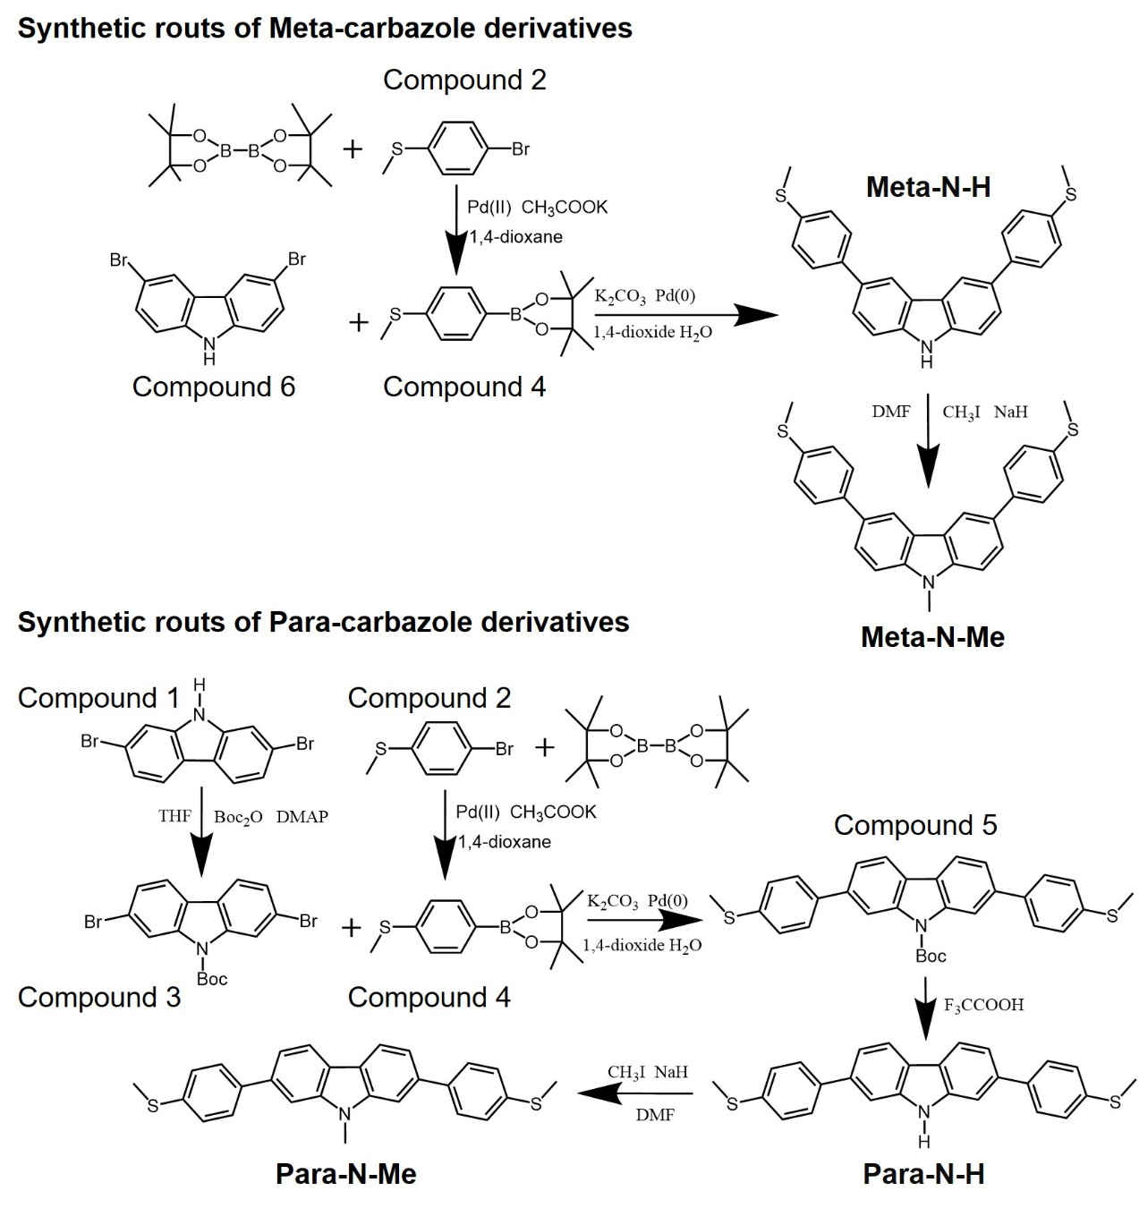Scheme S1. Synthetic routes to molecules used in conductance measurements.

1.3 Molecular NMR
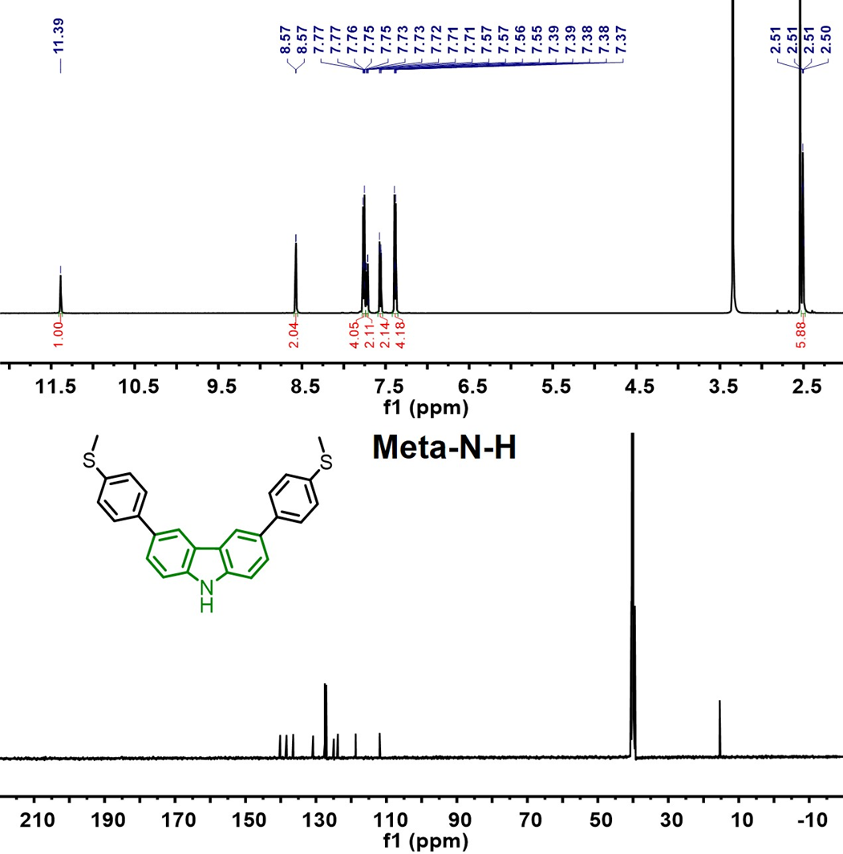
Figure S1. ¹H NMR and ¹³C NMR of Meta-N-H.
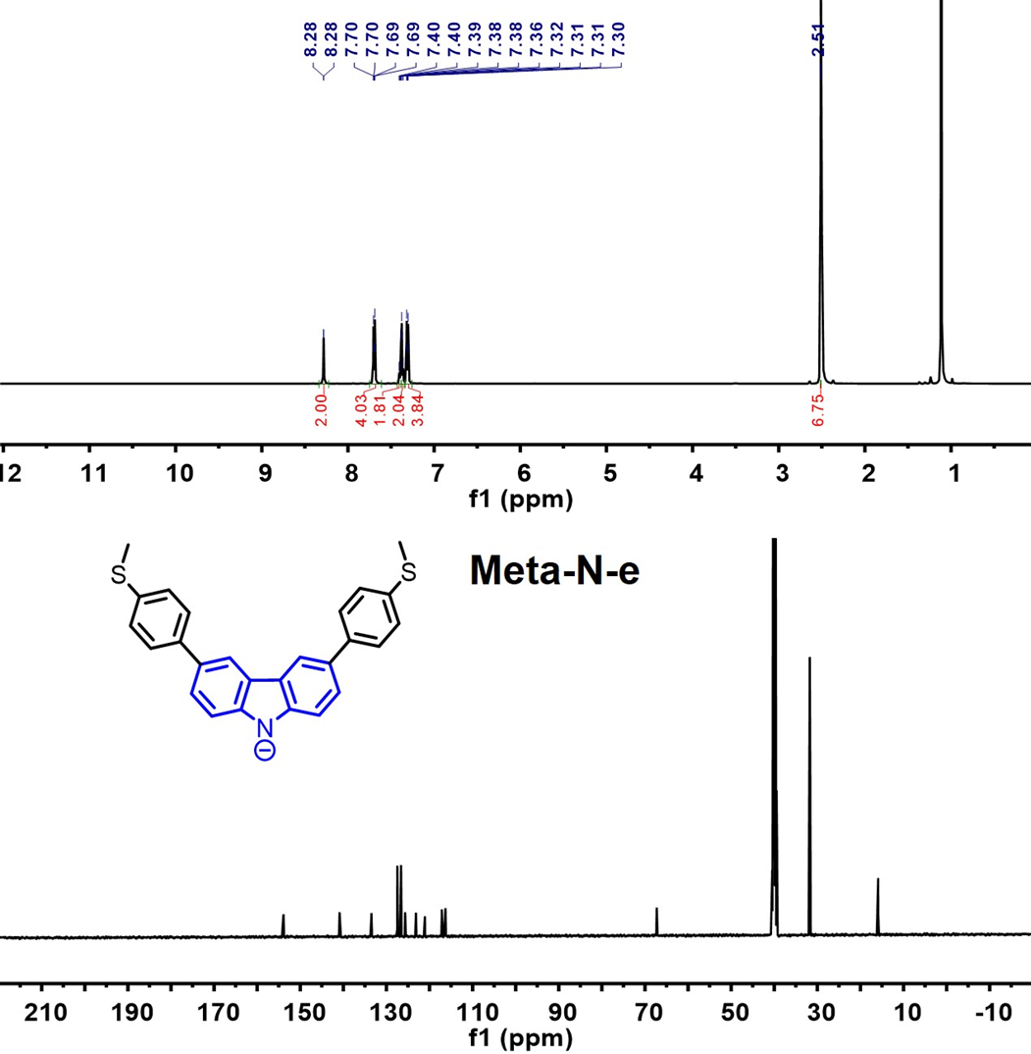
Figure S2. ¹H NMR and ¹³C NMR of Meta-N-e.
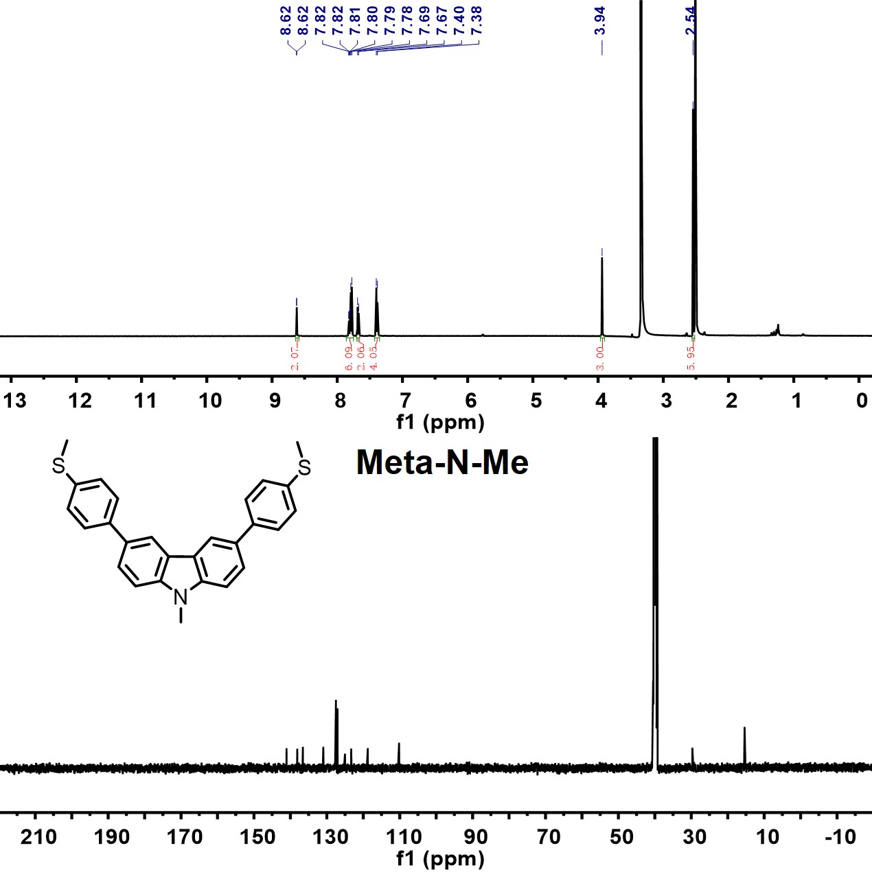
Figure S3. ¹H NMR and ¹³C NMR of Meta-N-Me.
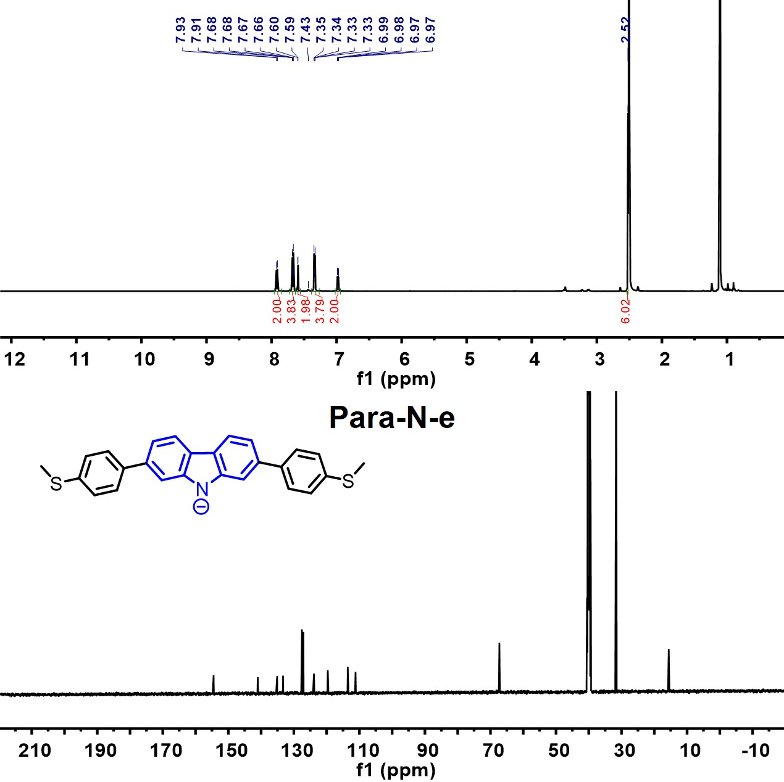
Figure S4. ¹H NMR and ¹³C NMR of Para-N-e.
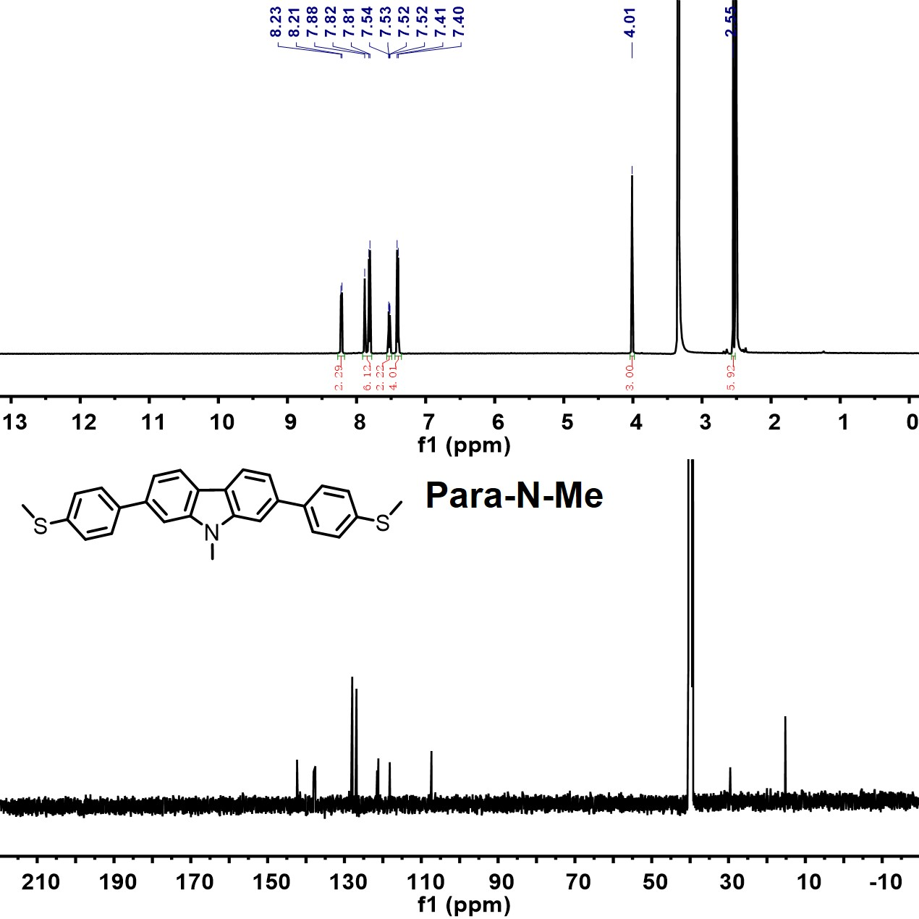
Figure S5. ¹H NMR and ¹³C NMR of Para-N-Me.

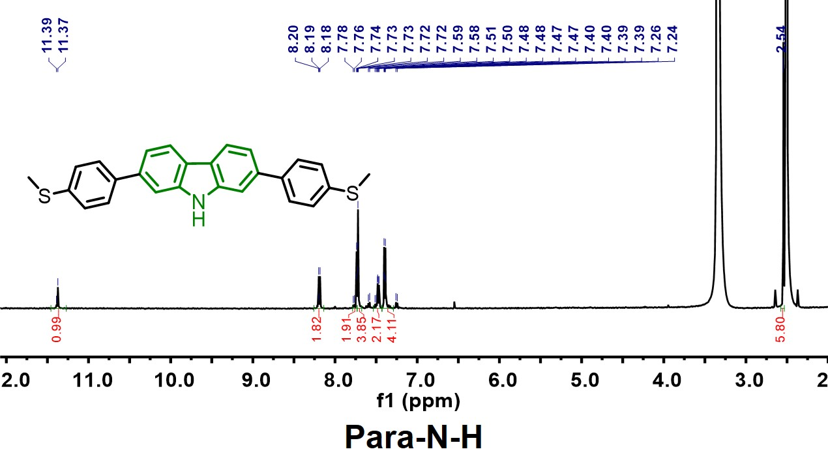
Figure S6. ¹H NMR of Para-N-Me.
- UV and fluorescence spectra
To further eliminate the influence of solvent, t-BuOK and MeOTf, The UV-Vis absorption spectra of t-BuOK and MeOTF in DMF solvent were measured, as shown in Figure S7.
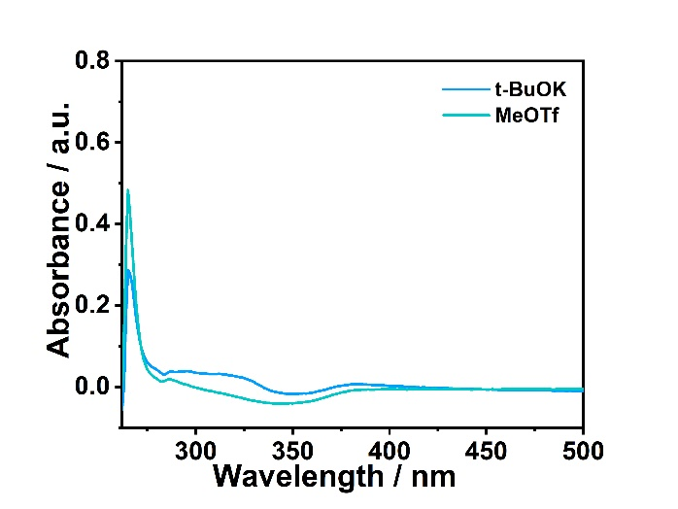
Figure S7. The UV-Vis absorption spectra of t-BuOK and MeOTF in DMF solvent at ambient temperature.

The photos of color change and fluorescence spectra of the carbazole intermediates are shown in Figure S8.
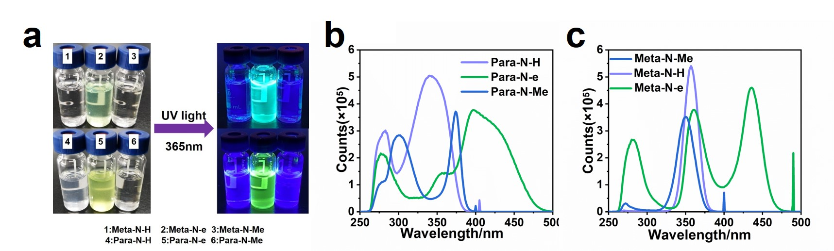Figure S8. (a) Fluorescence of carbazole derivatives under illumination of 365 nm light; (b) The fluorescence excitation spectra of para-carbazole; (c) The fluorescence excitation spectra of meta-carbazole.

- Mass spectrometry
The mass spectrometry of carbazole and intermediates is shown in Figure S9. The theoretical calculation value of Para-N-H and Meta-N-H is 410.1043, and the test results are 410.1054 and 410.1058, with a difference within the range of 5 ppm, indicating the presence of substances. The theoretical calculation value of Para-N-e and Meta-N-e is 410.1043, while the test result is 410.1055 and 410.1063, with a difference within the range of 5 ppm, indicating the presence of substances.
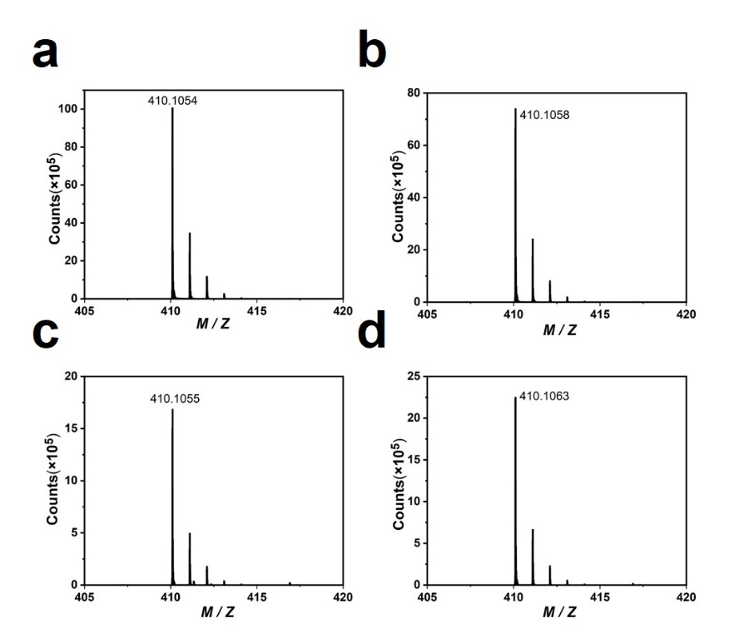
Figure S9. Mass spectrometry of Para-N-H (a), Para-N-e (b), Meta-N-H (c) and Meta-N-e (d).

The mass spectrometry of Para-N-Me-S and Meta-N-Me-S are shown in Figure S10. The theoretical calculation value of Para-N-Me-S and Meta-N-Me-S is 425.1266, and the test results are 425.1245 and 425.1247, with a difference within the range of 5 ppm, indicating the presence of substances.
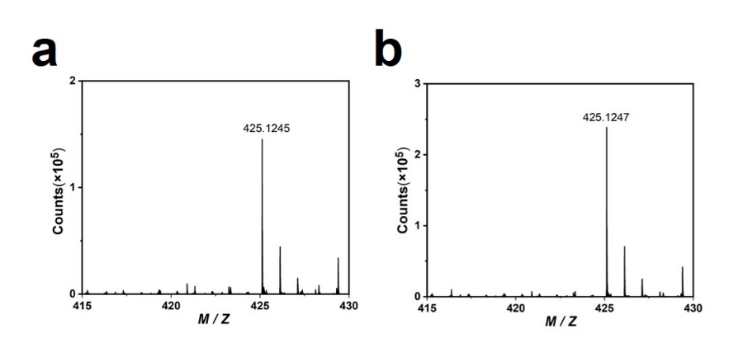
Figure S10. Mass spectrometry of Para-N-Me-S (Para-N-Me, S means that the substance is synthetic) and Meta-N-Me-S (Meta-N-Me-S, S means that the substance is synthetic).
- Single-molecule Junction Measurements

4.1 Scanning Tunneling Microscope Break Junction
In this work, we used a home-built Scanning Tunneling Microscope Break Junction (STM-BJ) set-up to perform the single-molecule conductance measurement. An Insulating hafnium dioxide coated gold tip (See Section 3.2 for details.) is used as a tip, which is fixed onto a piezo, while the piezo is adhered to the bottom of a stepping motor. A gold-evaporated silicon wafer, which was pre-washed by piranha solution (V (H₂SO₄): V(H₂O₂) = 3:1 CAUTION! piranha solution is extremely corrosive) and rinsed with fresh deionized water, is placed below the tip. Then, 50 μL N, N-Dimethylformamide (DMF) solution containing 1 mmol target molecule was dripped on the substrate, and the tip was also immersed in the solution. In the text, both the tip and the substrate are connected into the external current amplifier and the controller, and a 100-mV bias voltage is applied between them. Using the current between the two electrodes as feedback, the tip was controlled to pull up and down to contact/leave the substrate repeatedly. Molecular junctions can be formed during the break junction process so that the single-molecule conductance can be detected. The construction method of 1D/2D conductance and PSD analysis histograms can refer to some recent works.^{4, 5}
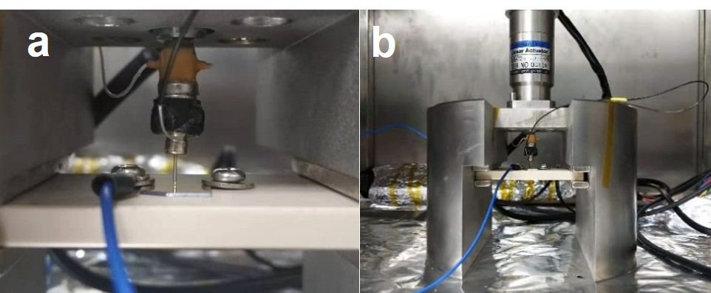
Figure S11. The photos of home-built STM set-up: (a) Schematic diagram of tip and base; (b) Schematic diagram of STM-BJ.

4.2 Hafnium Dioxide coated tip
The hafnium dioxide coated gold tip was prepared by Atomic Layer Deposition (ALD). The specific preparation method is as follows:
(1) Preparation of the etched gold tip: The cleaned gold wire is etched into the gold tip in the electrochemical etching device as shown in Figure S12. The potentiostatic method is adopted, and the voltage is set at 2.3 V. The etching solution is a mixed solution of hydrochloric acid and deionized water (V (HCl): V (H₂O) = 1:1).⁶
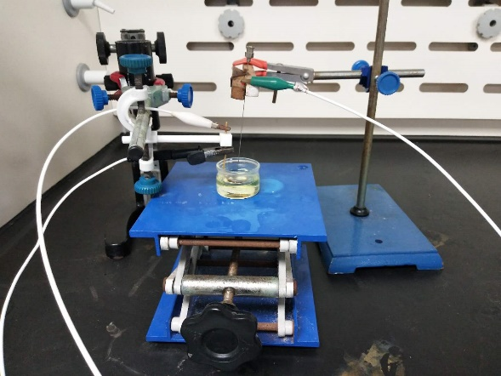
Figure S12. The tip electrochemical etching system.

(2) MPS ((3-mercaptopropyl) trimethoxysilane) pretreatment and hydrochloric acid hydrolysis: The gold tip is immersed in MPS ethanol solution for half an hour, then immersed in the hydrochloric acid aqueous solution of pH 5 for hydrolysis for 4 hours, and then taken out for cleaning with deionization. This process can make the MPS adsorb on the surface of the gold tip, thereby improving the insulation of the hafnium dioxide layer.⁷
(3) The preparation of the hafnium dioxide layer: the gold tip with adsorbed MPS is sent into the atomic layer deposition chamber, and the hafnium dioxide coating of 125 cycles is deposited. The hafnium dioxide coated tip is shown in Figure S13.
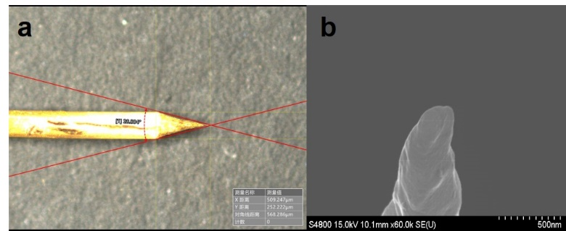
Figure S13. (a) The hafnium dioxide coated tip image taken with 3D Super Depth Digital Microscope; (b) The hafnium dioxide coated tip image taken with SEM.

The atomic layer deposition system is a TFS200 produced by Beneq Company in Finland. The deposition parameters are as follows: Vacuum reaction chamber temperature: 200 ℃, hafnium source temperature: 80 ℃, nitrogen pressure: 2 bar.
The process parameters of each cycle are:
(1) Infuse high-purity nitrogen (Pulse DV-BHA1, DV-BH1 1 s) into hafnium source for 1 s;
(2) wait for 100ms (WTIME 100ms);
(3) high purity nitrogen containing hafnium source is fed into the vacuum reaction chamber for 500ms (Pulse DV-PH1 500 ms);
(4) The unreacted Teman and the by-reactants (Purge 3 s) are removed by passing high purity nitrogen into the vacuum reaction chamber;
(5) Inject high-purity nitrogen containing water into the vacuum reaction chamber for 100 ms (Pulse DV-PL4 100 ms);
(6) The unreacted water and the by-reactants were removed for 2.5 s (Purge 2.5 s) by the passage of high purity nitrogen into the vacuum reaction chamber.
Under this parameter, the thickness of hafnium dioxide film is about 0.1 nm for each atomic layer deposition cycle.
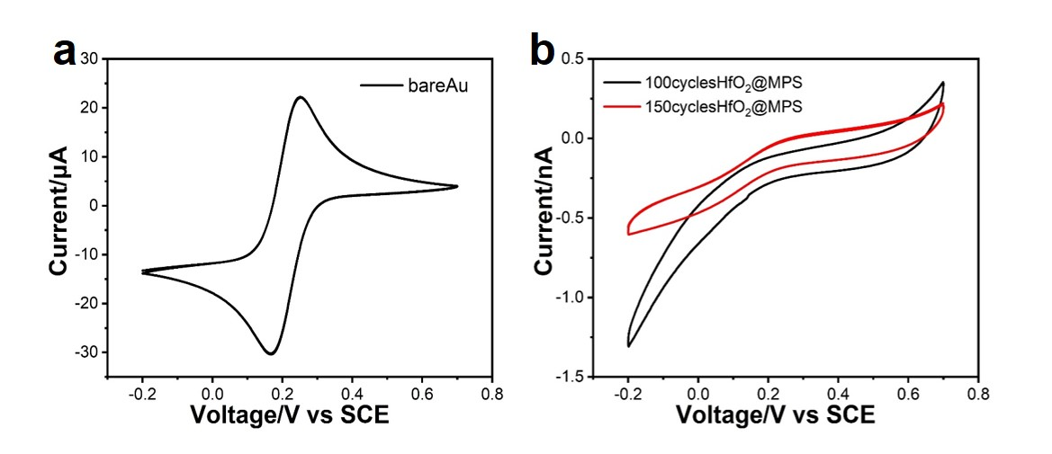
Figure S14. (a) CV curve of exposed gold tip after etching; (b) CV curves of 100 cycles (The black line) and 150 cycles (The red line) of tips were prepared under the above atomic layer deposition parameters.

The CV curve of the exposed gold tip after etching in the aqueous solution of K₃[Fe(CN)₆] is shown in Figure S14a, from which an obvious redox peak can be observed. However, there is no obvious redox peak in the CV curve of the hafnium dioxide coated tip, which indicates that hafnium dioxide has specific insulating properties and can be used in polar solvents to reduce leakage current (Figure S14b).

4.3 Testing of electric transport properties
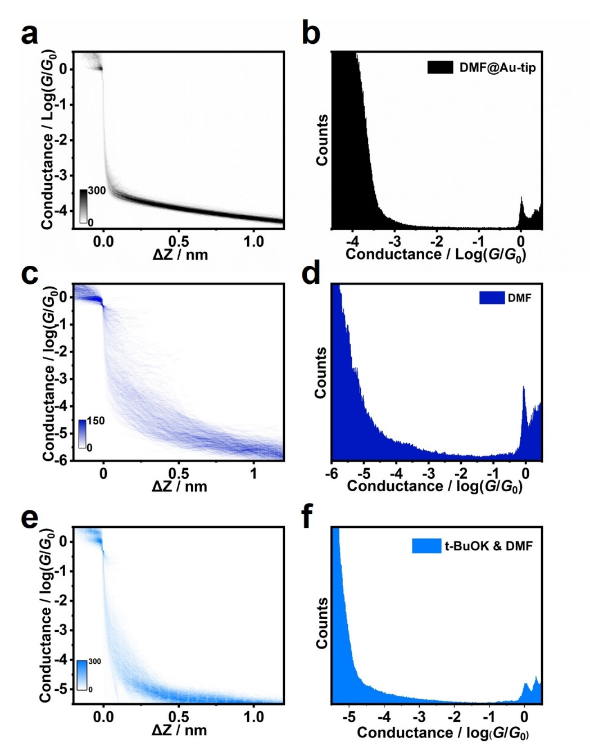
Figure S15. (a) 2D conductance versus relative displacement histogram and (b) 1D conductance histogram of pure DMF by bare Au tip, indicating a much higher tunneling background; (c) 2D conductance versus relative displacement histogram and (d) 1D conductance histogram of the pure DMF by the HfO₂ coated tip, indicating a lowered tunneling background with good insulation; (e) 2D conductance versus relative displacement histogram and (f) 1D conductance histogram of the t-BuOK in DMF by the HfO₂ coated tip, indicating the background remained lowered.
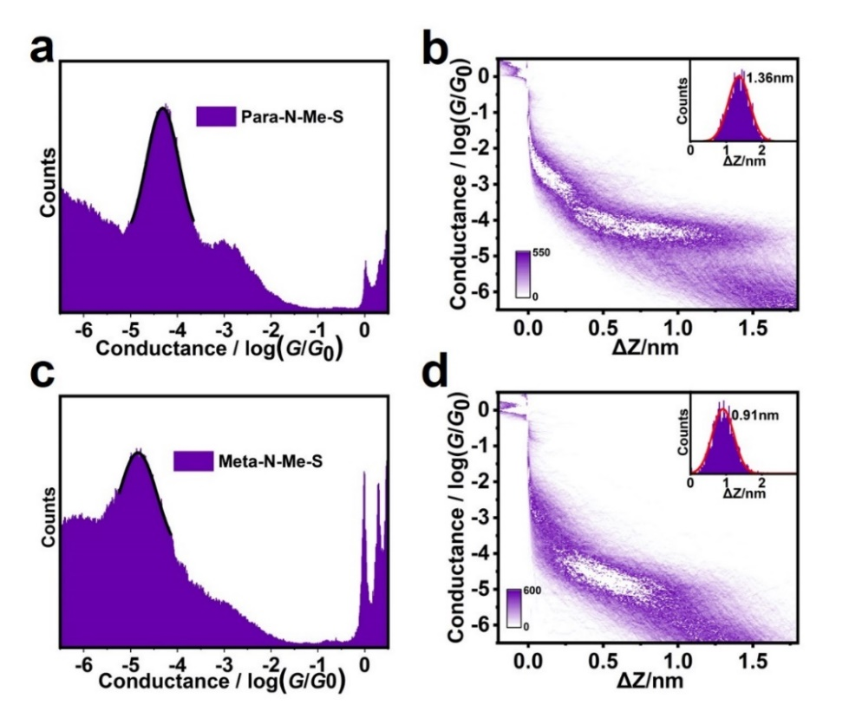
Figure S16. (a) 1D conductance histogram and (b) 2D conductance versus relative displacement histogram of the Para-N-Me-S (Para-N-Me, S means that the substance is synthetic, 10^{-4.31} G₀ (3.80 nS)); (c) 1D conductance histogram and (d) 2D conductance versus relative displacement histogram of Meta-N-Me-S (Meta-N-Me-S, S means that the substance is synthetic, 10^{-4.84} G₀ (1.12 nS)).
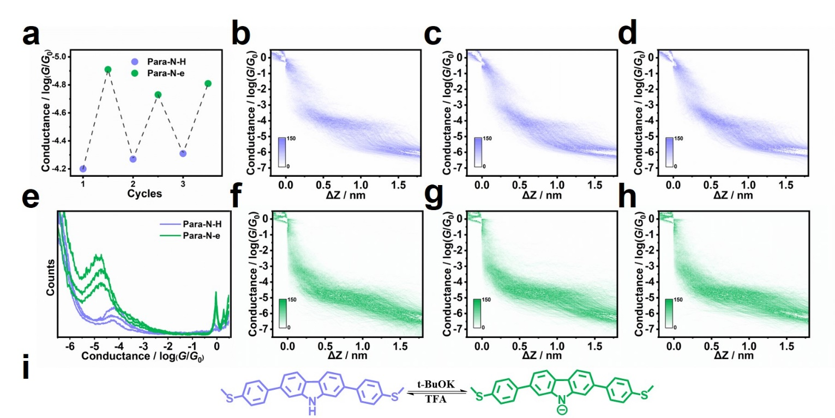Figure S17. (a) Reversible on-off conductance switches of Para-N-H and Para-N-e by deprotonation and protonation. 2D conductance versus relative displacement histogram of the (b) first cycle, (c) second cycle and (d) third cycle of Para-N-H. (e) 1D conductance histograms of Para-N-H and Para-N-e. 2D conductance versus relative displacement histogram of the (f) first cycle, (g) second cycle and (h) third cycle of Para-N-e. (i) the chemical reaction of the deprotonation and protonation of para-carbazole.
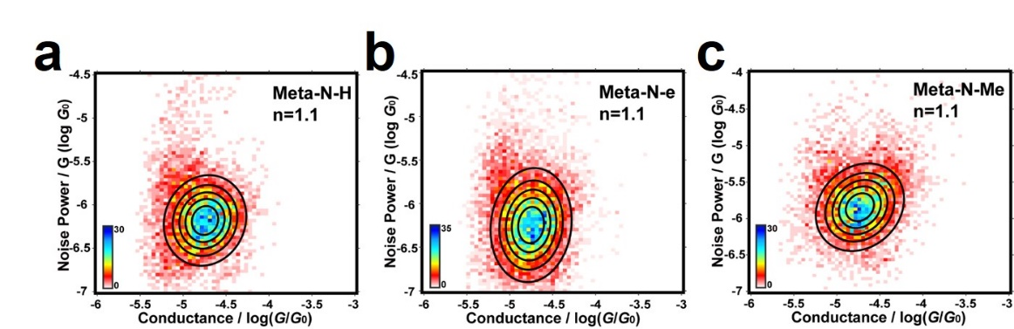
Figure S18. Two-dimensional histogram of normalized conductance changes versus normalized noise power for (a) Meta-N-H, (b) Meta-N-e and (c) Meta-N-Me.
- The theoretical calculation
The geometry optimizations of molecules were carried out using the B3LYP functional and 6-31G(d) basis set, and the frequency analysis was performed at the same theoretical level to verify that the stationary points are minimal or transition states. Then the optimized molecular structures were placed between two gold electrodes to construct the single-molecule devices. The surface of the gold electrode was cut into a pyramid structure, and the anchor groups were connected to the gold atom at the top of the pyramid. In the initial configuration of the device, the distance between the sulfur atom of the methylthio group and the gold atom of the electrode was controlled at about 2.5 Å. When optimizing these configurations, fixed the coordinates of all gold atoms in the electrode, and no restrictions on the coordinates of the molecules. The geometry optimization and transmission spectrum of the single-molecule device were calculated using GGA-PBE exchange-correlation functional with the NEGF approach by using the quantum ATK 2019.^{8, 9} The FHI pseudopotential together with double-ζ basis set was used for Au atoms, and the PseudoDojo pseudopotential together with the medium basis set was used for other atoms.

Figure 19. (a) Para-N-H and Para-N-e molecular junction structure diagram; (b) Meta-N-H and Meta-N-e molecular junction structure diagram.
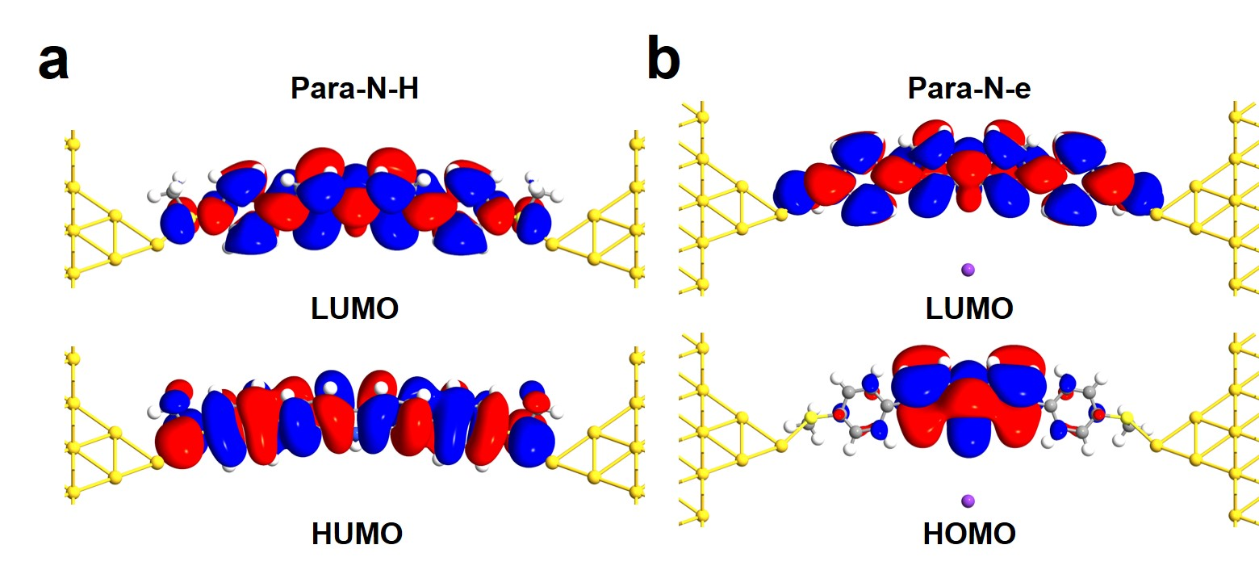
Figure 20. The Molecular projection self-consistent Hamiltonian states of HOMO and LUMO for (a) Para-N-H and (b) Para-N-e.
Table S1. The S-S distances in the molecules of by Para-N-H, Para-N-e, Para-N-Me, Meta-N-H, Meta-N-e and Meta-N-Me theoretical calculation .
Molecule | Para-N-H | Para-N-e | Para-N-Me | Meta-N-H | Meta-N-e | Meta-N-Me
the S-S distances in the molecules by theoretical calculation / nm | 1.87 | 1.87 | 1.87 | 1.45 | 1.49 | 1.45
Table S2. The transmission probability of an electron in the electron transport channel for Para-N-H, Para-N-e, Meta-N-H and Meta-N-e (The minus sign means the current is going in the opposite direction).
Molecule | The energy relative to the Fermi level (eV) | The transmission probability of an electron in the electron transport channel |  |  | the ratio of current in the C-C pathway | the ratio of current in the C-N-C pathway
 |  | C-C (a) | C-N-C |  | |a|/(|a|+|b|) | |b|/(|a|+|b|)
 |  |  | C-N (b) | N-C
Para-N-H | -1.4 | 7.56040×e⁻³ | 3.03433×e⁻³ | 3.04134×e⁻³ | 71.36% | 28.64%
 | 0.5 | 9.11470×e⁻³ | 7.60616×e⁻⁴ | 7.56145×e⁻⁴ | 92.29% | 7.71%
Para-N-e | -0.5 | 1.62812×e⁻² | -1.25579×e⁻² | -1.25458×e⁻² | 56.45% | 43.55%
 | -0.3 | -9.71884×e⁻⁵ | 1.24917×e⁻⁴ | 1.24745×e⁻⁴ | 40.14% | 59.86%
Meta-N-H | -1 | -1.46557×e⁻⁵ | 6.41750×e⁻⁴ | 6.40927×e⁻⁴ | 2.23% | 97.77%
 | 1 | 2.91582×e⁻² | 6.51499×e⁻² | 6.54163×e⁻² | 30.92% | 69.08%
Meta-N-e | -1 | -3.18967×e⁻⁴ | 1.44380×e⁻³ | 1.44618×e⁻³ | 18.10% | 81.90%
 | 0.4 | 3.27862×e⁻⁴ | 2.04260×e⁻³ | 2.06256×e⁻³ | 13.83% | 87.17%

Reference
1. Pascanu, V. et al. Sustainable catalysis: Rational pd loading on mil-101cr-nh2 for more efficient and recyclable suzuki-miyaura reactions. Chem. Eur. J. 19, 17483-17493 (2013).
2. Bzeih, T. et al. A general synthesis of arylindoles and (1-arylvinyl)carbazoles via a one-pot reaction from n-tosylhydrazones and 2-nitro-haloarenes and their potential application to colon cancer. Chem. Commun. 52, 13027-13030 (2016).
3. Diep, V., Dannenberg, J. J. & Franck, R. W. An o-iminothioquinone: Its cycloaddition to produce an indologlycoside and its self-dimerization to form a dithio-diazocycloctane, the structure assignment of which is based on the dft prediction of its ir spectrum. J. Org. Chem. 68, 7907-7910 (2003).
4. Mishchenko, A. et al. Single-molecule junctions based on nitrile-terminated biphenyls: A promising new anchoring group. J. Am. Chem. Soc. 133, 184-187 (2011).
5. Adak, O. et al. Flicker noise as a probe of electronic interaction at metal-single molecule interfaces. Nano Lett. 15, 4143-4149 (2015).
6. Ren, B., Picardi, G. & Pettinger, B. Preparation of gold tips suitable for tip-enhanced raman spectroscopy and light emission by electrochemical etching. Rev. Sci. Instrum. 75, 837-841 (2004).
7. Soylu, M. C., Shih, W.-H. & Shih, W. Y. Insulation by solution 3-mercaptopropyltrimethoxysilane (mps) coating: Effect of ph, water, and mps content. Ind. Eng. Chem. Res. 52, 2590-2597 (2013).
8. Soler, J. M. The siesta method for ab initio order-n materials simulation. J. Phys. Condens. Matter 14, 2745-2779 (2002).
9. Brandbyge, M., Mozos, J. L., Ordejon, P., Taylor, J. & Stokbro, K. Density-functional method for nonequilibrium electron transport. Phys. Rev. B 65, 165401 (2002).

