Table S1. Associations between high-frequency hearing loss and total mortality stratified by selected characteristics (N=11,732)
 |  | HRs (95% CIs) by HFHL |  |  |  | P for trend
 |  | Normal | Mild | Moderate | Severe
 | Gender
 | Male | 1 (ref.) | 1.04 (0.69, 1.56) | 1.12 (0.76, 1.66) | 1.14 (0.75, 1.72) | 0.5003
 | Female | 1 (ref.) | 1.37 (0.87, 2.16) | 1.42 (0.93, 2.17) | 2.07 (1.36, 3.15) | 0.0026
 | Age, years
 | ≤60 | 1 (ref.) | 1.81 (1.19, 2.76) | 1.75 (1.04, 2.98) | 2.36 (1.45, 3.83) | 0.0008
 | >60 | 1 (ref.) | 1.15 (0.81, 1.63) | 1.76 (1.26, 2.45) | 2.09 (1.44, 3.01) | <0.0001
 | BMI. kg/m²
 | <25 | 1 (ref.) | 1.27 (0.72, 2.22) | 1.56 (0.92, 2.64) | 1.67 (0.95, 2.93) | 0.0543
 | 25-30 | 1 (ref.) | 1.18 (0.71, 1.97) | 1.27 (0.80, 2.04) | 1.54 (0.93, 2.55) | 0.0924
 | ≥30 | 1 (ref.) | 1.20 (0.77, 1.87) | 1.09 (0.64, 1.84) | 1.14 (0.67, 1.95) | 0.7042
 | Smoking status
 | Never smoker | 1 (ref.) | 1.33 (0.76, 2.34) | 1.72 (0.99, 3.01) | 1.77 (0.98, 3.21) | 0.0316
 | Former smoker | 1 (ref.) | 0.81 (0.53, 1.25) | 0.94 (0.59, 1.50) | 0.93 (0.57, 1.53) | 0.9312
 | Current smoker | 1 (ref.) | 1.46 (0.89, 2.41) | 1.33 (0.82, 2.16) | 1.90 (1.13, 3.19) | 0.0357
 | Drinking status
 | Never drinker | 1 (ref.) | 1.25 (0.68, 2.30) | 1.45 (0.90, 2.32) | 1.69 (0.96, 2.98) | 0.0383
 | Low to moderate drinker | 1 (ref.) | 1.29 (0.83, 2.02) | 1.02 (0.71, 1.47) | 1.04 (0.63, 1.72) | 0.8744
 | Heavy drinker | 1 (ref.) | 1.07 (0.63, 1.81) | 1.33 (0.80, 2.22) | 1.44 (0.90, 2.29) | 0.0941
 | Physical activity, times/week
 | 0 | 1 (ref.) | 1.20 (0.73, 1.98) | 1.51 (0.88, 2.59) | 1.56 (0.96, 2.54) | 0.0428
 | 1-2 | 1 (ref.) | 1.13 (0.71, 1.79) | 1.08 (0.73, 1.60) | 1.41 (0.90, 2.22) | 0.1637
 | ≥3 | 1 (ref.) | 1.63 (0.65, 4.09) | 1.18 (0.35, 4.03) | 1.34 (0.49, 3.67) | 0.7839
 | Occupational noise exposure
 | Yes | 1 (ref.) | 1.30 (0.84, 2.03) | 1.22 (0.76, 1.96) | 1.48 (0.90, 2.42) | 0.1415
 | No | 1 (ref.) | 1.14 (0.77, 1.70) | 1.31 (0.92, 1.88) | 1.38 (0.99, 1.92) | 0.0428
 | General health condition
 | Very good to excellent | 1 (ref.) | 1.27 (0.75, 2.16) | 1.36 (0.69, 2.68) | 1.55 (0.81, 3.00) | 0.2065
 | Good | 1 (ref.) | 0.82 (0.53, 1.29) | 1.00 (0.72, 1.40) | 1.08 (0.74, 1.58) | 0.5101
 | Poor to fair | 1 (ref.) | 1.82 (0.99, 3.35) | 1.75 (0.89, 3.46) | 1.83 (1.00, 3.35) | 0.0985
 | Adjusted age, gender, race, educational levels, BMI, family income-poverty ratio level, married status, smoking status, drinking status, physical activity, general health condition, healthy eating index, occupational noise exposure, history of diabetes, cardiovascular disease, hypertension and cancer. Abbreviation: HFHL: high-frequency hearing loss; HRs: hazard ratios; CIs: confidence intervals.

Table S2. Associations between speech-frequency hearing loss and total mortality stratified by selected characteristics (N=11,732)
 | HRs (95% CIs) by SFHL |  |  |  | P for trend
 | Normal | Mild | Moderate | Severe
Gender
Male | 1 (ref.) | 1.00 (0.70, 1.41) | 1.36 (1.00, 1.84) | 1.54 (1.13, 2.11) | 0.0269
Female | 1 (ref.) | 1.46 (1.02, 2.09) | 1.86 (1.14, 3.03) | 2.46 (1.49, 4.07) | 0.0013
Age, years
≤60 | 1 (ref.) | 1.65 (1.06, 2.58) | 2.17 (1.38, 3.42) | 2.65 (1.61, 4.34) | <0.0001
>60 | 1 (ref.) | 1.30 (1.06, 1.60) | 2.00 (1.59, 2.52) | 2.71 (1.98, 3.71) | <0.0001
BMI. kg/m²
<25 | 1 (ref.) | 1.46 (1.03, 2.05) | 1.46 (1.02, 2.11) | 1.80 (1.15, 2.81) | 0.0052
25-30 | 1 (ref.) | 1.03 (0.72, 1.48) | 1.54 (1.04, 2.28) | 1.58 (0.93, 2.69) | 0.0533
≥30 | 1 (ref.) | 1.09 (0.72, 1.66) | 1.55 (0.91, 2.66) | 2.05 (1.22, 3.44) | 0.0344
Smoking status
Never smoker | 1 (ref.) | 1.31 (0.88, 1.95) | 1.75 (0.96, 3.20) | 2.33 (1.36, 4.01) | 0.0092
Former smoker | 1 (ref.) | 1.24 (0.82, 1.86) | 1.61 (1.19, 2.18) | 1.59 (0.93, 2.71) | 0.0059
Current smoker | 1 (ref.) | 1.04 (0.63, 1.72) | 1.37 (0.80, 2.35) | 1.72 (0.87, 3.40) | 0.1839
Drinking status
Never drinker | 1 (ref.) | 1.14 (0.81, 1.63) | 1.21 (0.86, 1.68) | 1.67 (0.98, 2.85) | 0.0779
Low to moderate drinker | 1 (ref.) | 1.18 (0.79, 1.77) | 1.20 (0.81, 1.78) | 1.62 (0.88, 2.97) | 0.1619
Heavy drinker | 1 (ref.) | 1.13 (0.75, 1.71) | 2.19 (1.33, 3.61) | 1.59 (0.77, 3.30) | 0.011
Physical activity, times/week
0 | 1 (ref.) | 1.29 (0.90, 1.84) | 1.68 (1.09, 2.59) | 1.97 (1.27, 3.05) | 0.0046
1-2 | 1 (ref.) | 1.06 (0.74, 1.50) | 1.54 (1.05, 2.25) | 2.00 (1.27, 3.15) | 0.011
≥3 | 1 (ref.) | 1.08 (0.42, 2.77) | 1.20 (0.48, 2.97) | 1.34 (0.25, 7.27) | 0.7022
Occupational noise exposure
Yes | 1 (ref.) | 1.13 (0.74, 1.72) | 1.69 (1.24, 2.32) | 1.87 (1.32, 2.66) | 0.0002
No | 1 (ref.) | 1.19 (0.92, 1.55) | 1.48 (1.00, 2.20) | 1.92 (1.26, 2.93) | 0.0093
General health condition
Very good to excellent | 1 (ref.) | 1.00 (0.64, 1.56) | 1.28 (0.76, 2.14) | 1.65 (0.91, 3.02) | 0.1967
Good | 1 (ref.) | 1.09 (0.81, 1.47) | 1.63 (1.22, 2.20) | 1.83 (1.23, 2.71) | 0.0008
Poor to fair | 1 (ref.) | 1.34 (0.77, 2.31) | 1.74 (0.95, 3.19) | 1.99 (1.03, 3.84) | 0.0449
Adjusted age, gender, race, educational levels, BMI, family income-poverty ratio level, married status, smoking status, drinking status, physical activity, general health condition, healthy eating index, occupational noise exposure, history of diabetes, cardiovascular disease, hypertension and cancer. Abbreviation: HFHL: high-frequency hearing loss; HRs: hazard ratios; CIs: confidence intervals.

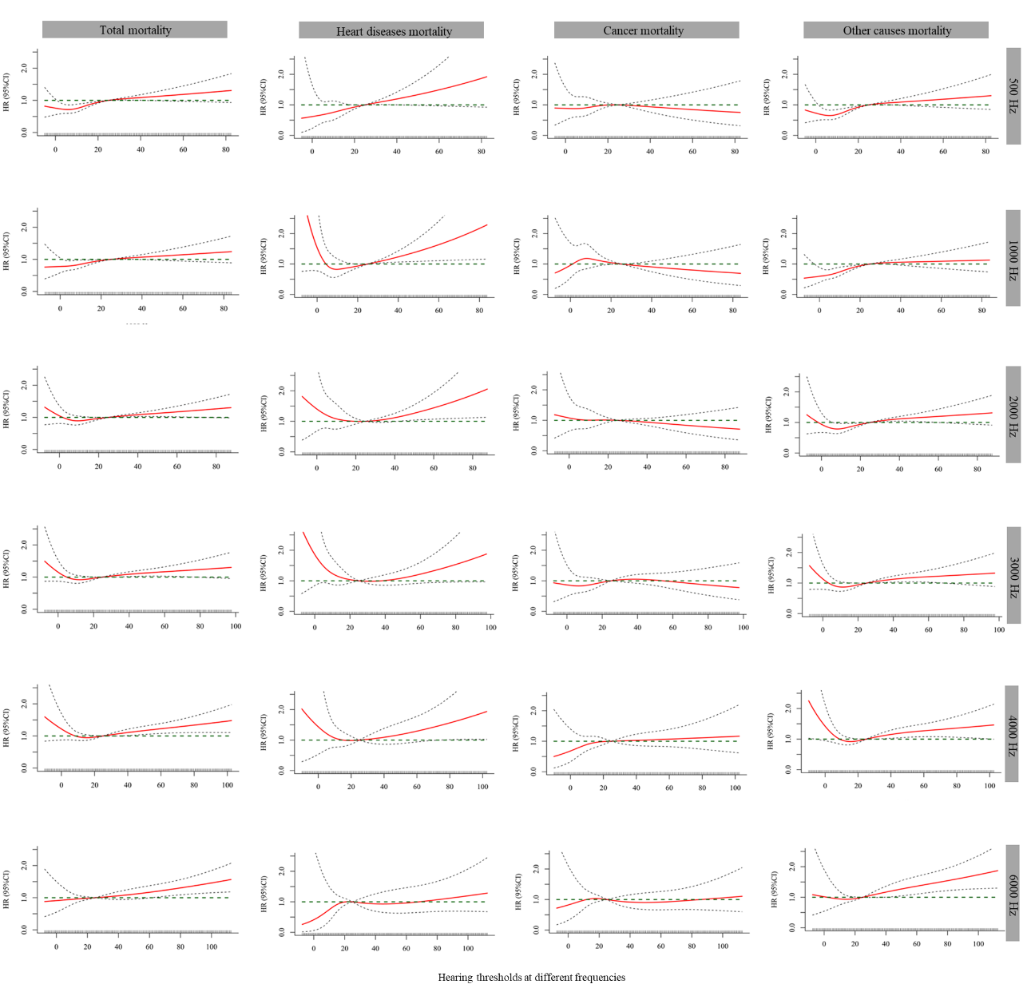
Figure S1. Dose-response associations between hearing thresholds at different frequencies and total/cause-specific mortality (N=11,732). Adjusted age, gender, race, educational levels, BMI, family income-poverty ratio level, married status, smoking status, drinking status, physical activity, general health condition, healthy eating index, occupational noise exposure, history of diabetes, cardiovascular disease, hypertension and cancer. Abbreviation: HR: hazard ratio; CI: confidence interval.

