ELECTRONIC SUPPLEMENTARY MATERIALS

Suantak Paolalsiam Vaiphei¹ and Rama Mohan Kurakalva^{1,2}*
¹Hydrogeochemistry Group, CSIR-National Geophysical Research Institute (CSIR-NGRI)
Hyderabad 500007, Telangana, India.
²Faculty of Physical Sciences, Academy of Scientific & Innovative Research (AcSIR), Ghaziabad 201002, India

Revised Version
Submitted to
Environmental Earth Sciences
June 2021

___________
*Corresponding Author:
E-mail: krenviron@ngri.res.in ; Tel: 040-27012632; Fax: 040-23434651
Orcid.org/0000-0001-7199-7475

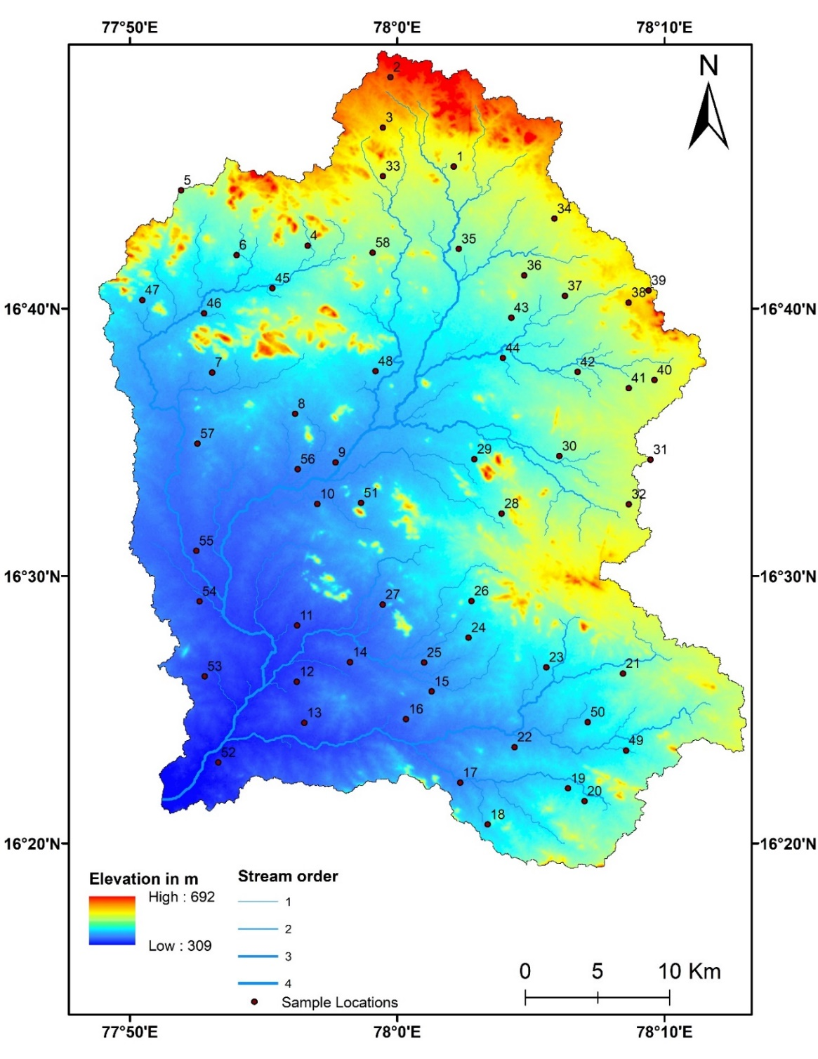
ESM_Fig.1 Topographical map of the Wanaparthy watershed of upper Krishna River basin, Telangana

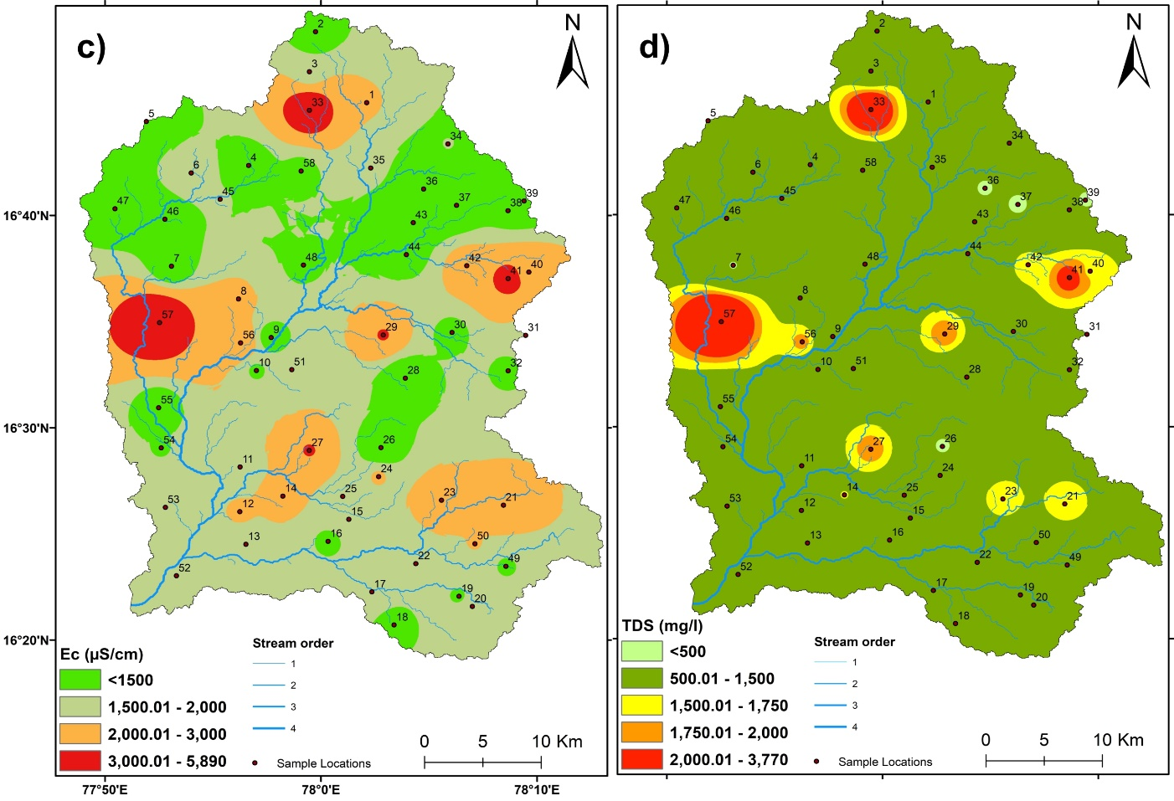
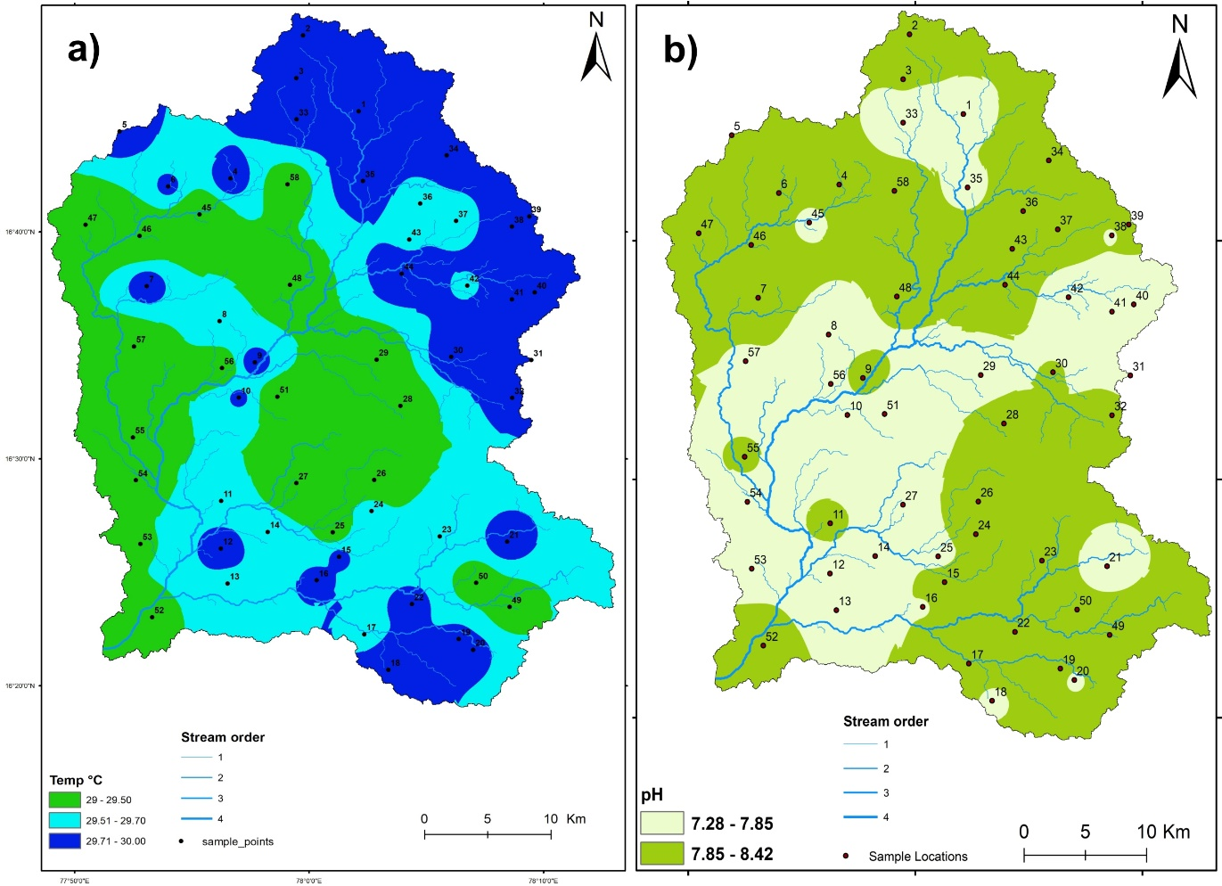

ESM_Fig.2 Spatial distribution map of a) Temperature b) pH c) EC d) TDS e) TH and f) Alkalinity of groundwater of Wanaparthy watershed
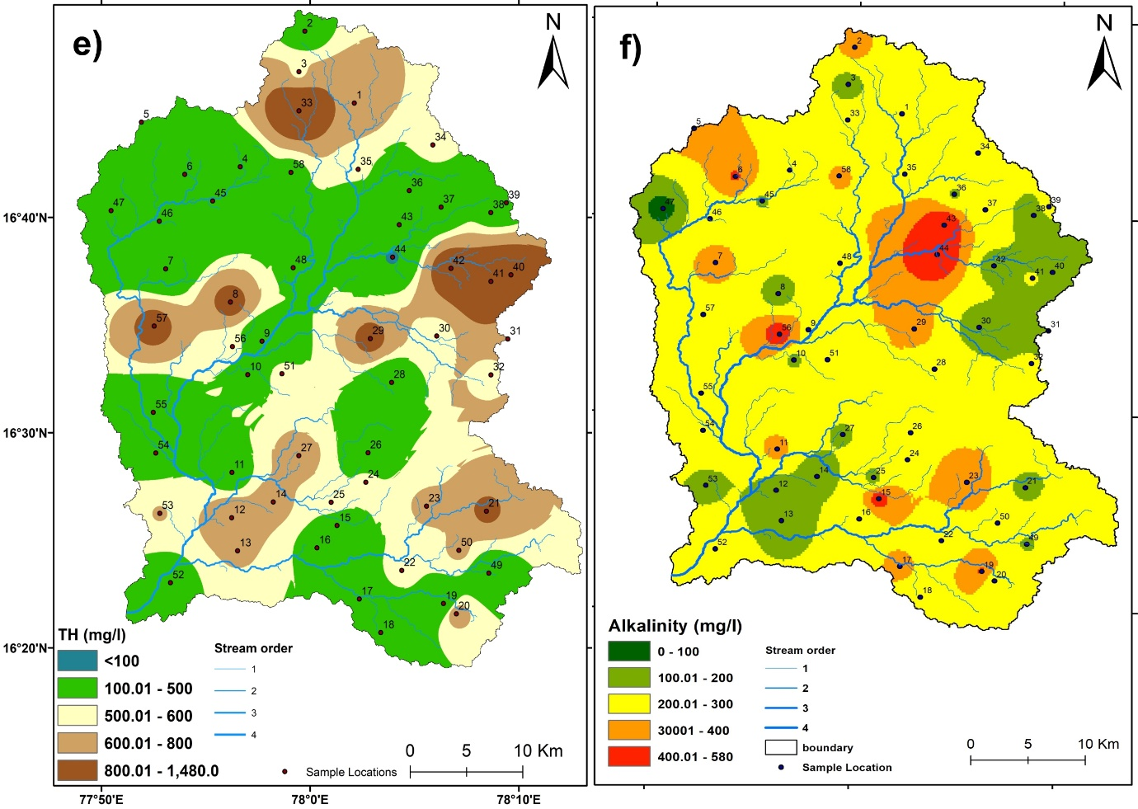
ESM_Fig.2. Continue

