**Supplementary Information**

**Electrochemical detection of white spot syndrome virus with a silicone rubber disposable electrode composed of graphene quantum dots and gold nanoparticle-embedded polyaniline nanowires**

Kenshin Takemura1, Jun Satoh2, Jirayu Boonyakida1, Sungjo Park3, Ankan Dutta Chowdhury4, Enoch Y. Park1,4,[1]

1*Laboratory of Biotechnology, Department of Bioscience, Graduate School of Science and Technology, Shizuoka University, 836 Ohya, Suruga-ku, Shizuoka 422-8529, Japan*

2*Division of Pathology, Department of Aquaculture Research, Fisheries Technology Institute of Japan Fisheries Research and Education Agency, National Research and Development Agency, Tamaki Field Station, 224-1 Hiruta, Tamaki, Watarai, Mie 519-0423, Japan*

3 *Division of Cardiovascular Diseases, Mayo Clinic College of Medicine and Science, Mayo Clinic, 200 First Street SW, Rochester, MN, 55905, USA*

4 *Laboratory of Biotechnology, Research Institute of Green Science and Technology, Shizuoka University, 836 Ohya, Suruga-ku, Shizuoka 422-8529, Japan*

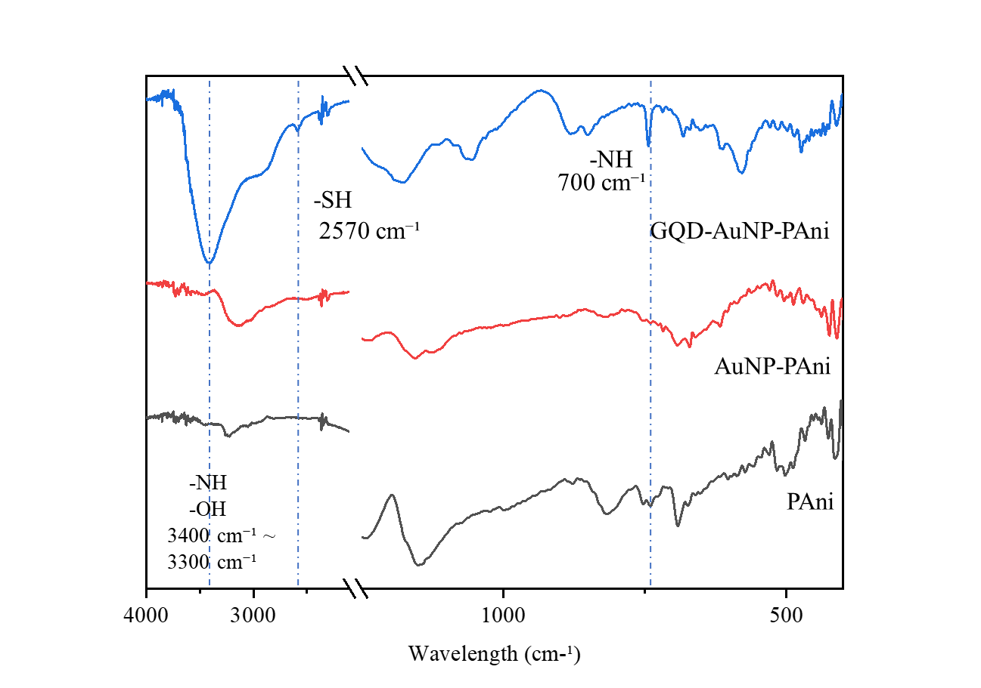

**Fig. S1** Analysis of functional groups on the surface of named materials by FT-IR infrared absorption spectra.



**Fig. S2** Impedance analysis of the PAni/PAni@CSR sensor electrode 5 to 20cycles of electrodeposition.

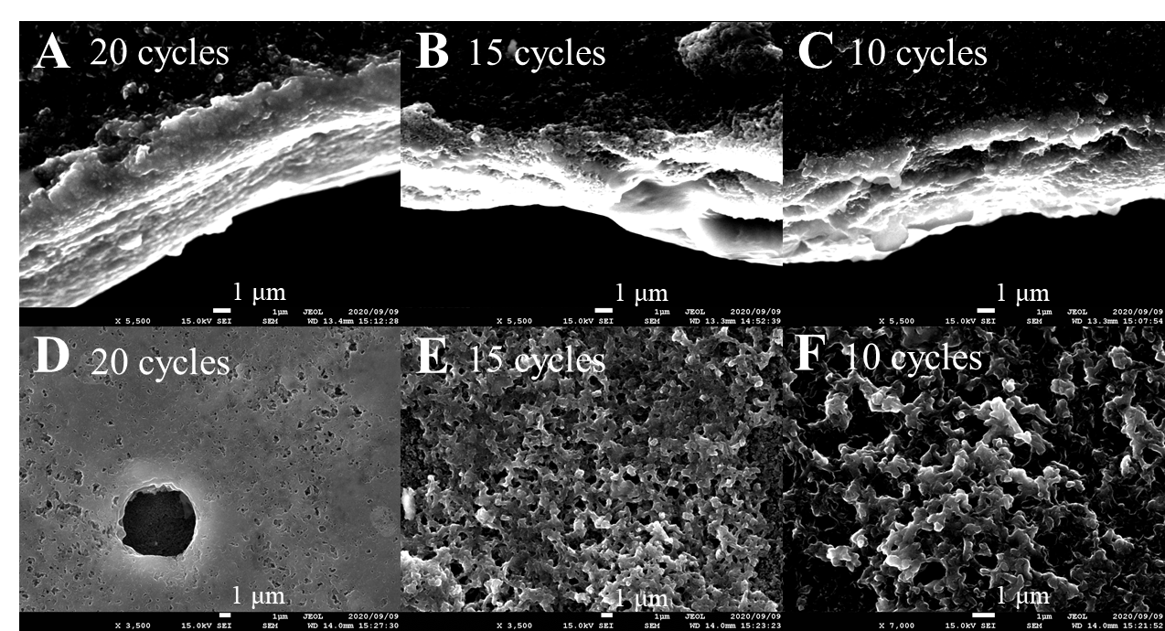

**Fig. S3** (**A–C**) SEM observed the difference in thickness of the polyaniline layer deposited on CSR.

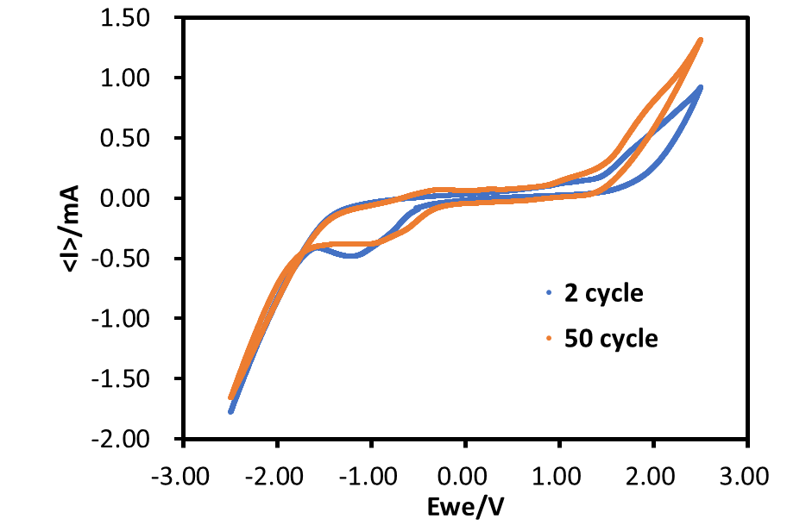

**Fig. S****4** Cyclic voltammetry analysis of the Ab-N,S-GQDs@AuNP-PAni/PAni@CSR sensor electrode 2 to 50cycles.

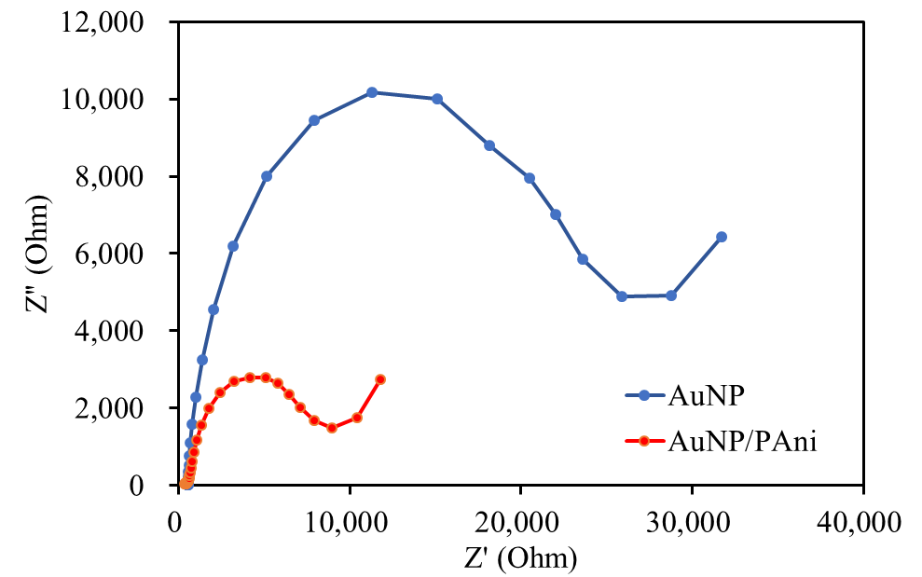

**Fig. S5** Comparison of Rct value with AuNP-modified CSR (blue line) and AuNP/PAni-modified CSR (orange line)

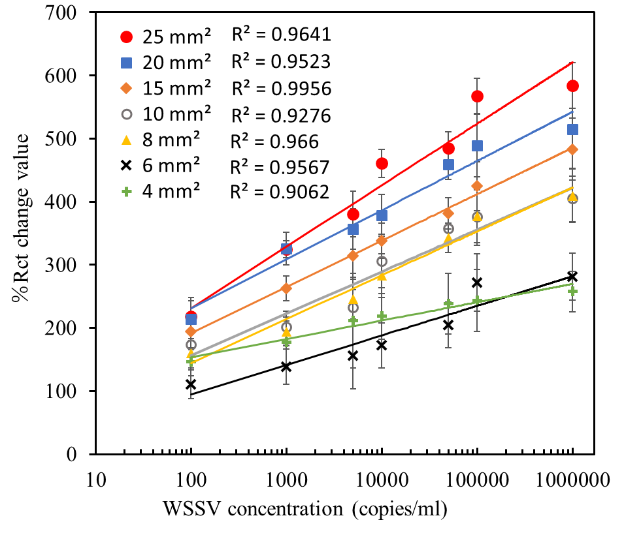

**Fig. S6** Detection result of WSSV using different surface area of Ab-GQD@AuPAni/PAni@CSR.



**Fig. S7** AFM images of the bare disposable sensor electrode (A) and with WSSV bound electrode (B).

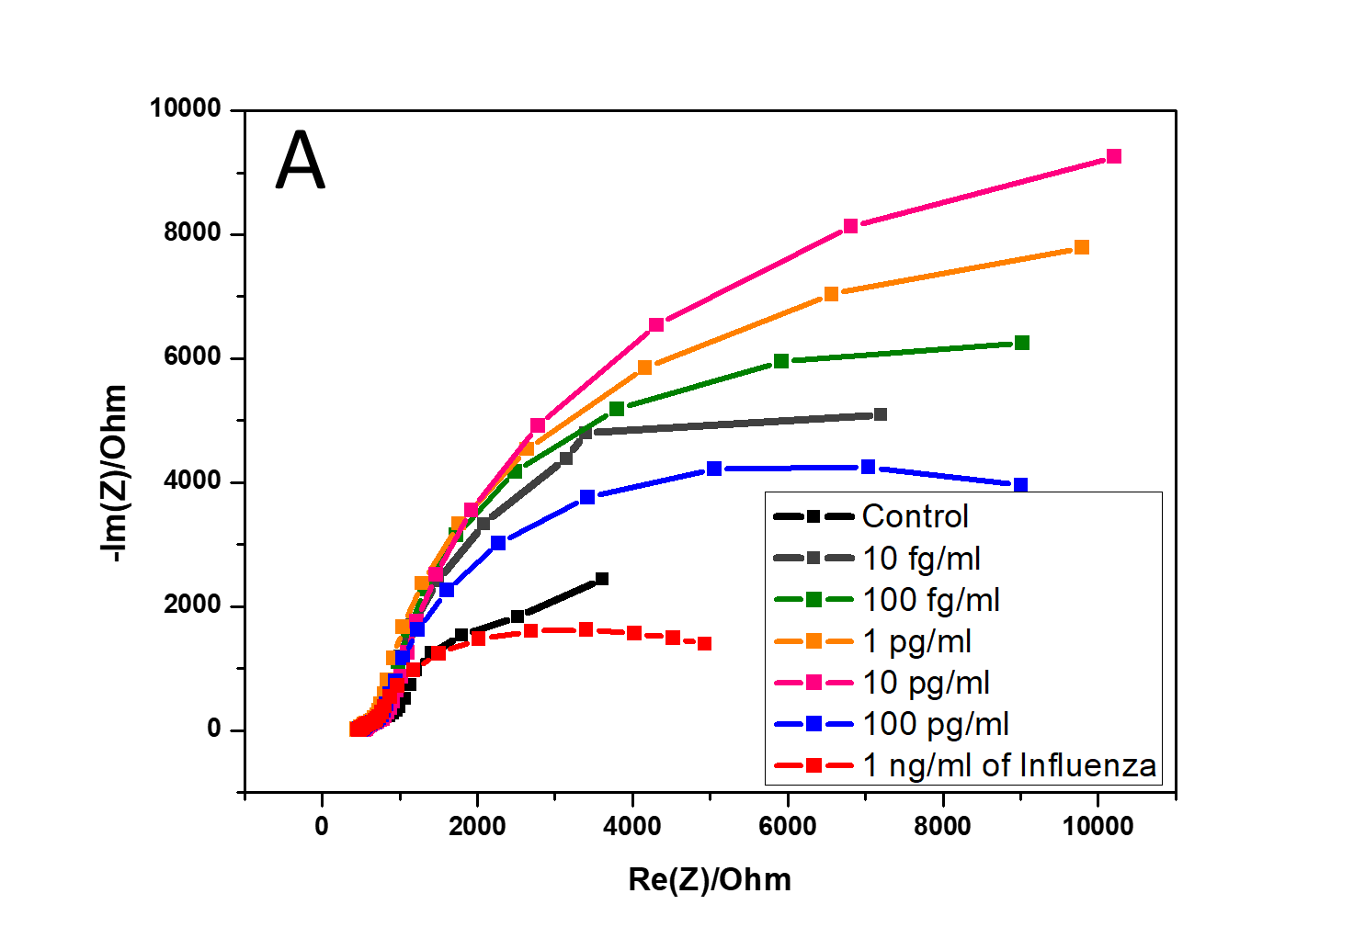

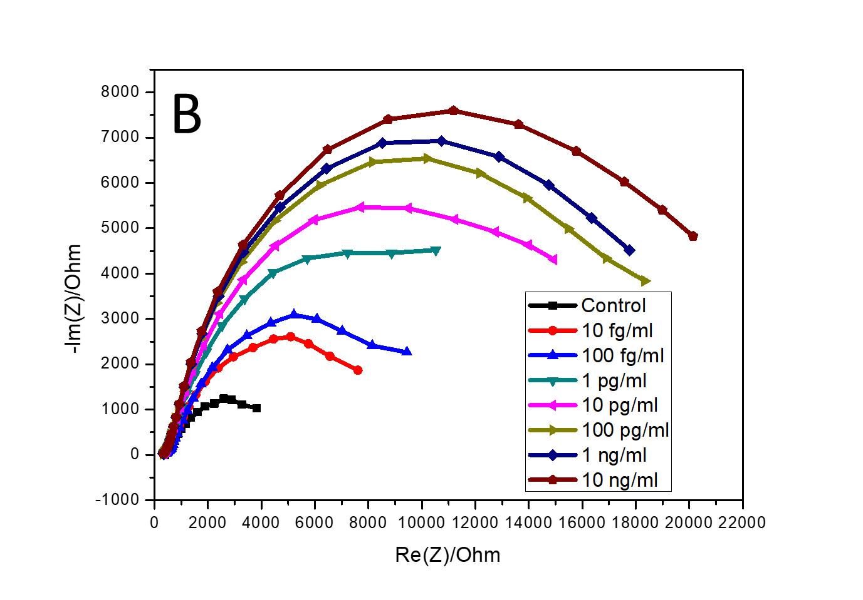

**Fig. S8** Nyquist impedance plots of the Ab-N,S-GQDs@AuNP-PAni/PAni@CSR sensor electrode before and after loading A) HEV and B) influenza virus.

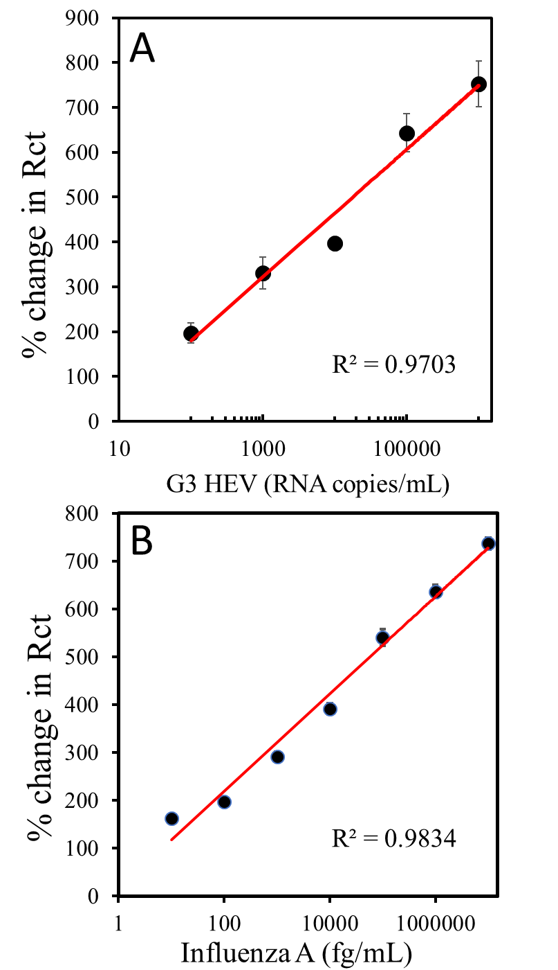

**Fig. S9** Detection result of the genotype 3 HEV (A) and Influenza virus A (H1N1) (B) using the Ab-GQD@AuNP-PAni/CSR sensor electrode, bound with their corresponding antibodies.

1. Correspondence to: Research Institute of Green Science and Technology, Shizuoka University, 836 Ohya Suruga- ku, Shizuoka, 422-8529, Japan. Tel. & fax: +81 54 238 4887. *E-mail address:* park.enoch@shizuoka.ac.jp (EYP)