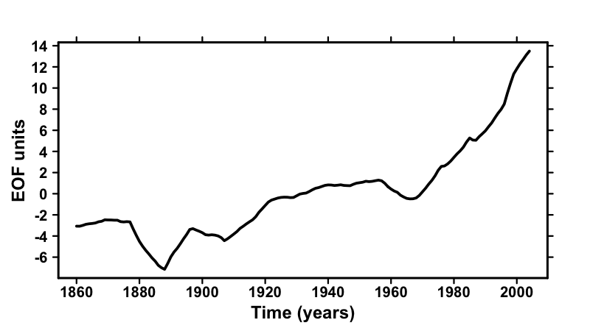
Extended Data Fig. 1 | Estimated forced component of historical NASST. Estimation is performed using signal-to-noise maximizing EOF² (cf. Methods), using historical simulations from 37 climate models (Extended Data Table 2). The timeseries is filtered with 11-years running mean.

