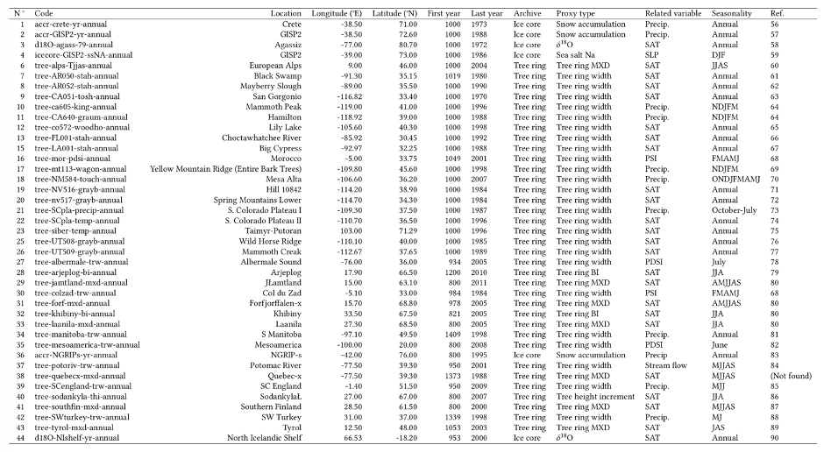
Extended Data Table 1 | Proxy records added to the PAGES 2k database⁹ to build the P2k+ database (References in Supplementary information).

