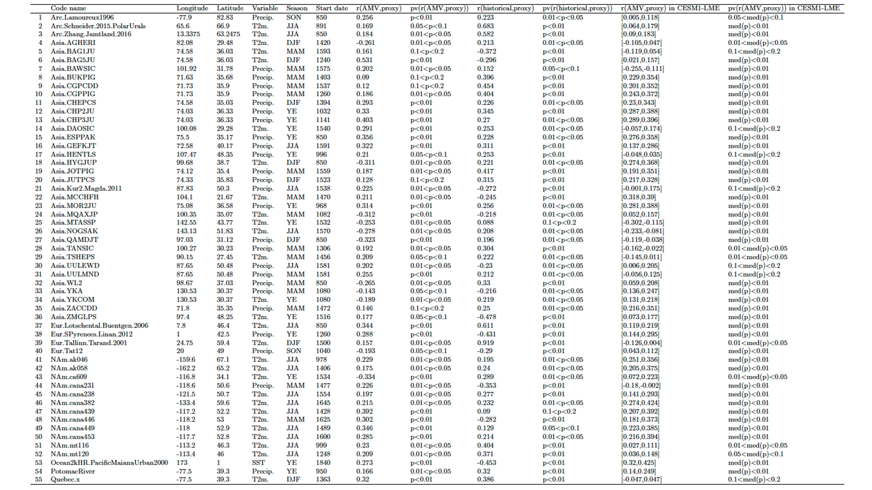

Extended Data Table 3 | Characteristics of proxy records used for the final reconstruction presented in this study. The correlation metric is denoted r, and the p-value of the correlation metric is denoted pv(r). Historical correlations and their significance have been calculated using the CRUTS4 dataset for the period 1901-2020. Correlations and their significance for the CESM1-LME experiment have been calculated for the period 850-1990, for the 12 members used in this study.

