SUPPLEMENTARY MATERIAL

**Evaluation of optimal fermentation conditions for volatile fatty acids production from artisanal fish waste**

L. S. Cadavid-Rodríguez 1[1]*, V. E. Castro-López1 and J. Plácido2,3*

1. *Departamento de Ingeniería. Facultad de Ingeniería y Administración. Universidad Nacional de Colombia sede Palmira. Carrera 32 No. 12-00 Vía a Candelaria. Palmira, Colombia.*

*2. Institute of Life Science, Swansea University Medical School, Swansea University, Swansea, SA2 8PP, Wales, UK*

*3. VEDAS Corporación de Investigación e Innovación (VEDAS CII), Calle 8 B 65-261, Medellín, Colombia.*

**ANNEX 1**

**Statistical analysis for the VFA production experiment**

**ANNEX 2**

**Additional variables measured for the VFA production from FW experiment**

**Figure 1.** COD removal %

**Figure 2.** Grade of acidification

**Figure 3.** Hydrolysis efficiency

**ANNEX 1**

**Statistical analysis for the VFA production experiment**

The ANOVA Procedure for a Randomized Complete Block with Area under the curve of VFA as Dependent Variable:

| **Source** | **DF** | **Sum of Squares** | **Mean Square** | **F Value** | **Pr > F** |
| --- | --- | --- | --- | --- | --- |
| **Model** | 15 | 1.0179838E12 | 67865585694 | 15.39 | <.0001 |
| **Error** | 14 | 61724325241 | 4408880374.4 |  |  |
| **Corrected Total** | 29 | 1.0797081E12 |  |  |  |

| **R-Square** | **Coeff Var** | **Root MSE** | **VFA_AUC Mean** |
| --- | --- | --- | --- |
| 0.942832 | 14.44937 | 66399.40 | 459531.6 |

| **Source** | **DF** | **Anova SS** | **Mean Square** | **F Value** | **Pr > F** |
| --- | --- | --- | --- | --- | --- |
| **Block** | 1 | 21233435889 | 21233435889 | 4.82 | 0.0456 |
| **pH** | 2 | 930875043002 | 465437521501 | 105.57 | <.0001 |
| **IS** | 4 | 57191091930 | 14297772982 | 3.24 | 0.0443 |
| **IS*pH** | 8 | 8684214595.3 | 1085526824.4 | 0.25 | 0.9737 |

***Duncan's Multiple Range Test for AUC_VFA***

Note: This test controls the Type I comparison wise error rate, not the experiment wise error rate.

|  |  |
| --- | --- |
| **Alpha** | 0.05 |
| **Error Degrees of Freedom** | 14 |
| **Error Mean Square** | 4.4089E9 |

| **Number of Means** | **2** | **3** |
| --- | --- | --- |
| **Critical Range** | 63689 | 66736 |



***Duncan's Multiple Range Test for AUC_VFA***

Note: This test controls the Type I comparison wise error rate, not the experiment wise error rate.

|  |  |
| --- | --- |
| **Alpha** | 0.05 |
| **Error Degrees of Freedom** | 14 |
| **Error Mean Square** | 4.4089E9 |

| **Number of Means** | **2** | **3** | **4** | **5** |
| --- | --- | --- | --- | --- |
| **Critical Range** | 82222 | 86156 | 88582 | 90224 |

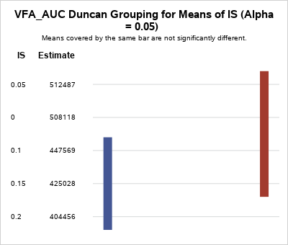

The statistical analysis of the VFA production utilising the area under the curve (AUC) revealed a similar description as depicted in Figure 1. The two-way ANOVA demonstrated that existed significant differences between the treatments (p value <0.0001, α=0.05). In this case, pH and I/S ratio, the main effects, were significant to the model (pH p value <0.0001 and I/S ratio p value <0.04, α=0.05), however, the interaction between pH and I/S ratio was not significant (p value <0.9737, α=0.05). These results agreed with the data presented in Figure 1, where the figures had a similar profile for the three pH even though they have different values. As the interaction term in ANOVA’s model was not significant, the main effects can be described and optimised individually. The Duncan’s multiple range test was used to evaluate the differences in the pH and I/S ratio for the AUC of the VFA production (AUC-VFA).

The ANOVA Procedure for a Randomized Complete Block with Area under the curve of TAN as Dependent Variable:

| **Source** | **DF** | **Sum of Squares** | **Mean Square** | **F Value** | **Pr > F** |
| --- | --- | --- | --- | --- | --- |
| **Model** | 15 | 93023991311 | 6201599420.8 | 12.41 | <.0001 |
| **Error** | 14 | 6998790639.3 | 499913617.09 |  |  |
| **Corrected Total** | 29 | 100022781951 |  |  |  |

| **R-Square** | **Coeff Var** | **Root MSE** | **AUC-TAN  Mean** |
| --- | --- | --- | --- |
| 0.930028 | 16.12076 | 22358.75 | 138695.4 |

| **Source** | **DF** | **Anova SS** | **Mean Square** | **F Value** | **Pr > F** |
| --- | --- | --- | --- | --- | --- |
| **Block** | 1 | 62769185050 | 62769185050 | 125.56 | <.0001 |
| **pH** | 2 | 27691233497 | 13845616748 | 27.70 | <.0001 |
| **IS** | 4 | 1988246725 | 497061681 | 0.99 | 0.4427 |
| **IS*pH** | 8 | 575326040 | 71915755 | 0.14 | 0.9952 |

Duncan's Multiple Range Test for **AUC-TAN**

Note: This test controls the Type I comparison wise error rate, not the experiment wise error rate.

|  |  |
| --- | --- |
| **Alpha** | 0.05 |
| **Error Degrees of Freedom** | 14 |
| **Error Mean Square** | 4.9991E8 |

| **Number of Means** | **2** | **3** |
| --- | --- | --- |
| **Critical Range** | 21446 | 22472 |



TAN statistical analysis (**Annex 1-Supplementary material**) also utilised AUC to have a more complete view of the TAN production process **Figure 3**. The two-way ANOVA demonstrated that existed significant differences between the treatments (p value <0.0001, α=0.05). In this case, only the pH was significant to the model (pH p value <0.0001) while I/S ratio (p value <0.4427, α=0.05) and the interaction between pH and I/S ratio (p value <0.99952, α=0.05) were not significant. Although, the TAN figures described high peaks at different I/S ratio, the lack of significance in this variable revealed the importance of using a variable that unite all the points instead of individual maximums. As I/S ratio and the interaction were not significant, pH was the only main effect that can be utilised for optimisation. The Duncan’s multiple range test was used to evaluate the differences in the pH for the AUC of the TAN production (AUC-TAN).

The ANOVA Procedure for a Randomized Complete Block with Area under the curve of Ln of Biogas-AUC

| **Source** | **DF** | **Sum of Squares** | **Mean Square** | **F Value** | **Pr > F** |
| --- | --- | --- | --- | --- | --- |
| **Model** | 15 | 69.82241100 | 4.65482740 | 3.01 | 0.0229 |
| **Error** | 14 | 21.61599345 | 1.54399953 |  |  |
| **Corrected Total** | 29 | 91.43840445 |  |  |  |

| **R-Square** | **Coeff Var** | **Root MSE** | **AUC-Biogas Mean** |
| --- | --- | --- | --- |
| 0.763600 | 16.10672 | 1.242578 | 7.714655 |

| **Source** | **DF** | **Anova SS** | **Mean Square** | **F Value** | **Pr > F** |
| --- | --- | --- | --- | --- | --- |
| **Block** | 1 | 17.21021291 | 17.21021291 | 11.15 | 0.0049 |
| **pH** | 2 | 28.33714674 | 14.16857337 | 9.18 | 0.0028 |
| **IS** | 4 | 10.44277666 | 2.61069417 | 1.69 | 0.2078 |
| **IS*pH** | 8 | 13.83227469 | 1.72903434 | 1.12 | 0.4071 |

***Duncan's Multiple Range Test for AUC_Biogas***

Note: This test controls the Type I comparison wise error rate, not the experiment wise error rate.

|  |  |
| --- | --- |
| **Alpha** | 0.05 |
| **Error Degrees of Freedom** | 14 |
| **Error Mean Square** | 1.544 |

| **Number of Means** | **2** | **3** |
| --- | --- | --- |
| **Critical Range** | 1.192 | 1.249 |



The AUC from the biogas plots (Figure 4) was used as variable for the statistical analysis (Annex 1-Supplementary material). The two-way ANOVA demonstrated that existed significant differences between the treatments (p value <0.0229, α=0.05). Similar to TAN, only the pH was significant to the model (pH p value <0.0028) while I/S ratio (p value <0.2078, α=0.05) and the interaction between pH and I/S ratio (p value <0.4071, α=0.05) were not significant. The statistical result confirmed the strong effect the pH had on biogas production as showed in Figure 4. As I/S ratio and the interaction between pH and I/S ratio were not significant, pH was the main effect employed for optimisation. The Duncan’s multiple range test determined the differences produced by the pH on the AUC of the Biogas figures (AUC-TAN).

The ANOVA Procedure for a Randomized Complete Block with Area under the curve of COD soluble

| **Source** | **DF** | **Sum of Squares** | **Mean Square** | **F Value** | **Pr > F** |
| --- | --- | --- | --- | --- | --- |
| **Model** | 15 | 207352448402 | 13823496560 | 2.40 | 0.0546 |
| **Error** | 14 | 80500404763 | 5750028911.6 |  |  |
| **Corrected Total** | 29 | 287852853164 |  |  |  |

| **R-Square** | **Coeff Var** | **Root MSE** | **COD-AUC Mean** |
| --- | --- | --- | --- |
| 0.720342 | 4.184483 | 75828.95 | 1812146 |

| **Source** | **DF** | **Anova SS** | **Mean Square** | **F Value** | **Pr > F** |
| --- | --- | --- | --- | --- | --- |
| **Block** | 1 | 17499233786 | 17499233786 | 3.04 | 0.1030 |
| **pH** | 2 | 97590228749 | 48795114374 | 8.49 | 0.0039 |
| **IS** | 4 | 55843729606 | 13960932402 | 2.43 | 0.0967 |
| **IS*pH** | 8 | 36419256261 | 4552407033 | 0.79 | 0.6187 |

***Duncan's Multiple Range Test for COD soluble***

Note: This test controls the Type I comparison wise error rate, not the experiment wise error rate.

|  |  |
| --- | --- |
| **Alpha** | 0.05 |
| **Error Degrees of Freedom** | 14 |
| **Error Mean Square** | 5.75E9 |

| **Number of Means** | **2** | **3** |
| --- | --- | --- |
| **Critical Range** | 72733 | 76213 |



***Duncan's Multiple Range Test for COD soluble***

Note: This test controls the Type I comparison wise error rate, not the experiment wise error rate.

|  |  |
| --- | --- |
| **Alpha** | 0.05 |
| **Error Degrees of Freedom** | 14 |
| **Error Mean Square** | 5.75E9 |

| **Number of Means** | 2 | 3 | 4 | 5 |
| --- | --- | --- | --- | --- |
| **Critical Range** | 93898 | 98391 | 101162 | 103037 |

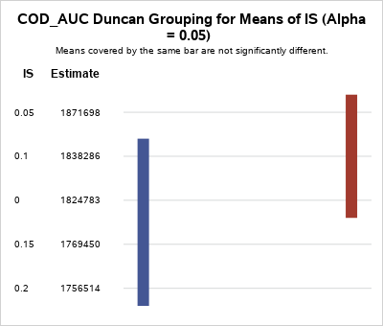

The statistical analysis of the AUC for sCOD (**Annex 1-Supplementary material**) corroborated the effect of pH and I/S ratio on sCOD concentration **Figure 5**. The two-way ANOVA demonstrated that existed significant differences between the treatments (p value <0.0546, α=0.1). In this variable, pH and I/S ratio were significant to the model (pH p value <0.0039 and I/S ratio p value <0.096, α=0.1), while, the interaction between pH and I/S ratio was not significant (p value <0.6187, α=0.1). As both main effects were significant, their best conditions can be selected using the Duncan’s test.

The Duncan’s test described pH 7 and 9 (**Figure 5F**) as the best conditions for sCOD as they had the highest values and were statistically similar. On the other hand, the Duncan’s test showed the I/S ratios of 0.05, 0.1 and 0 as the better conditions for sCOD as they had the highest values and were not statistically different.

The ANOVA Procedure for a Randomized Complete Block with Area under the curve of the square of COD reduction %

| **Source** | **DF** | **Sum of Squares** | **Mean Square** | **F Value** | **Pr > F** |
| --- | --- | --- | --- | --- | --- |
| **Model** | 15 | 0.05492069 | 0.00366138 | 1.39 | 0.2736 |
| **Error** | 14 | 0.03698152 | 0.00264154 |  |  |
| **Corrected Total** | 29 | 0.09190222 |  |  |  |

| **R-Square** | **Coeff Var** | **Root MSE** | **COD-AUC Mean** |
| --- | --- | --- | --- |
| 0.597599 | 8.092765 | 0.051396 | 0.635084 |

| **Source** | **DF** | **Anova SS** | **Mean Square** | **F Value** | **Pr > F** |
| --- | --- | --- | --- | --- | --- |
| **Block** | 1 | 0.03038716 | 0.03038716 | 11.50 | 0.0044 |
| **pH** | 2 | 0.00221480 | 0.00110740 | 0.42 | 0.6655 |
| **IS** | 4 | 0.00436082 | 0.00109020 | 0.41 | 0.7967 |
| **IS*pH** | 8 | 0.01795791 | 0.00224474 | 0.85 | 0.5769 |

***Duncan's Multiple Range Test for COD soluble***

Note: This test controls the Type I comparison wise error rate, not the experiment wise error rate.

|  |  |
| --- | --- |
| **Alpha** | 0.05 |
| **Error Degrees of Freedom** | 14 |
| **Error Mean Square** | 0.002642 |

| **Number of Means** | **2** | **3** |
| --- | --- | --- |
| **Critical Range** | .04930 | .05166 |

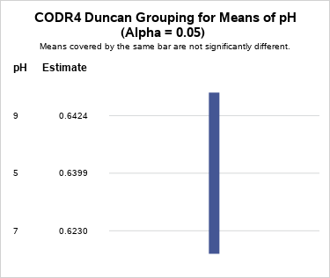

**ANNEX 2**

**Additional variables measured during the VFA production from FW experiment**



**Figure 1.** COD removal %

**.** 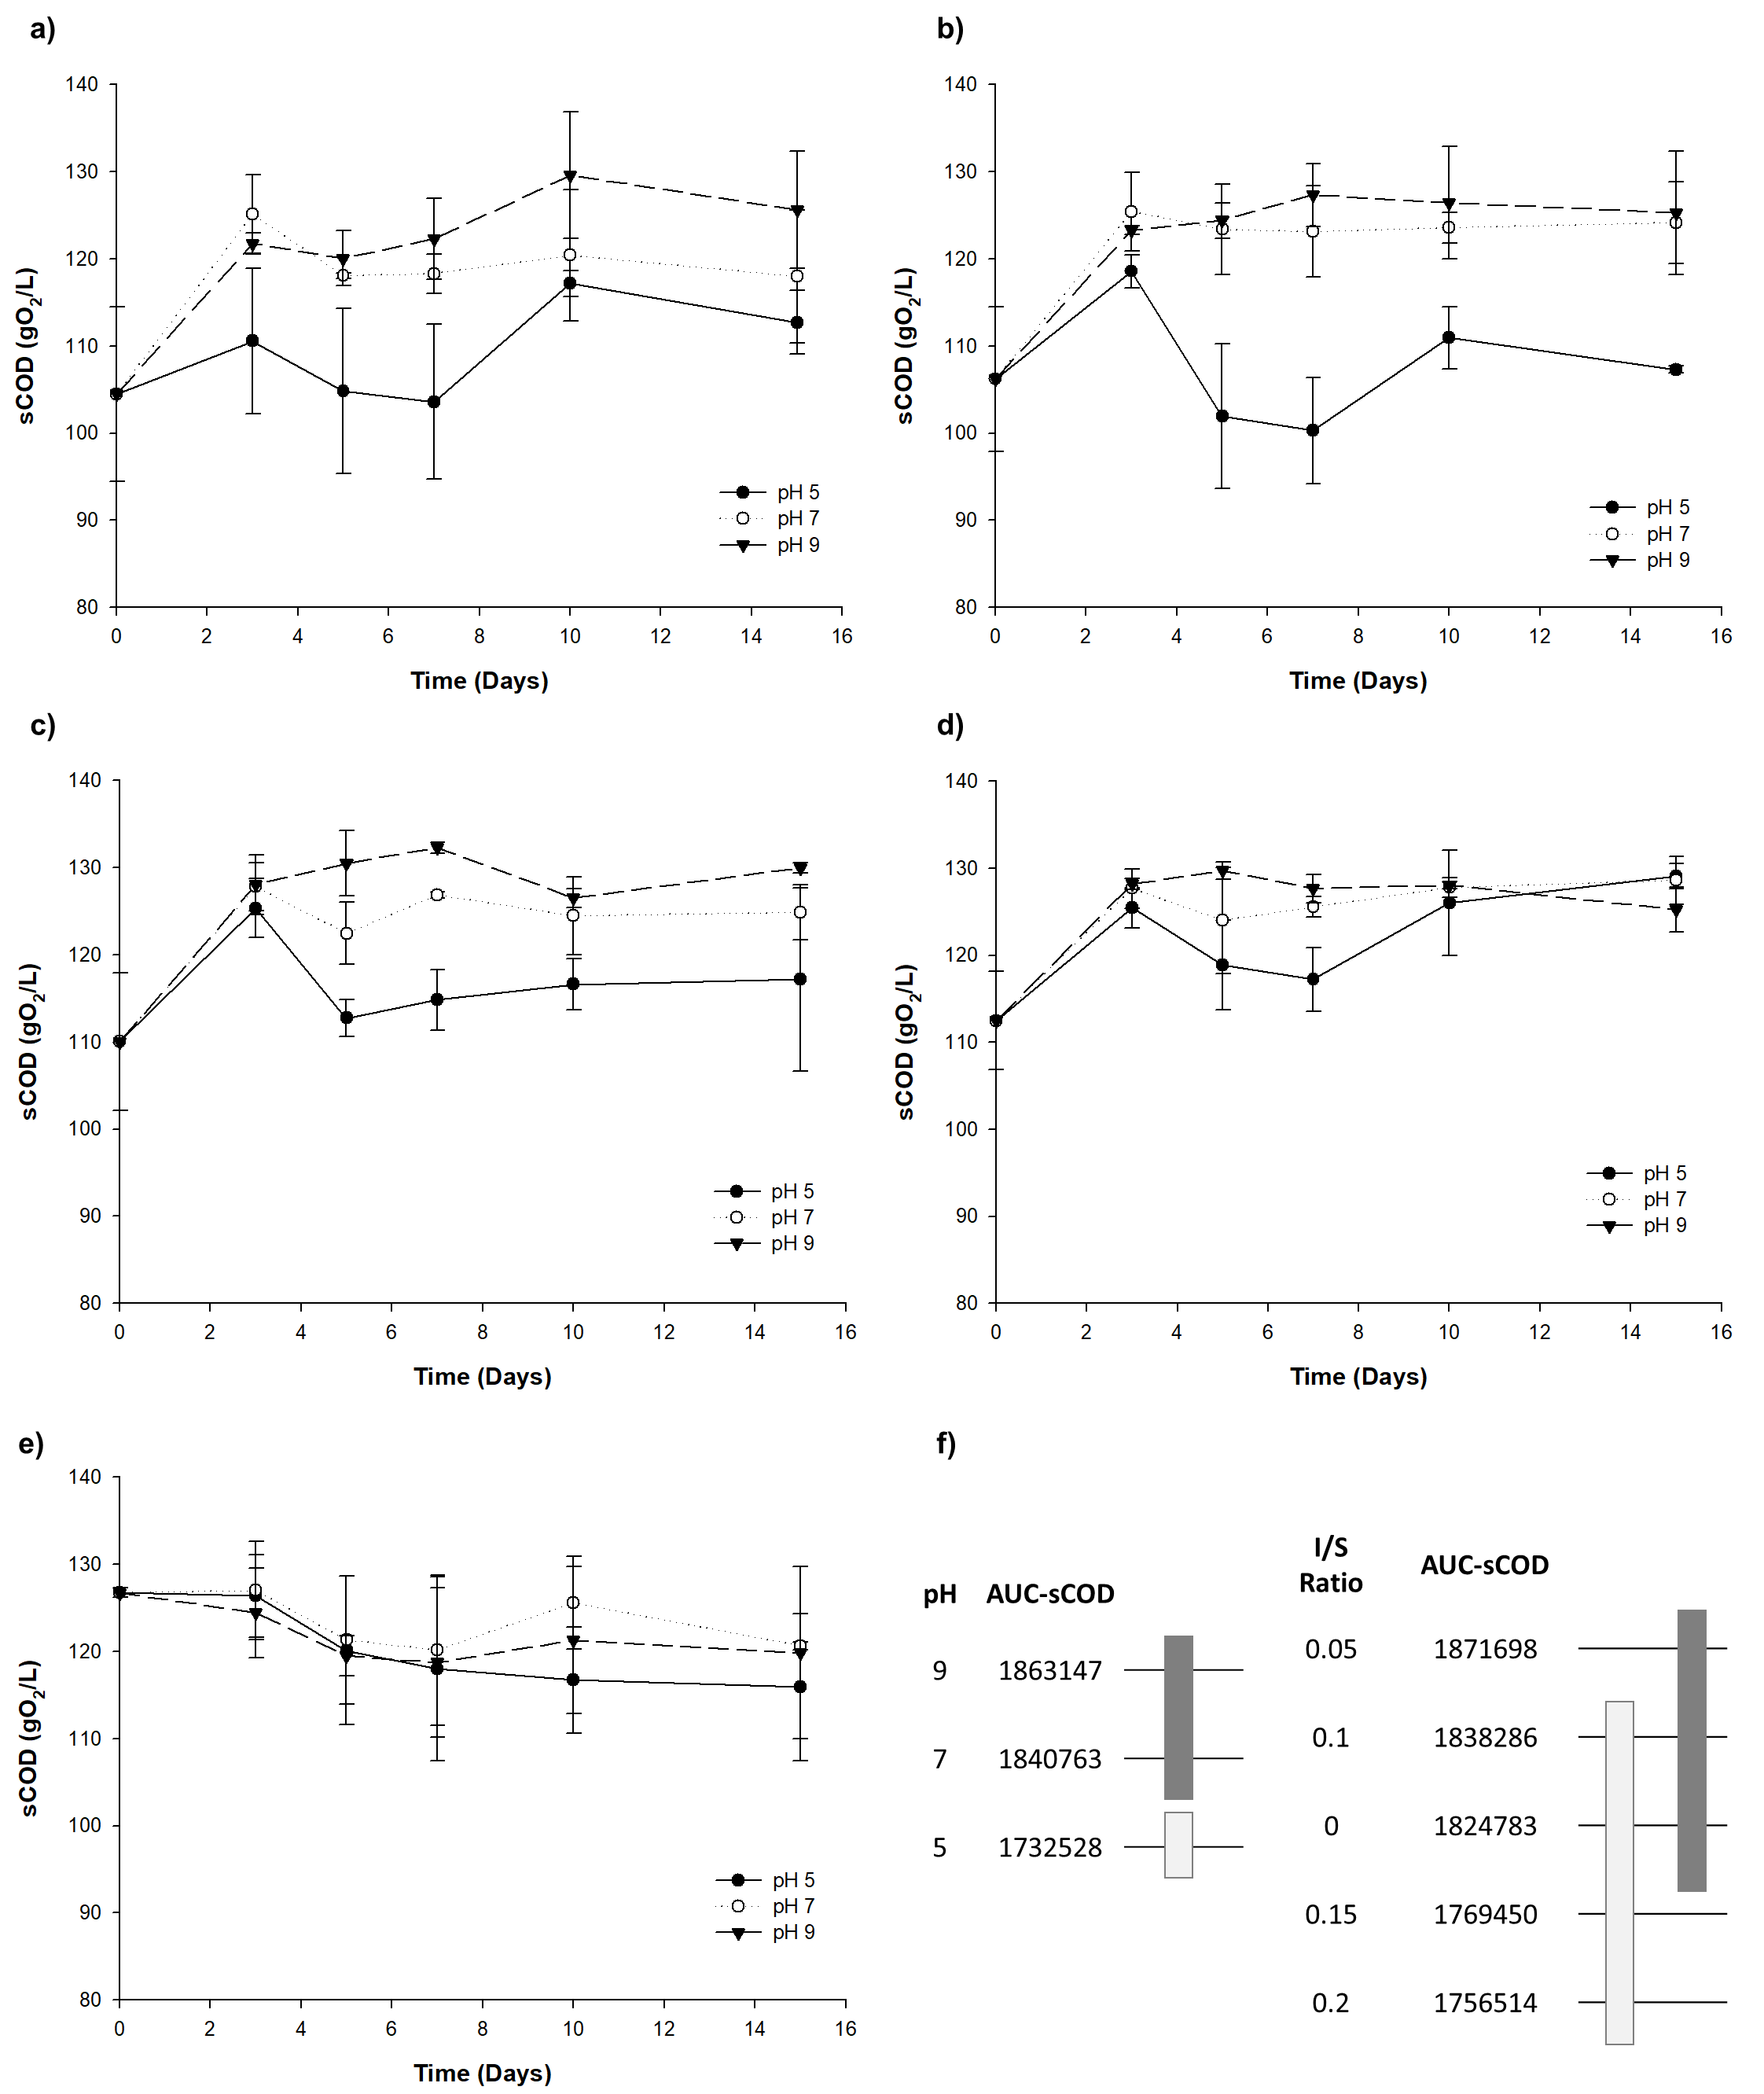**Figure 2. .** Soluble COD during FW transformation into VFA using different pH and I/S ratios: Each figure represents a different I/S value: **a.** 0.20, **b.** 0.15, **c.** 0.10, **d.** 0.05 and **e.** 0.00 **f.** Duncan groupings for means of pH and I/S ratio for the AUC-sCOD variable

1. * \***Corresponding authors:**

   E-mail address: [lscadavidr@unal.edu.co](mailto:lscadavidr@unal.edu.co) | Jersson.placido@vedascii.org

   Phone: (57-2) 2868888 Ext: 35709 | (57-4) 3620154