Supplementary Figure 1 The multiple supporting fields of cells for Figure 2D.
Supplementary Figure 2 The multiple supporting fields of cells for Figure 4D.

Supplementary Figure 3 The original western blot of Figure 5C.
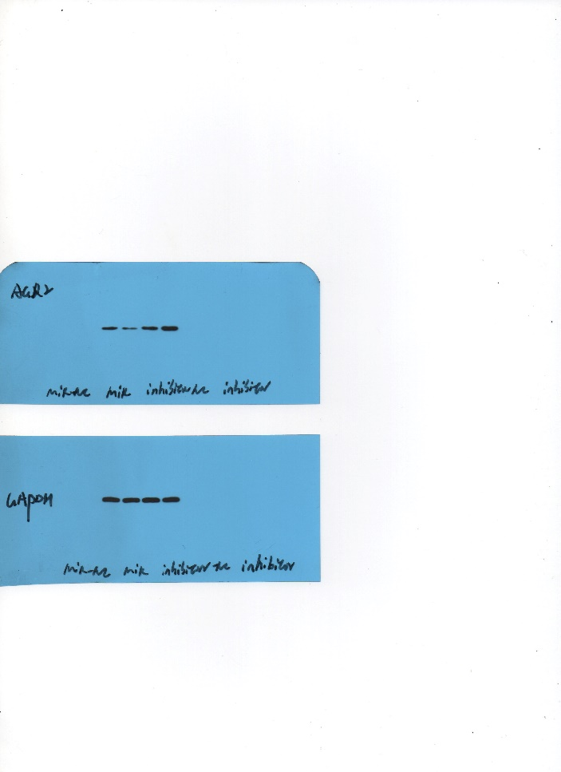

Supplementary Figure 4 The original western blot of Figure 5D.
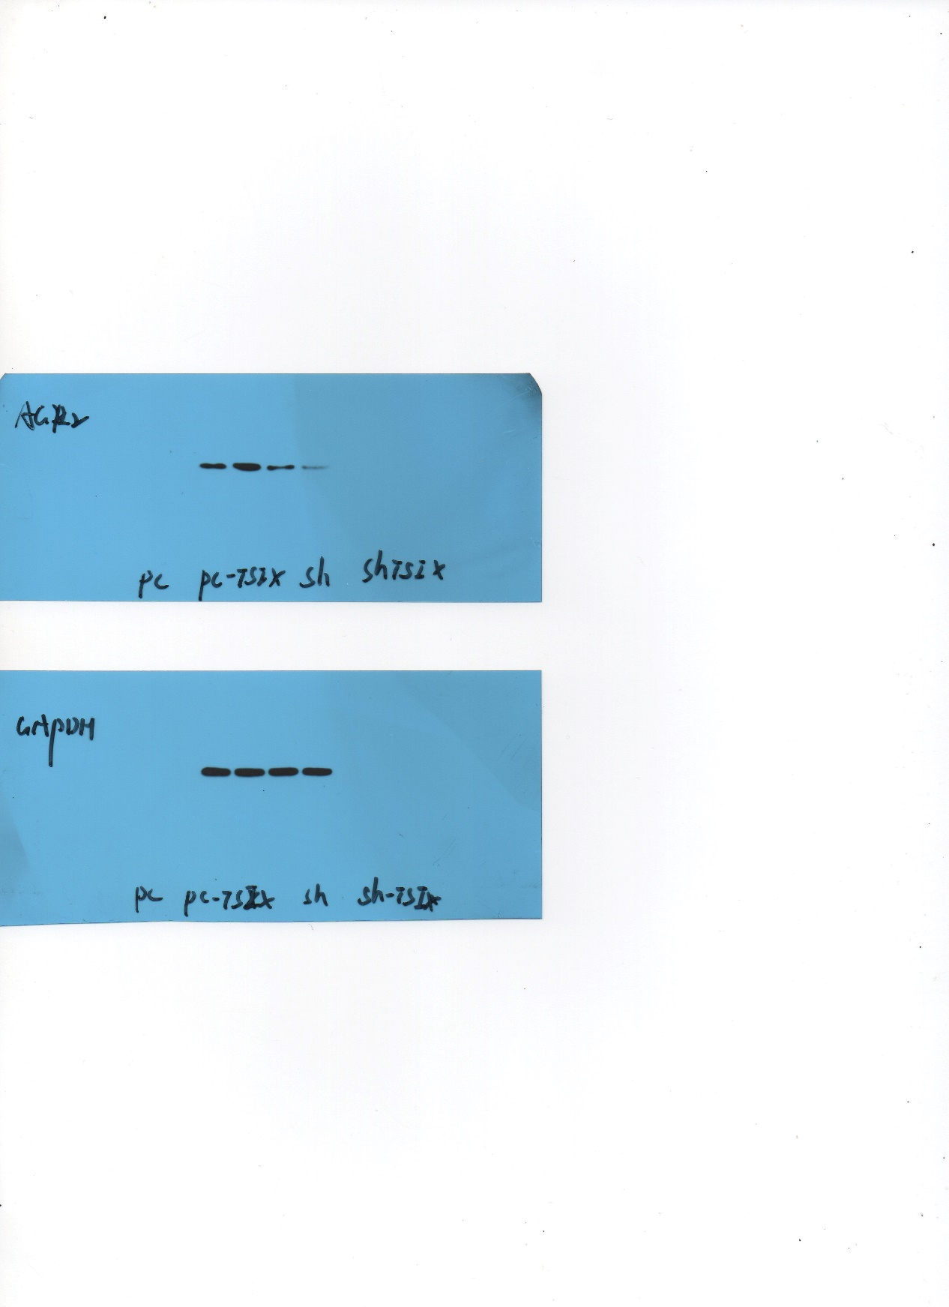

Supplementary Figure 5 The original western blot of Figure 6E.
