Additional File 14
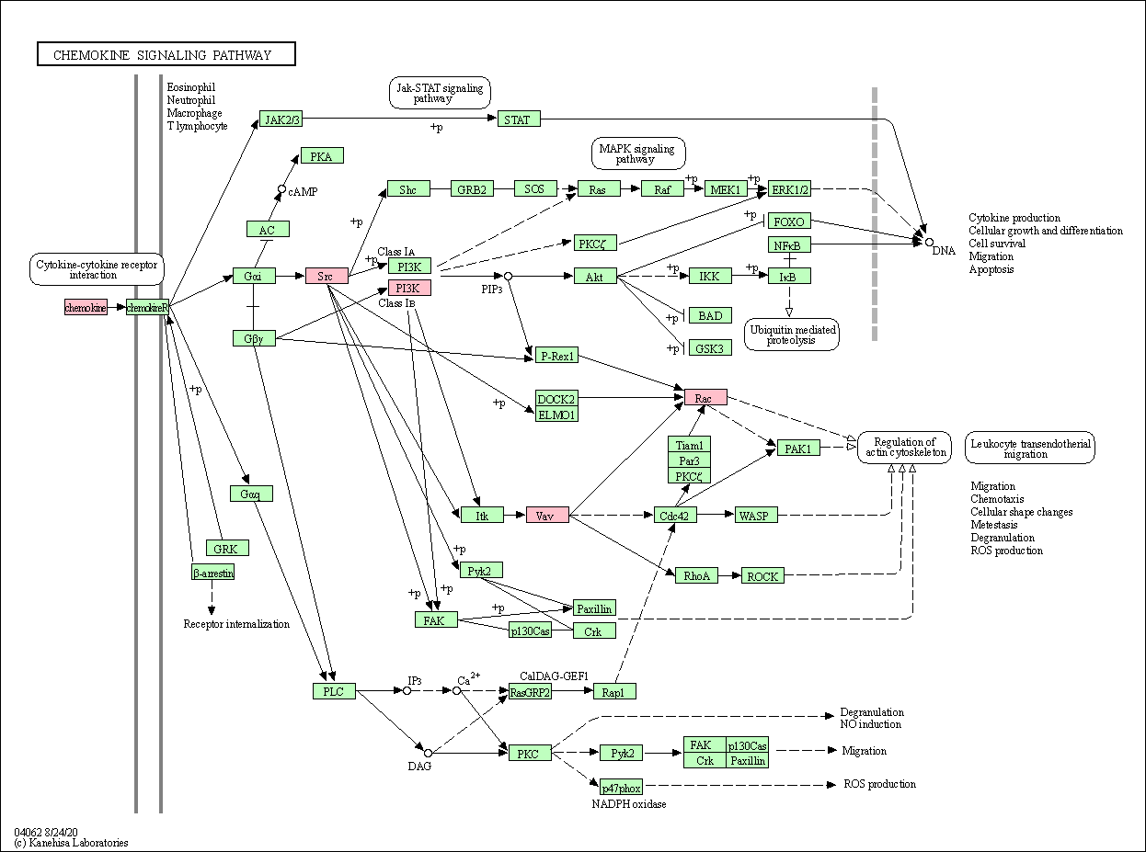
Figure S1. Chemokine Signaling Pathway virtualized by KEGG Pathway Maps. High-expressed monthly DEGs are highlighted with pink color, while low-expressed monthly DEGs are highlighted with blue color.

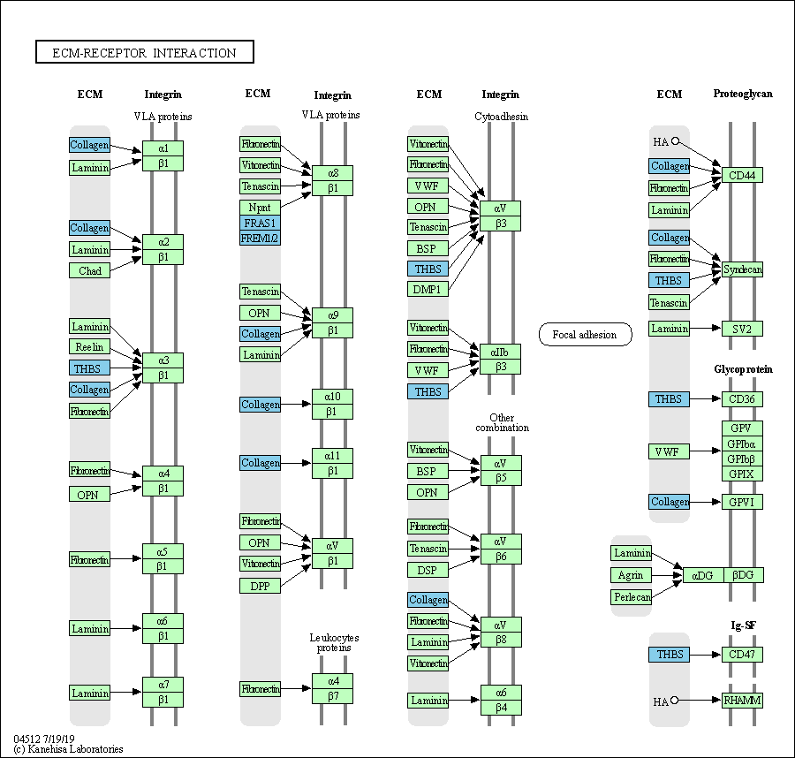
Figure S2. ECM-Receptor Interaction Signaling Pathway virtualized by KEGG Pathway Maps. High-expressed monthly DEGs are highlighted with pink color, while low-expressed monthly DEGs are highlighted with blue color.

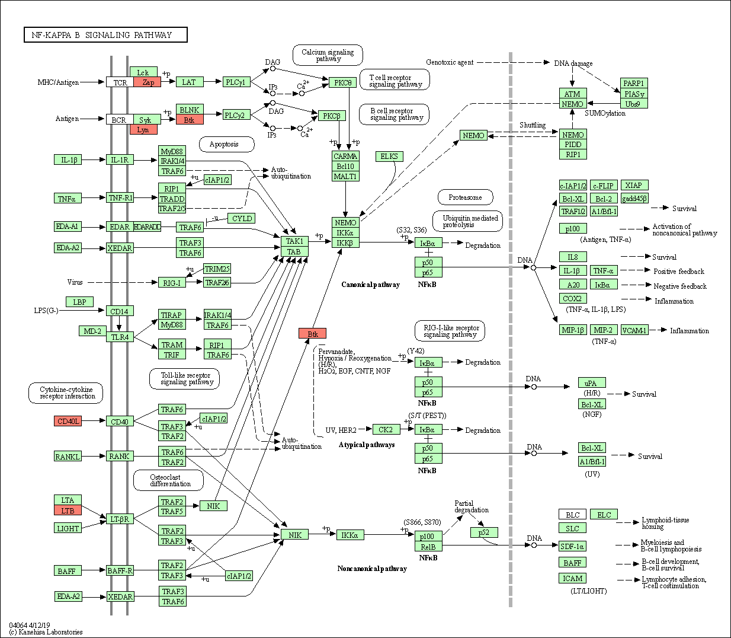
Figure S3. NF-Kappa B Signaling Pathway virtualized by KEGG Pathway Maps. High-expressed monthly DEGs are highlighted with pink color, while low-expressed monthly DEGs are highlighted with blue color.

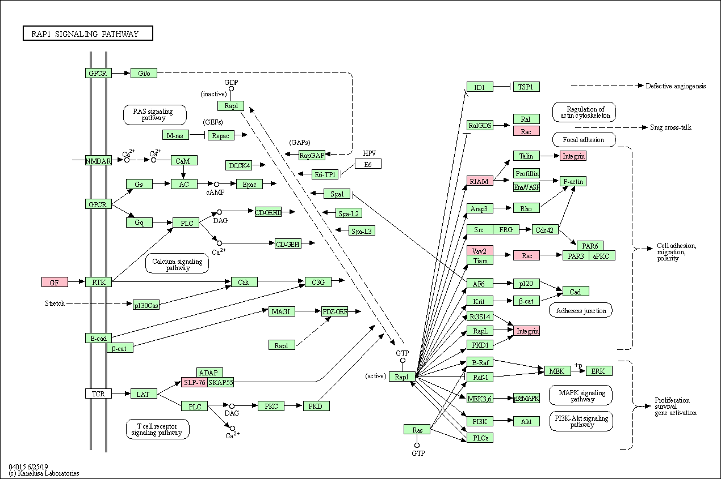
Figure S4. Rap1 Signaling Pathway virtualized by KEGG Pathway Maps. High-expressed monthly DEGs are highlighted with pink color, while low-expressed monthly DEGs are highlighted with blue color.

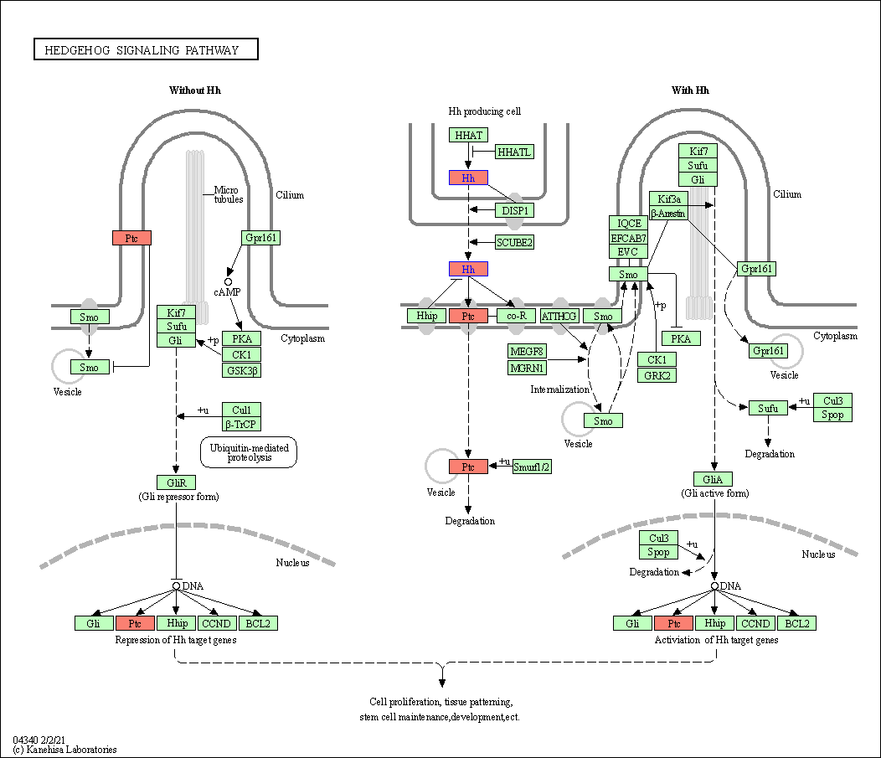
Figure S5. Hedgehog Signaling Pathway virtualized by KEGG Pathway Maps. High-expressed monthly DEGs are highlighted with pink color, while low-expressed monthly DEGs are highlighted with blue color.

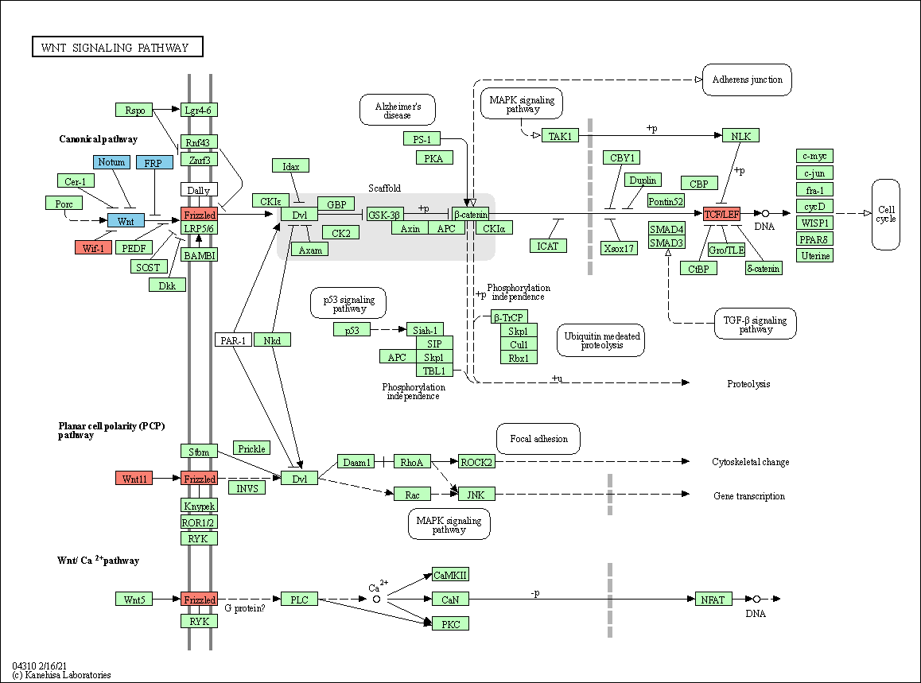
Figure S6. Wnt Signaling Pathway virtualized by KEGG Pathway Maps. High-expressed monthly DEGs are highlighted with pink color, while low-expressed monthly DEGs are highlighted with blue color.

