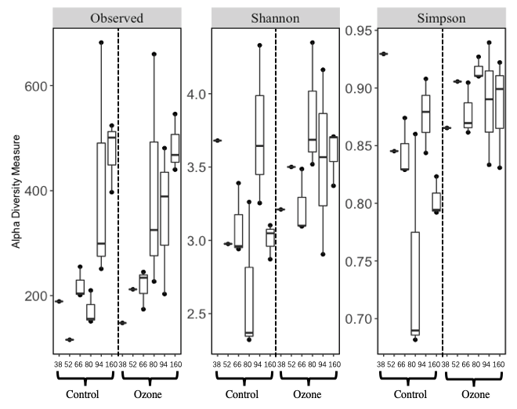

Supplementary material 1. Fig. 1. Alpha diversity indices of the samples from all sampling date.

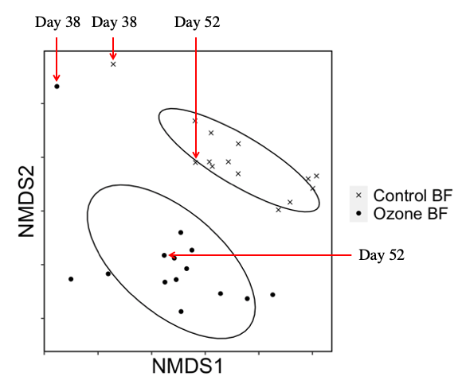

Supplementary material 1. Fig. 2. NMDS analysis of weighted-unifrac distance of all samples from all dates.

