Material code | Origin | Shape/Appearance | Initial Condition | Dating | Experiments | Images
WA | felled trunk, Valais Switzerland, Betula pendula | Compact, slightly bended | dry | Contemporary (6 years) | 1
C | Container by native American people in Canada, probably Betula papyrifera | Compact, strongly bended with the cambium side out and remains of the phloem | dry | Ethnographic (≈40 years) | 1, 2 and 3
P | Ceiling of a tumulus, Pazyryk culture, Berel, Altai region, Republic Kazakhstan, excavated in 2018 in permafrost soil, probably Betula pubescens | flat / delaminated | dry | 5th to 3rd century BC (Iron age) | 1 and 2
B | Trunks from the lake dwelling site Burgäschisee north, Switzerland, Cortaillod culture, excavated in 2017, probably Betula pendula | Fragile / bended with the outer side out (same orientation as on the tree) | waterlogged | 2800 BC (Neolithic) | 1 and 2 | 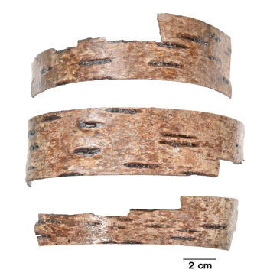
S cover | Schnidejoch bow case cover, preserved in alpine ice, species unknown | Found in 2003, in 2008 treated in several alcohol solutions | dry | 2800 BC (Neolithic) | 1 | 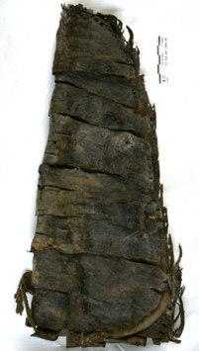
S middle part | Schnidejoch bow case middle part, preserved in alpine ice, species unknown | Found in 2005, untreated and stored frozen | damp and frozen | 2800 BC (Neolithic) | 1
S lower part | Schnidejoch bow case lower part, preserved in alpine ice, species unknown | Found in 2005, untreated and stored frozen | damp and frozen | 2800 BC (Neolithic) | 1
Table 1 Description of the samples used and mention of the experiments performed.

