Supporting Information

Stress transfer analyses in cellulose nanofiber/montmorillonite nanocomposites with X-ray diffraction and investigation on effects of chemical interaction between cellulose nanofiber and montmorillonite

Takuya Matsumoto, Sunichi Mori, Takuya Ohashi, Takashi Nishino*

Department of Chemical Science and Engineering, Graduate School of Engineering, Kobe University, Rokko, Nada, Kobe, 657-8501, Japan.
E-mail: tnishino@kobe-u.ac.jp

Experimental Procedure
Measurements of fourier transform infrared spectroscopy (FT-IR)
For the detection of carboxyl groups of TOCN, FT-IR measurements of FCN and TOCN sheets were performed with FT-IR spectrometer IRTracer-100 (Shimadzu). The samples were dispersed into KBr pellets at a concentration of 1 wt%. Before the measurements, the sample pellets were dried at 40°C for more than 6 h.
Observation of atomic force microscopy (AFM)
For the observation of nanofibrillated cellulose, the FCN and TOCN were observed with AFM NanoNavi II E-sweep (Hitachi High-Tech Science). The observed samples were prepared by casting 20 µL of 5 ppm CNF aqueous dispersion onto mica and drying under vacuum for more than 6 h at 40°C. The observation was performed under atmosphere condition with a canti lever SI-DF20 in the dynamic force mode. The scanning speed was from 0.5 Hz to 1 Hz. For the reliable diameters of the CNF, we measured heights of their CNF at 50 points and averaged their values as diameters of the obtained CNF.

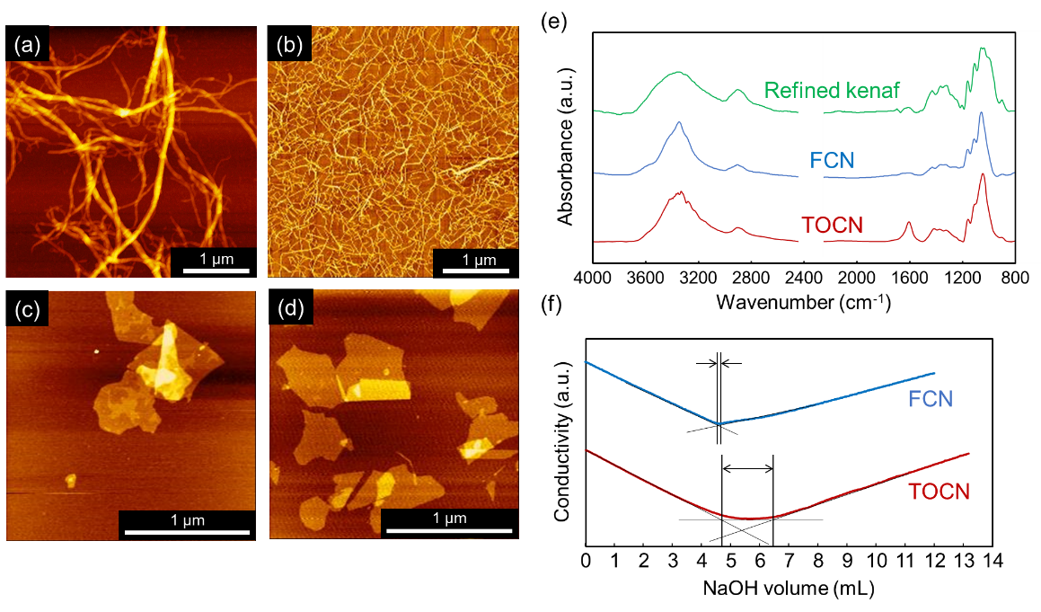
Figure S1. AFM topological images of (a) FCN, (b) TOCN, (c) MMT and (d) MMT-N⁺Et₄. (b) FT-IR spectra of refined kenaf, FCN and TOCN. (f) conductometric titrimetric profiles of FCN and TOCN.

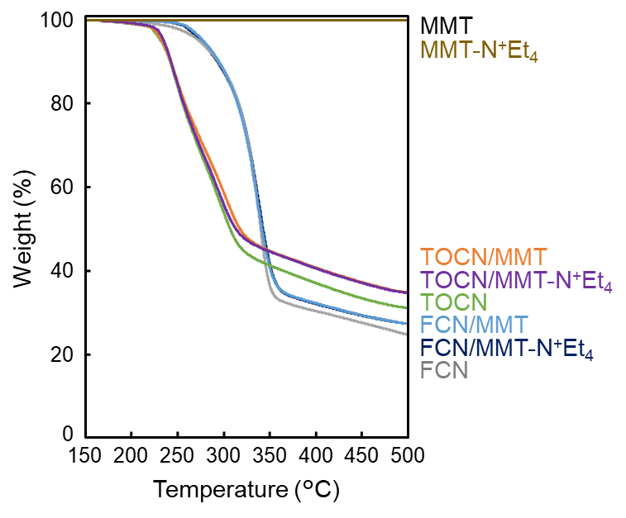
Figure S2. Thermo-gravimetric traces of FCN, TOCN, MMT, MMT-N⁺Et₄, FCN/MMT composite, FCN/MMT-N⁺Et₄ composite, TOCN/MMT composite, and TOCN/MMT-N⁺Et₄ composites.

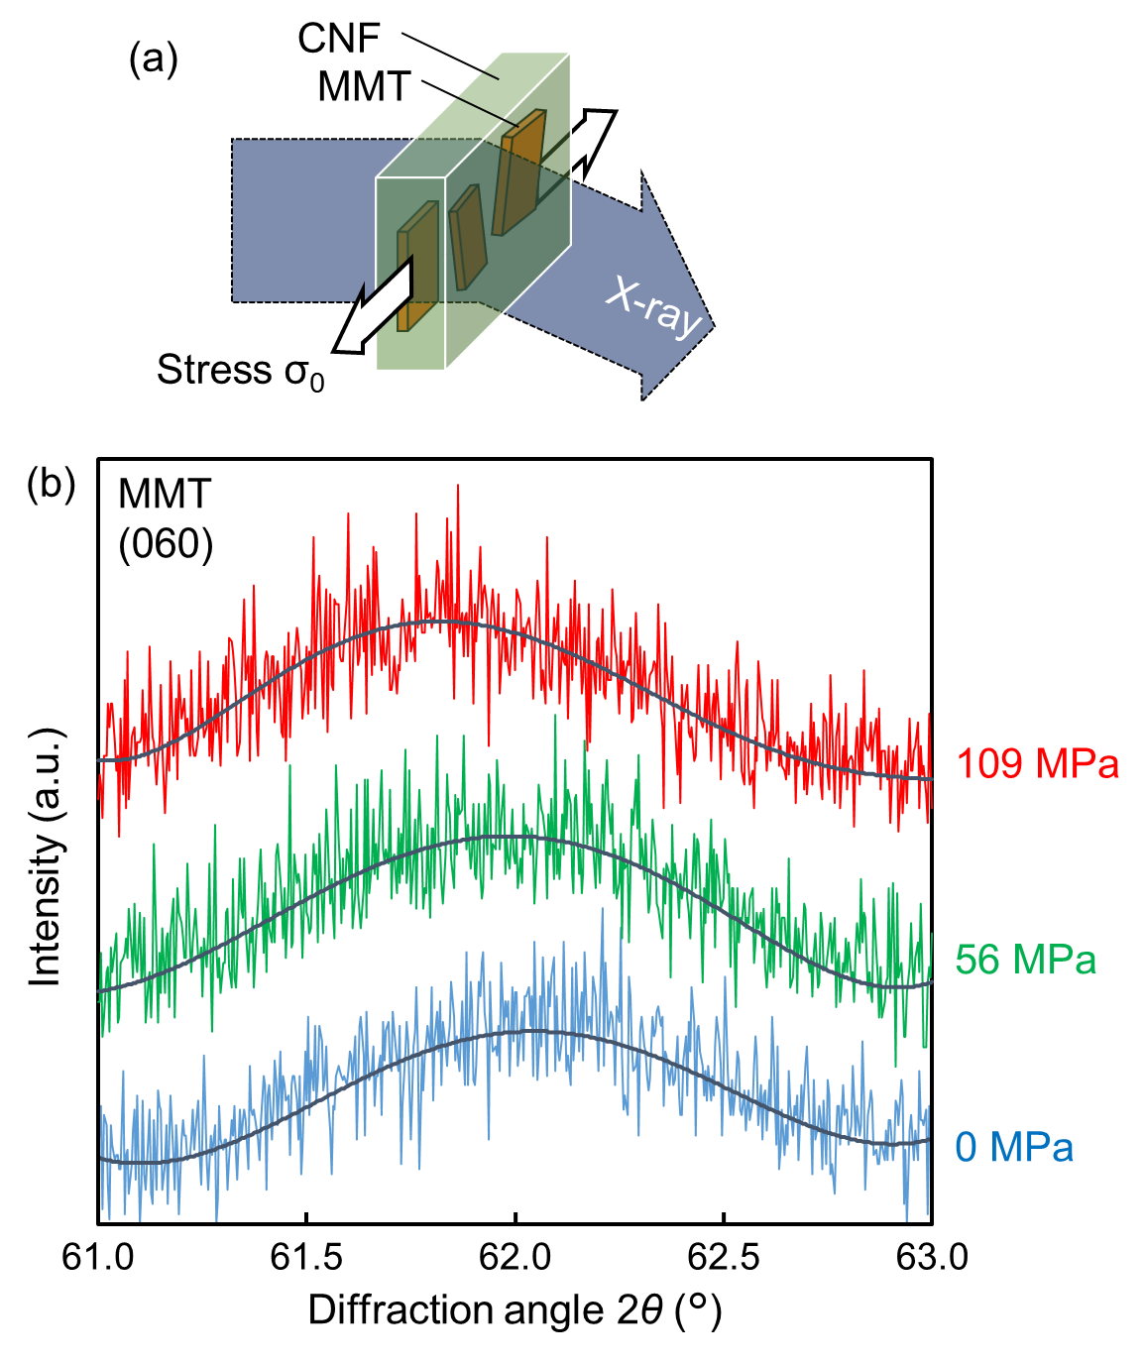
Figure S3. (a) Schematic image of stress transfer analyses using X-ray diffraction under loading tensile stress. (b) X-ray diffraction profiles of (060) plane of MMT in TOCN/MMT composite before and under loading stress.

