ROC of the three models of 24-hour AKI stage prediction
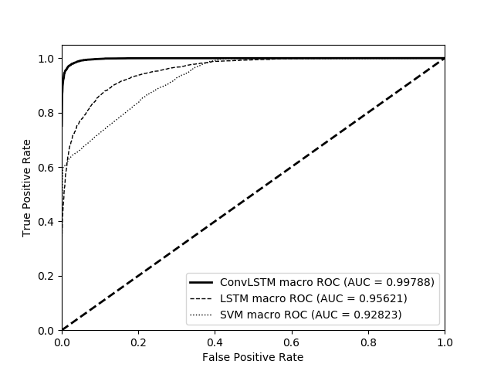

ROC of the three models of 24-hour AKI stage prediction
