Supplementary Material

Degradation of tris(1-chloro-2-propanyl) phosphate by the synergistic effect of persulfate and zero-valent iron during a mechanochemical process
Weichuan Qiao^{a,b,*}, Qiwen Yangª, Yi Qianª, Ziyan Zhangª

ª Department of Environmental Engineering, College of Biology and the Environment, Nanjing Forestry University, Nanjing 210037, China
^{b} Nanjing Yi Wei Environmental Protection Technology Co., Ltd., Nanjing 210048, China

* Corresponding authors. E-mail address: hgqwc@njfu.edu.cn (W. Qiao)

1. Materials and method

1.1. Sample extraction
In order to detect the degradation rate and intermediate of TCPP. 0.05 g of each milling sample was dissolved in 10 mL of ethyl acetate, and then vortexed for 2 min, following by ultrasonic treatment for 15 min. The supernatant was collected after centrifugation at 3000 rpm for 5 min. The above steps were repeated three times and all the supernatant was collected. The supernatant was concentrated to 1mL by a rotary evaporators (Rotavapor R-200, Buchi, Switzerland), and then the concentrated solution was filtered by a 0.22 μm polyether sulfone (PES) filter before determination by GC/MS and LC-QTOF-MS instrumental analysis.

Table S1. The FT−IR characteristic peaks of relevant functional group
Functional group | Absorption peak/cm⁻¹
O-H | 3262
C=O | 1642
CH₂ | 1428
C-C | 1281
P-O | 1110
P-O-C | 1049
C-Cl | 695
Table S2 Characteristics of three types of soils.
Soil types | pH | Fe (mg/L) | SOM (g/kg)
Red soil | 4.98 | 166.34 | 7.996
Yellow soil | 5.46 | 114.76 | 7.352
Black soil | 5.72 | 125 | 18.376

Fig.S1. GC/MS chromatogram of 10mg/L TCPP standard

Fig. S2 Standard curve of the concentration of two isomers of TCPP

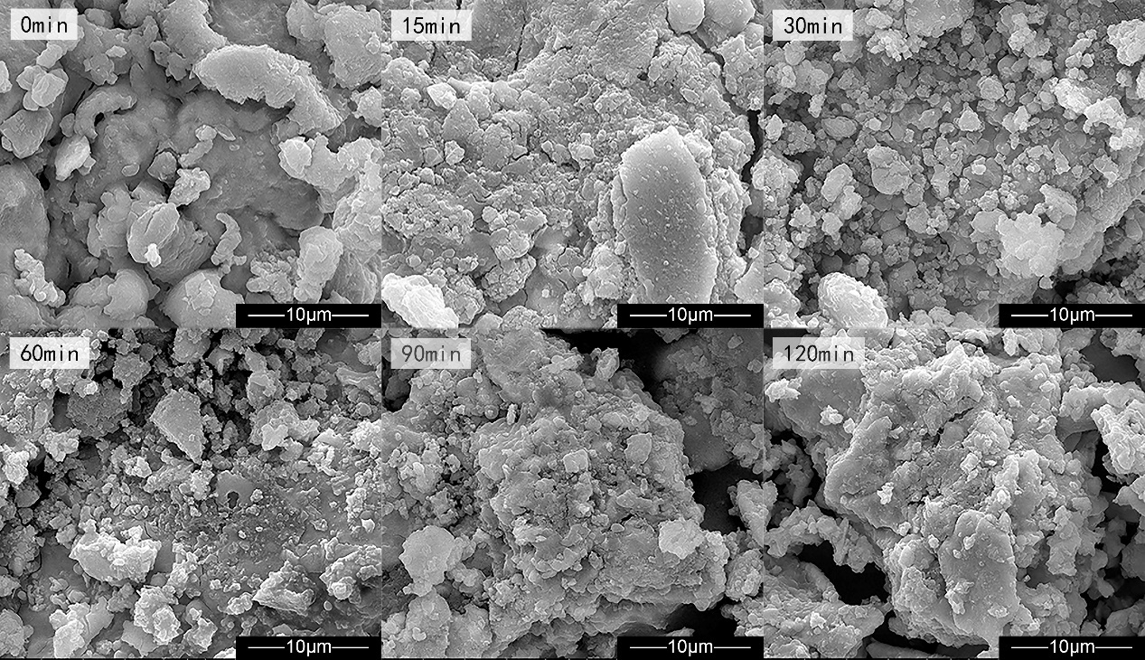
Fig. S3 SED analysis of the milled samples

Fig. S4 Particle size distribution of samples (measured by laser particle size analyzer, Dandong Baite, BT-9300ST, China)
Fig. S5 Color change of ball milled samples
Fig. S6. The concentrations of the produced Fe²⁺ and Fe³⁺ in MC process
Fig. S7 The Mass spectrum of the TCPP degradation intermediates in the PS-Fe-MC progress

Table S1 The names and structural formulas of TCPP isomers tested in the experiment
Abbreviation | Common name |  | Structure |  | CAS number
TCPP 1 |  | Tris(2-chloro-1-methylethyl) phosphate | 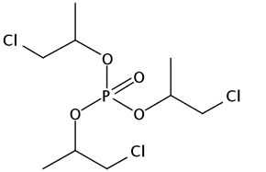 | 13674-84-5
TCPP 2 |  | Bis(3-chloro-1-propyl) (2-chloro-1-methylethyl) phosphate | 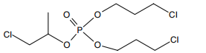 | 137888-35-8

Table S2 Deconvolution parameters of the Fe 2p spectra
Name | Binding energy position (eV)
ZVI 2p _{3/2} | 706.7
ZVI 2p _{1/2} | 720.0
Fe(Ⅱ) 2p _{3/2} | 712.7
Fe(Ⅱ) 2p _{1/2} | 723.8
Fe(Ⅱ)sat 2p _{3/2} | 714.7
Fe(Ⅱ)sat 2p _{1/2} | 726.9
Fe(Ⅲ) 2p _{3/2} | 710.9
Fe(Ⅲ) 2p _{1/2} | 725.1
Fe(Ⅲ)sat 2p _{3/2} | 716.9
Fe(Ⅲ)sat 2p _{1/2} | 728.8

Table S3 Deconvolution parameters of the Cl 2p spectra
Name | Binding energy position (eV)
C-Cl 2p _{3/2} | 200.7
C-Cl 2p _{1/2} | 202.5
Cl⁻ 2p _{3/2} | 198.2
Cl⁻ 2p _{1/2} | 200.0

Table S4 TCPP degradation intermediates in the PS-Fe-MC progress
Products label | Molecular formula |  | ［M+H］⁺ | ∆ppm | Retention time(min)
A |  | C₆H₁₃Cl₂O₄P | 251.0003 | 0.6 | 15.23
B |  | C₃H₈ClO₄P | 174.9922 | 0 | 15.2
C |  | C₉H₁₇Cl₂O₅P | 307.0275 | 3.8 | 10.43
D |  | C₉H₁₇Cl₂O₆P | 323.0273 | 0.2 | 9.74
E |  | C₆H₁₂ClO₆P | 247.0013 | 0.7 | 12.51

