Identify the impact of the covalent-bonded carbon matrix to FeN₄ sites for acidic oxygen reduction

Xueli Li, Zhonghua Xiang*

State Key Laboratory of Organic-Inorganic Composites, College of Chemical Engineering, Beijing University of Chemical Technology, Beijing, 100029, PR China
*Corresponding author. Email: xiangzh@mail.buct.edu.cn (Z. X.)

Chemicals. Ferric chloride [FeCl₃, Meryer, CAS#: 7705-08-0], Tetracyanoethylene [C6N4, Macklin, CAS#: 670-54-2], pyromellitic dianhydride (PMDA) [C10H2O6, aladdin, CAS#: 89-32-7], 1,4,5,8-Naphthalenetetracarboxylic dianhydride [C14H4O6, Macklin, CAS#: 81-30-1], 3,4,9,10-Perylenetetracarboxylic dianhydride [ C24H8O6, Macklin, CAS#: 128-69-8], urea [(NH₂)₂CO, Heowns, CAS#: 57-13-6], ammonium chloride [NH₄Cl, Macklin, CAS#: 12125-02-9], ammonium molybdate tetrahydrate [(NH₄)₆Mo₇O₂₄·4H₂O, Macklin, CAS#: 12054-85-2], cabot Vulcan XC-72 [C, Macklin, CAS#: 1333-86-4] were used without further purification.

Preparation of COP-Ene sample. In brief, for the synthesis of metal COP-Ene sample, tetracyanoethylene (0.320 g), urea (2.4 g), NH₄Cl (0.2675 g), and (NH₄)₆Mo₇O₂₄·4H₂O (0.08 g) and FeCl₃ (0.203 g) were mixed and ground adequately; the mixture was then transferred into crucible, and heated in a muffle furnace at 180 °C for 5 h. After cooling to room temperature, the product was washed repeatedly with 1M HCl, 0.5 M NaOH, and ethanol. The precipitates were dried under vacuum at 60 °C overnight.

Preparation of COP-Nap sample. In brief, for the synthesis of metal COP-Nap sample, 1,4,5,8-Naphthalenetetracarboxylic dianhydride (0.67 g), urea (2.4 g), NH₄Cl (0.2675 g), and (NH₄)₆Mo₇O₂₄·4H₂O (0.155 g) and FeCl₃ (0.225 g) were mixed and ground adequately; the mixture was then transferred into crucible, and heated in a muffle furnace at 275 °C for 3 h. After cooling to room temperature, the product was washed repeatedly with 1M HCl, 0.5 M NaOH, and ethanol. The precipitates were dried under vacuum at 60 °C overnight.

Preparation of COP-Pyr sample. In brief, for the synthesis of metal COP-Pyr sample, 3,4,9,10-Perylenetetracarboxylic dianhydride (0.98 g), urea (2.4 g), NH₄Cl (0.2675 g), and (NH₄)₆Mo₇O₂₄·4H₂O (0.155 g) and FeCl₃ (0.225 g) were mixed and ground adequately. The mixture was then transferred into crucible, and heated in a muffle furnace at 300 °C for 3 h. After cooling to room temperature, the product was washed repeatedly with 1M HCl, 0.5 M NaOH, and ethanol. The precipitates were dried under vacuum at 60 °C overnight.

Electrochemical Measurements. All electrochemical measurements were carried out at room temperature by using CHI760E electrochemical analyser with a typical three-electrode electrochemical cell. In this cases, saturated calomel electrode (SCE), carbon rod and glass carbon rotating disk electrode coated with catalysts were used as reference electrode, counter electrode and working electrode, respectively. Electrode potentials were converted to reversible hydrogen electrode (RHE), using the following relationship (ERHE = ESCE + 0.241 + 0.059 pH).

Preparation of catalyst ink. 5 mg as-synthesis catalysts were dispersed in 1000 μL mixture solution containing ethanol (950 μL) and Nafion solution (0.5 wt%, 50 μL). Another 5 mg XC-72 carbon black was added to the ink to improve the conductivity of catalyst. The ink was then shaken and sonicated in bath sonicator for at least 30 min to form a homogeneous suspension. Then 10 μL suspension (containing 50 μg of catalyst) was loaded onto a glass carbon electrode surface with a diameter of 5 mm and resulted in a mass loading of about 0.255 mg cm⁻². Cyclic voltammetry (CV) measurements were carried out at potential from 0 V to 1.1 V (vs. RHE) at a scan rate of 100 mV s⁻¹ and linear sweeping voltammetry (LSV) measurements were performed with a scan rate of 5 mV s⁻¹ at a rotating rate of 1600 rpm. The electrolyte (0.1 M HClO₄) was bubbled by high-purity O₂ or N₂ for 30 min into saturation state before each test.
The rotating ring-disk electrode (RRDE) examinations were performed with the Pt ring electrode (the potential of Pt ring was set at V= 1.1 VRHE) to test the ring current (Iring). The polarization curves were examined at a disk rotation rate of 1600 rpm and catalyst loading was 0.255 mg cm⁻². The peroxide yield (H2O2%) and the electron transfer number (n) were calculated by: n=4×I_{d}/ (I_{d} + I_{r}/N) and H₂O₂%=200 × (I_{r} /N) / (I_{d}+I_{r} /N), where I_{d} represents the disk current and I_{r} represents the ring current, N represents the RRDE collection efficiency, about ~ 0.37 in our system.
The turnover frequencies (TOF) of COP-Ene, COP-Ppcfe, COP-Nap and COP-Pyr were calculated by: TOF=(J_{k}×s)/ (4×m×F), where J_{k} represents kinetic current density at 0.7 V, s represents the surface area of the glass carbon electrode, m represents the mole numbers of FeN₄ active moieties on the electrode, F is the Faraday constant (96,500 C mol⁻¹). The mass activity (Ma) per mass of metal were calculated by: Ma=J_{k}/m, where J_{k} represents kinetic current density at 0.7 V, m represents the contents of metal in the glass carbon electrode.

Square wave voltammetry experiment. Square wave voltammetry test was performed in N₂-saturated 0.1 M HClO₄ electrolyte with a step potential of 1 mV, amplitude of 1 mV and scan frequency of 10 Hz.

Supplementary Figures:

Supplementary Fig. 1. The ¹³C solid-state nuclear magnetic resonance (NMR) spectra of COP-Ene, COP-Ppcfe, COP-Nap and COP-Pyr.

COP-Ene: ¹³C NMR (MHz) δ 167.4 (a), δ 161.3 (b);
COP-Ppcfe: ¹³C NMR (MHz) δ 171 (a), δ 167.4 (b), δ 138 (c), δ 118.3 (d);
COP-Nap: ¹³C NMR (MHz) δ 165 (a), δ 162.3 (b), δ 131 (c), δ 125.5 (d);
COP-Pyr: ¹³C NMR (MHz) δ 166 (a), δ 162.7 (b), δ 133.4 (c and d), δ 124 (e, f and g).

Supplementary Fig. 2. FT-IR spectra of COP-Ene, COP-Ppcfe, COP-Nap and COP-Pyr.

Notably, the FT-IR spectra of covalent organic polymers frameworks in all samples are presented the same signals: the stretching vibration peaks of ~1120 cm⁻¹ region are assigned to the coordination bond between central metal and ring inner N in COPs; the stretching vibration peaks of ~900 cm⁻¹ are ascrribed to metal ligand vibration; the stretching vibration peaks about 736 cm⁻¹ region are ascrribed to the characteristic peaks of backbone. Peaks at ~1445 cm⁻¹ region and ~1586 cm⁻¹ region are ascribed to the stretching vibration of the C=C and C=N links connecting building block, respectively. The vibration peaks of C=O appear at ~1690 cm⁻¹ and ~3046 cm⁻¹, respectively. Moreover, a sequential ascending C=C stretching vibrations (~1400 cm⁻¹) manifest successively incremental planar-electron abundance in for polymers. Through the peak position analysis of the above bonded groups comined with ¹³C solid-state nuclear magnetic resonance (NMR) spectra (Supplementary Fig. 1), we proved that the four target samples were successfully synthesized.
Supplementary Fig. 3. The SEM images of COP-Ene, COP-Ppcfe, COP-Nap and COP-Pyr samples.

Supplementary Fig. 4. The EDX mapping images of COP-Ene sample in HRTEM.

Supplementary Fig. 5. The EDX mapping images of COP-Ppcfe sample in HRTEM.
Supplementary Fig. 6. The EDX mapping images of COP-Nap sample in HRTEM.
Supplementary Fig. 7. The EDX mapping images of COP-Pyr sample in HRTEM.

In the element mapping of Fe (Supplementary Figs. 4-7.), the good dispersibility of Fe atom not only effectively indicates that Fe exists as single iron atoms, but the gradual decrease in Fe atom content also reflects the gradual increase in the degree of conjugation of the carbon skeleton in the synthesized four sample.

Supplementary Fig. 8. The HRTEM images of COP-Ppcfe sample.

Supplementary Fig. 9. The HAADF STEM images of COP-Ppcfe sample at different positions.

Through HRTEM, we observed that the Fe, N, and C in the COP-Ene, COP-Ppcfe, COP-Nap and COP-Pyr samples were uniformly dispersed, and no metal clusters were found. Furthermore, we observed multiple positions of the COP-Ppcfe sample through HAADF STEM, and observed numerous monodispersed bright spots images, which confirmed that the Fe atoms were dispersed in the form of atoms. In addition, the gradual decrease of Fe distribution content also shows the gradual increase of the conjugated system in the four COPs, which is consistent with the Fe content measured by ICP-OES.

Supplementary Fig. 10. The Fe K-edge XANES of Fe foil, FePc and COP-Ppcfe sample.

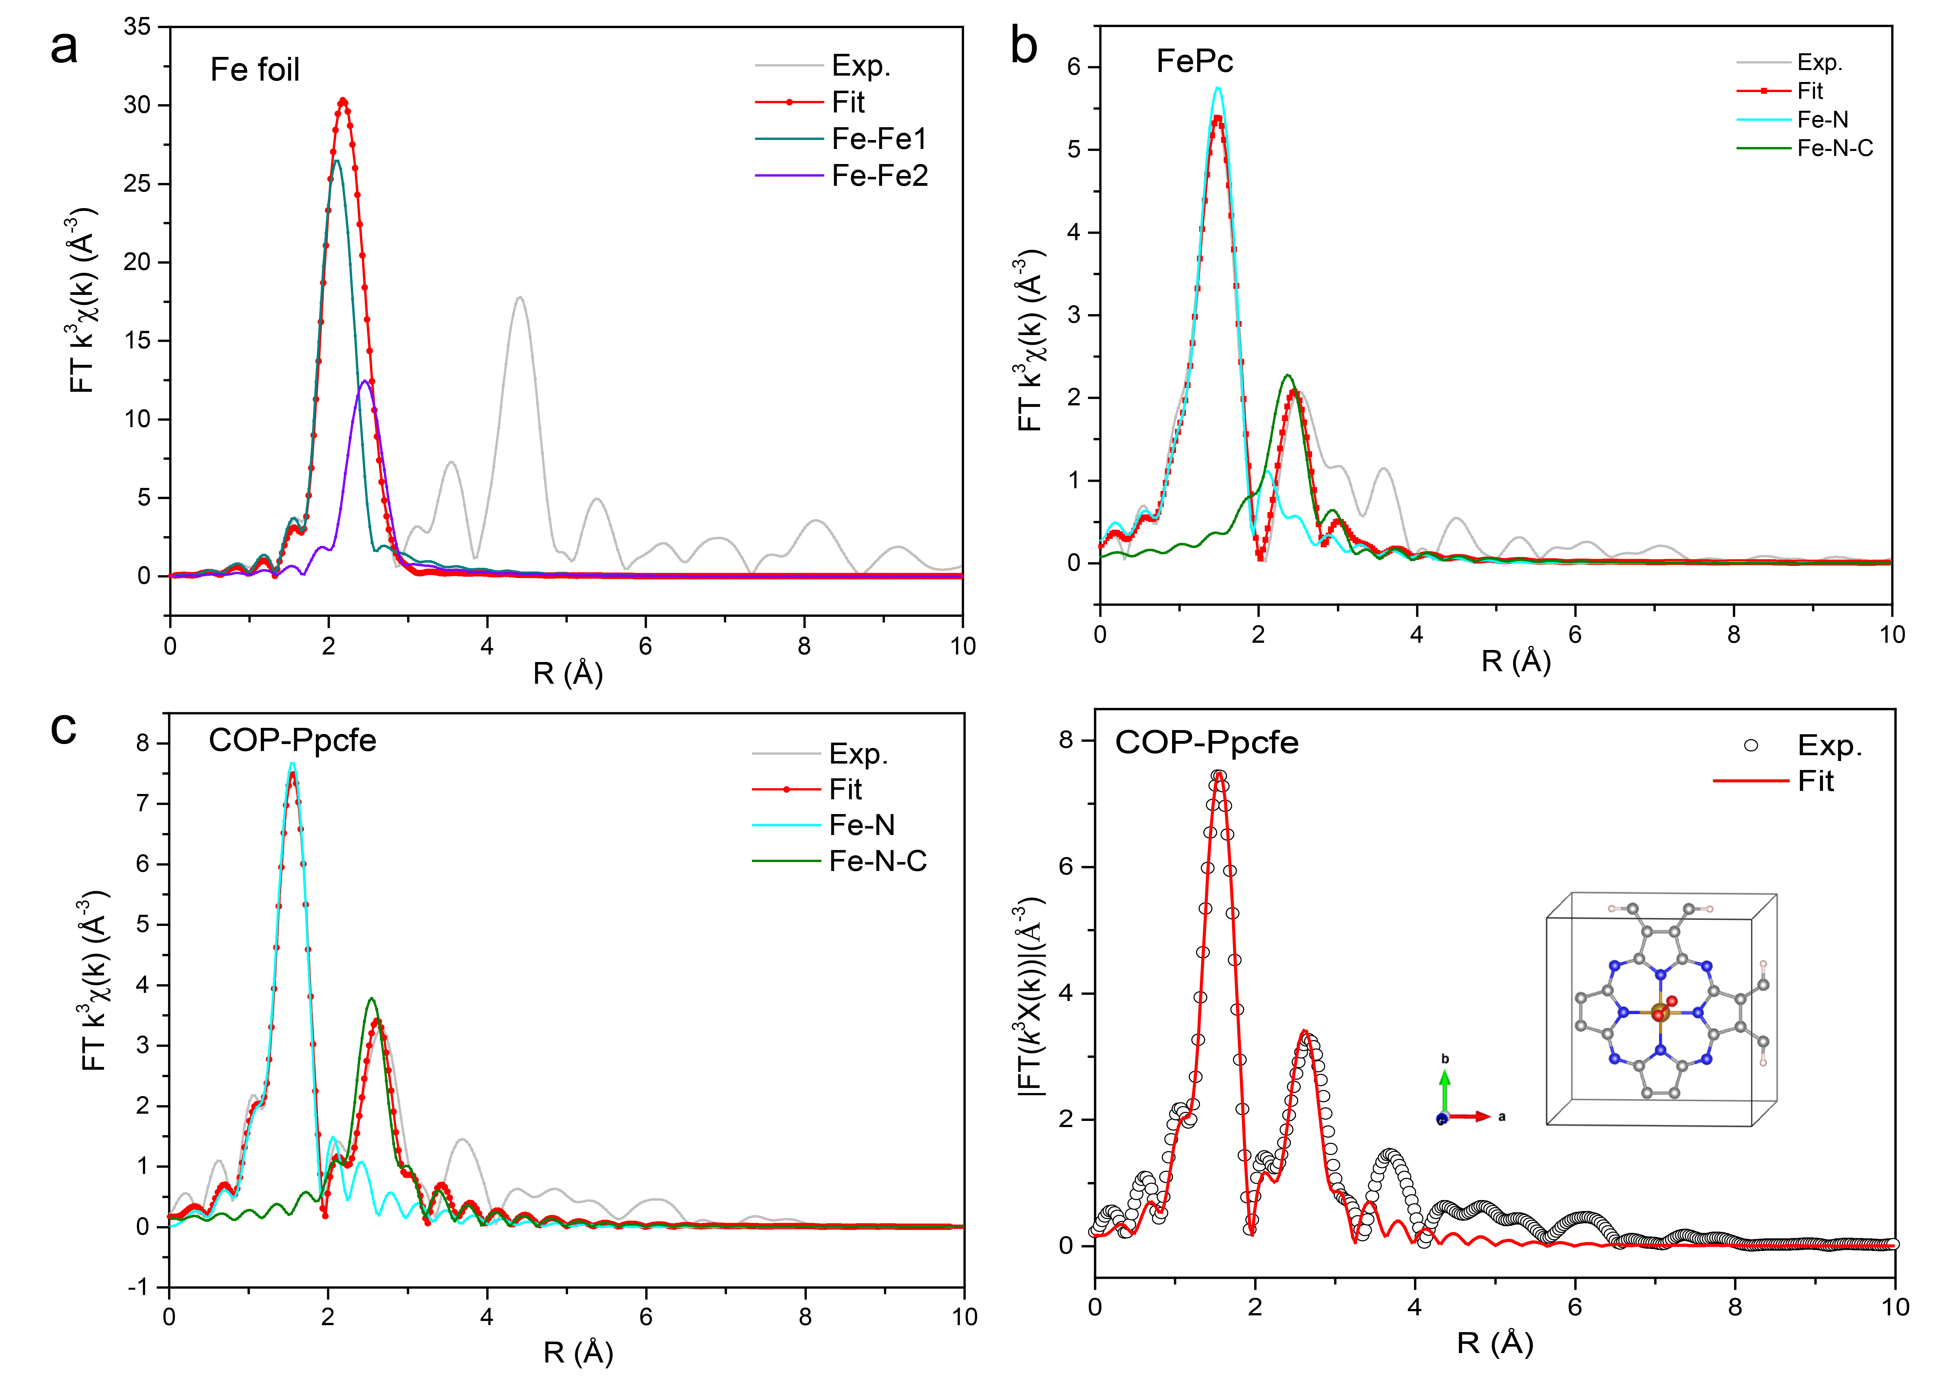
Supplementary Fig. 11. The Fourier transformations of the EXAFS spectra and corresponding EXAFS R space fitting curves of Fe foil, FePc and COP-Ppcfe sample.
Supplementary Fig. 12. The corresponding EXAFS k space fitting curves of Fe foil, FePc and COP-Ppcfe sample.
COP-Ppcfe sample was demonstrated high similarity to FePc benchmark, exhibiting dominated peaks corresponding to the Fe-N (~ 1.53 Å) and Fe-N-C (~ 2.7 Å) scattering paths, whereas the Fe-Fe bond (~ 2.18 Å) was not observed (Fig. 2d and Supplementary Fig. 11). EXAFS fitting of COP-Ppcfe sample in k-space were also consistent with that of FePc benchmark, whereas completely deviated from Fe foil (Supplementary Fig. 12), manifesting iron atom in COP-Ppcfe sample exists as mononuclear centers. The Fe K-edge XANES profiles in Supplementary Fig. 10 suggest the oxidation valence state of the isolated single Fe atoms in COP-Ppcfe is likely to be higher than metallic Fe⁰ (Fe foil) and lower than Fe²⁺ (FePc) and Fe³⁺ (Fe₂O₃), which indicates that the Fe-N₄ structure in COP-Ppcfe sample adsorbed O₂ of the air during storage or testing.^{1,2}
Supplementary Fig. 13. XPS survey spectra of four samples with COP-Ene, COP-Ppcfe, COP-Nap and COP-Pyr.

XPS spectra showed that only carbon, nitrogen, metals and oxygen were present in the four samples, indicating that the synthesized corresponding samples all had higher purity. The gradually weakening of Fe_{LMM} peak with the augment of the carbon conjugated skeletons also suggests stronger conjugated degree of the polymerization skeletons.

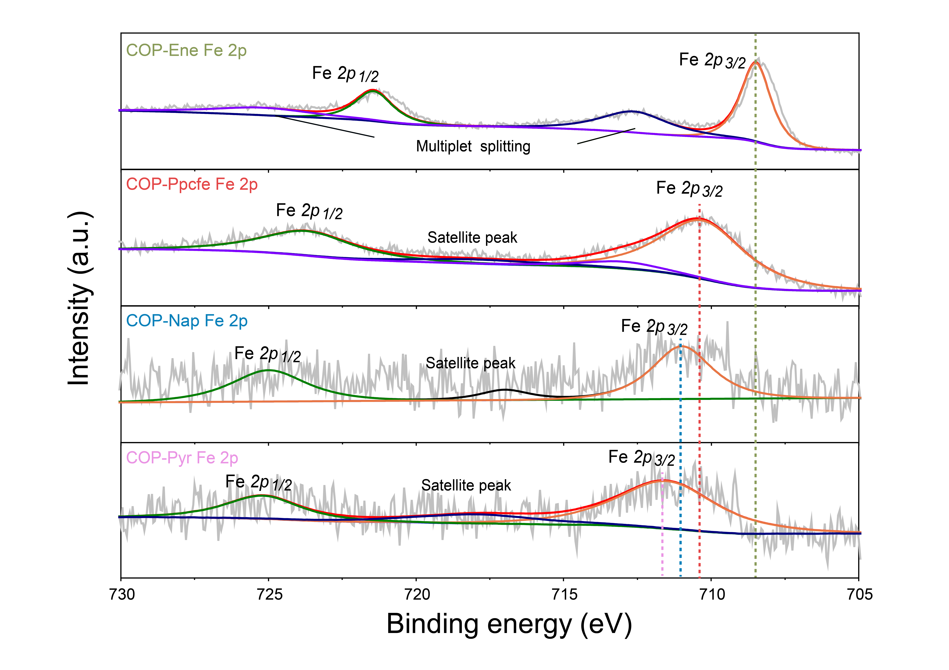
Supplementary Fig. 14. The Fe 2p XPS spectra of COP-Ene, COP-Ppcfe, COP-Nap and COP-Pyr.
The increasing DDE in the carbon matrix adjacent to FeN₄ moieties makes Fe 2p_{1/2} and Fe 2p_{3/2} peaks in COP-Nap and COP-Pyr samples closer to the higher binding energy than COP-Ene and COP-Ppcfe.
Supplementary Fig. 15. The N1s XPS spectra of (a) COP-Ene; (b) COP-Ppcfe; (c) COP-Nap; (d) COP-Pyr.

Supplementary Fig. 16. Electrochemical characterization. LSV curves of COP-Ene, COP-Ppcfe, COP-Nap and COP-Pyr samples in O₂-saturated 0.1 KOH solution at a scan of 5 mV s⁻¹ and a rotation speed of 1600 rpm.
To distinguished COP-Nap and COP-Pyr sample oxygen reduction activity, the ORR measurements for four COPs were first carried out in 0.1 M KOH (mass loading of about 0.255 mg cm⁻²). Linear sweep voltammetry (LSV) curves in Supplementary Fig. 16 exhibit their halfwave potential (E_{1/2}) comparison, following the order of COP-Ppcfe (E_{1/2}=874 mV) > COP-Ene (E_{1/2}=799 mV) > COP-Nap (E_{1/2}=669 mV) > COP-Pyr (E_{1/2}=598 mV), and embody a volcano relationship.

Supplementary Fig. 17. Electrochemical characterization. (a) LSV curves (b) onset potential of COP-Ene, COP-Ppcfe, COP-Nap and COP-Pyr without Cabot Vulcan XC-72 in O₂-saturated 0.1 HClO₄ solution at a scan of 5 mV s⁻¹ and a rotation speed of 1600 rpm.
To exclude the influence of the ORR activity of the conductive agent XC72, we tested their ORR activity without the conductive agent in 0.1M HClO₄. The activity trend (initial potential) of the different samples remained consistent with the condition of carbon black.

Supplementary Fig. 18. (a) Kinetic current density (J_{k}) of COP-Ene, COP-Ppcfe, COP-Nap and COP-Pyr over 0 ~ 1 V versus RHE. (b) The kinetic current density (J_{k}) @ 0.7 V of COP-Ene, COP-Ppcfe, COP-Nap and COP-Pyr.

The kinetic current density (J_{k}) @ 0.7 V embodies discrepancy of as-synthesis catalysts in electrocatalytic kinetics. As observed by Supplementary Fig. 18, the COP-Ppcfe sample exhibits a superior J_{k} of 5.51 mA cm⁻² at 0.7 V (versus RHE), which was about 42 times higher than that of COP-Ene, 137 times higher than that of COP-Nap and 275 times higher than that of COP-Pyr in 0.1 M HClO₄. These results indicate that the kinetics of the four COPs also show a trend of increasing first and then decreasing with the increase of the DDE.
Supplementary Fig. 19. Square wave voltammetry (SWV) profiles of COP-Ene, COP-Ppcfe, COP-Nap and COP-Pyr samples.
Supplementary Fig. 20. (a) Calculated activation energies for COP-Nap in dissociative mechanism. (b) Calculated activation energies for COP-Pyr in dissociative mechanism. (c) Free energy diagram for ORR on COP-Ene, COP-Ppcfe, COP-Nap and COP-Pyr at zero electrode potential. (d) Free energy diagram for ORR on COP-Ene, COP-Ppcfe, COP-Nap and COP-Pyr at equilibrium electrode potential.

Because COP-Nap and COP-Pyr taken a side-on configuration for dioxygen adsorption, we calculated the activation energies of O₂* dissociation, corresponding to 0.51 eV and 0.72 eV for COP-Nap and COP-Pyr, respectively. The grand barriers means that O₂ dissociative mechanism for COP-Nap and COP-Pyr is not considered.
In the associative mechanism, O₂ activation (O₂* +H⁺ + e⁻→ OOH*) in COP-Ene is the rate-determining step of four-electron reaction. When an electrode potential of U= 0.5836 V is applied, all the elementary steps of the oxygen reduction reaction in COP-Ene can occur spontaneously. Interestingly, COP-Ppcfe can co-balance the adsorption for the multiple reaction intermediates in oxygen reduction process, where the Gibbs free energies required during O₂* activation and OH* desorption are roughly equal. On the contrary, the sudden oxytropism of the central metal in the COP-Nap and COP-Pyr impose an obstacle to occur desorption of OH* intermediate, which limits the subsequent occurrence of entire four-electron reaction.
Supplementary Fig. 21. The electrode transfer numbers and H₂O₂ yields of COP-Ene, COP-Ppcfe, COP-Nap and COP-Pyr in O₂-saturated 0.1 HClO₄ solution at a scan of 5 mV s⁻¹ and a rotation speed of 1600 rpm.

The COP-Ppcfe sample is close to the four-electron reaction mechanism during the electrochemical reaction, and the H₂O₂ yield is less than 5%. For COP-Ene sample, the number of electrons transferred is close to between four electrons and two electrons, and about 10% of H₂O₂ is generated. However, the COP-Nap and COP-Pyr samples exhibited almost complete two-electron reaction under high voltage, and the H₂O₂ yield exceeded 50%.

Supplementary Fig. 22. The UPS of four samples (COP-Ene, COP-Ppcfe, COP-Nap and COP-Pyr).

Supplementary Fig. 23. (a) UPS work function (φ) spectra of COP-Ene, COP-Ppcfe, COP-Nap and COP-Pyr. (b) the UPS valence band spectra of COP-Ene, COP-Ppcfe, COP-Nap and COP-Pyr.

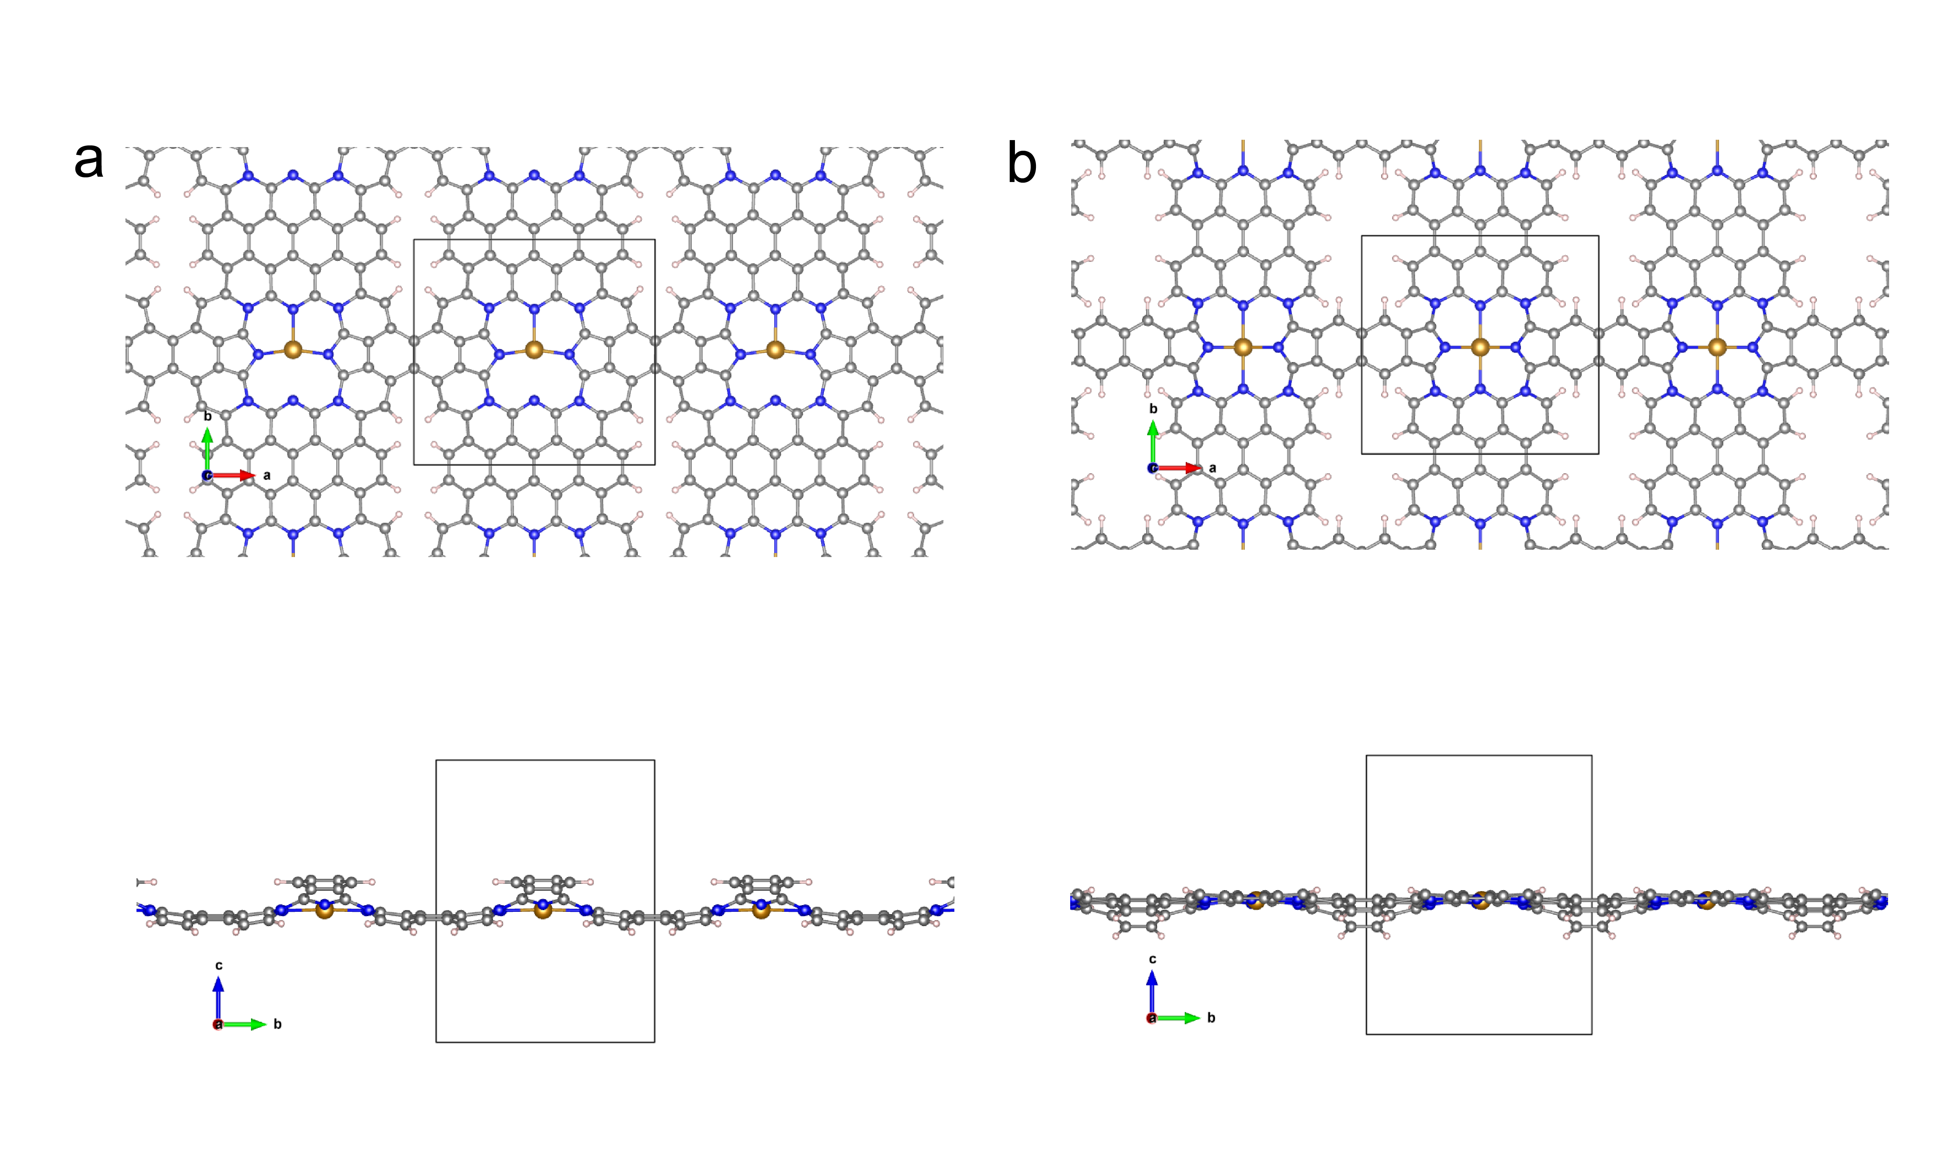
Supplementary Fig. 24. The structure obtained by continuously incremental the π-conjugated system based on COP-Pyr configuration.

From COP-Ene to COP-Pyr model, the degree of delocalization stemmed from π-electrons of the carbon conjugated skeleton around the FeN₄ site is progressively incremental. When we try to continue to increase the π conjugated moieties, the model of macrocyclic structure exhibits a certain degree of skeleton bending, indicating that further incremental conjugated structures will reduce the stability of polymers.

Supplementary Fig. 25. The total density of states (TDOS) of COP-Ene, COP-Ppcfe, COP-Nap1, COP-Nap2, COP-Nap and COP-Pyr models.

In the macrocyclic structure species, as the conjugated skeleton increases, the number of electrons delocalized in the carbocyclic skeleton in the system gradually increases, regardless of whether the electrons spin up or spin down, which corresponds with the conclusion obtained experimentally by FWHM (Fig. 2g-h).

Supplementary Fig. 26. The Electron localization functions (ELF) diagrams of different models (COP-Ene, COP-Ppcfe, COP-Nap1, COP-Nap2, COP-Nap, COP-Pyr). The primitive cell is inside red dotted curve and the entire graph is a 2*2 supercell.

It can be seen from the ELF diagram that electrons are mainly delocalized in the C=C or C=N carbon skeleton. And with the expansion of the carbon skeleton adjacent to the FeN₄ site in the four COPs, the area of electron delocalization in the carbon matrix also gradually increases, which corresponds with the conclusion obtained experimentally by FWHM (Fig. 2g-h). The ELF values of the carbon skeletons (C=C or C=N) in all synthesized COPs are between 0 and 1, reflecting the existence of carbon atoms in the form of covalent bonds.

Supplementary Fig. 27. Projected density of states plots of 2p orbitals for O₂ and 3d orbitals for COP-Ene, COP-Ppcfe, COP-Nap1, COP-Nap2, COP-Nap and COP-Pyr.

Note: Supplementary Fig. 27. (the coordinates of E-E_{f} are from -5 to 5 eV) is an entire picture of Fig. 5d in the text.

Supplementary Fig. 28. Crystal orbital Hamilton population (COHP) of O₂ absorbed on COP-Ene, COP-Ppcfe, COP-Nap1, COP-Nap2, COP-Nap and COP-Pyr surfaces.

As see from Supplementary Figs. 27-28, the unoccupied d orbitals of COPs accept electrons from the 3σ and 1π molecular orbitals of O₂, forming the bonding states to strengthen the O₂ adsorption. At the same time, the occupied d-orbitals of Fe atom in COPs back-donate electrons to the 1π* orbital of O₂, leading to the partially occupied 1π* orbital near the Fermi level. For FeN₄ moieties with abundant DDE, such as COP-Nap and COP-Pyr samples, electrons mainly transfer from 3d_{xz} and 3d_{yz} orbitals in Fe atom to 1π* orbitals in dioxygen through π-back bonding. In contrast, for other COPs, superoxide species form when O₂ molecules are absorbed on Fe atom by end-on interaction, where electrons mainly transfer from the Fe 3d_{z}² orbitals to the oxygen 1π* orbitals and form σ bonds.

Supplementary Fig. 29. Projected density of states plots of 2p orbitals for OH* and 3d orbitals for COP-Ene, COP-Ppcfe, COP-Nap1, COP-Nap2, COP-Nap and COP-Pyr.

From the pDOS plots of 2p orbitals for OH* and 3d orbitals for six COP models, we can see that the 1π valence orbital in lone pair O 2p_{x}, 2p_{y} electrons, and 3σ orbital in H 1s - O 2p_{z} of OH* intermediate occurred renormalizing when OH* reacted on 3d orbitals of Fe atom.
Supplementary Fig. 30. (a-d) Proposed ORR reaction scheme with the intermediates towards (a) COP-Ppcfe, (b) COP-Nap1, (c) COP-Nap2, (d) COP-Pyr. RDS is rate-determining step. The bule, grey, red, pink and golden spheres represent N, C, O, H and Fe, respectively. (e) Free energy diagram for ORR on six configurations (COP-Ene, COP-Ppcfe, COP-Nap1, COP-Nap2, COP-Nap and COP-Pyr) at zero electrode potential.

As the degree of carbon conjugation increases, the potential-limiting step of adsorption energy gradually converts from oxygen activation to OH* desorption. It is worth noting that when the degree of delocalization of the carbon skeleton increases to a certain level (COP-Ppcfe or COP-Nap1), the overpotentials of the above two steps (O₂* +H⁺ + e⁻→ OOH*; OH* + H⁺+ e⁻→ H₂O) at the equilibrium potential are nearly equal, and the entire four-electron reaction is under an optimal state.

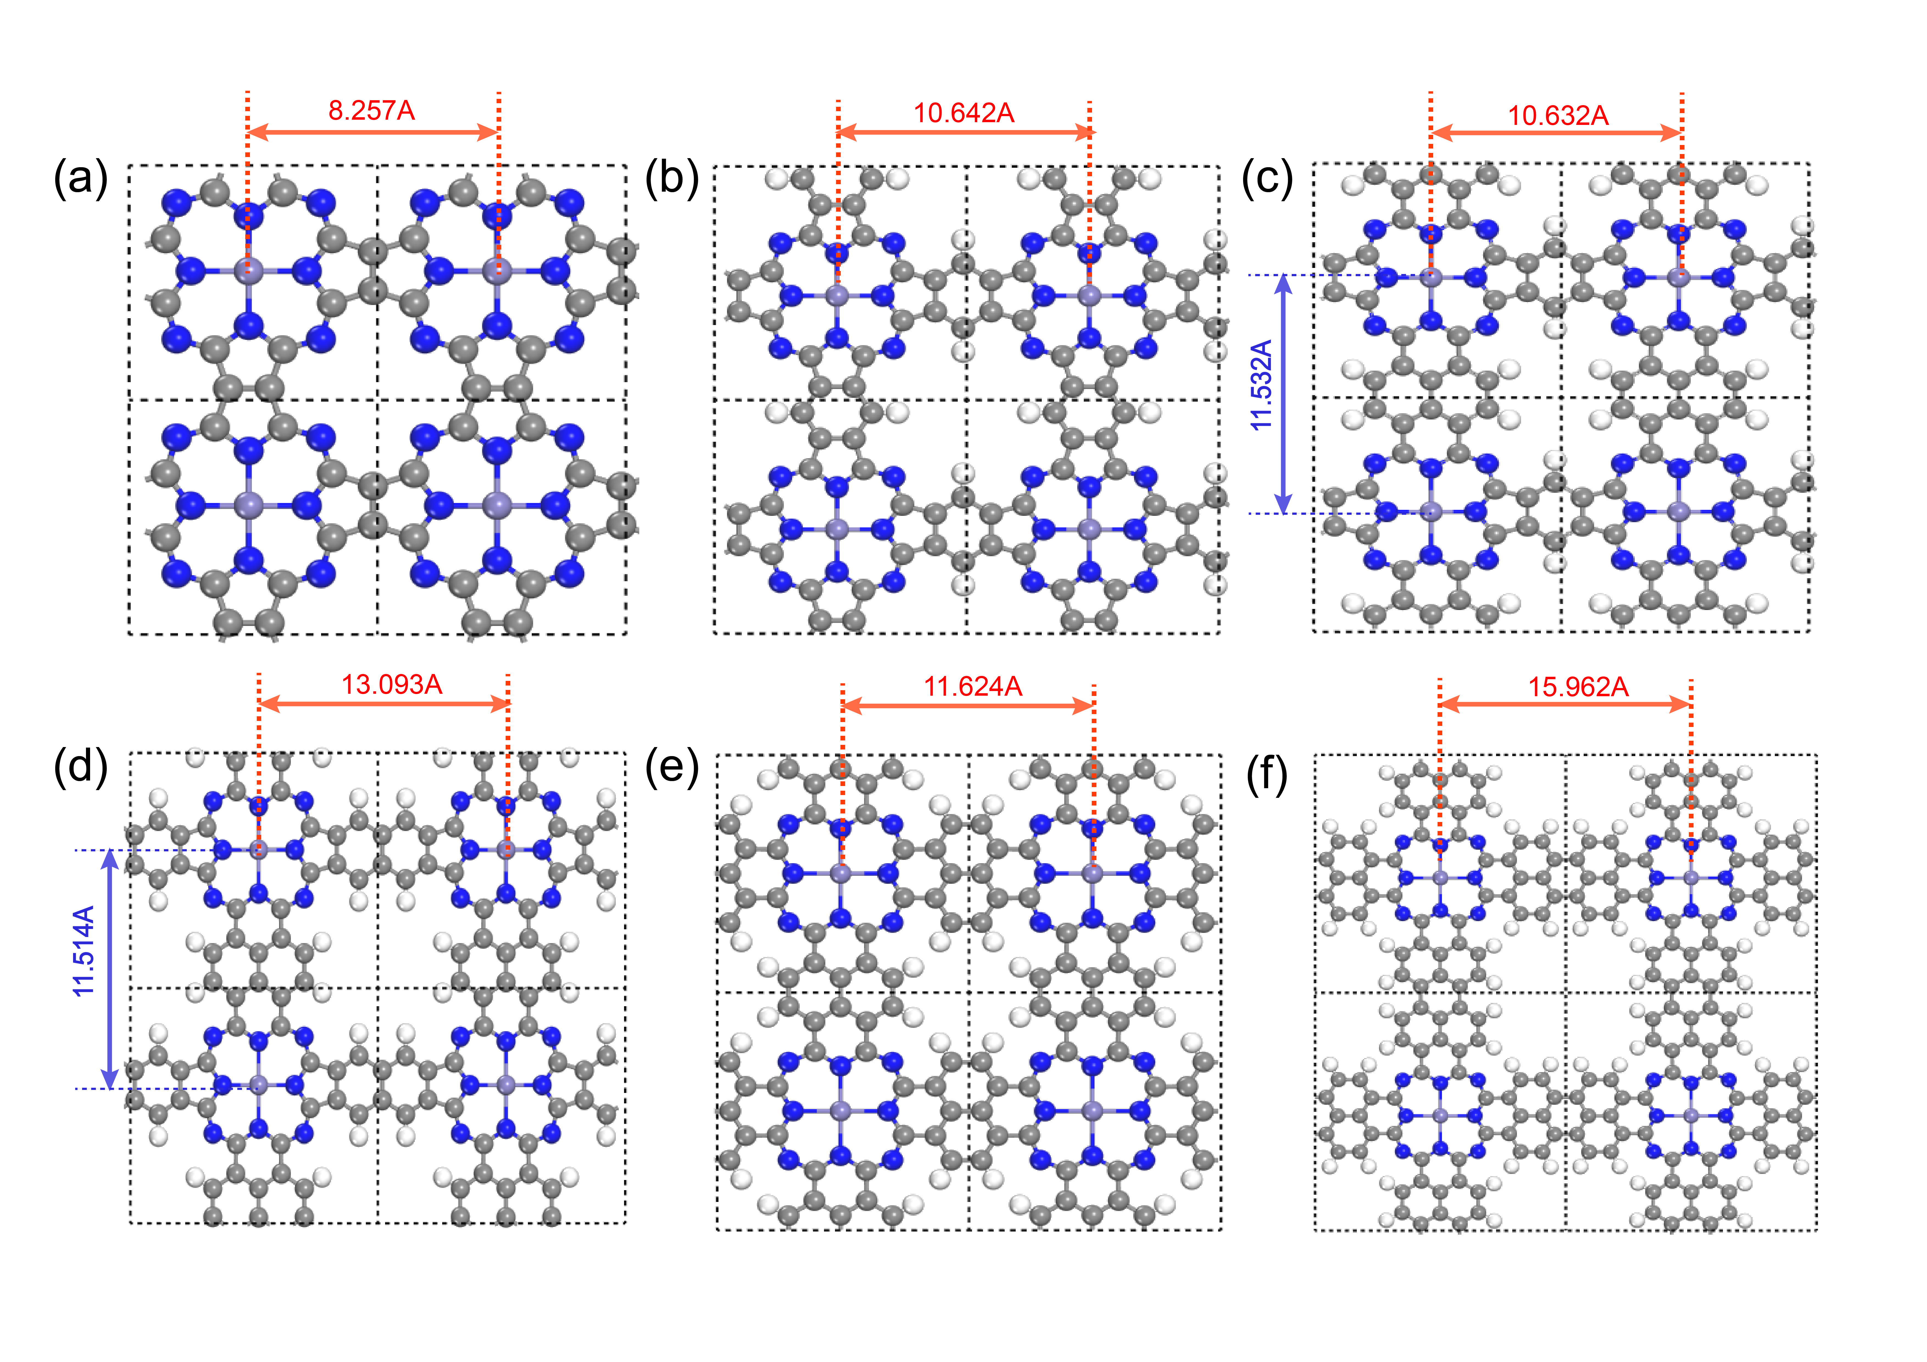
Supplementary Fig. 31. Schematic diagram of the Fe-Fe bond length in the six proposed models. The purple, dark blue, white, and grey colors represent Fe, N, H, and C atom, respectively.

Supplementary Fig. 32. Schematic diagram of the Fe-N bond length in the six proposed models. The purple, dark blue, white, and grey colors represent Fe, N, H, and C atom, respectively.
In the proposed six models, there is no direct rule for the bond length of Fe-Fe bond or Fe-N bond with the expansion of benzene ring. Therefore, some influence factors towards ORR performance such as single atom density or nitrogen atom types can be overlooked.

Supplementary Tables:

Supplementary Table 1. EXAFS fitting parameters at the Cu K-edge various samples (Ѕ₀²=0.82).
Sample | Path | C.N. | R (Å) | σ²×10³ (Å²) | ΔE (eV) | R factor
Fe foil | Fe-Fe | 8* | 2.47±0.01 | 4.5±1.2 | -2.8±1.6 | 0.002
 | Fe-Fe | 6* | 2.84±0.01 | 5.3±2.2 | -5.2±3.4
COP-Ppcfe | Fe-N/O | 5.4±1.0 | 1.93±0.01 | 3.8±1.2 | 5.7±2.8 | 0.016
 | Fe-C | 7.6±2.7 | 2.98±0.02 | 2.2±2.3 | 9.8±3.4
FePc | Fe-N | 3.9±1.0 | 1.94±0.02 | 9.1±2.4 | -0.4±3.6 | 0.008
 | Fe-C | 3.6±2.1 | 2.96±0.02 | 5.0±4.9 | 4.0±4.4

ªN: coordination numbers; ^{b}R: bond distance; ^{c}σ²: Debye-Waller factors; ^{d} ΔE₀: the inner potential correction. R factor: goodness of fit. * the experimental EXAFS fit of metal foil by fixing CN as the known crystallographic value.

Supplementary Table S2. The metal iron contents obtained by ICP-OES in four samples.
Sample | iron contents (wt.%)
COP-Ene | 3.78
COP-Ppcfe | 2.41
COP-Nap | 1.93
COP-Pyr | 1.30

Supplementary Table 3. Total energies, zero-point energy corrections and entropic contributions to the free energy.
Species | E | ZPE | TS
H₂O (0.035 bar) | -14.218 | 0.56 | 0.67
H₂ | -6.764 | 0.270 | 0.40
O* | - | 0.082 | 0.05
OH* | - | 0.385 | 0.07
OOH* | - | 0.457 | 0.16

Supplementary Table 4. Adsorption free energy (eV vs RHE) of OH, O, OOH, O₂ on different models.
 | ∆G_{OH}* | ∆G_{O}* | ∆G_{OOH}* | ∆G_{O2}*
COP-Ene | 0.8611 | 1.8154 | 3.9344 | 4.5180
COP-Ppcfe | 0.6923 | 1.6586 | 3.7707 | 4.4218
COP-Nap1 | 0.6833 | 1.7445 | 3.6098 | 4.2789
COP-Nap2 | 0.4749 | 1.7222 | 3.6339 | 4.2807
COP-Nap | -0.0086 | 1.6586 | 3.2496 | 4.0871
COP-Pyr | -0.1419 | 1.5859 | 2.8954 | 4.0222

Supplementary Table 5. Reaction free energy (eV vs RHE) of elementary step for oxygen reduction at U_{RHE} = 0 V on different models.
 | ∆G₁ | ∆G₂ | ∆G₃ | ∆G₄ | ∆G₅ | U^{onset} Potential
COP-Ene | -0.4020 | -0.5836 | -2.1190 | -0.9543 | -0.8611 | 0.5836
COP-Ppcfe | -0.4982 | -0.6511 | -2.1121 | -0.9663 | -0.6923 | 0.6511
COP-Nap1 | -0.6411 | -0.6691 | -1.8653 | -1.0611 | -0.6833 | 0.6691
COP-Nap2 | -0.6393 | -0.6468 | -1.9118 | -1.2472 | -0.4749 | 0.4749
COP-Nap | -0.8329 | -0.8374 | -1.5910 | -1.6673 | 0.0086 | -0.0086
COP-Pyr | -0.8978 | -1.1268 | -1.3095 | -1.7278 | 0.1419 | -0.1419

Supplementary Table 6. Net charge for single Fe atom and the numbers of electrons gained for FeN₄ moiety on different models.
 | COP-Ene | COP-Ppcfe | COP-Nap1 | COP-Nap2 | COP-Nap | COP-Pyr
Net charge for single Fe atom (|e|) | 1.1228 | 1.1664 | 1.1243 | 1.1048 | 1.1512 | 1.1027
The number of electrons gained for FeN₄ moiety (|e|) | 3.2766 | 3.4339 | 3.4971 | 3.5288 | 3.5553 | 3.6233

Supplementary Table 7. Comparison of the acid ORR performance between COP-Ppcfe and other pyrolysis-free catalysts in literature.
Catalyst | Electrolyte | Onset potential (mV) | Half-wave potential (mV vs RHE) | The number of  electrons  transferred | Loading  (mg cm⁻²) | Reference
COP-Ppcfe | 0.1M HClO₄ | 877 vs RHE | 748 vs RHE | 3.87 | 0.255 | This work
bi-FePc/GNS | 0.5 M H₂SO₄ | 120 vs. Hg/Hg₂SO₄ | -100 vs. Hg/Hg₂SO₄ | 3.64 | 0.398 | 3
FePc/C | 0.5 M H₂SO₄ | 770 vs RHE | 600 vs RHE | 3.9 | 0.18 | 4
(DFTPP)Fe-Im-CNTs | 0.1M HClO₄ | 1100 vs RHE | 880 vs RHE | ~ 4 | 1 | 5
FePPc/C | 0.5 M H₂SO₄ | 890 vs RHE | 800 vs RHE | 3.9 | 0.65 | 6
16(F)FePc-CNT | 0.1 M H₂SO₄ | 810 vs RHE | 650 vs RHE | 3.45 | 0.1 | 7
16(Cl)FePc | 0.1 M H₂SO₄ | 550 vs SCE | 400 vs SCE | 3.45 | 0.1 | 8
14-membered macrocyclic Fe complex | 0.5 M H₂SO₄ | 890 vs RHE | 800 vs RHE | \ | 0.04 | 9
(phen₂N₂)FeCl | 0.1M HClO₄ | 700vs RHE | 580 vs RHE | 3.99 | 2.5 | 10

The oxygen reduction electrocatalysts obtained by pyrolysis-free methods mainly focus on the modification towards porphyrins or phthalocyanines molecular catalysts. And as far as we know, pyrolysis-free electrocatalysts with acid performance are extremely limited. In this work, the acid performance of COP-Ppcfe sample is leading among the same type of catalysts. In addition, the COP-Ppcfe sample shows outstanding oxygen reduction performance, far exceeding the loaded carbon black molecule FePc (Ref. 5), which also reflects the successful polymerization of COP-Ppcfe sample.

Supplementary References
1. Wan, X. et al. Fe-N-C electrocatalyst with dense active sites and efficient mass transport for high-performance proton exchange membrane fuel cells. Nat. Catal. 2, 259-268 (2019).
2. Fei, H. et al. General synthesis and definitive structural identification of MN4C4 single-atom catalysts with tunable electrocatalytic activities. Nat. Catal. 1, 63-72 (2018).
3. Li, T. et al. Enhanced activity and stability of binuclear iron (III) phthalocyanine on graphene nanosheets for electrocatalytic oxygen reduction in acid. Journal of Power Sources 293, 511-518 (2015).
4. Baranton, S., Coutanceau, C., Roux, C., Hahn, F. & Léger, J.M. Oxygen reduction reaction in acid medium at iron phthalocyanine dispersed on high surface area carbon substrate: tolerance to methanol, stability and kinetics. Journal of Electroanalytical Chemistry 577, 223-234 (2005).
5. Wei, P.J., Yu, G.Q., Naruta, Y. & Liu, J.G. Covalent grafting of carbon nanotubes with a biomimetic heme model compound to enhance oxygen reduction reactions. Angew Chem Int Ed Engl 53, 6659-6663 (2014).
6. Wang, X. et al. Iron polyphthalocyanine sheathed multiwalled carbon nanotubes: A high-performance electrocatalyst for oxygen reduction reaction. Nano Research 9, 1497-1506 (2016).
7. Abarca, G. et al. In search of the most active MN₄ catalyst for the oxygen reduction reaction. The case of perfluorinated Fe phthalocyanine. Journal of Materials Chemistry A 7, 24776-24783 (2019).
8. Venegas, R. et al. Biomimetic reduction of O2in an acid medium on iron phthalocyanines axially coordinated to pyridine anchored on carbon nanotubes. Journal of Materials Chemistry A 5, 12054-12059 (2017).
9. Moriya, M. et al. Fourteen-Membered Macrocyclic Fe Complexes Inspired by FeN₄-Center-Embedded Graphene for Oxygen Reduction Catalysis. The Journal of Physical Chemistry C (2020).
10. Marshall-Roth, T. et al. A pyridinic Fe-N4 macrocycle models the active sites in Fe/N-doped carbon electrocatalysts. Nature Communications 11 (2020).

