Reversible writing/deleting of magnetic skyrmions through hydrogen adsorption/desorption

Gong Chen^{1,2*}, Colin Ophus³, Alberto Quintana¹, Heeyoung Kwon⁴, Changyeon Won⁵, Haifeng Ding⁶, Yizheng Wu⁷, Andreas K. Schmid³, Kai Liu^{1,2*}

¹ Physics Department, Georgetown University, Washington, DC 20057, USA
² Physics Department, University of California, Davis, California 95616, USA
³ NCEM, Molecular Foundry, Lawrence Berkeley National Laboratory, Berkeley, California, 94720 USA
⁴ Center for Spintronics, Korea Institute of Science and Technology, Seoul 02792, South Korea
⁵ Department of Physics, Kyung Hee University, Seoul 02447, South Korea
⁶ National Laboratory of Solid State Microstructures, Department of Physics and Collaborative Innovation Center of Advanced Microstructures, Nanjing University, 22 Hankou Road, Nanjing 210093, People’s Republic of China
⁷ Department of Physics, State Key Laboratory of Surface Physics and Advanced Materials Laboratory, Fudan University, Shanghai 200433, China

* Correspondence should be addressed to gchenncem@gmail.com (G.C.); Kai.Liu@georgetown.edu (K.L.)

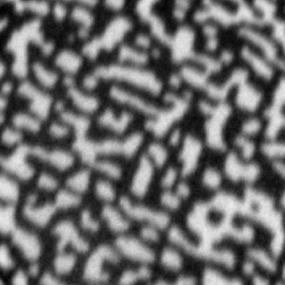
Figure S1. SPLEEM image with out-of-plane sensitivity of 24ML Ni/2ML Fe/1ML Ni/Cu(001), showing bubble-like domain pattern in the absence of magnetic field. The field of view is 7 μm.
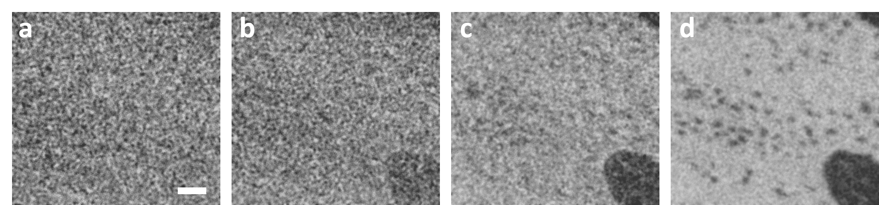
Figure S2. SPLEEM images with out-of-plane sensitivity as a function of Ni thickness d_{Ni} in Ni/3ML Co/5ML Pd/W(110), showing the evolution of out-of-plane magnetized domains during the SRT. (a) d_{Ni} = 0 ML, (b) d_{Ni} = 0.20 ML, (c) d_{Ni} = 0.27 ML, (d) d_{Ni} = 0.31 ML. Scale bar 1μm.

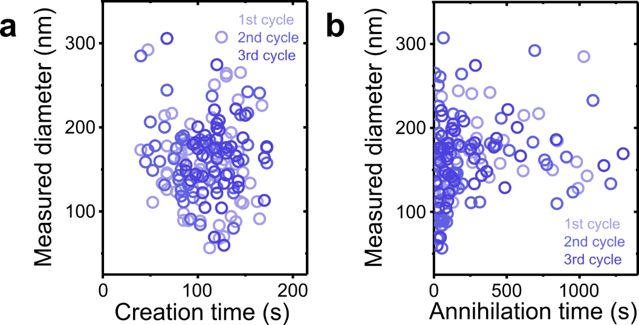

Figure S3. Relations between skyrmion diameter and the time required for skyrmion creation (panel a) and annihilation (panel b) over three cycles. The creation/annihilation time is counted from the instant when the hydrogen valve is turned ON/OFF until the moment each skyrmion appears/disappears.

