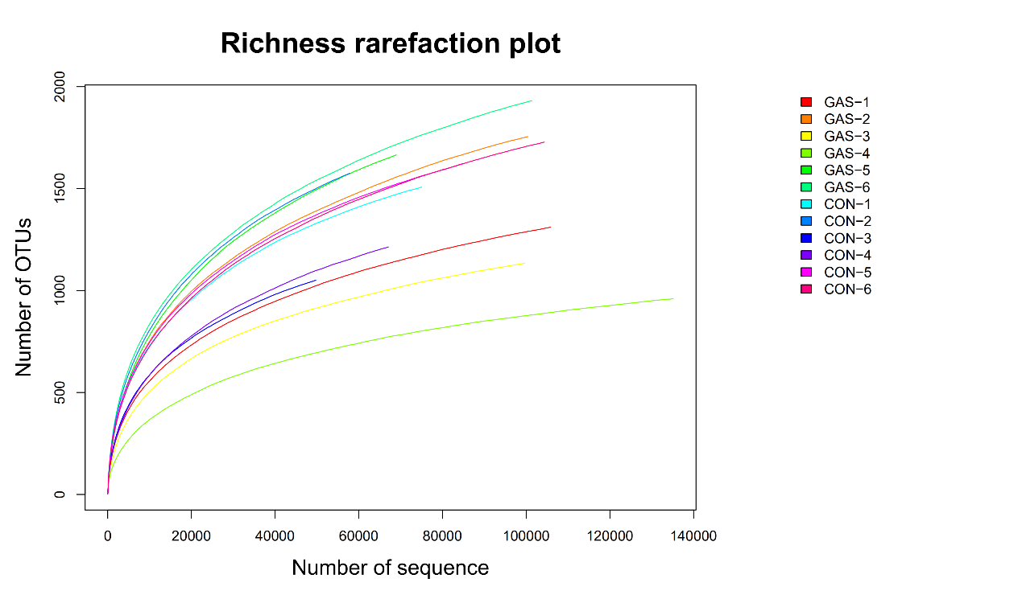
Figure S1. Rarefaction curves obtained based on assigned operational taxonomic units of rumen bacteria of sheep fed the garlic skin diet (GAS) and the control diet (CON).

