Supplementary data for
Spectral characterization of dissolved organic matter along
trophic gradients: Potential indicators of eutrophication of
plateau lakes in Southwest China
Yuying Guan^{a,b,1}, Ruiming Han^{a,c,1}, Nannan Jia^{b,d}, Da Huo^{b,d,*}, Gongliang Yu^{b,*}
a. School of Environment, Nanjing Normal University, Nanjing 210023, China
b. Key Laboratory of Algal Biology, Institute of Hydrobiology, Chinese Academy of Sciences, Wuhan 430072, People’s Republic of China
c. Jiangsu Center for Collaborative Innovation in Geographical Information Resource Development and Application, Nanjing, 210023, China
d. University of Chinese Academy of Sciences, Beijing 100049, People’s Republic of China
1 Co-first author
* Corresponding author:

Author for correspondence:
Co-corresponding author. Mailing address: Institute of Hydrobiology, Chinese Academy of Sciences, Wuhan 430072, Hubei Province, PR China. Phone: +86 027 68780067. Fax: +86 027 68780123.
Da Huo Email: Huoda@ihb.ac.cn
Gongliang Yu Email: Yugl@ihb.ac.cn

Conflict of Interest：The authors declare that they have no conflict of interest
Table of Content

Table S1 The ranges of Excitation and Emission wavelength of the three identified components of fluorescent dissolved organic matter (FDOM) by parallel factor analysis (PARAFAC).
Fig.S1 Variation in Fn(355) and fluorescent components for the DOM in different trophic states of Erhai watershed from November of 2018 to July of 2019.
Fig.S2 The principal component analysis (PCA) of colored dissolved organic matter (CDOM) absorption, fluorescent dissolved organic matter (FDOM) index, and environment factors.

Table S1 The ranges of Excitation and Emission wavelength of the three identified components of fluorescent dissolved organic matter (FDOM) by parallel factor analysis (PARAFAC)
Component | Ex/Em (nm/nm) | Description and source Chen et al. (2003) | Tradition peak Coble (1996) |  | Description | Reference
C1 | 220/292 | Tyrosine-like protein | B | Autochthonous DOM |  | C3:≤225(275)/322 (Zhang et al. 2010)  C1:225/305 (Zhang et al. 2020)
C2 | 230/356 | Tryptophan-like protein | T | Low molecular weight, microbial-derived or autochthonous DOM |  | C1:230/344 (Yao et al. 2011)  C5: <250/370 (Williams et al. 2010)  C5:225, 280/350 (Yang et al. 2019)
C3 | 245/458 | Humic-like | A | Plant or soil-derived DOM; possible microbial activity |  | C1: <255(355)/410 (Qin et al. 2020)  C2：250(335)/455 (Lin and Guo 2020)

Fig.S1 Variation in Fn(355) and fluorescent components for the DOM in different trophic states of Erhai watershed from November of 2018 to July of 2019. The % of the peaks per catchment type stand for the mean percentage of each fluorescence component intensity in the total fluorescence intensity for all sampling sites.

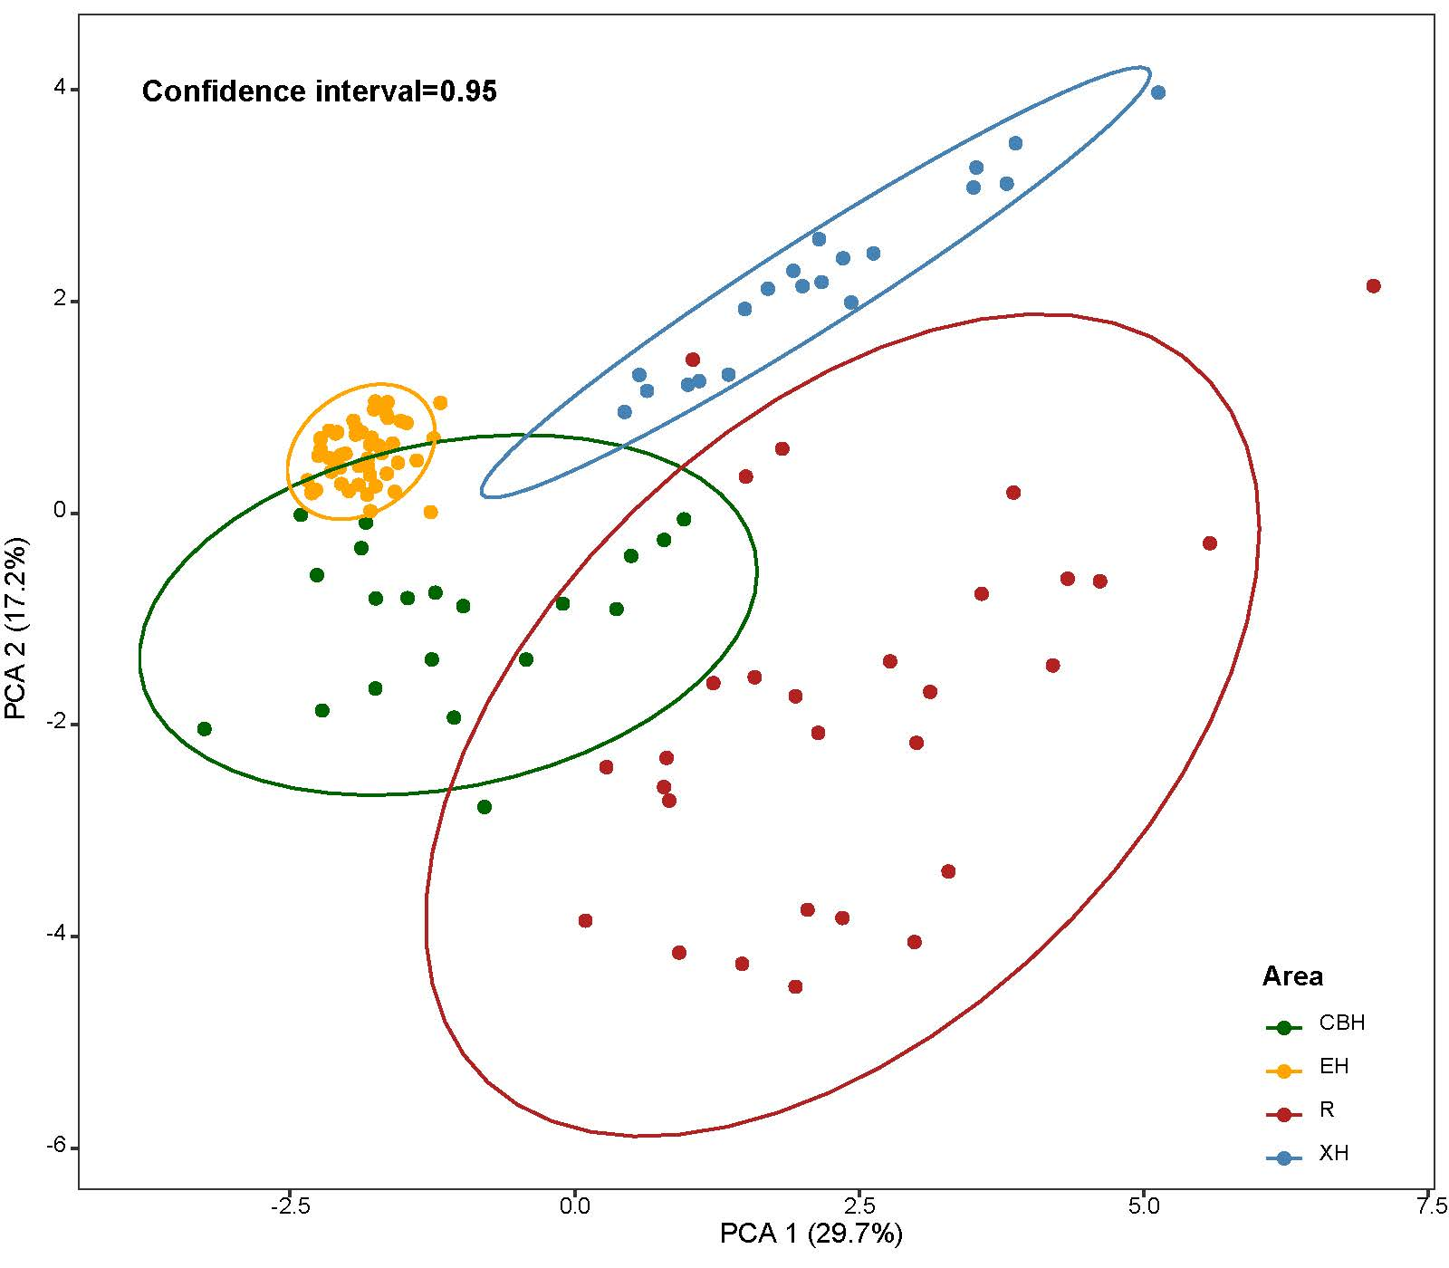
Fig.S2 The principal component analysis (PCA) of colored dissolved organic matter (CDOM) absorption, fluorescent dissolved organic matter (FDOM) index, and environment factors. All samples are divided into four groups with various colors according to PCA. The horizontal axis and the ordinate represent the first and second principal components respectively, which could explain 46.9% variations in total.

References
Chen, W., Westerhoff, P., Leenheer, J.A. and Booksh, K. (2003) Fluorescence Excitation−Emission Matrix Regional Integration to Quantify Spectra for Dissolved Organic Matter. Environmental Science & Technology.
Coble, P.G. Characterization of marine and terrestrial DOM in seawater using excitation-emission matrix spectroscopy. Marine Chemistry 51(4), 325-346.
Lin, H. and Guo, L. (2020) Variations in Colloidal DOM Composition with Molecular Weight within Individual Water Samples as Characterized by Flow Field-Flow Fractionation and EEM-PARAFAC Analysis. Environmental Science & Technology 54(3), 1657-1667.
Qin, X.-q., Yao, B., Jin, L., Zheng, X.-z., Ma, J., Benedetti, M.F., Li, Y. and Ren, Z.-l. (2020) Characterizing Soil Dissolved Organic Matter in Typical Soils from China Using Fluorescence EEM–PARAFAC and UV–Visible Absorption. Aquatic Geochemistry 26(1), 71-88.
Williams, C.J., Yamashita, Y., Wilson, H.F., Jaffé, R. and Xenopoulos, M.A. (2010) Unraveling the role of land use and microbial activity in shaping dissolved organic matter characteristics in stream ecosystems. Limnology & Oceanography 55(3), 1159-1171.
Yang, C., Liu, Y., Sun, X., Miao, S., Guo, Y. and Li, T. (2019) Characterization of fluorescent dissolved organic matter from green macroalgae (Ulva prolifera)-derived biochar by excitation-emission matrix combined with parallel factor and self-organizing maps analyses. Bioresource Technology 287, 121471.
Yao, X., Zhang, Y., Zhu, G., Qin, B., Feng, L., Cai, L. and Gao, G. (2011) Resolving the variability of CDOM fluorescence to differentiate the sources and fate of DOM in Lake Taihu and its tributaries. Chemosphere 82(2), 145-155.
Zhang, L., Liu, H., Peng, Y., Zhang, Y. and Sun, Q. (2020) Characteristics and significance of dissolved organic matter in river sediments of extremely water-deficient basins: A Beiyun River case study. Journal of Cleaner Production 277, 123063.
Zhang, Y., Zhang, E., Yin, Y., van Dijk, M.A., Feng, L., Shi, Z., Liu, M. and Qina, B. (2010) Characteristics and sources of chromophoric dissolved organic matter in lakes of the Yungui Plateau, China, differing in trophic state and altitude. Limnology and Oceanography 55(6), 2645-2659.

