Online Supplementary Material 6

Results
- Outliers detection from eligible studies
The meta and metafor packages for R were used to detect the outliers from all eligible studies.One study[1]were detected out and will be removed for R219K and LDLC level analysis (Figure S6-1 and Figure S6-2)
Figure S6-1. Plot of the various diagnostic measures of influence analyses. The influence measures of each study: retudent, the externally standardized residuals; diffits, DFFITS values; cook.d, Cook’s distances; cov.r, covariance ratios; tau2.del, estimates of T²; QE.del, the test statistics for (residual) heterogeneity when each study is removed in turn; hat, the diagonal elements of the hat matrix; weight, the weights (in%) given to the observed outcomes during the model fitting. Study considered to be influential, was colored in red in the plot.
Figure S6-2. Plot of DFBETAS values of influence analyses. Study considered to be influential, was colored in red in the plot.

- The overall and sub-group meta-analyses (Figure S6-3 and Figure S6-4)
Figure S6-3. The relationship between R219K and LDLC level grouped by race.

Figure S6-4. The relationship between R219K and LDLC level grouped by clinical status.

- To explore the source of heterogeneity by meta-regression analysis (Table S6-1)

Table S6-1. The meta-regressions of moderators for the estimated effect of R219K
Moderator | No. of studies | β | 95%CI | z | P | R-square
Intercept |  | -7.82 | -31.67 to 16.02 | -0.64 | 0.520 | 0.00
Publication data | 94 | < 0.01 | -0.01 to 0.02 | 0.61 | 0.539 | 0.00
Raceª
Asian | 66 | 0.25 | -0.11 to 0.60 | 1.36 | 0.175 | 0.02
Caucasian | 26 | 0.24 | -0.12 to 0.61 | 1.33 | 0.182 | 0.00
 |  | Q= 1.87, df = 2, P= 0.393
Health condition ^{b}
Patients | 36 | 0.04 | -0.08 to 0.17 | 0.71 | 0.475 | 0.00
Random | 33 | 0.10 | -0.04 to 0.25 | 1.37 | 0.171 | 0.00
 |  | Q = 1.88, df = 2, P = 0.391
Mean sample age | 88 | -0.05 | -0.26 to 0.16 | -0.43 | 0.665 | 0.00
Percentage of females | 89 | <0.01 | -0.01 to 0.01 | 0.75 | 0.450 | 0.00
ª Samples which consisted multiple ethnic subjects set as reference;
^{b}Samples including patients and controls set as reference.

- Publication bias analysis
The publication bias of current study was assessed with Begg’s rank correlation [2] andEgger’s weighted regression [3] methods, and visualized by funnel plots (Figure S6-5). The missing studies were estimated by trim-and-fill method [4], and analyzed the difference between the effect values and their adjusted values considering missing studies.
The Begg’s correlation indicated no publication selection bias in current study (Tau = 0.08, Z = 1.12, two-tailed P=0.265), while the Egger’s regression showed a significant bias (t ₍₉₁₎ = 2.16, two-tailed P= 0.033). However, the initial effect of R219K on LDLC level also was not significantly changed (the estimated missing studies n = 10, SMD_{adj} = 0.10, 95% CI = 0.04 ~ 0.15; t = 1.20, P = 0.231) after adjustment with missing studies. Together, it demonstrated that, there was no significant publication bias.
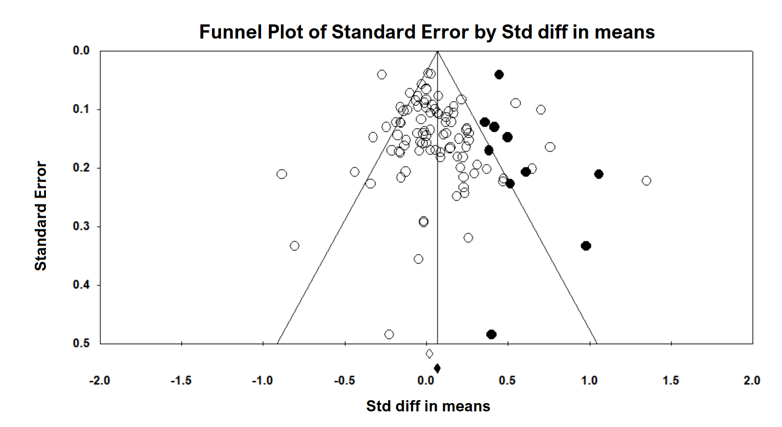
Figure S6-5: Shows the visually assessing on the asymmetry of funnel plot with imputed number of studies in all data (the black dots in the figure indicate the data that may be predicted).

References:
1. Abellan R, Mansego ML, Martinez-Hervas S et al. Association of selected ABC gene family single nucleotide polymorphisms with postprandial lipoproteins: results from the population-based Hortega study.Atherosclerosis 211(1), 203-209 (2010).
2. Begg CB, Mazumdar M. Operating characteristics of a rank correlation test for publication bias.Biometrics 1088-1101 (1994).
3. Egger M, Smith GD, Schneider M, Minder C. Bias in meta-analysis detected by a simple, graphical test.Bmj 315(7109), 629-634 (1997).
4. Duval S. The trim and fill method.Publication bias in meta-analysis: Prevention, assessment and adjustments 127-144 (2005).

