Online Supplementary Material 5
Results
- Outliers detection from eligible studies
The meta and metafor packages for R were used to detect the outliers from all eligible studies. Four samples (Abellán (2010) data 1, Sun (2011) data 2, Ya (2017) data 1 and data 2) were detected out and will be removed for R219K and HDLC level analysis (Figure S5-1 and Figure S5-2)
Figure S5-1. Plot of the various diagnostic measures of influence analyses. The influence measures of each study: retudent, the externally standardized residuals; diffits, DFFITS values; cook.d, Cook’s distances; cov.r, covariance ratios; tau2.del, estimates of T²; QE.del, the test statistics for (residual) heterogeneity when each study is removed in turn; hat, the diagonal elements of the hat matrix; weight, the weights (in%) given to the observed outcomes during the model fitting. Study considered to be influential, was colored in red in the plot.

Figure S5-2. Plot of DFBETAS values of influence analyses. Study considered to be influential, was colored in red in the plot.
- Publication bias analysis
The publication bias of current study was assessed with Begg’s rank correlation (Begg and Mazumdar 1994) and Egger’s weighted regression (Egger, Smith et al. 1997) methods, and visualized by funnel plots (Figure S5-3). The missing studies were estimated by trim-and-fill method (Duval 2005), and analyzed the difference between the effect values and their adjusted values considering missing studies.
The results of publication bias showed that both the Begg’s correlation (Tau = -0.24, Z = 3.83, two-tailed P<0.001) and the Egger’s regression (t ₍₁₁₀₎ = 3.82, two-tailed P< 0.001) showed significant bias. The initial effect of R219K on HDLC level was significantly changed (the estimated missing studies n = 23, SMD_{adj} = -0.26, 95% CI = -0.31 ~ -0.20; t = 2.34, P = 0.020) after adjustment with missing studies.
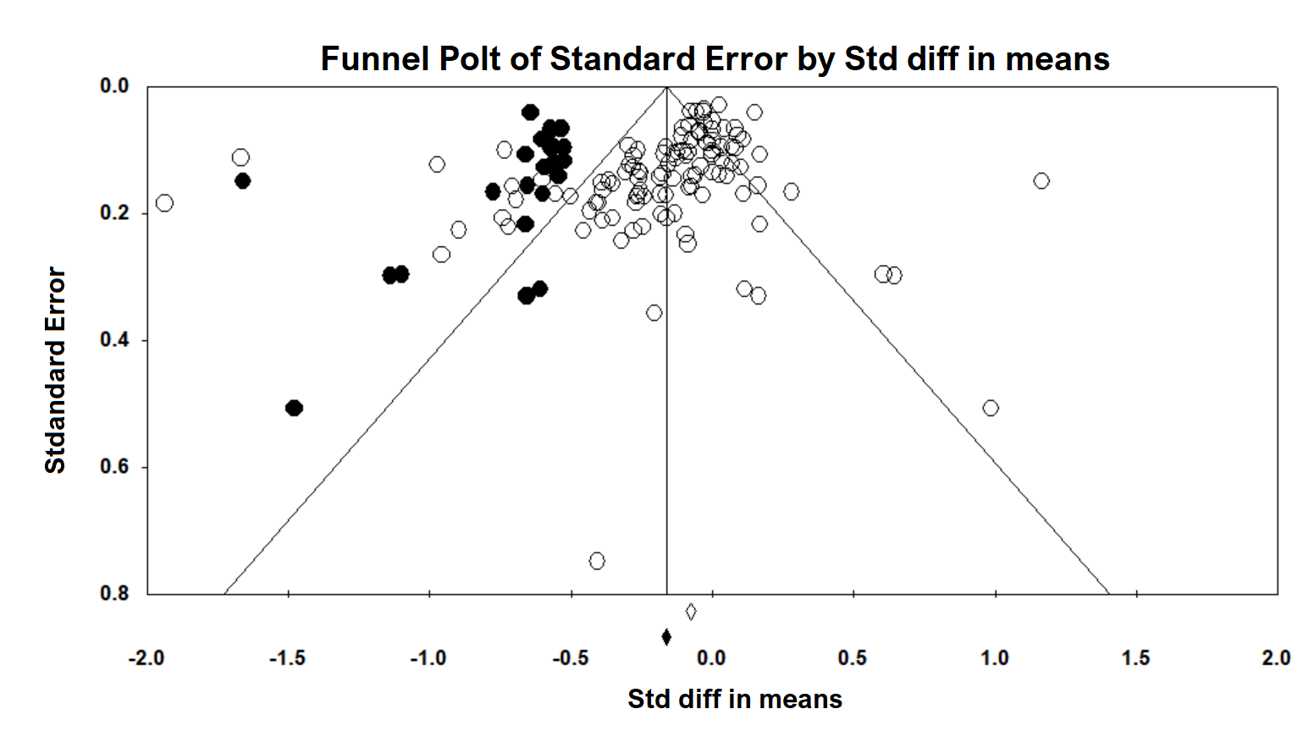
Figure S5-3: Shows the visually assessing on the asymmetry of funnel plot with imputed number of studies in all data (the black dots in the figure indicate the data that may be predicted).

References:
Abellán, R., M. L. Mansego, S. Martínez-Hervás, J. C. Martín-Escudero, R. Carmena, J. T. Real, J. Redon, J. J. Castrodeza-Sanz and F. J. Chaves (2010). "Association of selected ABC gene family single nucleotide polymorphisms with postprandial lipoproteins: Results from the population-based Hortega study." Atherosclerosis211: 7.
Begg, C. B. and M. Mazumdar (1994). "Operating characteristics of a rank correlation test for publication bias." Biometrics: 1088-1101.
Duval, S. (2005). "The trim and fill method." Publication bias in meta-analysis: Prevention, assessment and adjustments: 127-144.
Egger, M., G. D. Smith, M. Schneider and C. Minder (1997). "Bias in meta-analysis detected by a simple, graphical test." Bmj315(7109): 629-634.
Sun, M., Y. Ma, X. Xie, S. Yuan, L. Wang, Y. Yang, Z. Fu, X. Peng, F. Liu and B. Chen (2011). "Distributional characteristics of adenosine triphosphate binding cassette transport protein A1 gene R219K polymorphism and association with blood lipid level in healthy Han and Uygur population in Xinjiang." Journal of Chinese practical diagnosis and therapy25(1).
Ya, L. and Z. Lu (2017). "Differences in ABCA1 R219K polymorphisms and serum indexes in Alzheimer and Parkinson Diseases in Northern China." Medical science monitor: international medical journal of experimental and clinical research23: 4591.

