Online Resource 2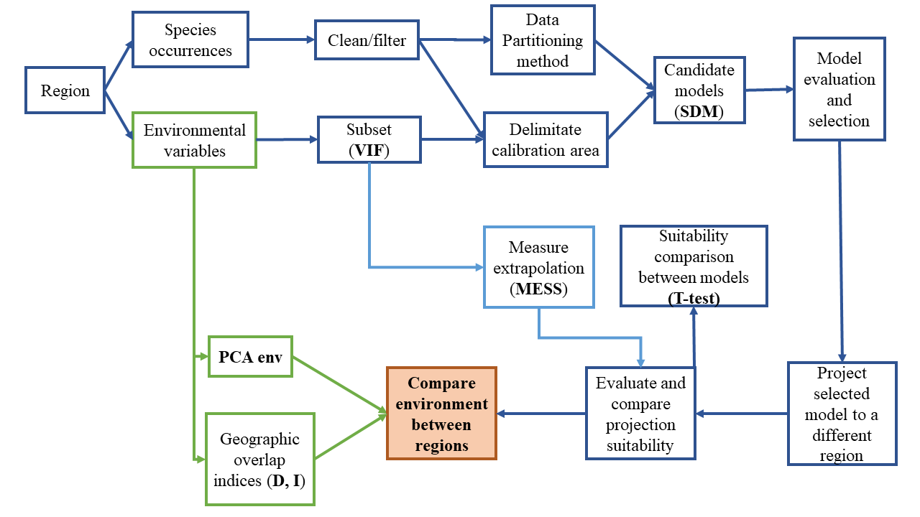
Figure S.1 Procedure followed to conduct the data analyses for each of the selected regions

