Fig. 3 Supplementary information
M: DL 2000 Marke, A: conserved
A
M

M: DL 2000 Marke, B: 5’RACE
M
B

M: DL 2000 Marke, C: 3’RACE
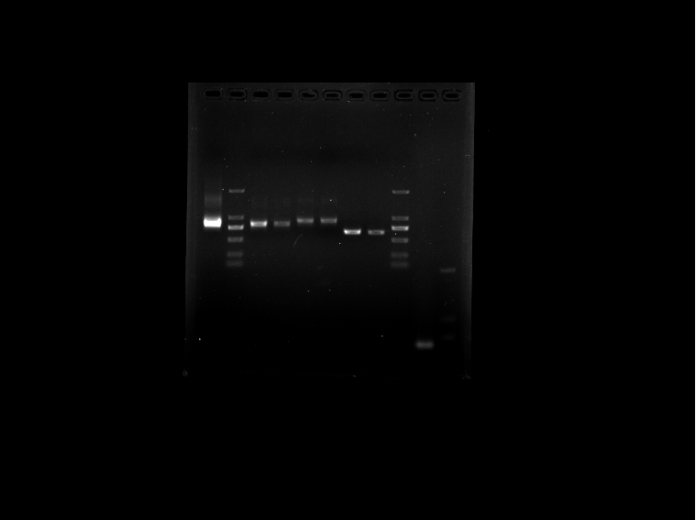
C
M

M: DL 2000 Marke, D: full-length cDNA
D
M

