Project summary
Vitamin D deficiency is a risk factor for neonatal respiratory distress syndrome. The aim of the present study is to evaluate the effect of 25-hydroxyvitamin administration in pregnant women at risk of preterm delivery on the incidence of RDS in their preterm neonates. A single-blinded randomized controlled clinical trial was conducted on pregnant mothers with a gestational age of less than 34 weeks at risk of preterm delivery. Subjects were randomly assigned into two groups, including intervention (injection of 50,000 units of 25(OH) D) and control (with no injection of 25(OH)D). Serum concentrations of 25(OH) D were measured. Short-term outcomes and the need for respiratory support were also assessed. Despite the homogeneity of neonates in the two groups in terms of gestational age, birth weight and the delivery method, 45% of neonates in the control group and 20% in the intervention group developed respiratory distress syndrome (P< 0.05). The mean 25(OH) D level in neonates was 17.7±10.5 and 23.7±13.5 ng/mL in the intervention and control groups, respectively. According to this study, a single dose of 50,000 units of intramuscular 25(OH) D in pregnant women at risk of preterm delivery can reduce the incidence of RDS in the newborn.
General information
Protocol title: Comparison of the incidence of respiratory distress syndrome in offspring of mothers receiving and those not receiving vitamin D: a pilot study
Date: January 21st, 2019 - August 23rd 2019
Protocol identifying number: IRCT20190814044529N1
Sponsor: Vice Chancellor for Research and Technology of Mashhad University of Medical Sciences and Health Services; Ghorashi Building, Deputy of Research and Technology, Daneshgah Avenue, Mashhad, Tel: 051 3841 2081
Investigator: Hassan Boskabadi, MD, Professor of Pediatrics; Department of Pediatrics, Faculty of Medicine, Mashhad University of Medical Sciences, Mashhad, Iran, Tel: 05138400000
Research Centre: Qaem Hospital, Department of Pediatrics and Department of Obstetrics and Gynecology, Mashhad, Iran, Tel: 05138400000
Clinical laboratory: Qaem hospital’s laboratory, Mashhad, Iran, Tel: 05138400000
Rationale & background information:
Vitamin D deficiency during pregnancy is a worldwide problem. The prevalence ranges up to 84% in pregnant women in different studies. Adequate vitamin D supplementation during the pregnancy period is necessary for fetal growth and lung development. Maternal 25(OH)D deficiencies during pregnancy have detrimental outcomes for both mothers and neonates, especially among pregnant women at risk of preterm delivery. Respiratory distress syndrome is more common in premature newborns as their lungs are not able to produce enough surfactant. Critical factors in the pathogenesis of RDS are surfactant deficiency and pulmonary immaturity. In animal studies 1,25(OH)2D has been shown to increase surfactant synthesis and secretion by increasing the number of type 2 alveolar cells. Vitamin D supplementation decreases the risk of respiratory distress syndrome and is relatively effective and safe for preterm neonates.
References:
1. Roberts D, Brown J, Medley N, Dalziel SR. Antenatal corticosteroids for accelerating fetal lung maturation for women at risk of preterm birth. Cochrane Database Syst Rev. 2017 21;3(3).
2. Saraf R, Morton SM, Camargo Jr CA, Grant CC. Global summary of maternal and newborn vitamin D status–a systematic review. M Matern Child Nutr. 2016;12(4):647-68.
3. Saadoon A, Ambalavanan N, Zinn K, Ashraf AP, MacEwen M, Nicola T,et al. Effect of Prenatal versus Postnatal Vitamin D Deficiency on Pulmonary Structure and Function in Mice. Am J Respir Cell Mol Biol. 2017;56(3):383-92.
4. Britt RD Jr, Faksh A, Vogel E, Martin RJ, Pabelick CM, Prakash YS. Perinatal factors in neonatal and pediatric lung diseases. Expert Rev Respir Med. 2013;7(5):515-31. doi:10.1586/17476348.2013.838020
5. Marin L, Dufour ME, Tordet C, Nguyen M. 1,25(OH)2D3 stimulates phospholipid biosynthesis and surfactant release in fetal rat lung explants. Biol Neonate. 1990;57(3-4):257-60.
6. Sakurai R, Shin E, Fonseca S, Sakurai T, Litonjua AA, Weiss ST, Torday JS, Rehan VK. 1alpha,25(OH)2D3 and its 3-epimer promote rat lung alveolar epithelial-mesenchymal interactions and inhibit lipofibroblast apoptosis. Am J Physiol Lung Cell Mol Physiol. 2009;297(3):496-505.
7. Lykkedegn S, Sorensen GL, Beck-Nielsen SS, Pilecki B, Duelund L, Marcussen N, et al. Vitamin D Depletion in Pregnancy Decreases Survival Time, Oxygen Saturation, Lung Weight and Body Weight in Preterm Rat Offspring. PLoS One. 2016;11(8):e0155203.
8. Yurt M, Liu J, Sakurai R, Gong M, Husain SM, Siddiqui MA, et al. Vitamin D supplementation blocks pulmonary structural and functional changes in a rat model of perinatal vitamin D deficiency. Am J Physiol Lung Cell Mol Physiol. 2014;307(11):859-67.
9. Ataseven F, Aygün C, Okuyucu A, Bedir A, Kücük Y, Kücüködük S. Is vitamin d deficiency a risk factor for respiratory distress syndrome? Int J Vitam Nutr Res. 2013;83(4):232-7.
10. Gatera VA, Abdulah R, Musfiroh I, Judistiani RTD, Setiabudiawan B. Updates on the Status of Vitamin D as a Risk Factor for Respiratory Distress Syndrome. Adv Pharmacol Sci. 2018;2018:8494816.
11. Abrams SA. Vitamin D supplementation during pregnancy. J Bone Miner Res. 2011;26(10):2338-40.
12. Dawodu A, Saadi HF, Bekdache G, Javed Y, Altaye M, Hollis BW. Randomized controlled trial (RCT) of vitamin D supplementation in pregnancy in a population with endemic vitamin D deficiency. J Clin Endocrinol Metab. 2013;98(6):2337-46.
13. Hollis BW, Johnson D, Hulsey TC, Ebeling M, Wagner CL. Vitamin D supplementation during pregnancy: double-blind, randomized clinical trial of safety and effectiveness. J Bone Miner Res. 2011;26(10):2341-57.
14. Boskabadi H, Mamoori G, Khatami SF, Faramarzi R. Serum level of vitamin ;D in preterm infants and its association with premature-related respiratory complications: a case-control study. Electron Physician. 2018;10(1):6208-14.
15. Mohamed Hegazy A, Mohamed Shinkar D, Refaat Mohamed N, Abdalla Gaber H. Association between serum 25 (OH) vitamin D level at birth and respiratory morbidities among preterm neonates. J Matern Fetal Neonatal Med. 2018;31(20):2649-55.
16. Dogan P, Ozkan H, Koksal N, Bagci O, Varal IG. Vitamin D deficiency and its effect on respiratory distress syndrome in premature infants: results from a prospective study in a tertiary care centre. Afr Health Sci. 2020;20(1):437-43.
17. Fettah ND, Zenciroğlu A, Dilli D, Beken S, Okumuş N. Is higher 25-hydroxyvitamin D level preventive for respiratory distress syndrome in preterm infants? Am J Perinatol. 2015;32(3):247-50.

Study goals and objectives: The aim of this study is to review the effects of vitamin D administration for pregnant women at risk of premature labor in reducing neonatal respiratory distress syndrome. The incidence of RDS is inversely proportional to the gestational age of the infant, causing more severe disease in neonates with a gestational age of less than 34 weeks. Accordingly, mothers at risk of premature labor and under 34 weeks of gestation were included in the study.
Study design:
This single-blind randomized controlled trial, including 175 cases, was performed under the supervision of Boskabadi H, MD, in the Department of Obstetrics and Gynecology and the Neonatal Intensive Care Unit of Qaem Hospital, affiliated to Mashhad University of Medical Sciences. The duration of the study was estimated to be 16 months.

Methodology
A single-blinded randomized controlled clinical trial was conducted on pregnant mothers with a gestational age of less than 34 weeks at risk of preterm delivery. Subjects were randomly assigned into two groups, including intervention (intramuscular injection of 50,000 units of 25(OH) D three days before delivery) and control (with no injection of 25(OH)D). Serum concentrations of 25(O) D were measured after delivery in the neonates along with the incidence of RDS and were collected and recorded in a checklist. Short-term outcomes and the need for respiratory support were also assessed. Data were analyzed by independent t-test, paired sample t-test and chi-square test.
- Interventions: intramuscular injection of 50,000 units of 25(OH) D three days before delivery to pregnant women in the intervention group at risk for preterm labor and under 34 weeks of gestation. Pregnant women in the intervention group had not taken any 25(OH) D supplements during pregnancy.
- Procedures: 1.5 milliliters of maternal and neonatal blood were withdrawn immediately after birth for 25(OH)D assessment.
- Measurement: Vitamin D level was measured in ng/mL by the ELISA method.
- Pregnant mothers at risk of preterm labor were assigned to the intervention and control arms of the study based on simple randomization with respect to the inclusion criteria
- Randomization: was done by the obstetrics nurse using the box of randomization
- The assignment of patients, including cases and controls, was blinded for the main researcher.
- The exclusion criteria was as follows: a gestational age≥ 34 weeks, neonatal death at birth, major congenital anomalies, severe perinatal asphyxia, necrotizing enterocolitis, stillbirth, respiratory distress except for neonatal respiratory distress syndrome, and neonatal abstinence syndrome.
- Flowchart of study: eight neonates were discharged early upon parents request and consent and we do not have any follow-up information about them.

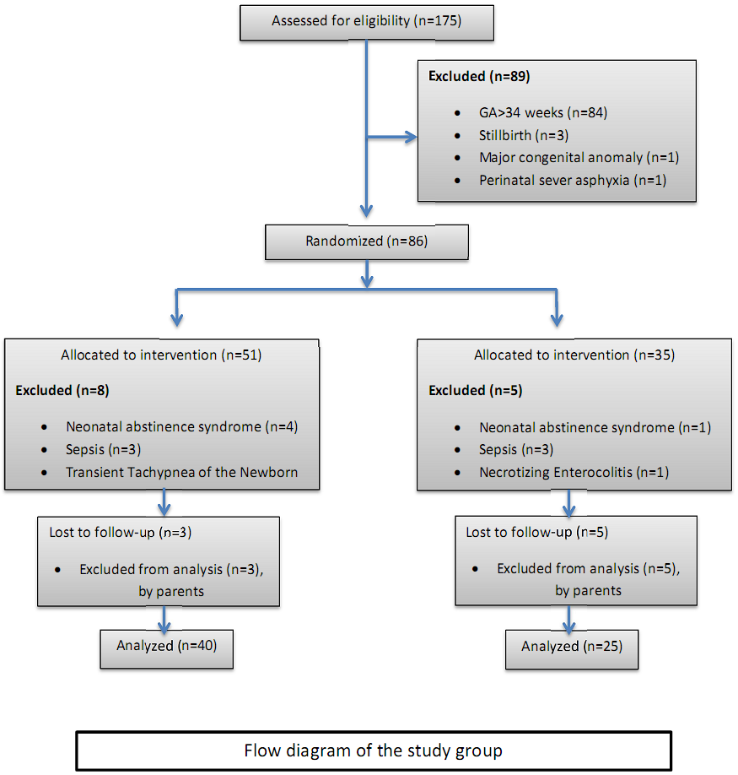

Safety considerations: All participants were informed of global vitamin D deficiency in pregnant women and their offspring, according to previous studies, and the cases in the intervention group were closely monitored in view of excess vitamin D.

Follow-up: The mothers and their neonates in the intervention group were followed up to one month after discharge from hospital.
- Data management: Due to the lack of similar studies in the literature, we estimated that for reducing the incidence of RDS to 0, a sample consisting of at least 20 cases and 20 controls will be sufficient to fulfill the comparisons. To reach 20 cases in the intervention group, a total of 175 mothers were enrolled in the study.
- The data variables were assigned as 0 or 1 to indicate the control or intervention group and absence or presence of one finding, such as requiring intubation and surfactant injection.
- Data Analysis was performed by the SPSS software after Coding
- The main researcher was uninformed of the coding.
- Independent t-test or Mann-Whitney test were used to compare quantitative variables between the two groups.
- Quantitative variables within each group were compared with paired sample t-test.
- Qualitative variables between the two studied groups were compared with Chi-square test and Fisher's exact tests.
- Data are presented as mean ± standard deviation (SD).
- A P-value< 0.05 was considered as statistically significant.

Quality management: all patients’ statistics were collected in written documents and then computerized. The study was controlled by the Ethics Committee of Mashhad University and all cases were monitored by the project supervisors.

Expected outcomes: Vitamin D administration to pregnant women could result in decreased Respiratory distress syndrome incidence in premature neonates and therefore has a significant effect on premature mortality and morbidity, as well as lowering hospital costs.

Dissemination of results: This article is a pilot study and presents a new and unique intervention on respiratory distress syndrome prophylaxis, and thus needs to submit to hearing the views of other researchers involved in this field. Also, we will discuss the results with our colleagues in favor of promoting the same trials in the near future. If all goes well, then we will present our findings in relevant societies, for government policymakers, and also through social media for informing the general population.

Duration: The study was conducted from January 21st to August 23rd, 2019. Patients were treated based on their individual condition, thus the time intervals varied from a few days for those that were discharged after parturition to several weeks for very low birth weight neonates.

Anticipation: Because of the de novo nature of this trial, we carefully supervised all neonates including those that were not hospitalized.

Project management

Hassan Boskabadi and Gholamali Maamouri have made substantial contributions to the conception and design of the work, Gholamali Maamouri and Nafiseh Saghafi had a significant role in data acquisition and interpretation, Hosein Ataee Nakhaei had a major role in data acquisition and drafted the work. All authors critically revised the manuscript, agree to be fully accountable for ensuring the integrity and accuracy of the work, and read and approved the submitted version of the manuscript.

Ethics
- The study protocol was approved by the Ethics Committee of Mashhad University of Medical Sciences (IR.MUMS.fm.REC.1395.52).
- An informed consent was obtained from each participant by a single researcher before study entrance, after consultation with mothers, and if needed their families.
- Due to global vitamin D deficiency, the ethical committee requested to perform serum vitamin D analysis after vitamin D injection to the intervention group and recommended that mothers and their offspring of both groups that were vitamin D deficient should be treated appropriately.

Informed consent forms:
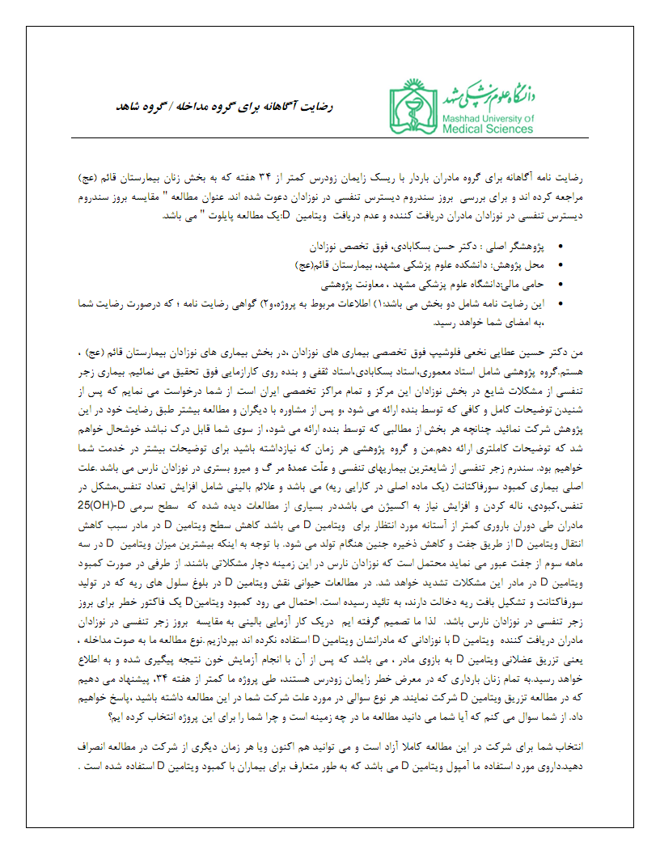 | 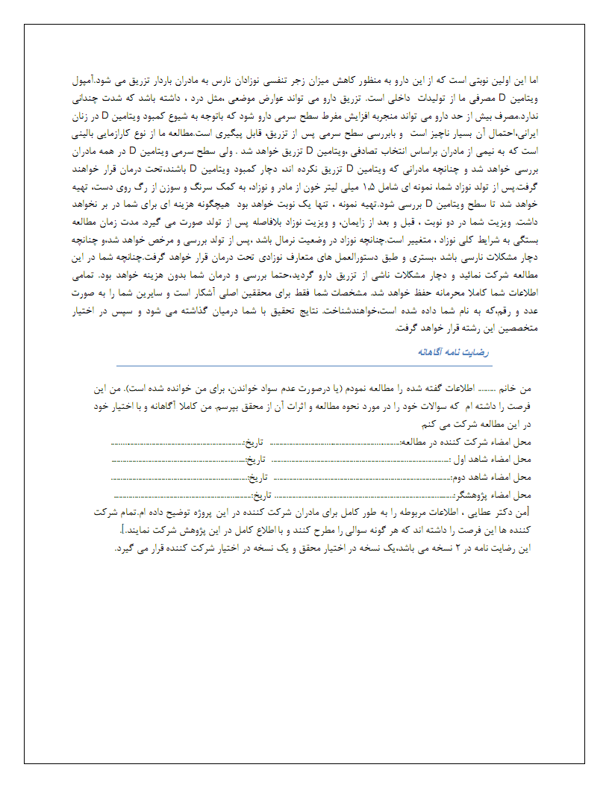

Budget

The cost of project
Personnel costs
Item |  |  | Costs(Iran Rial)
Serum Sampling |  |  | 4000,000
Collecting samples |  |  | 4200.000
Recording early data |  |  | 4800,000
Lab costs
Vitamin D analysis |  | No:175 |  | 60,000,000
Vitamin D Packs (including ampules and syringes)
Vitamin D ampules | No :90 |  |  |  | 1800,000
Syringes (2 mL) | No:90 |  |  |  | 900,000
Total costs |  |  | 75,700,000 Iranian Rial

Other support for the project: We have not received any support from others.

Curriculum Vitae of investigators:

Hassan Boskabadi

Qaem Medical center – Mashhad University of Medical Sciences, Mashhad, IRAN.

boskabadih@mums.ac.ir; Cell: 00985138417493

EDUCATION:

MD; General practitioner, Mashhad University of Medical Sciences, 1995

Pediatrics; Mashhad University of Medical Sciences, 1998

Neonatologist; Mashhad University of Medical Sciences, 2004

CERTIFICATION AND LICENSURE

•Board-certified Pediatrician, 2004-present

PROFESSIONAL EXPERIENCE

Attending Physician, Qaem Medical center, Department of Pediatrics, Mashhad, Iran

TEACHING EXPERIENCE

• Assistant professor, Qaem Hospital, Department of Pediatrics, 1999-2004

• Professor, Qaem Hospital, Department of Pediatrics, 2004 -present

PUBLICATIONS (among others)

Boskabadi H., Maamouri G., Akhondian J, et al. Comparison of birth weights of neonates of mothers receiving vs. not receiving zinc supplement at pregnancy. BMC Pregnancy Childbirth 21, 187 (2021). https://doi.org/10.1186/s12884-021-03598-8.

Boskabadi H, Rakhshanizadeh F, Moradi A, Zakerihamidi M. Risk Factors and Causes of Neonatal Hyperbilirubinemia: A Systematic Review Study. J. Pediatr. Rev. 2020; 8 (4) :211-222.

URL: http://jpr.mazums.ac.ir/article-1-269-en.html

Hassan Boskabadi, Maryam Zakerihamidi, Ali Moradi (2020) Predictability of prognosis of infantile hypernatremic dehydration: a prospective cohort study, The Journal of Maternal-Fetal & Neonatal Medicine, DOI: 10.1080/14767058.2020.1712698.

MEMBERSHIPS AND ASSOCIATIONS

• Medical Council of the Islamic Republic of Iran

COMMUNITY SERVICE

• Free clinic of the Iranian charity organization, Mashhad, 2004-Present

• Volunteer teaching Physician, Department of Pediatrics
Gholamali Maamouri
Qaem Hospital, Mashhad University of Medical Sciences, Mashhad, IRAN.
maamourigh@mums.ac.ir; Cell: 00985138417493
EDUCATION
MD; General practitioner, Mashhad University of Medical Sciences , 1982
Pediatrics; Mashhad University of Medical Sciences, 1984
Neonatology; Mashhad University of Medical Sciences, 1992
CERTIFICATION AND LICENSURE
• Board-certified Pediatric, 1984-present
PROFESSIONAL EXPERIENCE
Attending Physician, Qaem Hospital, Department of Pediatrics, Mashhad, Iran
TEACHING EXPERIENCE
• Assistant professor, Qaem Hospital, Department of Pediatrics, 1984-1992
• Professor, Qaem Hospital, Department of Pediatrics, 1992 -present
PUBLICATIONS (among others)
Boskabadi H, Maamouri G, Akhondian J, et al. Comparison of birth weights of neonates of mothers receiving vs. not receiving zinc supplement at pregnancy. BMC Pregnancy Childbirth 21, 187 (2021). https://doi.org/10.1186/s12884-021-03598-8
Maamouri Gholamali, et al. "Efficacy of oral zinc sulfate intake in prevention of neonatal jaundice." Iranian Journal of Neonatology IJN 4.4 (2014): 11-16.
Boskabadi Hassan, et al. "Neonatal Infections: a 5-year analysis in a neonatal care unit in north east of Iran." International Journal of Pediatrics 4.12 (2016): 3989-3998.
Maamouri Gholamali, et al. "Hyperbilirubinemia and neonatal infection." (2013): 5-12.

MEMBERSHIPS AND ASSOCIATIONS
• Medical Council of the Islamic Republic of Iran
COMMUNITY SERVICE
• Volunteer teaching Physician, Department of Pediatrics

Nafiseh Saghafi
Qaem Hospital, Mashhad University of Medical Sciences, Mashhad, IRAN.
saghafiN@mums.ac.ir; Cell: 00985138417493
EDUCATION
MD; General practitioner, Mashhad University of Medical Sciences, 1981
Obstetrics & Gynecology; Board of OB/GYN, Mashhad University of Medical Sciences, 1986
CERTIFICATION AND LICENSURE
• Board-certified Gynecologist, 1986-present
MEDICAL TRAINING
• Fellowship: Ultrasonography in OB/GYN, Mashhad University of Medical Sciences, 1994
• Sub-specialty: IVF and ART, Yazd Medical University, 1991
• Fellowship: Advanced laparoscopic surgery, Tehran University of Medical Sciences, 2008
PROFESSIONAL EXPERIENCE
Attending Physician, Qaem Hospital, Department of Obstetrics & Gynecology, Mashhad, Iran
TEACHING EXPERIENCE
• Assistant professor, Qaem Hospital, Department of Obstetrics & Gynecology, 1988-2004
• Professor, Qaem Hospital, Department of Obstetrics & Gynecology, 2004 -present
HONORS AND AWARDS
• Selected Teacher of faculty Of Medicine, 2014
• Distinguished Professor Award, 2013
• Voluntary Medical Service Award, 2012
• Maternal Health promoting Award, 2012
PUBLICATIONS (among others)
Saghafi Nafiseh, et al. (2014)”Clinical Medicine Strategy for Managing Hypertensive Disorders of Pregnancy” Mashhad University of Medical Sciences.
Saghafi Nafiseh, et al. (2020) Medical Treatment in Cesarean Scar Pregnancy with Fetal Heart Activity and High Level of Serum β-hCG: A Case Report. Current Women s Health Reviews. 16. 10.2174/1573404816999200917122124.
Saghafi Nafiseh, et al. (2020) Evaluation of the Effects of 1,25 Vitamin D3 on Regulatory T Cells and T Helper 17 Cells in Vitamin D-deficient Women with Unexplained Recurrent Pregnancy Loss. Current Molecular Pharmacology. 13. 10.2174/1874467213666200303130153.
Saghafi Nafiseh, et al. (2020) Evaluation of 1,25(OH)2D3 Effects on FOXP3, ROR-γt, GITR, and CTLA-4 Gene Expression in the PBMCs of Vitamin D-Deficient Women with Unexplained Recurrent Pregnancy Loss (URPL). Iranian biomedical journal. 24. 10.29252/ibj.24.5.290.
Saghafi Nafiseh, et al. (2019) First Trimester Uterine Rupture, a Rare but Life-Threatening Event: A Case Report. Iranian journal of medical sciences. 44. 422-426. 10.30476/IJMS.2019.44948.
CONFERENCE PRESENTATIONS (among others)
“Diagnosis of PCOD based on sonography and clinical finding”. International congress of ovulation induction, Italy, 2000.
“Successful Rate of pregnancy in 1846 clomiphene citrate cycle HCG timed using IUI”. International congress of ovulation induction, Italy, 2000.
“Comparative study of two methods of sterilization filshie clips and pomeroys”. 2nd world congress on controversies in OB/GYN and infertility, France, 2001.

MEMBERSHIPS AND ASSOCIATIONS
• Board of surgeon’s society, Khorasan Province Branch, Mashhad, IRAN, 2003- Present
• American Medical Member of SLS, USA
• FMF fetal medicine foundation, Germany
COMMUNITY SERVICE
• Free Clinic of the Iranian charity organization, Mashhad, 2003-Present
• Volunteer teaching Physician, Obstetrics & Gynecology

Mohammad Hosein Ataee Nakhaei
Imam Ali Hospital, Zahedan University of Medical Sciences, Zahedan, IRAN.
Drataee@ymail.com, Cell: 00985433295630
EDUCATION
MD; General practitioner, Mashhad University Of Medical Sciences, 1995
Pediatrics; Yazd University, 2012
Neonatology; Mashhad University of Medical Sciences, 2020
CERTIFICATION AND LICENSURE
• Board-certified Pediatrician, 2012-present
PROFESSIONAL EXPERIENCE
Pediatrician, Imam Khomeini Hospital, Khash, Zahedan, Iran, 2012-2017
TEACHING EXPERIENCE
• Assistant professor, Zahedan University of Medical Sciences, Department of Pediatrics, 2021
PUBLICATIONS (among others)
Boskabadi H, Maamouri G, Akhondian J, et al. Comparison of birth weights of neonates of mothers receiving vs. not receiving zinc supplement at pregnancy. BMC Pregnancy Childbirth 21, 187 (2021). https://doi.org/10.1186/s12884-021-03598-8.
Boskabadi Hassan, et al. "Comparison of Umbilical Cord Serum Vitamin D Levels between Infants with Transient Tachypnea of the Newborn and those without Respiratory Distress." Archives of Iranian Medicine 23.8 (2020): 530-535.
CONFERENCE PRESENTATIONS (among others)
“Neonatal resuscitation for nurses.” Mashhad University of Medical Sciences, 2019
“Congenital heart disease in neonates.” Zahedan University of Medical Sciences, 2021
“Approach to neonatal sepsis.” Zahedan University of Medical Sciences, 2021

MEMBERSHIPS AND ASSOCIATIONS
• Medical Council of the Islamic Republic of Iran

