**Supplementary File for**

**Altered regulation of mesenchymal cell senescence promotes pathological changes associated with diabetic wound healing**

**Authors: Arisa Kita MD1, Yuki Saito PhD2*, Norihiro Miura3, Maki Miyajima PhD3, Takatoshi Yotsuyanagi MD,PhD1, Mineko Fujimiya MD, PhD2, and Takako S. Chikenji PhD 2,3\***

**Affiliations:**

1. Department of Plastic and Reconstructive Surgery, Sapporo Medical University, Sapporo, Japan

2. Department of Anatomy, Sapporo Medical University School of Medicine, Sapporo, Japan

3. Department of Health Sciences, School of Medicine, Hokkaido University, Sapporo, Japan.

**\*Corresponding authors:**

**Takako S. Chikenji**

Address: North12 West5, Kitaku, Sapporo, 060-0812, Japan

Telephone: 011-706-3382 FAX: 011-706-3382

Email: [chikenji@pop.med.hokudai.ac.jp](mailto:chikenji@pop.med.hokudai.ac.jp)

**Yuki Saito**

Address: South1 West17, Chuoku, Sapporo, 060-8556, Japan

Telephone: 011-611-2111 FAX: 011-618-4288

Email: [yuki.saito@sapmed..ac.jp](mailto:yuki.saito@sapmed..ac.jp)

**Supplementary Figures**

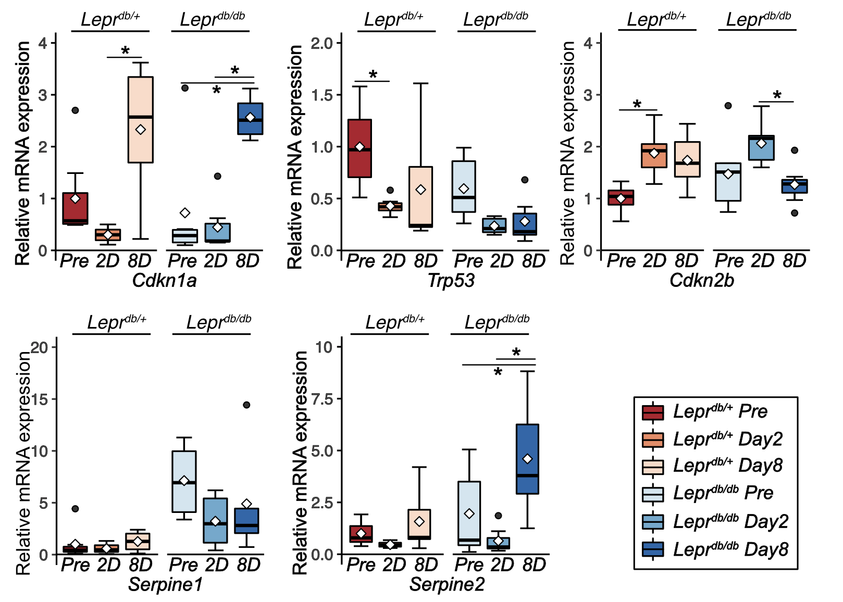

***Supplementary Figure 1. Senescence-related gene expression in skin during wound healing in Leprdb/+ and Leprdb/db mice***

Relative mRNA expression of senescence-related genes at pre-wound, 2DPW, and 8DPW for *Leprdb/+ and Leprdb/db* mice (n=6–7 for each group)*.* Quantitative data are presented as the means and medians with IQRs and 1.5 times the IQR and are displayed as box-and-whisker plots. *p*-values were determined by one-way ANOVA adjusted by the Tukey method (\**p*<0.05).

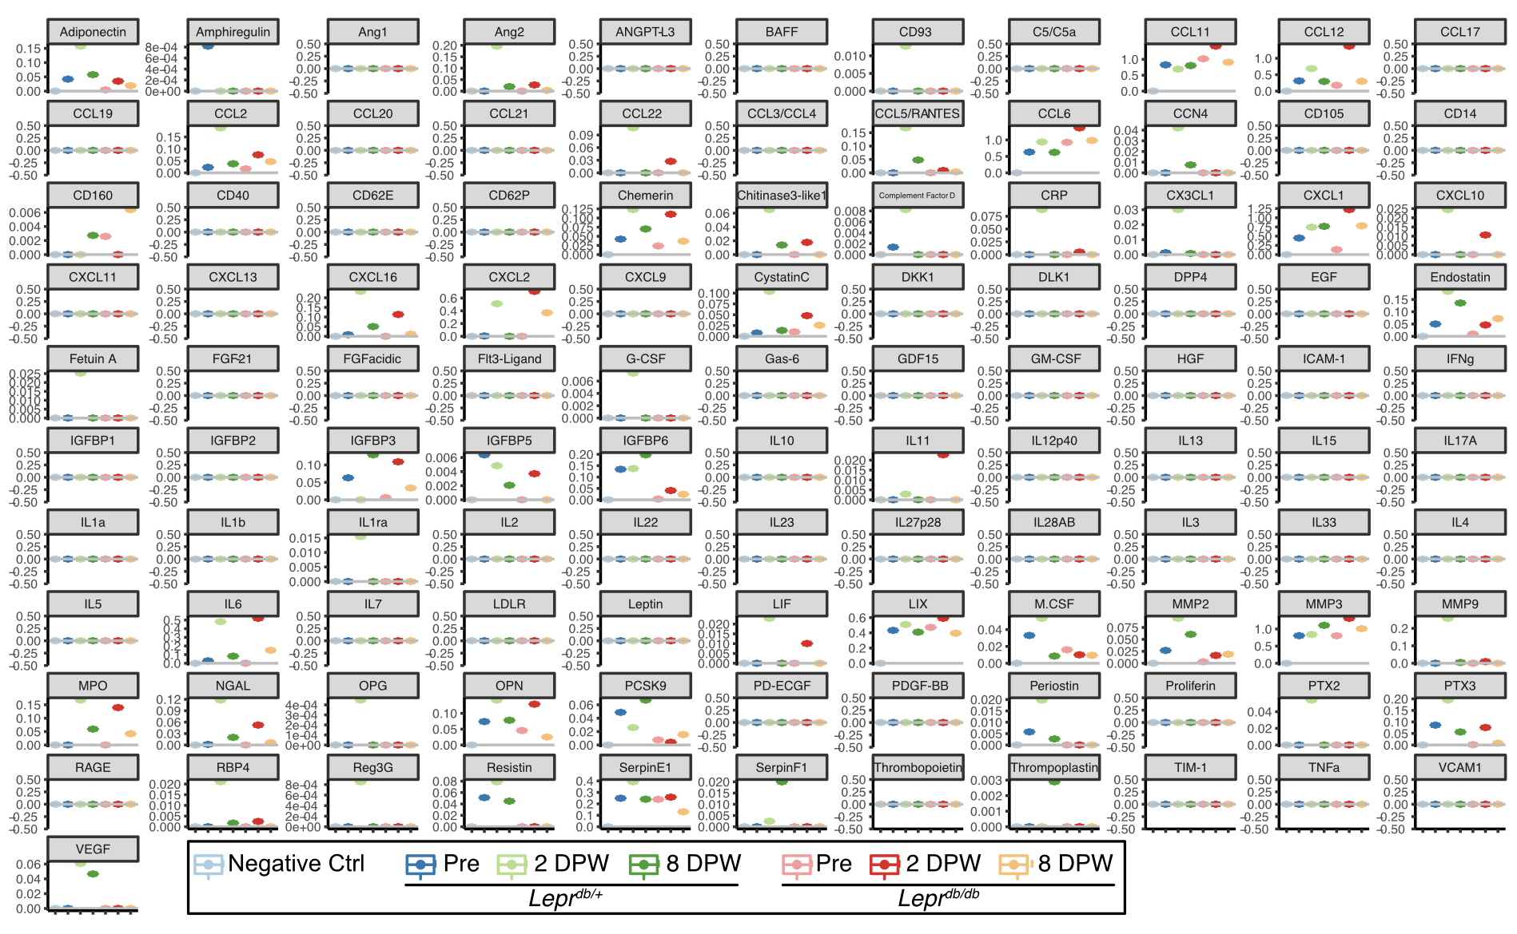

***Supplementary Figure 2.* Quantitative data for the proteome profiler antibody array**

Quantitative data for the proteome profiler antibody array for SASP-containing culture media collected from organ culture of adipose tissue at pre-wound, 2 DPW, and 8 DPW.

***Supplementary Table 1. Specific primer sequence used for real-time PCR***

