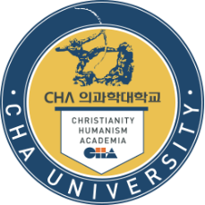
Jongman Yoo, M.D., Ph.D.
Department of Microbiology
School of Medicine, CHA University
Pangyo-ro, Seongnam-si, Gyeonggi-do 13488
Office +82-10-9444-4915; FAX +82-31-811-7114
Email) jongmanyoo@cha.ac.kr
August 26, 2020
Editor in chief
Stem Cell Reviews and Reports

Dear Editor,

We wish to submit the manuscript entitled “Establishment of functional epithelial organoid from human lacrimal glands” for publication as an original article to the Editor in Stem Cell Research & Therapy.

Tear deficiency due to dysfunction of the lacrimal gland is one of the major causes of dry eye disease (DED). The primary conventional therapy with artificial tears is often insufficient to alleviate symptoms or prevent the progression of ocular surface disease in severe cases. Recently, several studies suggest that lacrimal gland stem/progenitor cell-based therapy is considered to be a promising strategy for DED patients. But, there are limitations such as 1) small stem cell populations in the lacrimal gland and 2) reduction of differentiation capacity during long term cultivation.
In this study, we suggest new lacrimal gland organoids having functional epithelial properties as cell therapeutics and confirmed its curability for the regeneration of injured lacrimal gland tissue.

The major reports of this study include:
1. Establishment of novel lacrimal gland organoid.
2. Confirmation of similarity to human lacrimal gland tissue of our novel organoid.
3. Confirmation for the secretory function of the lacrimal gland organoid.
4. Demonstration of applicability as cell therapeutic of lacrimal gland organoid.

We successfully developed the lacrimal gland organoid resemble characteristics of the normal lacrimal gland and the organoids could be used as cell therapy for patients with DED. For these reasons, we believe that our study is of significant interest to your readership and suitable for publication as an original article to the Editor in Stem Cell Research & Therapy.
Please note that this manuscript has not been published or presented elsewhere in part or its entirety and is not under consideration by another journal. We have read and understood your journal’s policies, and we believe that neither the manuscript nor the study violates any of them. All authors have read and approved the submitted manuscript and agree with its submission to Stem Cell Research & Therapy for publication. There are no conflicts of interest to declare. All authors have contributed to the work and take responsibility for it.
Thank you in advance for your consideration.
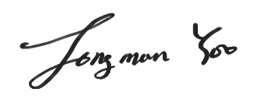
Sincerely,
Jongman Yoo, M.D., Ph.D.

