Curcumin-based-fluorescent probes targeting ALDH1A3 as a promising tool for glioblastoma precision surgery and early diagnosis

Edoardo L. M. Gelardi^{a,1}, Diego Caprioglio^{a,1}, Giorgia Colomboª, Daniele Mazzolettiª, Daiana Mattoteiaª, Stefano Salamoneª, Davide M. Ferraris^{a,h}, Eleonora Aronica^{b,c}, Giulia Nato^{d,e}, Annalisa Buffo^{f,e}, Menico Rizziª, Lorenzo Magrassi^{g,h}, Alberto Minassi^{a,i*} & Silvia Garavaglia^{a,*}.

ª Department of Scienze del Farmaco, University of Piemonte Orientale, Via Bovio, 6, Novara, 28100, Italy
^{b} Department of (Neuro)Pathology, Amsterdam UMC, University of Amsterdam, The Netherlands
^{c} Stichting Epilepsie Instellingen Nederland (SEIN), Heemstede, The Netherlands
^{d} Department of Life Sciences and System Biology University of Turin, Via accademia Albertina 13,Turin, Italy
^{e} Neuroscience Institute Cavalieri Ottolenghi (NICO), 10043 Orbassano, Torino, Italy.
^{f} Department of Neuroscience Rita Levi Montalcini, University of Turin, Via Cherasco 15, Torino, Italy.
^{g} Neurosurgery, Department of Clinical, Surgical, Diagnostic and Pediatric Science, University of Pavia, Foundation IRCCS Policlinico San Matteo, Pavia, 27100, Italy.
^{h} Istituto Di Genetica Molecolare IGM-CNR, via Abbiategrasso 207, 27100 Pavia, Italy.
^{i} PlantaChem srls, via Canobio 4/6, 28100 Novara, Italy
^{h} IXTAL srl, via Bovio 6, 28100, Novara, Italy

Correspondence: silvia.garavaglia@uniupo.it; alberto.minassi@uniupo.it
¹ These authors contributed equally to the work
² Co-last authors with Prof. Silvia Garavaglia

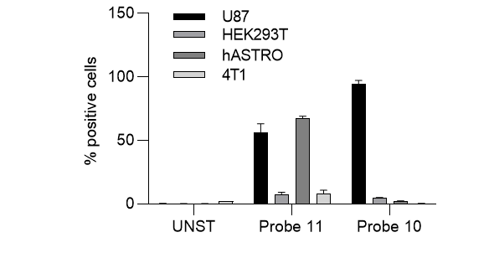

Figure Supplementary S1: Flow cytometry analysis of probe 10 and probe 11 on Human U87MG ALDH1A3+ glioblastoma cells, HEK293T ALDH1A2+ cell line, human foetal astrocytes (hASTRO) ALDH1A1+ cell line and 4T1 mammary carcinoma as triple negative ALDH1A subfamily.

