Supporting Information
Light Intensity Dependence of Current Density–Voltage Characteristics of an Organic Solar Cell and Dominance Switching between Shockley-Read-Hall and Radiative Recombination Losses
Shin Young Ryu, ¹ Na Young Ha^{1,2}, Y. H. Ahn^{1,2}, Ji-Yong Park^{1,2}, and Soonil Lee^{1,2,*}

¹ Department of Energy Systems Research, Ajou University, Suwon 16499, Korea
² Department of Physics, Ajou University, Suwon 16499, Korea
* Corresponding Author: soonil@ajou.ac.kr

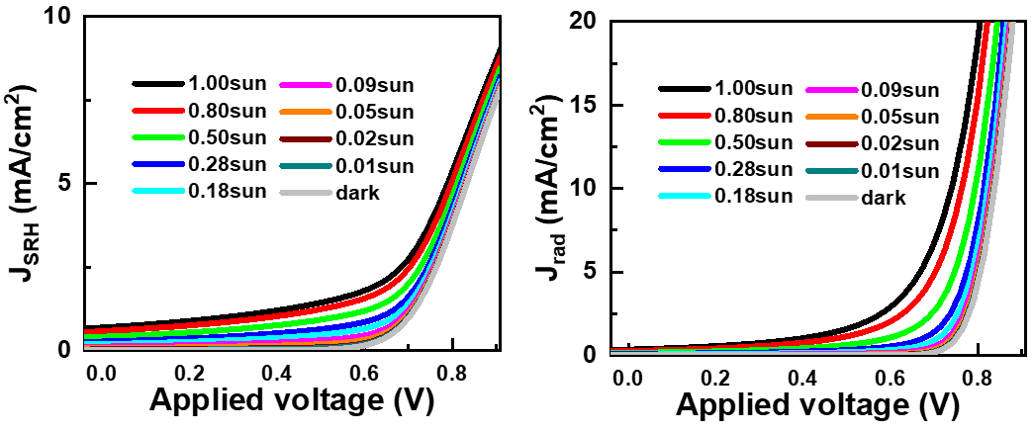
Figure S1. Simulated Shockley-Read-Hall (J_{SRH}) and radiative (J_{rad}) recombination-loss currents with respect to bias voltages:
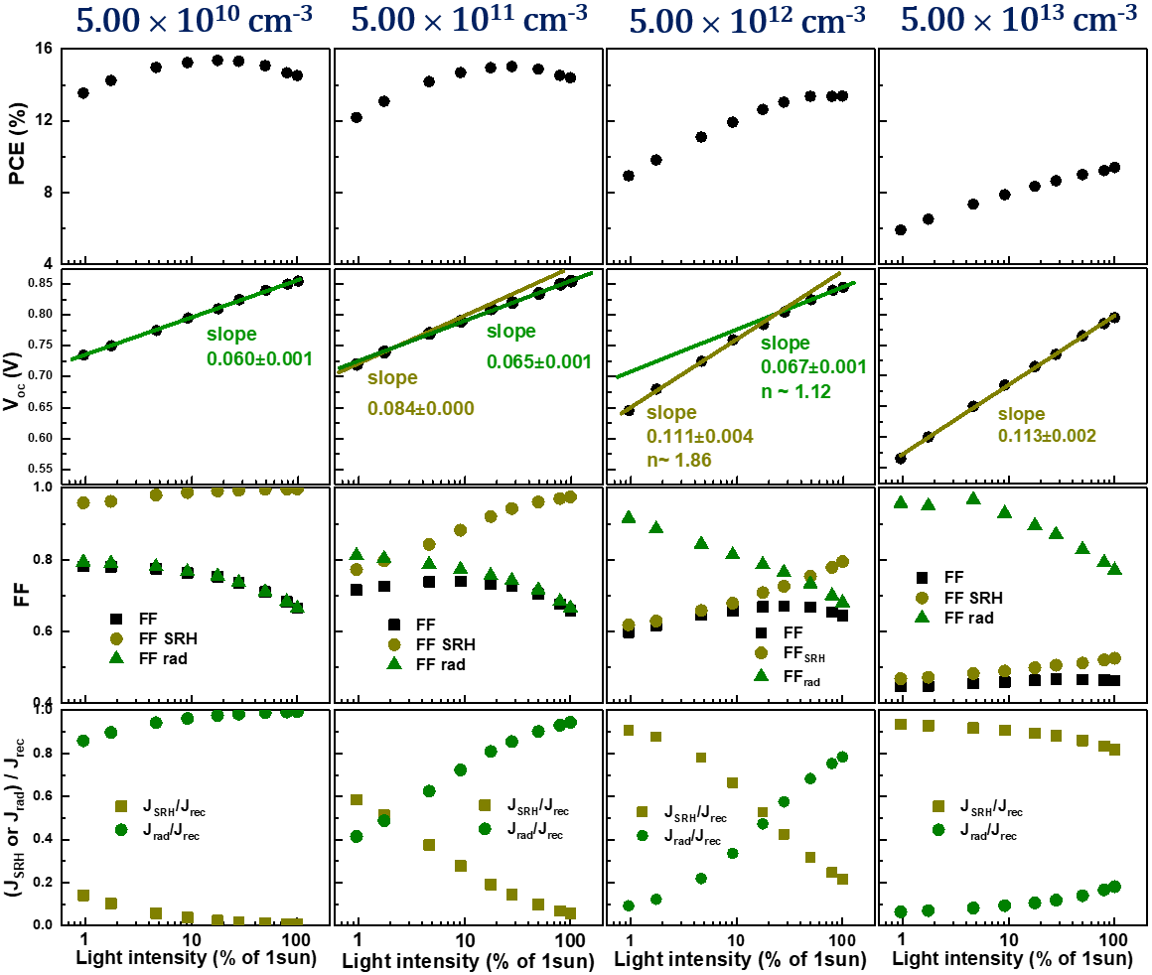
Figure S2. Comparison of light-intensity dependence of power conversion efficiency (PCE), open-circuit voltage (V_{oc}), fill factor (FF), and fractions of SRH (J_{SRH}/J_{rec}) and radiative recombination (J_{rad}/J_{rec}) components in recombination-loss currents at defect densities of 5.00 × 10¹⁰, 5.00 × 10¹¹, 5.00 × 10¹³, and 5.00 × 10¹³ cm⁻³.
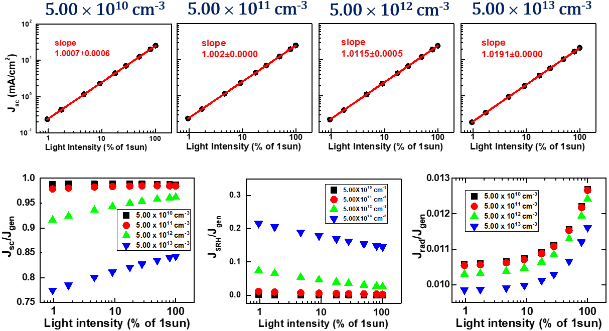
Figure S3. Upper row: Comparison of light-intensity dependence of short-circuit currents (J_{sc}) at defect densities of 5.00 × 10¹⁰, 5.00 × 10¹¹, 5.00 × 10¹², and 5.00 × 10¹³ cm⁻³. Lower row: Comparison of light-intensity dependence of current components J_{sc}, J_{SRH}, and J_{rad} normalized by generation currents J_{gen} at the same four defect densities.

Table S1. Parameter values for electric simulations. We used the following parameter values for all OSC-operation simulations corresponding to different light-intensity conditions.
 | ETL | AL | HTL
Thickness (nm) | 40 | 90 | 10
Band gap (eV) | 3.300 ^{[1]} | 1.290 ^{[2]} | 3.00 0^{[5]}
Electron affinity (eV) | 4.000 ^{[1]} | 4.100^{[2]} | 2.500 ^{[5]}
Conduction band effective density of states, N_{c} (cm⁻³) | 2.20×${10}^{18}$^{[4]} | 1.0×${10}^{20}$ ^{[2]} | 2.20×${10}^{18}$ ^{[5]}
Valance band effective density of states, N_{v} (cm⁻³) | 1.80×${10}^{19 }$^{[4]} | 1.0×${10}^{20}$ ^{[2]} | 1.80×${10}^{19}$ ^{[5]}
Electron thermal velocity  (cm sec⁻¹) | 1.00×${10}^{7}$ ^{[4]} | 1.0×${10}^{7}$ | 1.00×${10}^{7}$ ^{[5]}
Hole thermal velocity  (cm sec⁻¹) | 1.00×${10}^{7}$ ^{[4]} | 1.0×${10}^{7}$ | 1.00×${10}^{7}$ ^{[5]}
Electron mobility  (cm V⁻¹ sec⁻¹) | 1.00×${10}^{2}$ ^{[4]} | 3.2×${10}^{-3}$ ^{[2]} | 2.50×${10}^{1}$ ^{[5]}
Hole mobility  (cm V⁻¹ sec⁻¹) | 2.50×${10}^{1}$ ^{[4]} | 2.7×${10}^{-4}$ ^{[2]} | 1.00×${10}^{2}$ ^{[5]}
Bimolecular recombination coefficient, ϒ (cm³sec⁻¹) |  | 3.0×${10}^{-11}$ ^{[2]}
Defect density (cm⁻³) |  | 5.0×${10}^{12}$ ^{[3]}

References
1. Gutmann, S., Conrad, M., Wolak, M. A., Beerbom, M. M. & Schlaf, R. Work function measurements on nano-crystalline zinc oxide surfaces. J. Appl. Phys. 111, (2012).
2. Tokmoldin, N. et al. Extraordinarily long diffusion length in PM6:Y6 organic solar cells. J. Mater. Chem. A 8, 7854–7860 (2020).
3. Karki, A. et al. The role of bulk and interfacial morphology in charge generation, recombination, and extraction in non-fullerene acceptor organic solar cells. Energy Environ. Sci. 13, 3679–3692 (2020).
4. Zapukhlyak, Z. R. et al. SCAPS simulation of ZnO/CdS/CdTe/CuO heterostructure for photovoltaic application. Phys. Chem. Solid State 21, 660–668 (2020).
5. Li, W., Li, W., Feng, Y. & Yang, C. Numerical analysis of the back interface for high efficiency wide band gap chalcopyrite solar cells. Sol. Energy 180, 207–215 (2019).

