

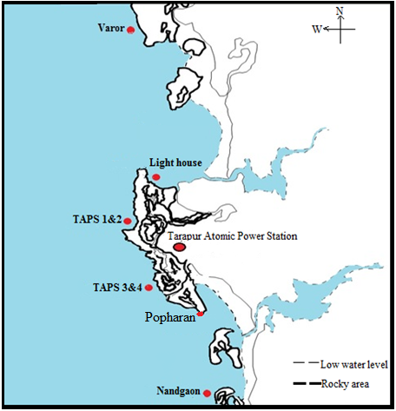

**S Fig. 1 Study area**



**(Study animal of *Nerita oryzarum*)**



**S Fig.2 Experimental set-up of diiferent temperature**

**S Table 1**: GPS positioning and importance of sampling locations with location code

|  |  |  |
| --- | --- | --- |
| **Sampling location / code** | **GPS position** | **Importance of location** |
| TAPS 1 & 2  (NW-I) | N -19050.003’  E -72039.139’ | Intertidal area near to intake channel (Northside) |
| Lighthouse  (NW-II) | N -19050’32.1”  E -72039’21.6” | Intertidal area at the discharge channel of TAPS 1 & 2 (Northside) |
| Varror  (NW-III) | N -19054’32.4”  E -72040’35.6” | Reference location, at the distance of 8.00 km from the discharge channel of TAPS 1&2 (Northside) |
| TAPS 3 & 4  (SW-I) | N -19049.533’  E -72039.557’ | Intertidal area near to intake channel (Southside) |
| Popharan  (SW-II) | N – 19050.638”  E – 72040.651” | Intertidal area at the discharge channel of TAPS 3 & 4 (Southside) |
| Nandgaon  (SW-III) | N -19045’09.0”  E -72041’19.2” | Reference location, at the distance of 8.00 km from the discharge channel of TAPS 3& 4 (Southside) |

**S Table 2:** Levels of different antioxidant enzyme activity at different locations during different seasons

|  |  |  |  |  |  |  |  |  |
| --- | --- | --- | --- | --- | --- | --- | --- | --- |
| **Season /**  **Locations** | **N I** | **N II** | | **N III** | | **S I** | **S II** | **S III** |
| **Lipid peroxidation (LPO)** | | | | | | | | |
| Monsoon | 1.06 ± 0.02c | 1.57 ± 0.14d | | 0.88 ± 0.04d | | 1.12 ± 0.16c | 1.11 ± 0.14b | 0.89 ± 0.05d |
| Postmonsoon | 0.42 ± 0.03a | 0.47 ± 0.05a | | 0.34 ± 0.10a | | 0.41 ± 0.08a | 0.89 ± 0.06a,b | 0.20 ± 0.03a |
| Premonsoon | 1.03 ± 0.02c | 1.04 ± 0.12c | | 0.78 ± 0.07c,d | | 0.91 ± 0.05b,c | 1.88 ± 0.12c | 0.87 ± 0.05c,d |
| **Catalase (CAT)** | | | | | | | | |
| Monsoon | 0.4 ± 0.12a | 0.52 ± 0.11a,b | | 0.33 ± 0.09b,c | | 0.52 ± 0.11a,b | 0.60 ± 0.06a | 0.25 ± 0.11a,b |
| Post-monsoon | 0.46 ± 0.12a | 0.54 ± 0.12a,b | | 0.17 ± 0.08a,b | | 0.36 ± 0.1a | 0.50 ± 0.11a | 0.08 ± 0.003a |
| Pre-monsoon | 0.79 ± 0.08b | 0.65 ± 0.02b | | 0.49 ± 0.08c | | 0.65 ± 0.05b | 1.52 ± 0.14c | 0.71 ± 0.07c |
| **Superoxide Dismutase (SOD)** | | | | | | | | |
| Monsoon | 8.14 ± 0.48c | 10.2 ± 0.73c | | 4.16 ± 0.38a | | 12.23 ± 0.7d | 16.71 ± 0.57d | 6.18 ± 0.6a,b,c |
| Postmonsoon | 0.46 ± 0.58a | 4.87 ± 0.32a | | 3.49 ± 0.3a | | 5.52 ± 0.38a,b | 10.92 ± 0.52b,c | 4.68 ± 0.25a |
| Premonsoon | 10.24 ± 0.43d | 9.14 ± 0.76c | | 5.47 ± 0.38b | | 11.3 ± 0.28d | 22.57 ± 0.89e | 7.41 ± 0.71c |
| **Glutathione peroxidase (GPx)** | | | | | | | | |
| Monsoon | 1.08 ± 0.06d | 1.39 ± 0.1c | | 1 ± 0.1c,d | | 1.26 ± 0.13c | 1.17 ± 0.13b | 1.1 ± 0.1c |
| Post-monsoon | 0.51 ± 0.1a,b | 0.46 ± 0.1a | | 0.54 ± 0.04a,b | | 0.62 ± 0.1a | 0.72 ± 0.1a | 0.34 ± 0.03a |
| Pre-monsoon | 1.1 ± 0.2d | 1.02 ± 0.13b | | 1.1 ± 0.1d | | 1.15 ± 0.2c | 1.98 ± 0.2c | 0.69 ± 0.1b |
| **Glutathione-S- transferase (GST)** | | | | | | | | |
| Monsoon | 14.44 ± 0.48c | | 12.89 ± 0.43b | | 12.12 ± 0.4a,b | 14.24 ± 0.33c | 14.75 ± 0.4a,b | 13.7 ± 0.53c,d |
| Post-monsoon | 12.31 ± 0.41a | | 10.92 ± 0.35a | | 11.33± 0.5a | 11.81 ± 0.6a | 13.23 ± 0.4a | 10.52 ± 0.4a |
| Pre-monsoon | 14.18 ± 0.25b,c | | 13.89 ± 0.43b,c | | 13.1 ± 0.4b,c | 13.1 ± 0.6a,b,c | 17.22 ± 0.63c | 12.89 ± 0.47b,c |