GeneTargeter: Automated in silico design for genome editing in the malaria parasite, Plasmodium falciparum

Pablo Cárdenas ¹, Lisl Y. Esherick¹, Gaël Chambonnier¹, Sumanta Dey^{1,2}, Christopher V. Turlo¹, Armiyaw Sebastian Nasamu^{1,3} and Jacquin C. Niles^{1,4*}
¹Department of Biological Engineering, Massachusetts Institute of Technology, 77 Massachusetts Ave 02139 Cambridge, MA, USA
²Present address: Pfizer, Inc., Cambridge, MA, USA.
³Present address: Johns Hopkins Bloomberg School of Public Health, 615 Wolfe Street, Baltimore, MD 21205, USA.
⁴Broad Institute of MIT and Harvard, 415 Main Street, Cambridge, Massachusetts 02142, USA
*Correspondence: jcniles@mit.edu

Supplementary Material

Contents
- Results:
  - Table S1: GeneTargeter DNA oligos used to assemble sample pSN054 constructs
  - Table S2: Expected DNA digestion fragment sizes for sample pSN054 constructs
  - Table S3: Expected PCR amplicon sizes for sample pSN054 constructs
- Methods:
  - Figure S1: GeneTargeter software architecture
  - Table S4: GeneTargeter additional optional parameters

Table S1: GeneTargeter DNA oligos used to assemble sample pSN054 constructs
Primer Name | Primer Sequence
PF3D7_1401800 (CK) LHR fw | ttcaaacttcattgactgtgccggccggccaaaactccttgtgtatttaaaatgatggat
PF3D7_1401800 (CK) LHR rv | cgcttgcggctgtgctgtcgtctagatatttggatagataagtcgttacaaaaagtattc
PF3D7_1401800 (CK) RHR fw | tgtacggtacaaacccggaattcgagctcggtcaaaaaaaacagaaaaaatttacattct
PF3D7_1401800 (CK) RHR rv | gggtattagacctagggataacagggtaataaaagaaaagaaaaagaaggaaaaaaatta
PF3D7_1124600 (EK) LHR fw | ttcaaacttcattgactgtgccggccggcctcacccgtggttctttgtcattgtgatttg
PF3D7_1124600 (EK) LHR rv | agggttagggataggcttacccgcgatcgcgtttttttccaatttgctcctaaattttac
PF3D7_1124600 (EK) RHR fw | gtacggtacaaacccggaattcgagctcggtgctaaaaaaattatgaacagttcattatt
PF3D7_1124600 (EK) RHR rv | gggtattagacctagggataacagggtaatgaagggaagggaagggaaagcaaagcaaag
PF3D7_0910000 (PfSET4) LHR fw | ttcaaacttcattgactgtgccggccggccatattttaaatgtcaaaaatgcagaggacg
PF3D7_0910000 (PfSET4) LHR rv | accaacgggaccaagtccgtgtgtatcgcctggggacattgaatttgaataaaatagaaa
PF3D7_0910000 (PfSET4) RHR fw | gtacggtacaaacccggaattcgagctcggttatatcccttctcaaaagatgagatgttt
PF3D7_0910000 (PfSET4) RHR rv | gggtattagacctagggataacagggtaatagctgaaatagcagcagtattatcatgttt
PF3D7_1355300 (PfSET6) LHR fw | ttcaaacttcattgactgtgccggccggccgattagtagacaaagaaaaagaaaccttta
PF3D7_1355300 (PfSET6) LHR rv | tccaagtccttgtatatcaagctgtccggaccatacgttttaataatatttttttttgct
PF3D7_1355300 (PfSET6) RHR fw | gtacggtacaaacccggaattcgagctcggaaaaagggaaataaaataaaaaaagaaaca
PF3D7_1355300 (PfSET6) RHR rv | gggtattagacctagggataacagggtaattttccttaaaaacaataatgtggaacacat
PF3D7_1115200 (PfSET7) LHR fw | tttcaaacttcattgactgtgccggccggccacatctcaatgggaaaaagcaatatacta
PF3D7_1115200 (PfSET7) LHR rv | cgtaaggttgtcaatgcggtagtacttgttcaatgaatctcttaaataatcatgagagta
PF3D7_1115200 (PfSET7) RHR fw | tgtacggtacaaacccggaattcgagctcggggtggaaaatgaaattaaagaatttcaaa
PF3D7_1115200 (PfSET7) RHR rv | gggtattagacctagggataacagggtaataataaatttttgaatatcattattccggtt
PF3D7_1304600 (PfLSMT) LHR fw | ttcaaacttcattgactgtgccggccggccttgtaacagttgtaaatatgtaggatgttc
PF3D7_1304600 (PfLSMT) LHR rv | ccaaagccgttcacgtgtacgttaatccacttttcaatatagttgtatacatgatttgtc
PF3D7_1304600 (PfLSMT) RHR fw | gtacggtacaaacccggaattcgagctcgggttattataaagtttaaaggaattacacaa
PF3D7_1304600 (PfLSMT) RHR rv | gggtattagacctagggataacagggtaattataaaaaaatacaaacatgtgcttcctcc
PF3D7_0922200 (SAMS) LHR fw | ttcaaacttcattgactgtgccggccggccatttcaactcaacatgctgaagatataaaa
PF3D7_0922200 (SAMS) LHR rv | ctaggtcgtagtccgtgtagcccgtgcttacggtaccataagaattaacattaagtgata
PF3D7_0922200 (SAMS) RHR fw | gtacggtacaaacccggaattcgagctcggaaaaaaaaacatcatattataattaagcgt
PF3D7_0922200 (SAMS) RHR rv | gggtattagacctagggataacagggtaataaaaaaatagaaacaaggtcaaatataaac

Table S2: Expected DNA digestion fragment sizes for sample pSN054 constructs
Target | Restriction digest expexted sizes (bp)
 | AscI + I-SceI | FseI + AsiSI | ApaI + XmaI | ApaI + XbaI
PF3D7_1401800 (CK) | 17822, 42, 964, 2094 | 10358, 649, 9915 | 11125, 73, 861, 8863 | 10207, 558, 48, 385, 1742, 3996, 3986
PF3D7_1124600 (EK) | 17591, 42, 654, 2094 | 10358, 418, 9605 | 10894, 73, 861, 8553 | 10207, 760, 1742, 3996, 3676
PF3D7_0910000 (PfSET4) | 17851, 42, 654, 2094 | 10358, 678, 9605 | 11154, 73, 861, 8553 | 10207, 1020, 1742, 3996, 3676
PF3D7_1355300 (PfSET6) | 17635, 42, 813, 2094 | 10358, 462, 9764 | 10938, 73, 861, 8712 | 10207, 804, 1742, 3996, 3835
PF3D7_1115200 (PfSET7) | 17650, 42, 728, 2094 | 10358, 477, 9679 | 10953, 73, 861, 8627 | 10207, 819, 1742, 3996, 3750
PF3D7_1304600 (PfLSMT) | 17957, 42, 654, 2094 | 10358, 784, 9605 | 11260, 73, 861, 8553 | 10207, 445, 681, 1742, 3996, 3676
PF3D7_0922200 (SAMS) | 17786, 42, 755, 2094 | 10358, 613, 9706 | 10822, 267, 73, 861, 8654 | 10207, 955, 1742, 3996, 3777

Table S3: Expected PCR amplicon sizes for sample pSN054 constructs
Target | Homology Region Amplicon size (bp)
 | LHR | RHR
PF3D7_1401800 (CK) | 460 | 772
PF3D7_1124600 (EK) | 471 | 461
PF3D7_0910000 (PfSET4) | 460 | 461
PF3D7_1355300 (PfSET6) | 460 | 620
PF3D7_1115200 (PfSET7) | 474 | 536
PF3D7_1304600 (PfLSMT) | 461 | 462
PF3D7_0922200 (SAMS) | 460 | 562

Figure S1: GeneTargeter software architecture
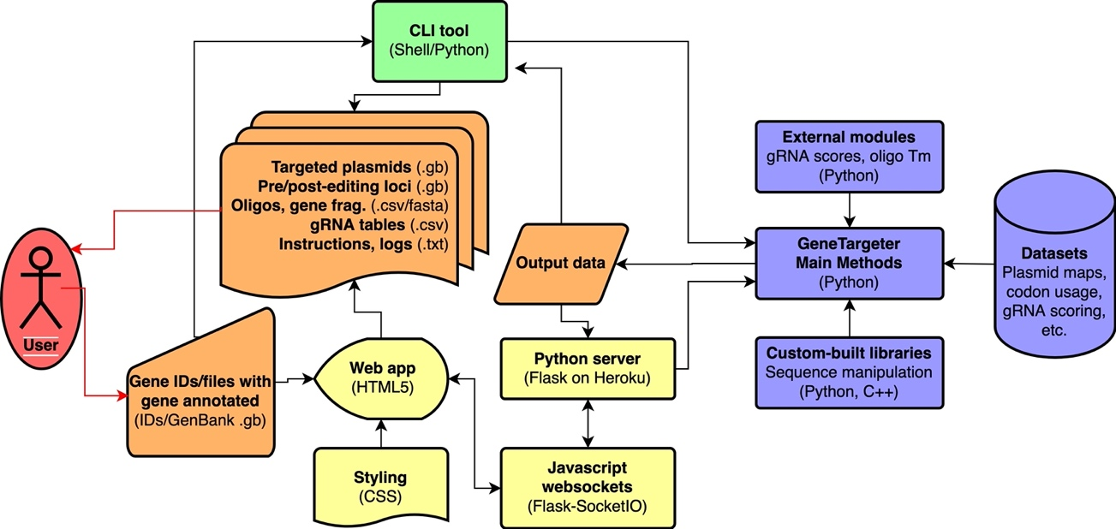

Figure S1 GeneTargeter combines multiple modules to allow flexibility in usage. The user provides GenBank gene files which may be processed through the CLI tool or the Web application, both of which rely on a series of Python modules and databases to produce the output files for the gene(s) provided.

Table S4: GeneTargeter additional optional parameters
Parameter | Default value | Comments
Use manual sgRNA, LHR, and/or RHR annotations | False | Instructs GeneTargeter whether to use manually-selected annotations within the input file for the design process (True/False).
Treat as non-coding | False | Instructs GeneTargeter to search for edits exclusively outside of the gene sequence; if Auto, GeneTargeter evaluates whether gene is non-coding based on absence of stop codon (True/False/Auto).
Plasmid type | pSN054_V5 | Defines which plasmid type to use (’pSN054V5’, ’pSN054’, ’pSN150’, ’pSN150-KO’ for 3’, 5’, and for gene knockouts, respectively; also ’pSN150-Ter’, ’pSN150-KO-Ter’ with modified T7 terminator with no Nhe1 sequence).
Use HA tags | True | Adds or removes a hemagglutinin (HA) tag fusion to the target (True/False).
LHR and RHR length (minimum, preferred, maxi-mum) | 400 bp, 500bp, 750 bp | GeneTargeter will optimize over the range given by the minimum and maximum values if the preferred one possesses unsatisfactory melting temperature.
LHR and RHR start and end optimization range | –20 bp to 20bp | After choosing valid start and end positions, the software searches the given range around each position for the value with the highest melting temperature.
LHR and RHR end analysis length | 40 bp | Length of sequences at the ends (start and finish) of the LHR and RHR taken into account for melting temperature analysis.
LHR and RHR end minimum melting temperature | 55 °C | Minimum melting temperature of sequences at the start and end of the LHR and RHR.
LHR maximum distance from sgRNA | 500 bp | Maximum distance the LHR can end from the most upstream sgRNA. GeneTargeter will use this to restrain its LHR end point search range.
RHR maximum distance from gene | 500 bp | Maximum distance the RHR can start from the end of the gene. GeneTargeter will use this to restrain its RHR start point search range.
Minimum sgRNA GC content | 25% | Minimum GC content a potential sgRNA must have to be considered minimally acceptable.
CRISPR cutting enzyme | Cas9 | Type of CRISPR enzyme being used, determines PAM location as 3’ or 5’, for Cas9 and Cas12a, respectively (only accepts “cas9” or “cpf1”).
CRISPR enzyme PAM sequence | NGG | PAM sequence used by CRISPR enzyme, determines search motif used by GeneTargeter to locate potential sgRNAs.
On-target scoring method | Azimuth | Algorithm used to determine on-target scores for potential sgRNAs (only accepts “azimuth”, “ruleset2”, and “cindel”).
Minimum on-target score | 35% | Minimum on-target score for potential sgRNAs to be considered minimally acceptable.
Off-target scoring method | CFD | Algorithm used to determine off-target scores for potential sgRNAs (only accepts “cfd”, “hsu”, and “hsu unweighted”).
Maximum pairwise off-targetscore | 50% | Maximum off-target score a single hit can have for potential sgRNAs to be considered minimally acceptable.
Minimum total off-target score | 20% | Minimum aggregated off-target score for potential sgRNAs to be considered minimally acceptable.
Gibson homology range length (minimum, preferred, maximum) | 30 bp, 40 bp, 50 bp | GeneTargeter will optimize over the range given by the minimum and maximum values if the preferred one possesses unsatisfactory melting temperature. Each primer will be designed with approximately twice the homologous region size.
Gibson primer minimum melting temperature | 65°C | Minimum melting temperature of Gib-son primers.
Gibson primer maximum melting temperature difference | 5°C | Maximum melting temperature differ-ence of a pair of Gibson primers.
Codon optimization organism | T. gondii | Codon frequency table used for optimization (can be ’P. falciparum 3D7’,’P. vivax’, ’T. gondii’, ’E. coli K12’, ’S. cerevisiae’, ’H. sapiens’, ’R. norvegicus’, ’scramble’).
Use codon sampling instead of CAI maximization | False | GeneTargeter uses a deterministic CAI maximization algorithm [1] for codon optimization by default. To use a probabilistic codon sampling approach, set this argument to True (True/False).
Minimum gene fragment size | 250 bp | Minimum synthesis size of gene fragments.
Extended gene fragments | True | GeneTargeter extends a recoded region to the minimum gene fragment size if this requirement is set to True, otherwise, anneal-extension oligonucleotides or overhangs are used.
Consolidate output files | False | Aggregates all gene outputs into a single file for each output type, containing all gene outputs of that given file type; oligos are sorted by purpose and orientation before gene (True, False).
Prefix | *None* | If not *None*, adds this prefix to all file, oligo, DNA fragment, and Gen-Bank names.
Prefix number | −1 | If prefix is not *None* and a number >−1 is given here, numbers each gene processed consecutively starting at the given value; adds number to prefix on all file, oligo, DNA fragment, and GenBank names (integer)

