The proteasome inhibitor Bortezomib induces tongue, pharynx and salivary gland cancer cells death in vitro and delays tumor growth of salivary gland cancer cells transplanted in mice
Monica Benvenuto ^{1, 2, †}, Sara Ciuffa ^{2, †}, Chiara Focaccetti ^{2, 3, †}, Diego Sbardella ⁴, Sara Fazi ⁵, Grazia Raffaella Tundo ², Giovanni Barillari ², Maria Segni ⁶, Vittorio Manzari ², Andrea Modesti ², Laura Masuelli ⁵, Massimo Coletta ^{2, ‡} and Roberto Bei ^{2, ‡,} *
¹ Saint Camillus International University of Health and Medical Sciences, via di Sant’Alessandro 8, 00131, Rome, Italy; monica.benvenuto@unicamillus.org
² Department of Clinical Sciences and Translational Medicine, University of Rome “Tor Vergata”, via Montpellier 1, 00133, Rome, Italy; sara.ciuffa3@gmail.com (S.C.); chiara.focaccetti@uniroma5.it (C.F.); grazia.tundo@libero.it (G.R.T.); barillar@uniroma2.it (G.B.); manzari@med.uniroma2.it (V.M.); modesti@med.uniroma2.it (A.M.); coletta@med.uniroma2.it (M.C.); bei@med.uniroma2.it (R.B.)
³ Department of Human Science and Promotion of the Quality of Life, San Raffaele University Rome, Via di Val Cannuta 247, 00166, Rome, Italy
⁴ IRCCS-Fondazione G.B. BIETTI, via Livenza, 3, 00189, Rome, Italy; diego.sbardella@fondazionebietti.it
⁵ Department of Experimental Medicine, University of Rome “Sapienza”, viale Regina Elena 324, 00161, Rome, Italy; sara.fazi@uniroma1.it (S.F.); laura.masuelli@uniroma1.it (L.M.)
⁶ Department of Maternal Infantile and Urological Sciences, Sapienza University of Rome, 00161 Rome, Italy. Pediatric Endocrinology Unit, Policlinico Umberto I, Viale Regina Elena 364 -00161- Rome Italy, maria.segni@uniroma1.it
* Correspondence: bei@med.uniroma2.it; Tel.: +39-0672596522
† These authors contributed equally to this work
‡ These last authors contributed equally to this work

SUPPLEMETARY INFORMATIONS

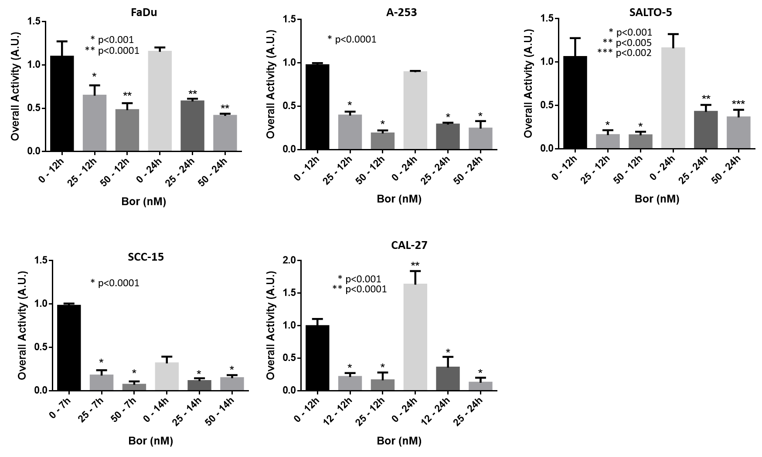
Figure S1: Semi-quantitative analysis of proteasome proteolytic activity.
Proteasome activity of particles shown in Figure 6A, was determined by calculating the overall light intensity of all proteasome assemblies along the lane. A nominal value of 1 was assigned to the intensity of the untreated cell harvested at the earliest time-point; A representative panel of a single experiment is shown. Every assay has been carried out three independent times. Data are presented as mean±SD (n=3). One-way ANOVA followed by Tukey’s post-hoc significance test. The statistical analysis reported refers to the ratio between each Bortezomib-related experimental condition vs untreated cells at the same time-point.

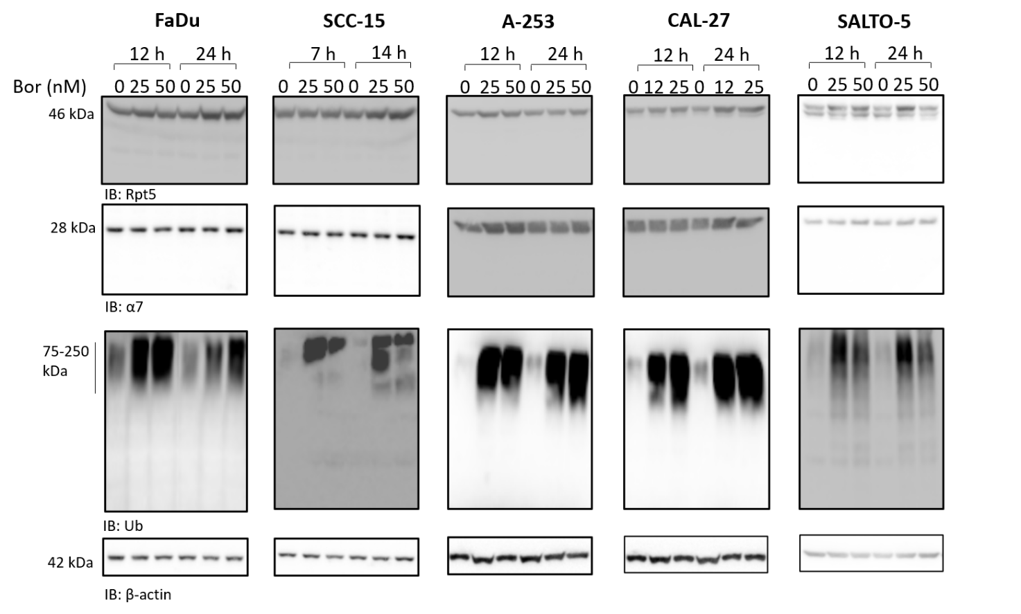

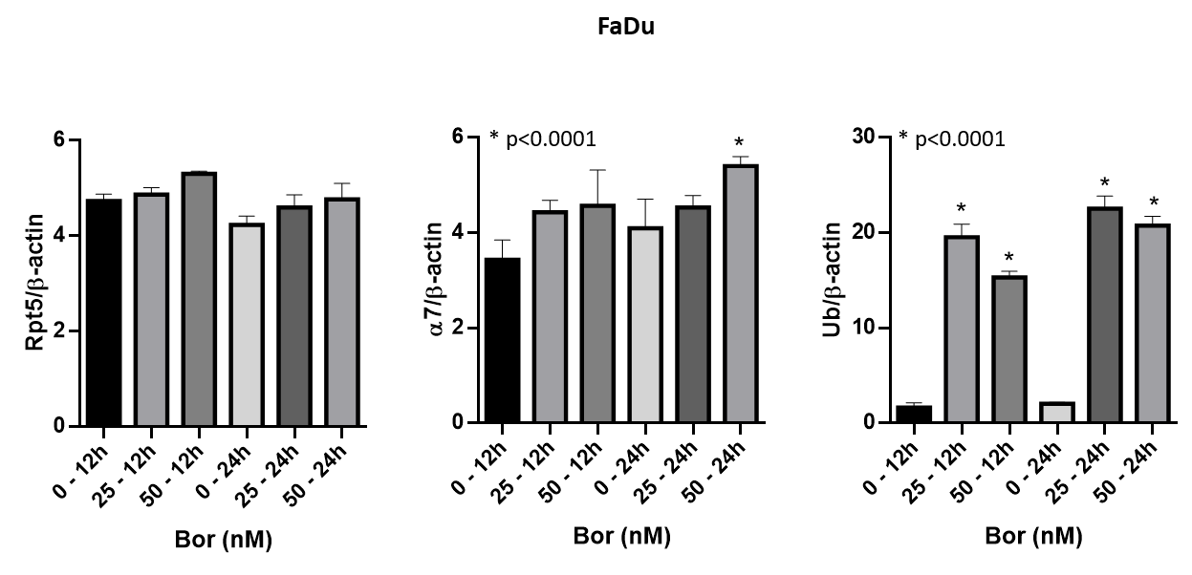

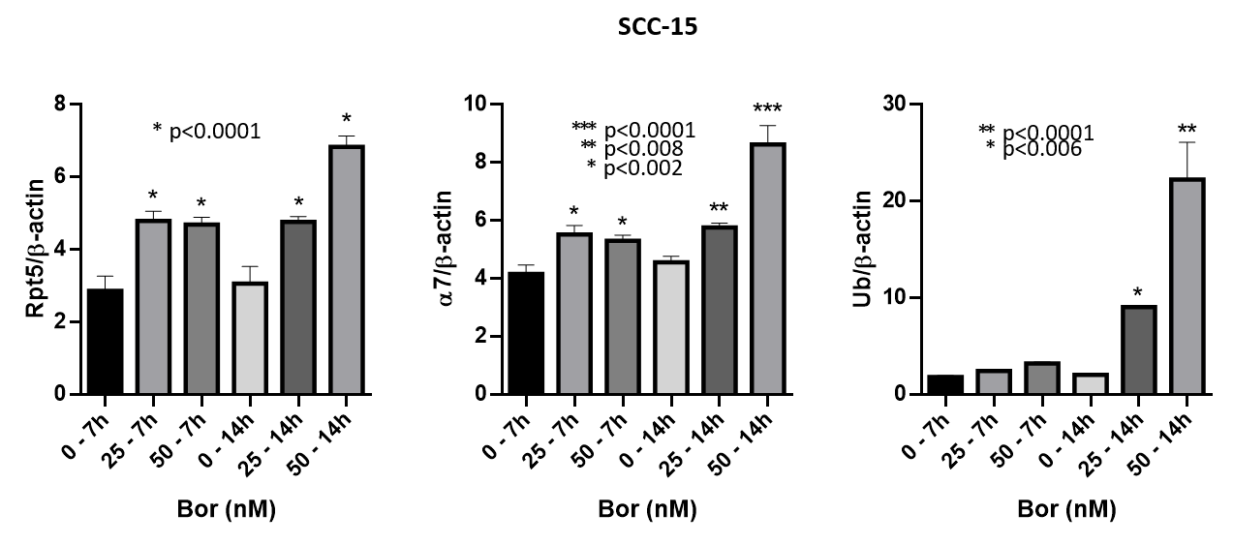
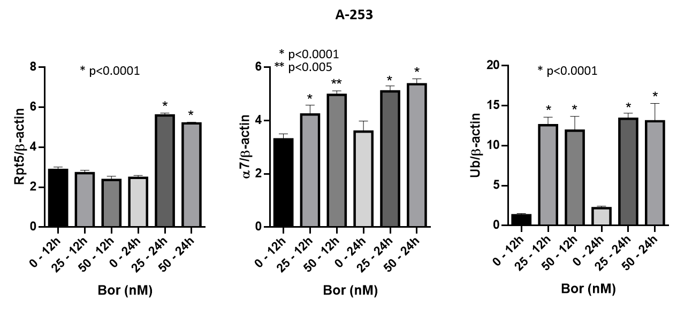
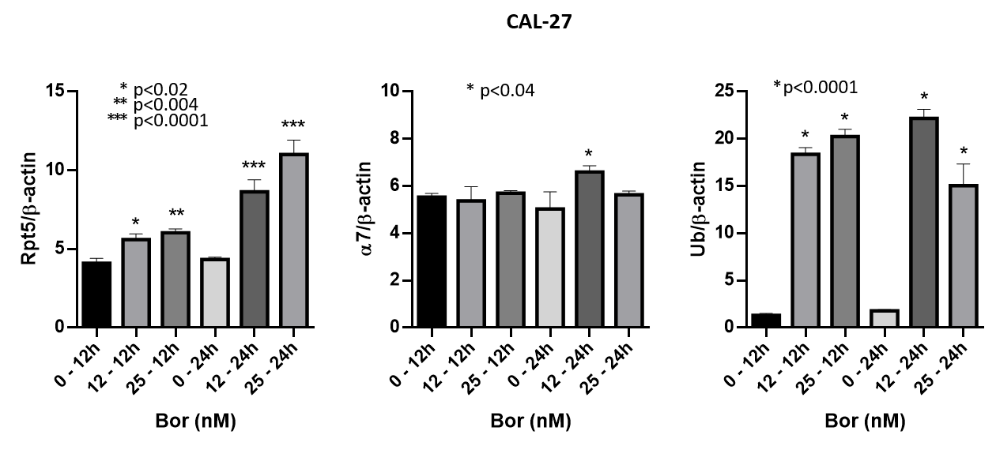

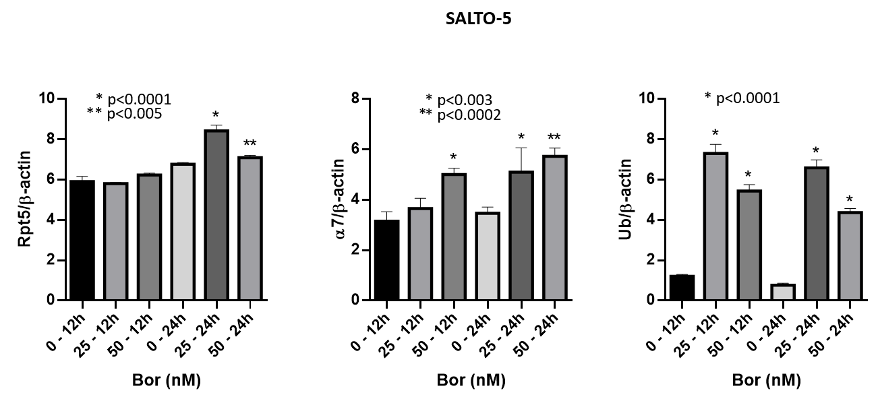

Figure S2: Semiquantitative analysis of selected proteasome subunits and of poly-ubiquitinated proteins.
Cytosolic extracts of cell lines were analysed for free α7, Rpt5 and poly-ubiquitinated proteins by denaturing and reducing Western Blotting. β-actin was used as internal control. A representative panel of a single experiment is shown. Every assay has been carried out three independent times. Densitometric analysis of immunoblotting data are presented as mean±SD (n=3). One-way ANOVA followed by Tukey’s post-hoc significance test. The statistical analysis reported refers to the ratio between each Bortezomib-related experimental condition vs untreated cells at the same time-point. Uncropped western blots are reported in Supplementary Fig. S4.

Figure S3: Uncropped Western blots corresponding to Figures 3, 4, 5. Note that the membranes were cut before probing.

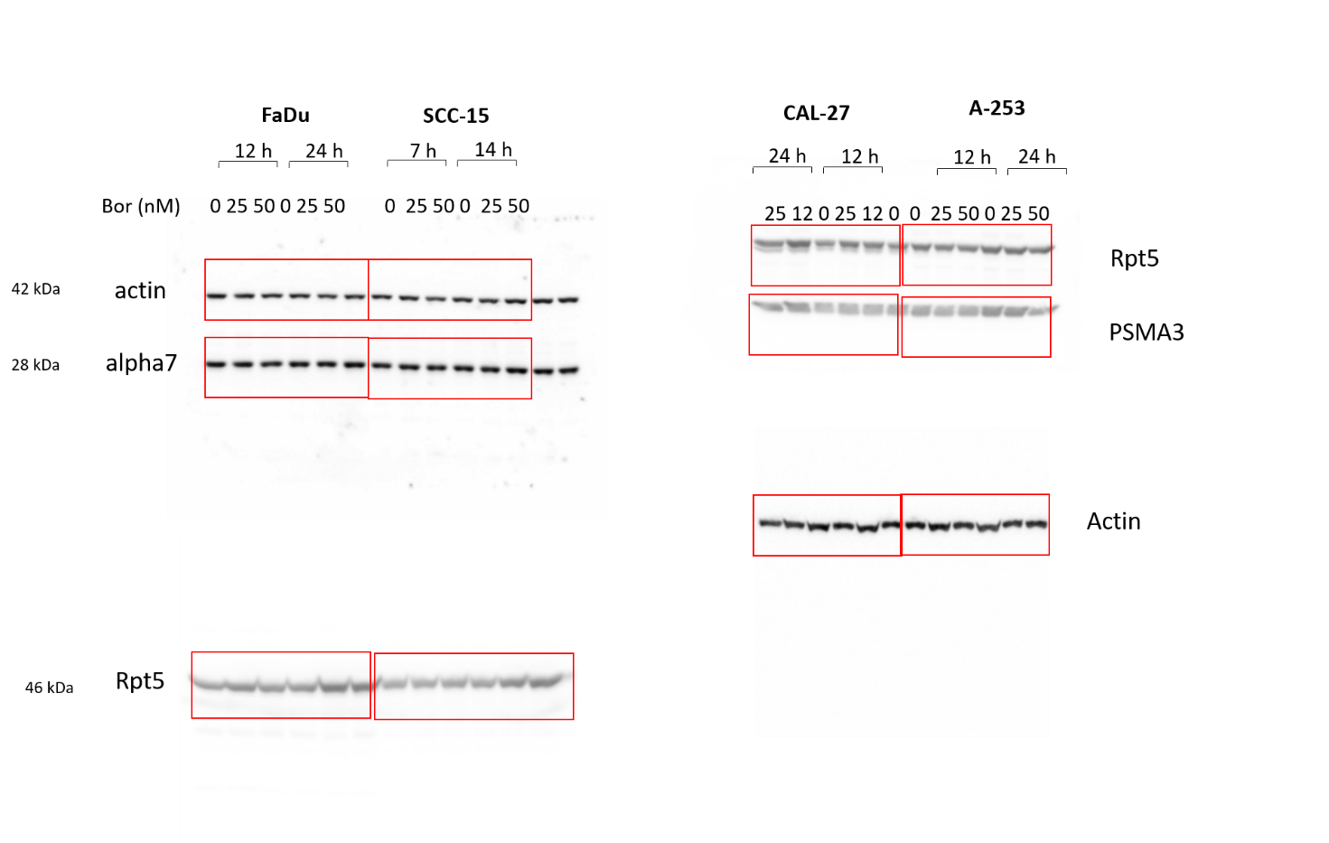
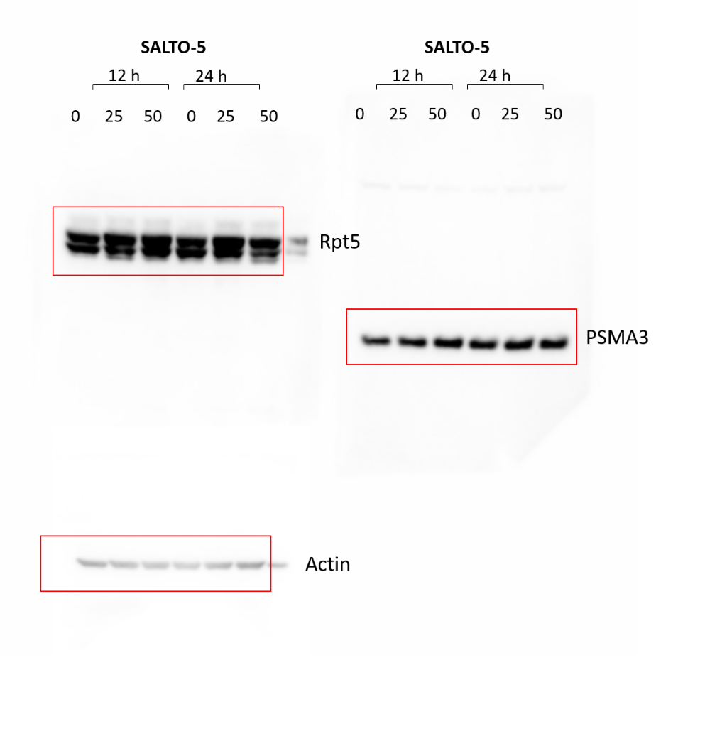
Figure S4: Uncropped Western blots corresponding to proteasome subunits expression in Supplementary Fig. S2.

