Supplementary Information

Photo-induced Afterglow of Carbon Dots for Dynamic Patterning

Yanfeng Liu†, Xin Huang†, Zuoji Niu†, Dongni Wang, Huilin Gou, Qiaobo Liao, Kai Xi*, Zhongfu An*, Xudong Jia*

†: These three authors contributed equally to the work.

Y. Liu, Dr. X. Huang, D. Wang, H. Gou, Q. Liao, Prof. K. Xi, Prof. X. Jia
School of Chemistry and Chemical Engineering
Nanjing University, 163 Xianlin Road, Nanjing, 210023, China
E-mail: xikai@nju.edu.cn; jiaxd@nju.edu.cn

Z.Niu, Prof. Z. An*
Key Laboratory of Flexible Electronics (KLOFE) & Institute of Advanced Materials (IAM)
Nanjing Tech University (NanjingTech), 30 South Puzhu Road, Nanjing, 211816, China
E-mail: iamzfan@njtech.edu.cn

Y. Liu, Prof. X. Jia*
State Key Laboratory of Coordination Chemistry, Nanjing National Laboratory of Microstructures
Nanjing University, 163 Xianlin Road, Nanjing, 210023, China
E-mail: jiaxd@nju.edu.cn

Materials:
Reagent grade p-benzoquinone (PBQ, CP) and ethylenediamine (EDA, AR) were purchased from Sinopharm Chemical Reagent Co., Ltd. (Shanghai, China). Methanol (AR), ethanol (AR) and dichloromethane (DCM, AR) were purchased from General Reagent, Shanghai Titan Scientific Co.,Ltd (Shanghai, China). Polyvinyl pyrrolidones (PVP, average molecular weight: 8 kD/ 58 kD/ 360 kD/ 1300 kD) were purchased from Energy Chemical-Saan Chemical Technology Co., Ltd. (Shanghai, China). Deionized water was used throughout the study.

Characterizations:
The transmission electron microscopy (TEM) images were acquired from a JEM 2100 instrument (JEOL) (acceleration voltage: 200 kV); the UV-vis absorption spectra were obtained with a UV-3600 spectrophotometer (Shimadzu, Japan); the Fourier transform infrared (FT-IR) absorption spectra were obtained with a NICOLET iS10 FT-IR spectrometer (Thermo ScientificTM, America); the X-ray photoelectron spectroscopy (XPS) data, including binding energy survey and high resolution spectra of C1s, N1s and O1s were acquired on a PHI 5000 Versa Probe (UlVAC-PHI, Japan). The photoluminescence (PL) emission spectra, emission mapping and the photoluminescence quantum yield (PLQY) of CDs in ethanol solution were measured with FluoroLog FL3 spectrophotometer (HORIBA, Japan). The PL lifetime, room temperature phosphorescence (RTP) lifetime and RTP emission spectra were measured on an FLS980 spectrophotometer (Edinburgh Instrument, UK) equipped with a microsecond flash-lamp (μF900); emission spectra of all delayed emission were measured with following configuration unless otherwise specified: Lamp frequency: 50 Hz, initial delay: 5 ms, sampling window: 15 ms.

Morphology characterization of the CDs
Powdery CDs were firstly dissolved in deionized water at a concentration of 20 μg/mL. To prepare the sample for TEM imaging, the solution was drop-casted onto a super thin carbon-coated copper mesh TEM grid (mesh number: 200, purchased from Zhongjingkeyi Technology Co., Ltd., Nanjing, China.) set on a piece of filter paper, and allowed the excess liquid to run off. The TEM grid was then allowed to dry under room temperature overnight (298 K, 25% humidity) before characterization.
TEM images of the CDs were acquired at 100,000 times (Supplementary Fig. 1a) and 800,000 times (Supplementary Fig. 1b) magnificent, respectively, the latter one revealed a partially crystalline morphology of the dots. An average size of 6.4 nm for the CDs was calculated after counting 97 particles in a frame (Supplementary Fig. 1c). The fast Fourier transform (FFT) pattern in Supplementary Fig. 1d based on Supplementary Fig. 1b and its corresponding inverse-FFT pattern showed a regular 0.24 nm stripe interval, similar to other CDs previously reported ^{s1}.

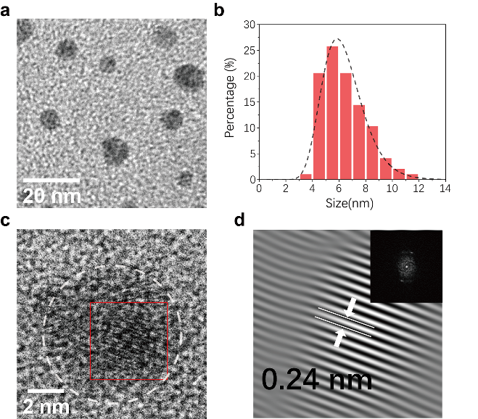
Supplementary Fig. 1 The nanoscale morphology of CDs revealed by TEM. a TEM image of CDs under 100,000x magnificent. b Size distribution of CDs calculated from 97 individual dots. c TEM image of an individual PCD under 800,000x magnificent, lattice fringes indicated that the dots were partially crystalline. d The Fourier-filtered image of the selected red square area. Inset: Fast Fourier Transform (FFT) from the red square labeled in c. The average stripe interval was 0.24 nm, corresponding to the [1 0 0] lattice plane of graphitic carbon.

Structural characterization of the CDs
Two molecular precursors, namely the PBQ and EDA, were used. These two precursors were highly reactive, and capable of reacting through Michael addition pathway under heating conditions ^{s2}. Due to the high degree of functionality of both precursors (4~6 for PBQ and 2 for EDA), inter-locked crosslinking nano-structure subsequently formed through initial linkage and following condensation, which further carbonized under into the CDs (Supplementary Fig. 2a).
The Fourier transform infrared (FT-IR) absorbance spectrum of CDs was measured using KBr pellet method (Supplementary Fig. 2b). The detailed absorbance peak wavelengths and their assignments were tabulated as Supplementary Table 1. Signals originated from the amine structure, hydroxyl groups, and C=C/C=O/C=N double bonds were clearly observed.
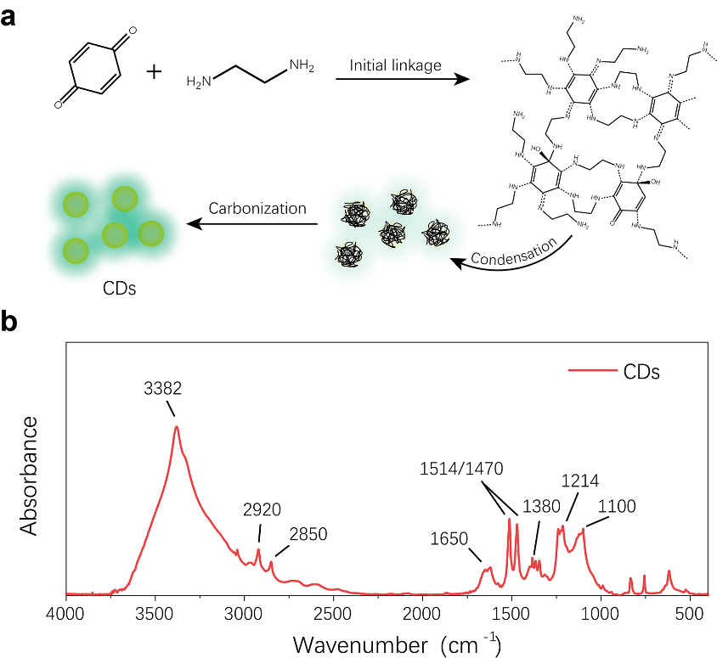
Supplementary Fig. 2 Structural analysis of the CDs. a Schematic illustration for the formation process of CDs. b Fourier transformed infrared (FT-IR) absorbance spectrum of CDs.

Supplementary Table 1 The peak assignments in the FT-IR absorbance of CDs.
Wavenumber (cm⁻¹) | Assignment | Type
3382 | Amine/Hydroxyl | N-H stretch/O-H stretch
2920 | Alkyl | C-H stretch
2850 | Alkyl | C-H stretch
1650 | Double bonds | C=C /C=O/C=N stretch (Overlapped)
1514 | Alkenyl | C=C stretch
1470 | Alkyl | C-H bend
1380 | Amine | C-N stretch (C=C-N)
1214 | Hydroxyl | C-O stretch
1100 | Amine | C-N stretch (C-C-N)

Furthermore, the X-ray photoelectron spectra (XPS) of the CDs were also acquired. As showed in Supplementary Fig. 3a, three peaks occurred in the XPS survey, namely the C1s (285 eV), the N1s (400 eV) and the O1s (532 eV). The element contents (At%) of C, N and O were 73.0%, 13.5% and 13.5%, respectively. (Note that the relative contents of C and O measured were higher than actual value due to inevitable environmental contamination). Detailed components of C1s, N1s and O1s were depicted in Supplementary Fig. 3b-d, consistent with the FT-IR data.

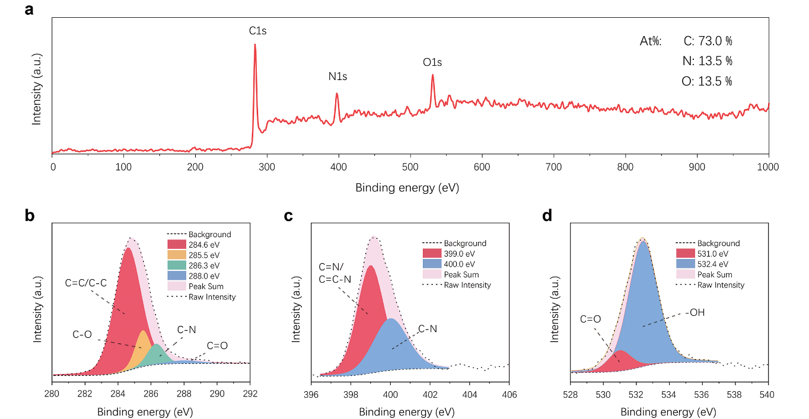
Supplementary Fig. 3. The X-ray photoelectron spectra (XPS) data of CDs. a The XPS Survey. b The C1s binding energy. c The N1s binding energy. d The O1s binding energy.

Optical properties of CDs in solution
The powdery CDs was dissolved in ethanol at a concentration of 20 μg/mL, and the optical features of CDs (absorption, emission, PL lifetime) in solution were measured and depicted as Supplementary Fig. 4:
In terms of UV-Vis absorbance, CDs showed intense absorption at 230 and 280 nm, corresponding to the π-π* transition and n-π* transition, respectively. In addition, a broad excitonic absorption peak at 416 nm occurred at the red end of the absorbance, which was related to the PL emission of CDs (Supplementary Fig. 4a). The ethanol solution pf CDs emitted bright cyan luminescence centered at 480 nm upon the irradiation of 365 nm UV light (photograph inserted in Supplementary Fig. 4a). The PLQY of this emission was determined as 24% when measured with an integrating sphere accessory. Emission mapping of the CDs under different excitation wavelengths was also measured and depicted as a contour graph in Supplementary Fig. 4b, which clearly demonstrated an excitation-independent emission center with maximum excitation efficiency at ~425 nm. Meanwhile, excitation at 400 nm gave 79% of the maximum emission intensity. Considering the facile availability of light source, we adopted commercial hand-held led lamps and flashlight with 400 nm emission (power intensity: 10 mW/cm²) as irradiation sources throughout this work, and all relative PL properties of the composites were measured under 400 nm excitation.
The PL lifetime of CDs in the solution phase was also investigated. As showed in Supplementary Fig. 4c, the CDs featured mono-exponential decay with an average lifetime of 3.3 ns.

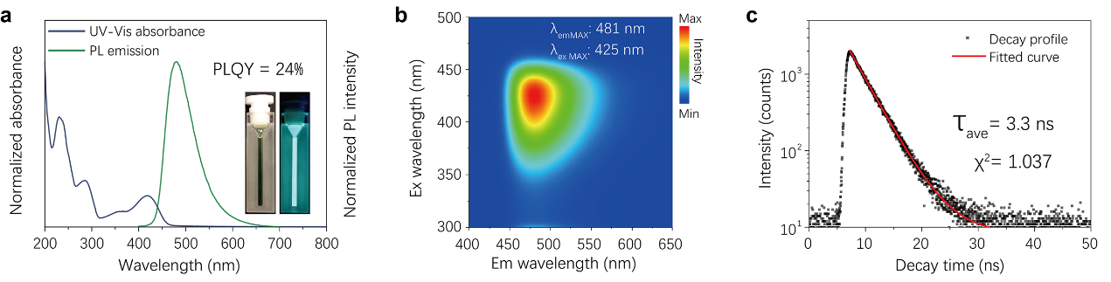
Supplementary Fig. 4 Absorbance and PL features of CDs in ethanol solution (20 μg/mL). a Normalized UV-Vis absorbance and PL emission spectra of CDs. b Emission mapping of CDs with excitation range from 300 to 500 nm and emission range from 400 to 650 nm. Maximal PL intensity occurred at 425 nm excitation and 481 nm emission. CDs can also be efficiently excited with 400 nm irradiation, where 79.4% of maximal PL intensity maintained. c PL lifetime profile of CDs (Excitation wavelength: 400 nm, emission wavelength: 481 nm).

Supplementary data for the RTP of CDs/PVP composite
The RTP lifetime of CDs/PVP composite was measured with a spectrophotometer equipped with a microsecond flash-lamp (uF900). Flash frequency of the lamp was set as 0.1 Hz, λ_{ex} and λ_{em} were set as 400 nm and 580 nm, respectively. Resultant decay profile was fitted with the following equation:

$I\left(t\right)=A_{1}e^{-t/τ1}+A_{2}e^{-t/τ2}+A_{3}e^{-t/τ3}$ (1)

And the average lifetime was calculated with the following equation:

$τ_{ave}= \frac{A_{1}{τ_{1}}^{2}+ A_{2}{τ_{2}}^{2}+A_{3}{τ_{3}}^{2}}{A_{1}τ_{1}+ A_{2}τ_{2}+A_{3}τ_{3}}$ (2)

The fitting results were tableted as followed. (χ² = 1.176)

Supplementary Table 2 Supplementary RTP lifetime data of CDs/PVP composite
Lifetime component | Lifetime value (ms) | A | Relative portion/B
τ₁ | 66.84 | 583.85 | 2.69%
τ₂ | 327.42 | 990.52 | 22.32%
τ₃ | 676.99 | 1610.03 | 74.99%
τ_{ave} | 582.62 | / | /

Reversibility test
To evaluate the reversibility of the afterglow on/off switch, herein, the RTP intensity of the composite film was measured during multiple on-off switches. For afterglow activation (switching on), the film was irradiated with a 400 nm light (10 mW/cm²) for 30 s; for afterglow deactivation or erasing (switching off), the film was heated at 393 K on a flat heater for 10 min. Following are the intensity, lifetime and spectral data of the film within 40 on-off cycles.
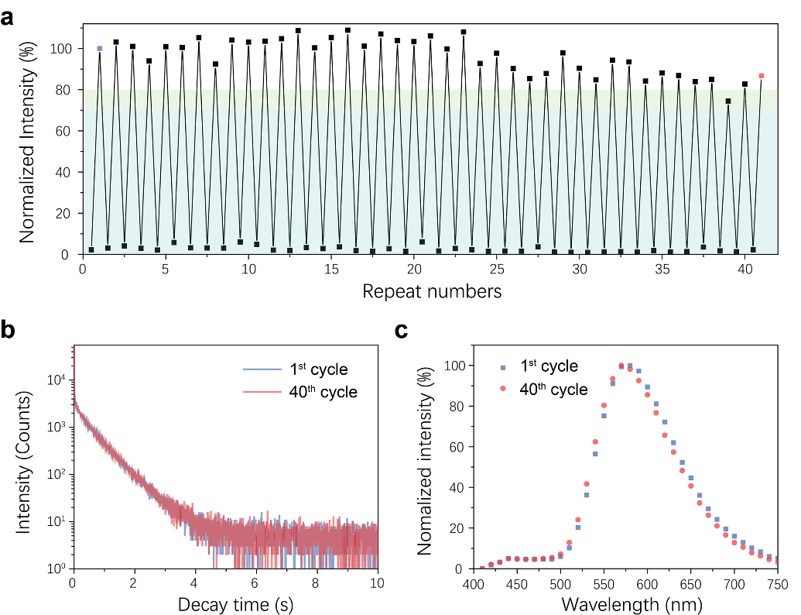
Supplementary Fig. 5 Reversibility test of the photo-induced long afterglow in CDs/PVP film. a The RTP intensity measured after each photo-activation and thermal-erasing was plotted against repeat numbers. No severe RTP intensity loss occurred within the first 40 cycles. More specifically, the lowest activated RTP intensity (cycle 39) remained over 70% intensity of the first cycle. Apart from that, all activated RTP intensity exceeded 80% intensity of the first cycle. b The RTP decay profile of the film at 1st and 40th cycle, respectively. No significant variation in decay properties was observed. c RTP emission spectra of the film measured at 1st and 40th cycle (RTP-on). No significant variation in emission properties were observed.

Supplementary data for the RTP emerging/disappearing dynamics
To achieve different irradiation density, an optical attenuator with different transmittance (10%, 25%, 50%, 75%) was applied. The original power density of the irradiation light in the PL spectrometer (FLS 980) was measured with a PM100D Digital Handheld Optical Power and Energy Meter Console (Thorlab, America) and adjusted to 0.8 mW/cm² by tuning excitation silt. As a result, different RTP turn-on dynamics were acquired under variable power density (Fig. 2d in manuscript).
To establish a quantitative relationship between the irradiation intensity and the RTP turn-on speed, the t_{1/2} and power density was plotted. Since the time required to achieve maximum intensity was hard to determine because of the decreasing slope, herein, t_{1/2} (time required to achieve half maximum intensity) was used as a parameter to indicate the turn-on speed instead.
The scale in this plotted diagram was set up in a logarithm manner. As depicted in Supplementary Fig. 6, the fitted slope was -0.97 (~ -1), which indicated that the emerging speed of the afterglow feature and the irradiation power density had an inversely proportional relationship.
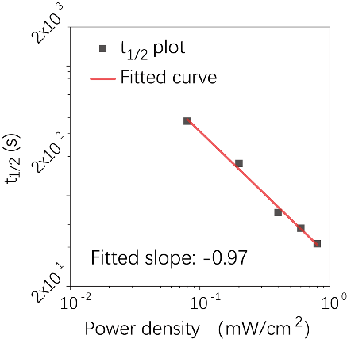
Supplementary Fig. 6 t_{1/2} (time required to achieve 50% RTP intensity) plotted against irradiation power density.

Since the disappearing of the long afterglow feature was realized by oxygen permeation, it is reasonable to speculate that by interfering the oxygen permeating process, the disappearing speed of its afterglow feature can be adjusted.
Herein, PVP with four different molecular weights were used to prepare PCD/PVP composites, the procedure was the same as described above, except for the different molecular weights of PVP. (Note that PVP with 8 kD and 58 kD molecular weight formed very fragile films, which required excess caution in preparation.) It had been demonstrated before that the decrement of molecular weight allowed higher oxygen permeation ^{s3}, therefore should result in faster disappearing of the afterglow feature. As depicted in Supplementary Fig. 7a, PVP with a molecular weight of 8 kD shows faster RTP disappearing rate (within 30 min at 298 K), and higher molecular weight resulted in prolonged RTP retention time, ranging from 60 to 120 min at 298 K.
In this work, PET layers were applied on the composite for protection, which can also be utilized to adjust the oxygen permeability. By directly varying the thickness of the PET protection layer, the RTP retention time could also be tuned: as Supplementary Fig. 7b demonstrated, by increasing the thickness of the PET layer, the RTP retention time clearly increased: the retention time of long afterglow at room temperature increased from 1.5 h to 5 h, with the thickness of PET layers increasing from 50 to 150 μm.

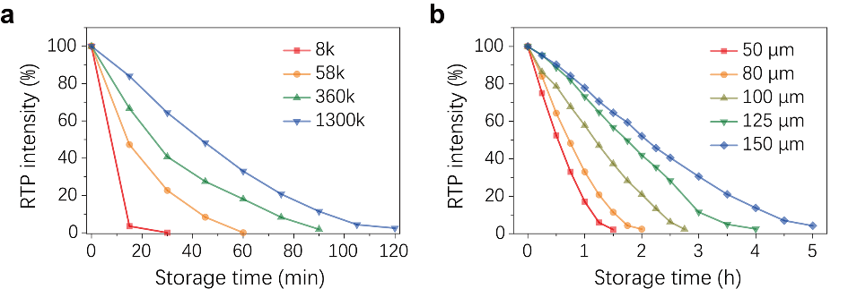

Supplementary Fig. 7 Tuning of the RTP memory retention. a Normalized RTP intensity of CDs/PVP with different molecular weight of PVP plotted against storage time after sufficient irradiation. b Normalized RTP intensity of CDs/PVP with different thickness of PET package layer plotted against storage time after sufficient irradiation.

Supplementary data for CDs/PAM composite
The CDs/PAM composite was prepared with the same technic used to prepare the CDs/PVP composite. 1 g of reagent grade polyacrylamide (average molecular weight: 100 kD, purchased from Acros Organics) was dissolved in 19 mL of deionized water and mixed with 1 mL of ethanol solution containing 5 mg CDs. The resultant solution was then drop-casted to fabricate an 80-μm-thick film using the same procedure for the production of CDs/PVP film.
The resultant CDs/PAM composite film emitted intense orange RTP upon each irradiation. Photograph of the afterglow emitted from CDs/PAM film was provided in Supplementary Fig. 8a. The PL steady-state emission of CDs/PAM composite peaked at 487 nm, and its delayed emission spectrum showed a maximum λ_{em} at 606 nm corresponding to RTP. Both PL and RTP emission of the CDs/PAM composite slightly red-shifted compared to that of CDs/PVP composite (Supplementary Fig. 8b). The reason for this bathochromic shift might be explained by the increment of polarity from PVP to PAM. Measured and analyzed under the same conditions described for Fig. 2b and Supplementary Table 2, the average lifetime of this RTP emission was calculated to be 413 ms (χ² = 1.154) (Supplementary Fig. 8c, Supplementary Table 3), slightly shorter than that of the CDs/PVP composite.
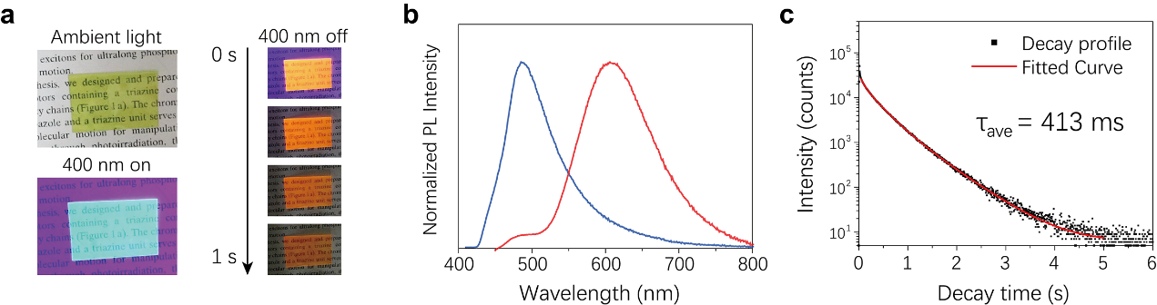
Supplementary Fig. 8 The RTP properties of CDs/PAM composite. a Photographs of the CDs/PAM composite film under ambient light, 400 nm irradiation and after 400 nm light switched off. b The steady-state PL emission (blue line) and RTP emission spectrum (red line) of CDs/PAM composite film under 400 nm excitation. c The RTP lifetime of CDs/PAM measured at 606 nm emission under 400 nm excitation.

Supplementary Table 3 Supplementary RTP lifetime data of CDs/PAM composite
Lifetime component | Lifetime value [ms] | A | Relative portion/B
τ₁ | 70.65 | 6271.83 | 5.40%
τ₂ | 291.75 | 14100.74 | 50.16%
τ₃ | 592.4 | 6151.61 | 44.44%
τ_{ave} | 413.42 |  | /

Supplementary data for patterned CDs/PVP composite films

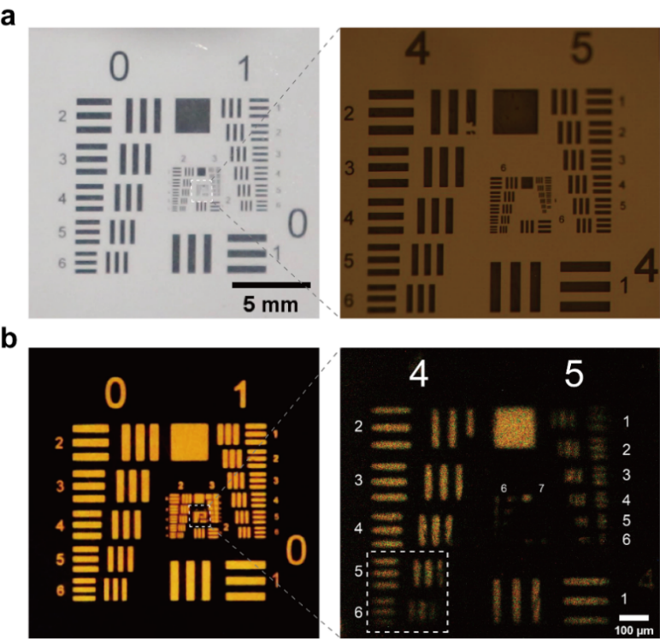

Supplementary Fig. 9 The miniature RTP pattern created on CDs/PVP composite film using a negative USAF-1951 test target mask. a The photographs of the standard test target under direct observation (left) and optical microscopy (right). b The miniature RTP pattern created from a by masking and lithography under direct observation (left) and optical microscopy (right). The boundary between lines started to blur in group 4, between element 5 (line width: 19.69 μm) and 6 (line width: 17.54 μm), corresponding to a limiting resolution of 1289 ~ 1451 dpi. The lines in group 5 were barely legible but the existence of all six elements was still recognizable.

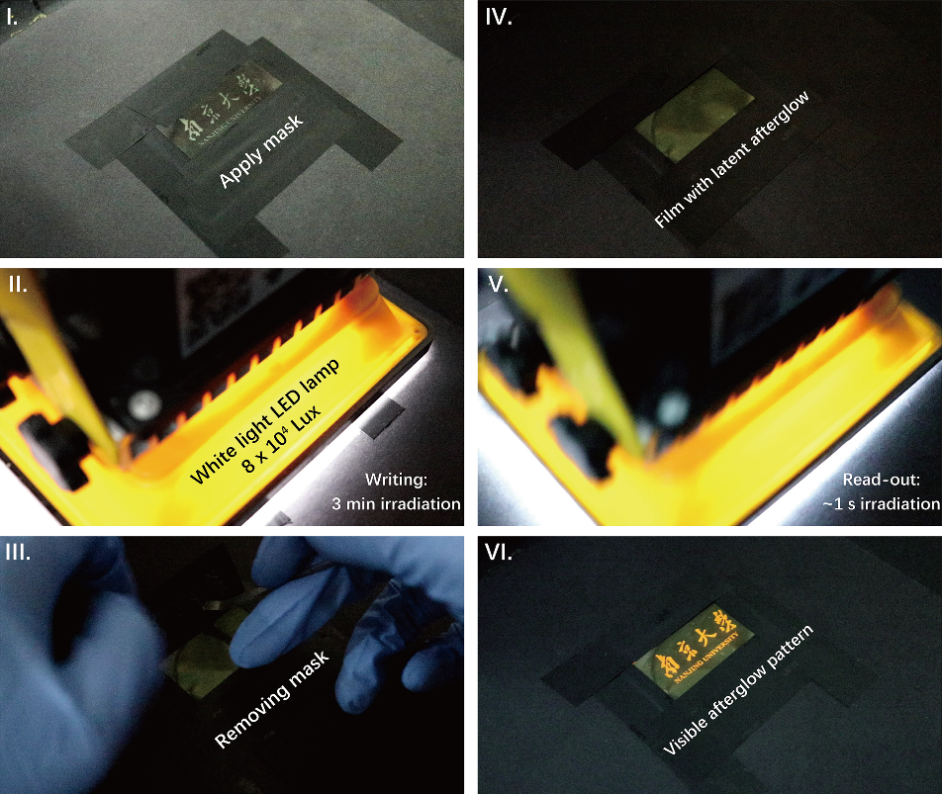
Supplementary Fig. 10 The optical printing of the long afterglow pattern with a white light source. (I). To begin with, a mask with a hollow pattern was applied. (II). For optical printing with white light, a commercial white light LED lamp was applied to irradiate the film through the mask for 3 min. (III). Afterward, the mask was removed to expose the whole film. (IV). The film with a latent afterglow pattern was acquired, no visible pattern could be observed under ambient light. (V). To visualize the afterglow pattern, the film was irradiated for ~ 1 s with the LED lamp. (VI). Visible afterglow pattern appeared after shortly irradiated. Multiple read-outs with the same operation was possible.

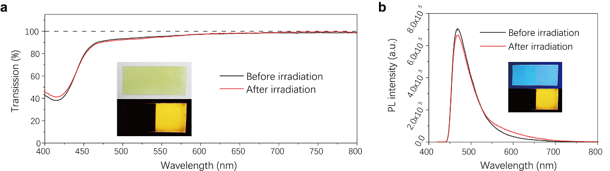
Supplementary Fig. 11 The transmittance and steady-state emission features of CDs/PVP composite film before and after evoking photo-induced afterglow. a Visible light (400~800 nm) transmittance of the film before and after irradiation. (Inserted: CDs/PVP film half irradiated on the right side. Top: under ambient light; bottom: RTP emission.) b PL emission of the film before and after irradiation. (Inserted: CDs/PVP film half irradiated on the right side. Top: under 400 nm irradiation; bottom: RTP emission.)

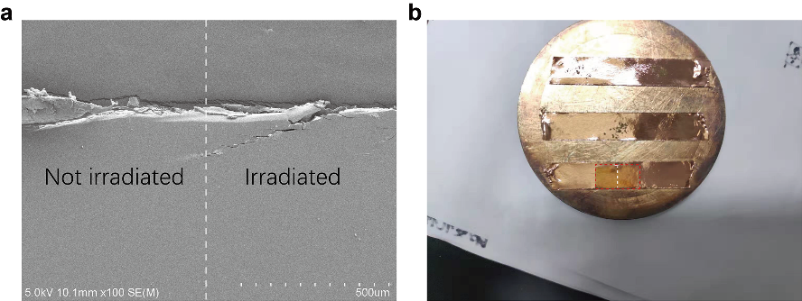
Supplementary Fig. 12 The morphology of CDs/PVP composite film before and after irradiation. a The SEM image of CDs/PVP composite film with (left) and without (right) sufficient irradiation (PET layer peeled off). b Photograph of the CDs/PVP composite film half irradiated on the right side.

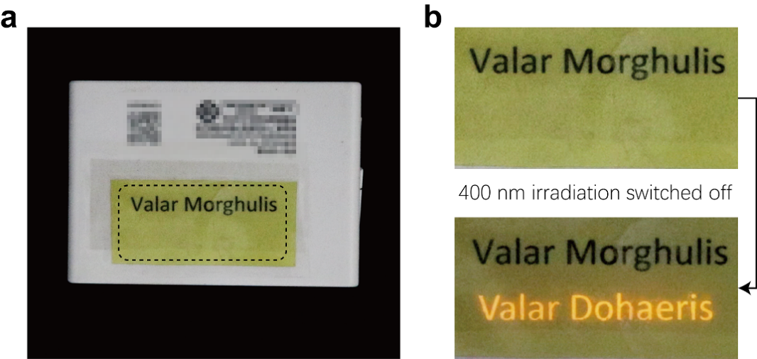

Supplementary Fig. 13 Photograph of CDs/PVP tags for text information encryption. a Photograph of CDs/PVP tag with hidden text information attached to an object. The text printed with toner was clearly observable through the transparent film. Meanwhile, the optically-printed information remained invisible. b Photographs of the selected region (labeled with the dotted line in a) enlarged. After shortly irradiated with 400 nm lamp and switched off, the optically-printed information became observable in delayed emission.

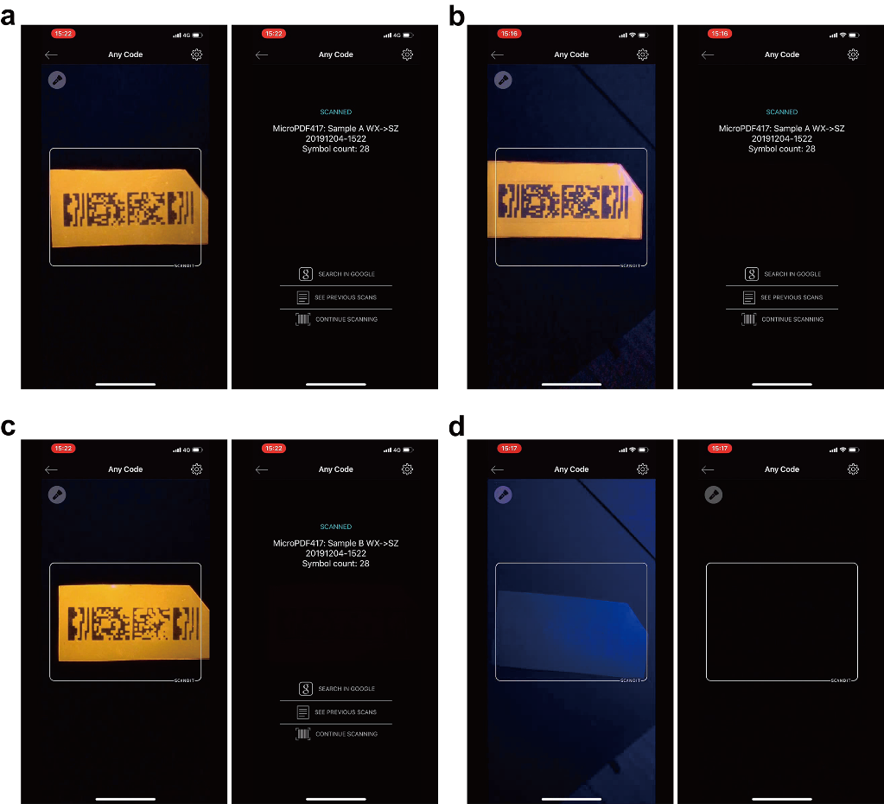

Supplementary Fig. 14 The screenshot of a smartphone while scanning the editable TTI tags of sample A and B upon departure and arrival. (In this work, an iphone X cellphone installed with an APP named scandit was used as the barcode reading device.) a Scanning sample A upon departure. b Scanning sample A upon arrival. c Scanning sample B upon departure. d Scanning sample B upon arrival.

References
s1. Feng, T. et al. Supramolecular Cross-Link-Regulated Emission and Related Applications in Polymer Carbon Dots. ACS Appl. Mater. Interfaces 10, 12262–12277 (2018).
s2. Ahmad, M. U., Saha, K., Mahmuda, T. & Yasmine, M. Reactions of 1,4-benzoquinone with aliphatic diamines. Indian J. Chem. B Org. Med. Chem. 38, 843–846 (1999).
s3. Minelli, M. et al. Oxygen permeability of novel organic–inorganic coatings: I. Effects of organic–inorganic ratio and molecular weight of the organic component. Eur. Polym. J. 44, 2581–2588 (2008).

