**Additional File 5**

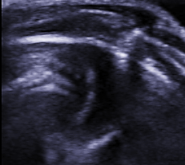

LV

RV

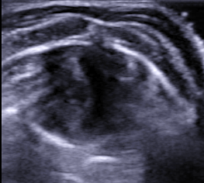

LV

RV

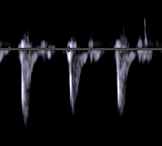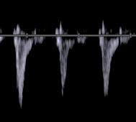

INITIAL FINAL

NORMO FAST

A

B

C

D

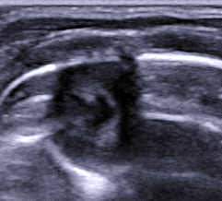

LV

RV

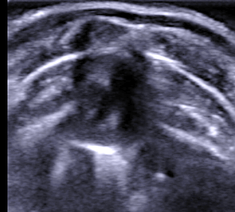

LV

RV

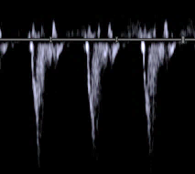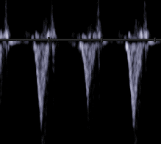

I

J

K

L

INITIAL FINAL

NORMO SLOW

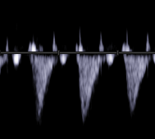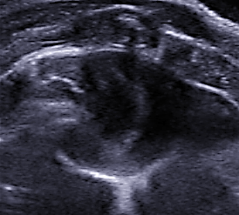

LV

RV

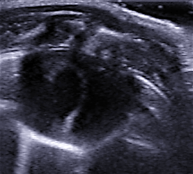

LV

RV

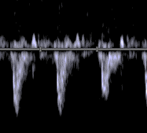

E

F

HIGH FAST

G

H

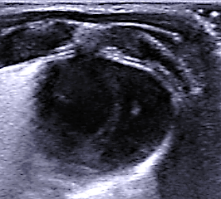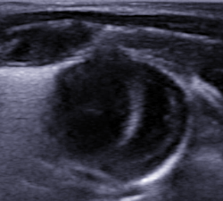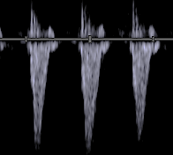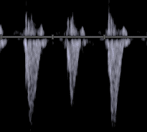

LV

RV

LV

RV

HIGH SLOW

M

N

O

P

**Fig. S2.** A, B, E, F, I, J, M and N. Short-axis view of the left and right ventricles (LV, RV). C, D, G, H, K, L, O and P. Pulmonary Doppler. The NORMO-FAST and HIGH-FAST groups exhibit a significant increase of the RV at FINAL. Pulmonary Doppler shows a short acceleration time that is remained at FINAL. The NORMO-SLOW group shows slight increases in the LV and RV as well as in acceleration time at FINAL. Unlike the NORMO-SLOW group, the HIGH-SLOW group exhibited an increase in LV at FINAL, which was accompanied by an increase in pulmonary flow.