Additional File 4
Table S4 – Semiquantitative analysis of lung electron microscopy
 | FLUIDS | PEEP
Interstitial edema | NORMO | FAST | 2 (2 – 2)*
 | HIGH |  | 4 (3 – 4)
 | NORMO | SLOW | 1 (1 – 1)#
 | HIGH |  | 3 (3 – 4)
Basement membrane injury | NORMO | FAST | 3 (3 – 4)
 | HIGH |  | 3 (3 – 4)
 | NORMO | SLOW | 1 (1 – 2)#
 | HIGH |  | 2 (1 – 2)*
Extracellular matrix  damage | NORMO | FAST | 2 (2 – 3)
 | HIGH |  | 3 (3 – 4)
 | NORMO | SLOW | 1 (1 – 2)#
 | HIGH |  | 1 (1 – 2)*
Type II epithelial cell damage | NORMO | FAST | 3 (3 – 4)
 | HIGH |  | 3 (2 – 3)
 | NORMO | SLOW | 1 (1 – 2)#
 | HIGH |  | 1 (1 – 2)*
Endothelial cell damage | NORMO | FAST | 3 (3 – 4)
 | HIGH |  | 3 (3 – 3)
 | NORMO | SLOW | 1 (1 – 2)#
 | HIGH |  | 2 (2 – 2)*

Pathologic findings were graded on a five-point, semiquantitative severity-based scoring system: 0=normal lung parenchyma, 1=changes in 1 to 25%, 2=26 to 50%, 3=51 to 75%, and 4=76 to 100% of examined tissue. Values are median (interquartile range) of 7 animals per group. NORMO and HIGH: administration of Ringer lactate at 10 mL/kg/h and 30 mL/kg/h, respectively. FAST: abrupt PEEP decrease from 9 to 3 cmH₂O. SLOW: gradual PEEP decrease (0.2 cmH₂O/min) from 9 to 3 cmH₂O. *Significantly different from HIGH-FAST (p<0.0125). #Significantly different from NORMO-FAST (p<0.0125).

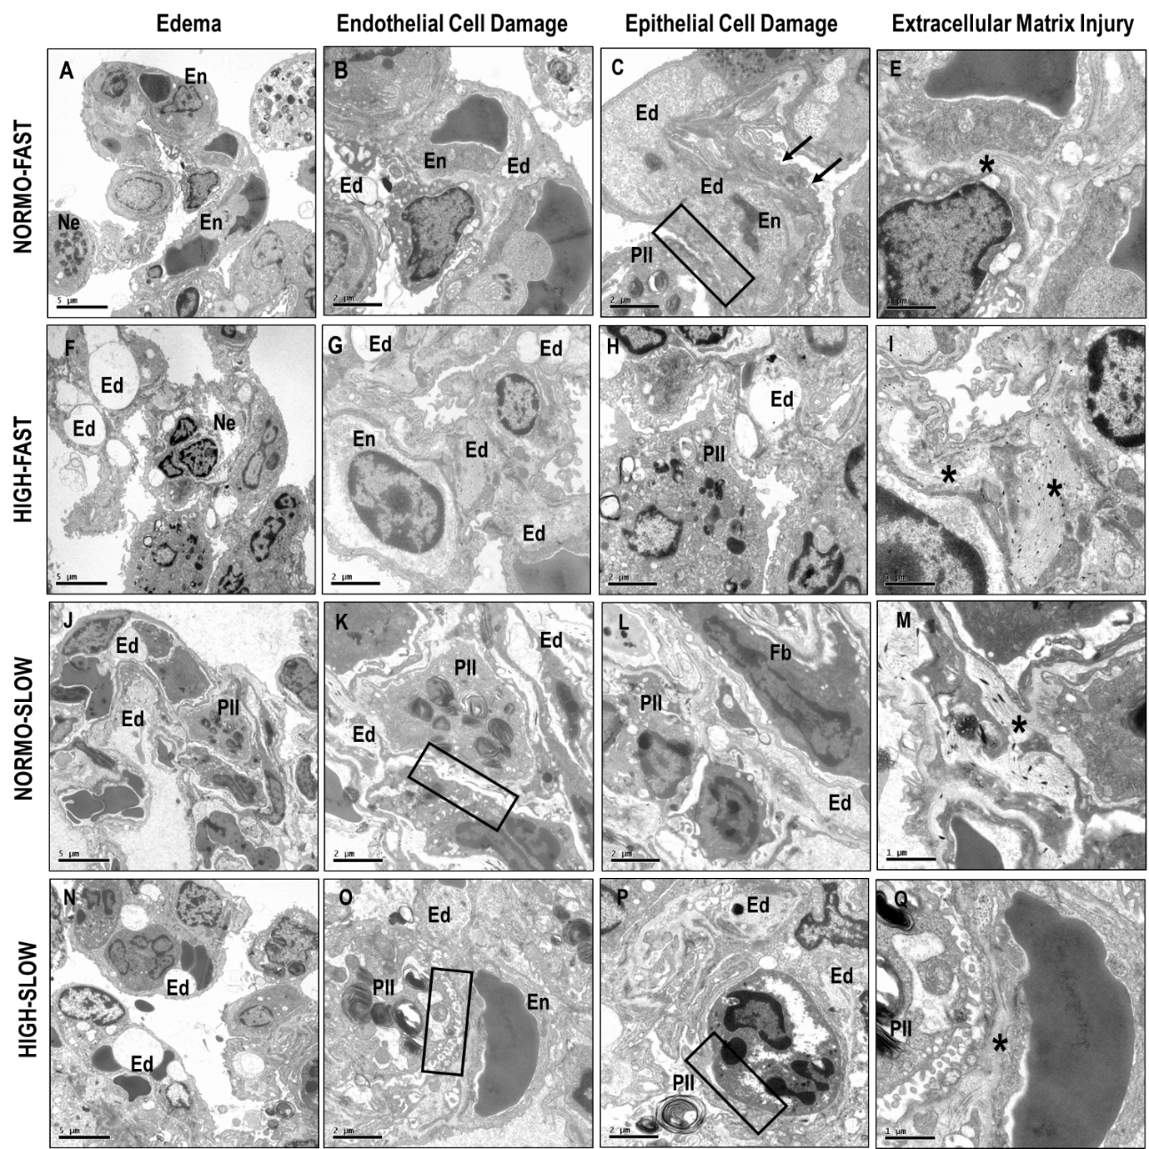

Fig. S1. Transmission electron photomicrographs of lung parenchyma. Ultrastructural features of alveolar–capillary barrier evaluating the combination of fluids and PEEP removal. In the NORMO-FAST group, edema along of the alveolar septa is less prominent (A,B) but there is more endothelial cell apoptosis (B), type II epithelial cell detachment, and irregularity of the basement membrane (C), as well as less collagen fiber disarrangement (D). The HIGH-FAST group shows increased neutrophil counts (E), prominent edema in the form of bubbles along the alveolar septa (E.F), endothelial cell apoptosis (F), fragmentation of the lamellar bodies in type II epithelial cells (PII), and disarrangement of collagen fibers (H). In the NORMO-SLOW group, there is substantial attenuation of edema compared with other groups (I), relatively preserved integrity of endothelial cells (K), basement membrane (K), and lamellar bodies of type II epithelial cells (K), and less disarrangement of collagen fibers that were better distributed along of the alveolar septa (L). The HIGH-SLOW group also presented both interstitial and alveolar edema. Note the presence of bubbles along the alveolar septa (M, N). However, the degree of damage to endothelial cells (N), basement membrane (N) and type II epithelial cells (O), as well as disarrangement of collagen fibers (P), was substantially reduced compared to FAST groups. Ne, neutrophils; Ed, edema; En, endothelium; Square, basement membrane; PII, type II epithelial cells; * collagen fibers

