Current-Induced Crystallisation in Heusler Alloy Films
for Memory Potentiation in Neuromorphic Computation
William Frost,^{1), a)} Kelvin Elphick,^{2), b)} Marjan Samiepour ^{2), c)} and Atsufumi Hirohata ^{2), *}
¹⁾ Department of Physics, University of York, York YO10 5DD, United Kingdom
²⁾ Department of Electronic Engineering, University of York, York YO10 5DD, United Kingdom
^{a)} Present Address: Oxford Instruments Plasma Technology, Bristol BS49 4AP, United Kingdom
^{b)} Present Address: Taiwan Semiconductor Manufacturing Company, Hsinchu 300-78, Taiwan, R.O.C.
^{c)} Present Address: Seagate Technology, Londonderry BT48 0LY, United Kingdom
* Corresponding author: E-mail: atsufumi.hirohata@york.ac.uk
Figure S1 shows the development of giant magnetoresistive (GMR) behaviour by an applied current of 50 µA for 1 s up to 45 times. The noise decreases with increasing the current application, proving the Co₂FeAl_{0.5}Si_{0.5} (CFAS) Heusler-alloy films in the GMR pillar device. Similar behaviour has been observed in over 12 devices.
(a)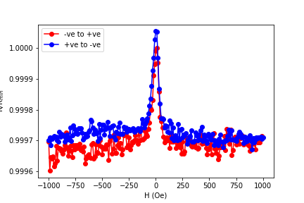 (b)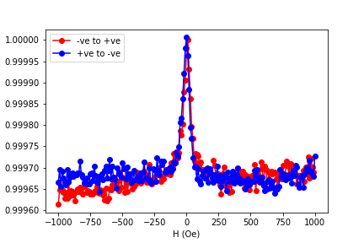
R/R_{min} (%)
(c) 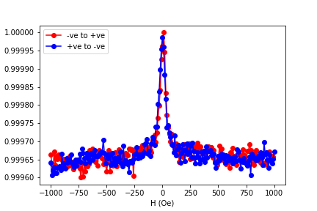 (d)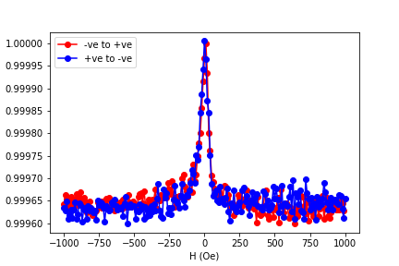
(e)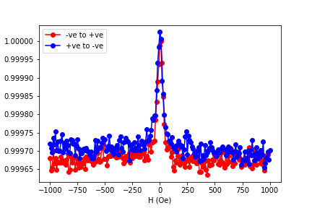 (f)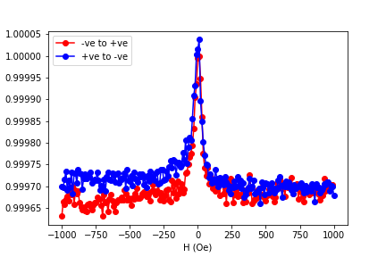
Figure S1: GMR curves of a CFAS/Ag/CFAS GMR device with the diameter of 150 nm × 100 nm. | Normalised GMR curves measured under an applied field of ±1 kOe (a) before and after the current crystallisation by an applied current of 50 µA for 1 s (b) once, (c) 3, (d) 10, (e) 20 and (f) 45 times. Red and blue curves correspond to the field sweep from negative to positive and vice versa.

