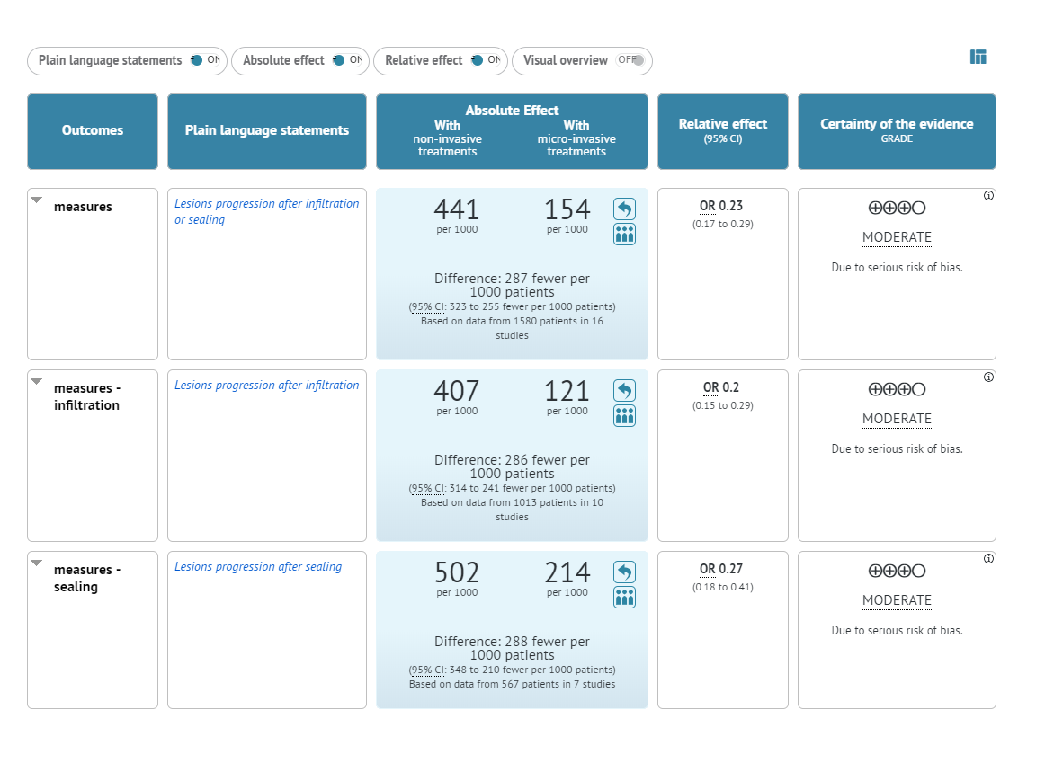
Quality of evidence evaluated by GRADEpro (online software).

