Supplementary Information:
Hyperbolic Shear Polaritons in Low-Symmetry Crystals
Nikolai C. Passler, Xiang Ni, Guangwei Hu, Joseph R. Matson, Martin Wolf, Mathias Schubert, Andrea Alù, Joshua D. Caldwell, Thomas G. Folland, Alexander Paarmann
Supplemental Section 1
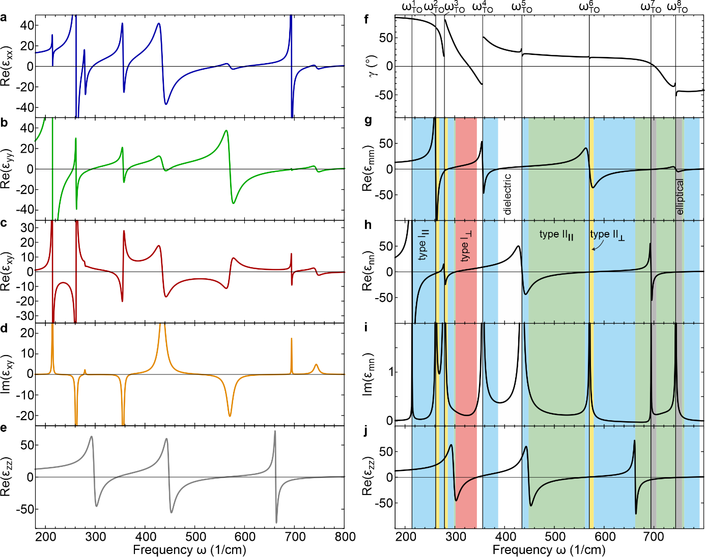
Fig. S1 Frequency-dispersive dielectric permittivity of bGO and surface polariton mode assignment. (a-e) Dielectric permittivity tensor elements $ε_{xx}$, $ε_{yy}$, $ε_{xy}(=ε_{yx})$, and $ε_{zz}$, respectively, of undoped bGO at IR frequencies¹. (f) Rotation angle $γ$ as a function of frequency. (g-h) Diagonal elements $ε_{mm}$ and $ε_{nn}$ of the frequency-dispersive in-plane permittivity, featuring four distinct reststrahlen bands each. (i) Non-zero imaginary part of the off-diagonal element $Im\left(ε_{mn}\right).$ (i) Unchanged out-of-plane permittivity $ε_{zz}$. Depending on the combination of positive or negative real parts of $ε_{mm}$, $ε_{nn}$, and $ε_{zz}$, different types of phonon polaritons are supported (color-shaded), such as elliptical SPhPs, and type I and type II, in-plane ($∥$) and out-of-plane ($⊥$) hyperbolic polariton modes, respectively.
First, we briefly outline how conventional optical materials are classified. A material which supports surface polaritons is supported at frequencies where the real part of the crystal permittivity fulfills $Re\left(ε\right)<-1$ ². In anisotropic crystals, the diagonal permittivity elements are of different sign, leading to hyperbolic behavior where either the real part of one element is negative and the other two are positive (type I), or two are negative and one is positive (type II)³. For aQ, based on its dielectric permittivity values at 455 1/cm,⁴ we anticipate a type II in-plane hyperbolic polariton with strong azimuthal dependence, as we observe experimentally (Fig. 2b). However, this classification of anisotropic materials relies on the off-diagonal permittivity tensor elements being zero at all frequencies for an appropriate choice of coordinate system. The lower symmetry of bGO requires the emergence of $ε_{xy}≠0$. The dielectric permittivity elements using coordinates as indicated in Fig. 1a are shown in Fig. S1a-e, but no coordinate system exists where $Re\left(ε_{xy}\right)≠0$ at all frequencies. This, as we have demonstrated in the Otto-geometry experiments (Fig. 2d), results in a non-trivial polaritonic response with highly directional modes that propagate along frequency-dictated propagation angles in the a-c-plane. Furthermore, because $ε_{xy}≠0$, it is not straight-forward to determine if the modes are elliptical ($ε_{xx}, ε_{yy}, ε_{zz}<-1$), or hyperbolic in nature (type I or type II), as the propagation angle is typically not aligned with one of the principal axes.
To unambiguously describe the nature of the polariton modes, we switch to a frequency-dispersive coordinate system [$mnz$], which enables the permittivity tensor to be diagonalized. This is achieved by rotating the monoclinic plane by the frequency-dependent angle $γ\left(ω\right)$ (Eq. 2). The dispersion of $γ\left(ω\right)$ and the resulting diagonal elements of $ε^{[mnz]}$ are plotted in Fig. S1f-j. This new frequency-dispersive coordinate system allows for the unique assignment of the supported polariton mode nature, which we have color-coded in Fig. S1g-j. For bGO, we interestingly observe the full range of possible combinations of positive and negative real parts of $ε_{mm}$, $ε_{nn}$, and $ε_{zz}$, leading to dielectric (white), elliptical (gray) and hyperbolic spectral regimes of type I (in-plane in blue, out-of-plane in red) and II (in-plane in green, out-of-plane in yellow). By performing such a frequency-dependent rotation of the permittivity tensor, we have simplified the system into a pseudo-biaxial crystal at each frequency. However, since the dielectric tensor of a monoclinic crystal is not diagonalizable^{5–7}, the in plane off-diagonal element of $ε^{[mnz]}$ retains a non-vanishing imaginary part at all frequencies, i.e., ${Im(ε}_{mn})≠0$ (plotted in Fig. S1i), giving rise to the reduced symmetry of hyperbolic shear polaritons (HShPs) in monoclinic crystals, as discussed in Fig. 3.
The frequency-dependent rotation of the dielectric permittivity tensor is performed in three subsequent steps. First, the in-plane permittivity tensor as shown in Fig. S1a-c is rotated about the angle $γ\left(ω\right)$ (Eq. 2). However, $γ\left(ω\right)$ has jumps of 90° at arbitrary frequencies, resulting in abrupt discontinuities in the real parts of $ε_{mm}$ and $ε_{nn}$ where the two curves switch values. By analyzing the derivative of $ε_{mm}$, we extract the frequency values $ω_{jump}$ where the jumps occur and reassign the permittivity curves, respectively. At the eight in-plane TO frequencies $ω_{TO}$ of bGO, the permittivity curves feature a pole, which is also captured in the analysis of the derivative. Therefore, at this step, the resulting curves are smooth between the TO frequencies, but switch assignment at every $ω_{TO}$. The switching of the curves at every $ω_{TO}$ is performed in the last step. However, near $ω_{TO}$, the permittivity features a large imaginary part, which is not accounted for in the rotation angle $γ\left(ω\right)$. This leads to poles in $γ\left(ω\right)$ at $ω_{TO}$ (see Fig. S1f) which in turn results in a small avoided crossing of $ε_{mm}$ and $ε_{nn}$ at the TO frequencies. Therefore, the reassignment of the last step results in discontinuous solutions near $ω_{TO}$, which is clearly not physical. In order to resolve this issue, we cut out $±1 1/cm$ in both $ε_{mm}$ and $ε_{nn}$ at all eight $ω_{TO}$ and smooth the curves by interpolation, resulting in the pseudo-biaxial permittivity curves as shown in Fig. S1g-i. The rotation about $γ\left(ω\right)$ also leads to discontinuities in the off-diagonal imaginary part $Im\left(ε_{mn}\right)$ at the frequencies $ω_{jump}$. However, because $ε_{mn}=ε_{nm}$, the abrupt rotation about 90° only leads to sign changes at every $ω_{jump}$. The curve of $Im\left(ε_{mn}\right)$ shown in Fig. S1i is corrected for these sign changes.

Supplemental Section 2
To verify the polaritonic behavior of the pseudo-biaxial crystal, we subsequently analyze the surface polariton dispersion in the rotated coordinate system [mnz] in Fig. S2. For electric fields in the $m-z$ or $n-z$ planes, the analytical expression describing extraordinary surface polaritons in uniaxial crystals can be employed⁸:
$$k_{polariton}=\frac{ω}{c}\sqrt{\frac{ε_{zz} ε_{in-plane}-ε_{zz}}{ε_{zz} ε_{in-plane}-1}} ,$$ | (S1)
where $ε_{in-plane}=ε_{mm}, ε_{nn}$. In bGO, the solutions of Eq. S1 yield four polariton branches for each direction, $m$ and $n$, respectively, plotted as red dotted lines in Fig. S2c and d. These analytical results are in perfect agreement with the numerically obtained surface polariton dispersion using a transfer matrix formalism⁹ (see Methods for details). To obtain the polariton propagation properties of the system, we calculate the full electric field patterns by placing a point dipole source above the bGO surface at $x=y=0$, and simulating the optical response along the bGO/air interface ($z=0$) with COMSOL Multiphysics¹⁰ (see Methods for details). The real space field profiles clearly show the rotation of the major polarizability direction as a function of frequency, demonstrated for six different modes M1-3 and N1-3 (See Fig. S2e-g and k-m). Frequencies are indicated as black, dash-dotted lines in Fig. S2a-d. Mode N4 is shown in Fig. 1e,g. The field profiles align with the rotated coordinate system, with basis vectors indicated by the ‘m’ and ‘n’ cross hair in each figure.
To relate the calculated dispersion of the polariton branches to the field profiles, we calculate the momentum-$k$ maps of these modes, as obtained by a two-dimensional Fourier transformation of the respective electric field patterns of Fig. S2e-g and k-m in Fig. S2h-j and n-p, respectively. At all selected frequency positions, the electric field patterns contain a directional wave of large amplitude with low spatial frequency, as well as a wave with high spatial frequency. The observed in-plane momenta of the low-k modes follow the modal dispersion predicted in Fig. S2c and d, along the $m$- and $n$-axes for modes M1-M3 and N1-N3, respectively, as indicated by the black circles in Fig. S2h-j and n-p. According to the mode characterization provided in Fig. S1, these modes are hyperbolic either of type I in-plane (M1-M3 and N1) or of type II in-plane (N2-N4). For all HShP modes, field patterns and $k$-space maps are characterized by two-fold rotational symmetry only, in agreement with the 2D plane group 2 (no mirror plane symmetries). Further, the distinct peaks in the $k$-space maps verify the principle polariton propagation direction, while the corresponding radial and azimuthal spreads are representative of their decay length and degree of directionality, respectively. Analogous to mode N4 discussed in the main text, the maxima of the k-space maps shown in FigS2 do not lie on the major polarizability axes (most prominently for the cases in Fig S2n and o), owing to shear dissipation in monoclinic bGO. This is further discussed in the main text and in Fig. 3.
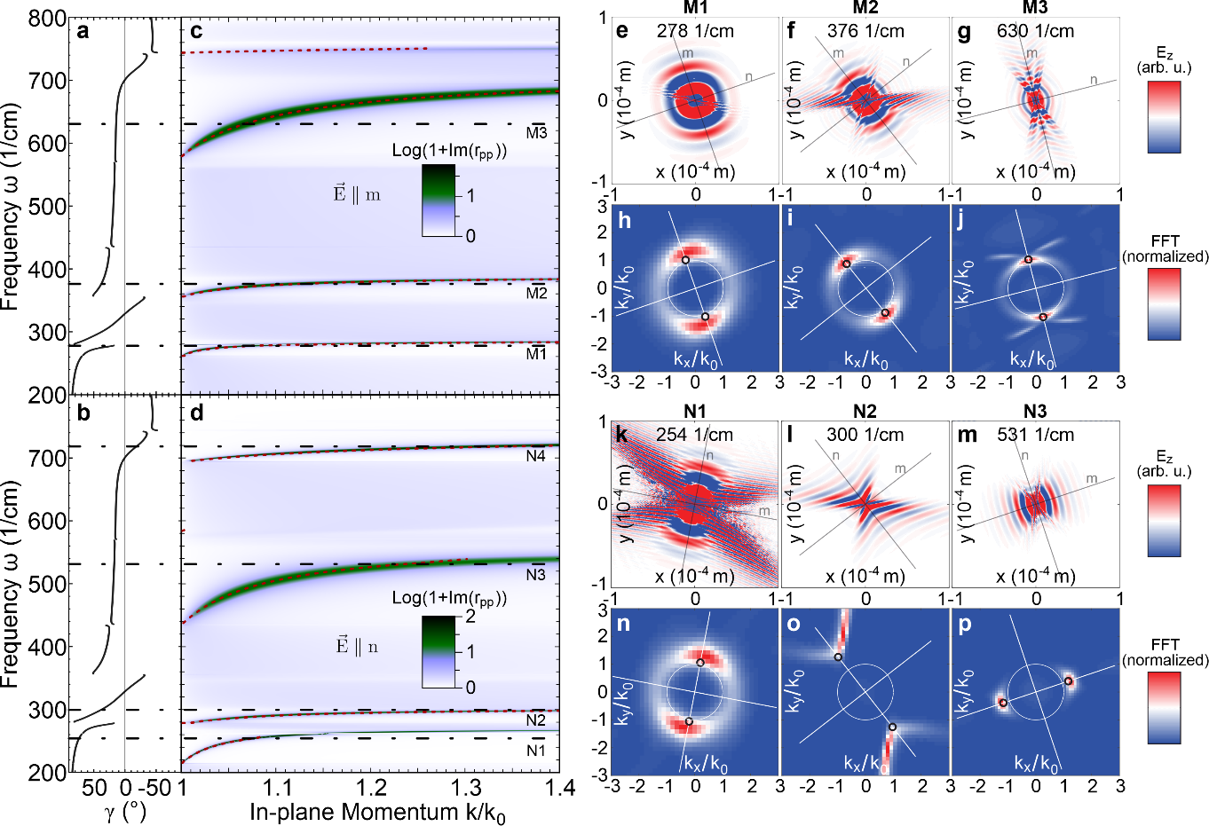

Fig. S2 Rotating hShPs on bGO. (a,b) Rotation angle $γ$ as a function of frequency. (c,d) Dispersion of hShPs on the surface of a bulk bGO crystal calculated with the frequency-dispersive permittivity tensor along the (rotating) $m$-axis (c) and the $n$-axis (d), obtained using a transfer matrix method⁹. The four supported polaritons along each axis $m$ and $n$ are clearly distinguishable, in perfect agreement with the theoretically calculated polariton dispersion (red, dotted lines)⁸. Black horizontal dash-dotted lines mark the frequencies M1-M3 and N1-N4 at which the electric field distribution is plotted. N4 is shown in Fig. 1e,g. (e-g) Real-space electric fields at the bGO surface at frequencies M1-M3, respectively, and (h-j) the respective two-dimensional Fourier transformation. The fields were calculated using COMSOL Multiphysics¹⁰ (see Methods for details). (k-m) Real-space electric fields at frequencies N1-N3, respectively, and (n-p) the respective Fourier transforms. All maps (e-p) were calculated using the non-dispersive permittivity tensor (Fig. 3a-d), thus showing rotated field patterns with different orientations depending on the frequency. The thin black and white crosshairs indicate the principle axes of the respective frequency-dispersive coordinate system, its rotation given by $γ$ at the corresponding frequency. Small black circles in (h-j) and (n-p) mark the momentum value of the analytical dispersion in (c) and (d), respectively.

Supplemental Section 3
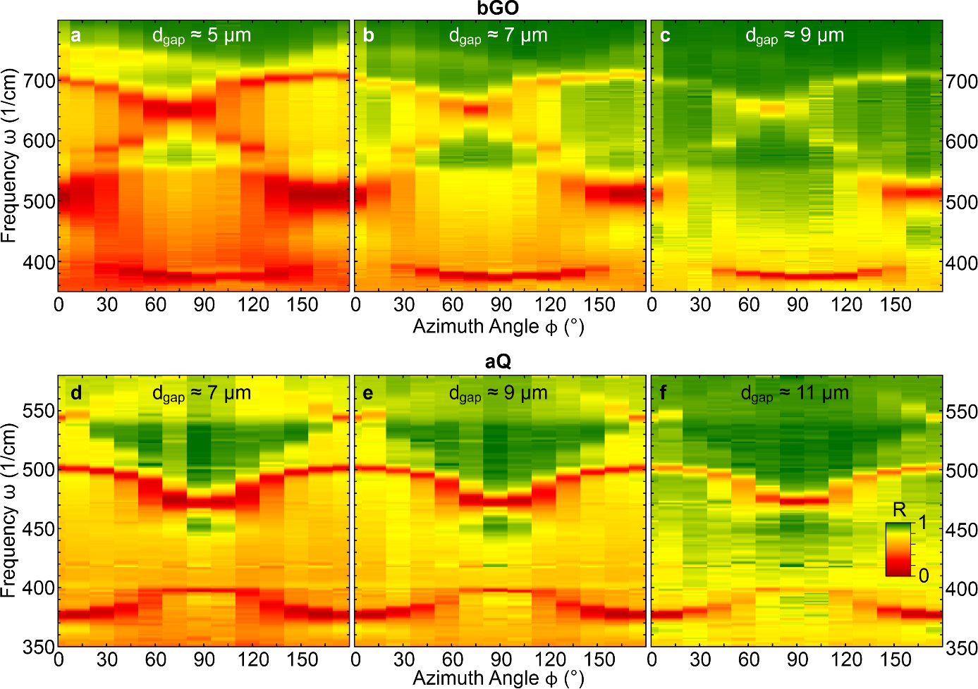
Fig. S3 Experimental data sets for bGO and aQ at different gap sizes. The gap size d_{gap} in our Otto geometry setup can be tuned and monitored¹¹, enabling control over the excitation efficiency of the polariton modes⁹. (a-c) shows the data sets measured for bGO, and (d-f) for aQ, at three different gap sizes each, respectively. For smaller gaps, some modes are overcoupled and their resonance features broadened (such as the mode at 500 1/cm in bGO), while for larger gaps, some modes are undercoupled and their resonance features too weak to be clearly distinguishable (in particular the mode at 725 1/cm in bGO). The center gap sizes compromise between these effects. Note that the gap sizes indicated here are the values monitored with a whitelight interferometry setup¹¹. The fits performed for the data sets shown in the main text in Fig. 2 (data set (b) for bGO and (e) for aQ), however, yielded larger gap sizes of 8.3 μm (bGO) and 10.4 μm (aQ). The offset can be attributed to non-perfect parallel alignment between prism and sample and a lateral offset between the polariton excitation site with the FEL and the whitelight spot for the gap measurement.

Supplemental Section 4
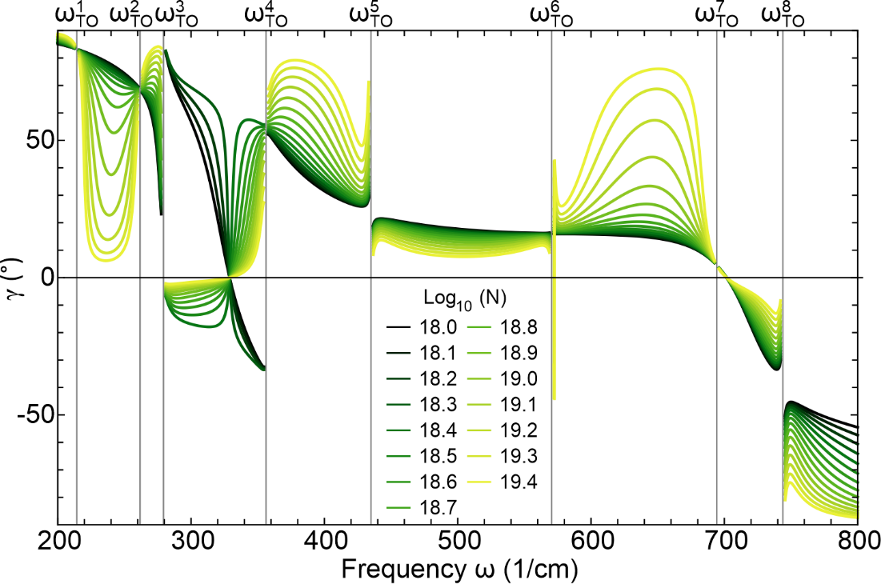
Fig. S4 Active tuning of the propagation direction of HShPs in bGO. Rotation angle γ (Eq. 2 of the main text) calculated as a function of doping concentration N (in cm⁻³), assuming a Drude contribution with anisotropic charge carrier mobility, μ_{x}=296 cm²V⁻¹s⁻¹, μ_{y}=μ_{z}=37 cm²V⁻¹s⁻¹. (Literature values of μ in bGO feature a large variance¹². We here assume strong anisotropy of the charge carrier mobility in order to emphasize the rotation mechanism.) Clearly, between the TO frequencies where the HShPs disperse, the rotation angle γ is strongly dependent on the doping concentration, enabling active tuning of the propagation direction of the supported polariton modes. Note that for an isotropic Drude contribution, on the other hand, Eq. 2 predicts no rotation of the propagation direction as a function of doping concentration.
Supplemental Section 5
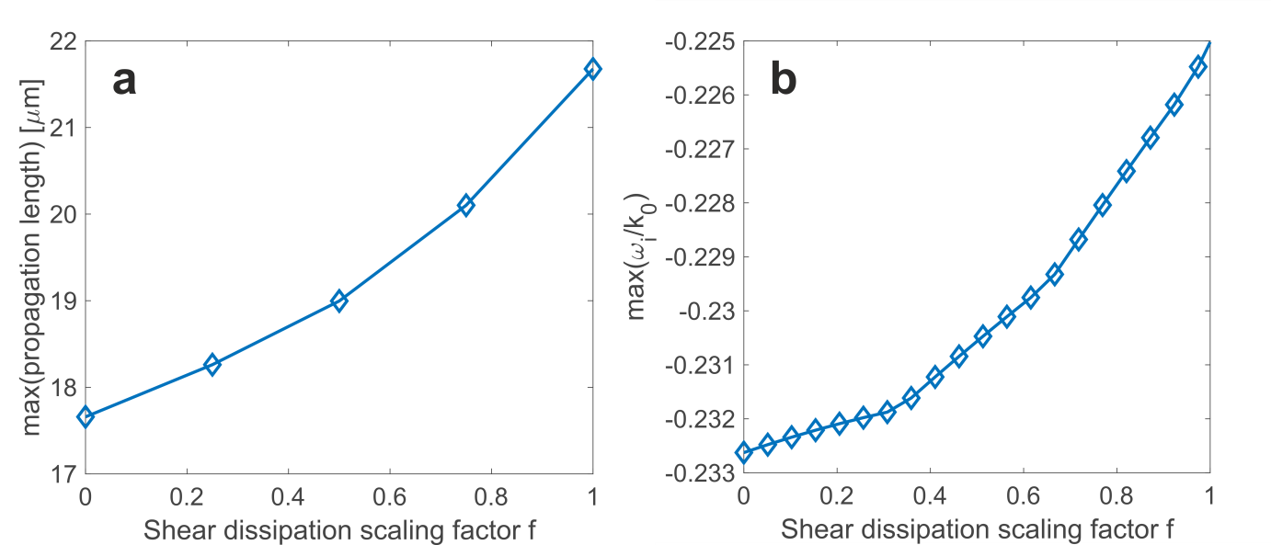
Fig. S5 Propagation losses as function of shear dissipation scaling. (a) Extracted propagation length from COMSOL field patterns for various values of the scaling factor $f$, see main text. The decay lengths of the surface waves were fitted for all azimuthal directions, and the maximum value was taken for each $f$. (b) Minimum loss $min(-\frac{ω_{i}}{k_{0}})$ at $k_{z}=0$ for analytical solutions of the complex frequency calculations as a function of the shear dissipation scaling factor $f$, compare Fig. 3i. Both calculations predict systematic reduction of propagation losses with increasing $f$, i.e. going from the artificial biaxial to the natural monoclinic bGO. All calculations were performed at $718 1/cm$.
References
1. Schubert, M. et al. Anisotropy, phonon modes, and free charge carrier parameters in monoclinic β-gallium oxide single crystals. Phys. Rev. B 93, 125209 (2016).
2. Raether, H. Surface Plasmons on Smooth and Rough Surfaces and on Gratings. Surface Plasmons on Smooth and Rough Surfaces and on Gratings vol. 111 (Springer Berlin Heidelberg, 1988).
3. Caldwell, J. D. et al. Sub-diffractional volume-confined polaritons in the natural hyperbolic material hexagonal boron nitride. Nat. Commun. 5, 5221 (2014).
4. Winta, C. J., Gewinner, S., Schöllkopf, W., Wolf, M. & Paarmann, A. Second-harmonic phonon spectroscopy of α-quartz. Phys. Rev. B 97, 094108 (2018).
5. Jellison, G. E. et al. Spectroscopic dielectric tensor of monoclinic crystals: CdWO4. Phys. Rev. B 84, 195439 (2011).
6. Sturm, C. et al. Dipole analysis of the dielectric function of color dispersive materials: Application to monoclinic Ga2O3. Phys. Rev. B 94, 035148 (2016).
7. Mock, A. et al. Band-to-band transitions, selection rules, effective mass, and excitonic contributions in monoclinic β−Ga2O3. Phys. Rev. B 96, 245205 (2017).
8. Falge, H. J. & Otto, A. Dispersion of Phonon-Like Surface Polaritons on α-Quartz Observed by Attenuated Total Reflection. Phys. Status Solidi 56, 523–534 (1973).
9. Passler, N. C. & Paarmann, A. Generalized 4 x 4 matrix formalism for light propagation in anisotropic stratified media: study of surface phonon polaritons in polar dielectric heterostructures. J. Opt. Soc. Am. B 34, 2128 (2017).
10. Comsol. COMSOL Multiphysics. accessed: July 27, 2020 https://www.comsol.com/.
11. Pufahl, K. et al. Controlling nanoscale air-gaps for critically coupled surface polaritons by means of non-invasive white-light interferometry. Appl. Phys. Lett. 113, 161103 (2018).
12. Schubert, M. et al. Phonon Properties. in Gallium Oxide: Materials Properties, Crystal Growth, and Devices (eds. Higashiwaki, M. & Fujita, S.) 501–534 (Springer International Publishing, 2020). doi:10.1007/978-3-030-37153-1_28.

