Supplementary figure 1. Comparison of the analytical sensitivities of real-time RT-PCR, PNA RT-LAMP and Colorimetric LAMP assays. A) Real-time PCR assay result. B) PNA RT-LAMP assay result. C) Analytical sensitivity of Colorimetric LAMP assay. All three methods showed positive amplification signals when testing serially diluted samples contain approximately 10,000 to 1 cp/µL SARS-CoV-2 RNA template while detection of samples contain ~ 0.1 cp/µL of template RNA were not produced positive signals.
a)
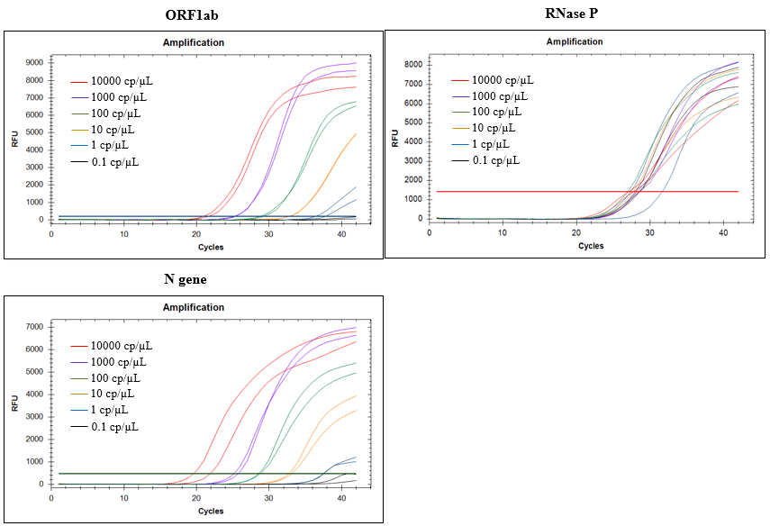
b)
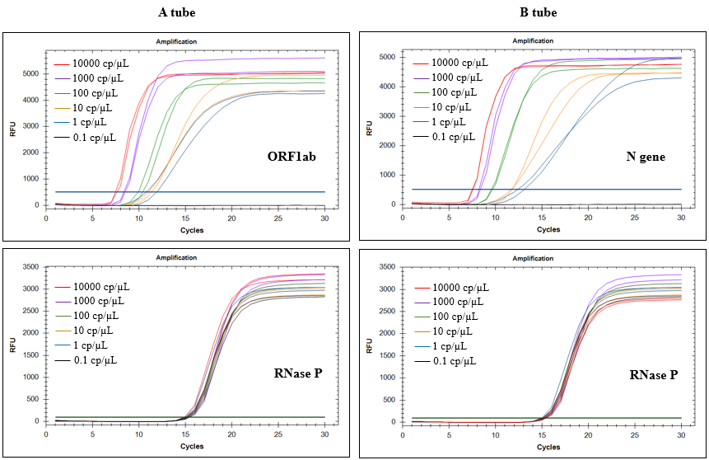

c)
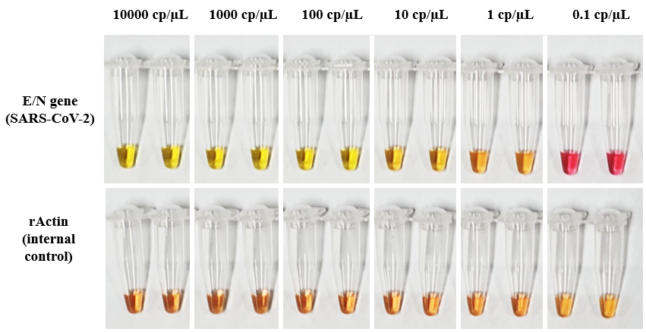

Supplementary figure 2. Comparative analysis of the sensitivities of SARS-CoV-2 molecular assays using clinical positive NP swabs including high, moderate and low positives. A) Results of the real-time PCR assay tested 15 samples of 3 positive groups. B) Results of the PNA RT-LAMP assay on CFX-96 real-time PCR detection system. All 15 samples of 3 positive groups exhibited amplification curves less than 30 for both ORF1ab and N gene targets. C) Results of PNA RT-LAMP assay on a portable isothermal amplifier SMARTAMP. All 15 samples exhibited amplification curves less than 30 for both ORF1ab and N gene targets. D) Results of the Colorimetric LAMP assay. Colors of all 10 samples of high and moderate positive groups turned into yellow or orange indicating the amplification of SARS-CoV-2 targets, while two (2) low positive NP swabs (sample #1, 5) out of the five (5) could not been detected as positive. An internal control rActin showed positive amplification signal for 15 samples.
a)
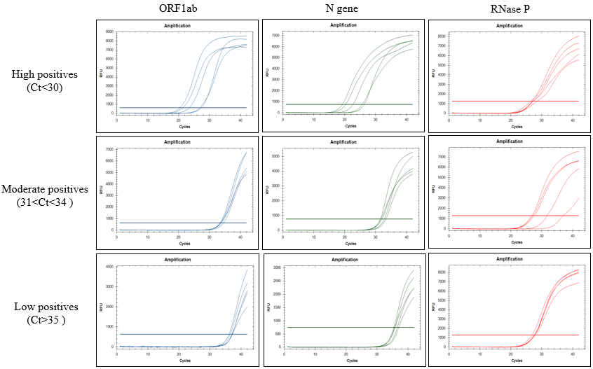
b)
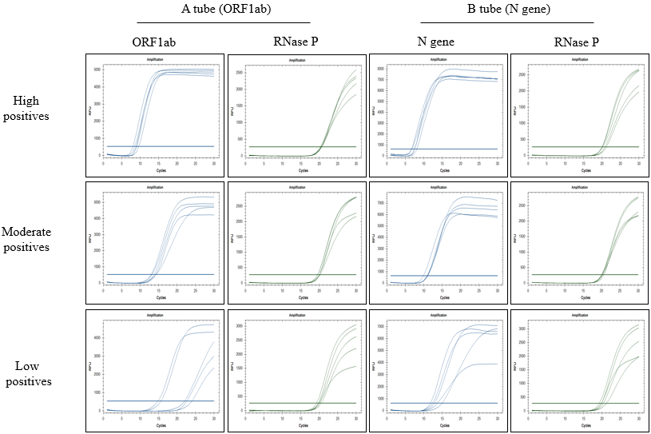

c)
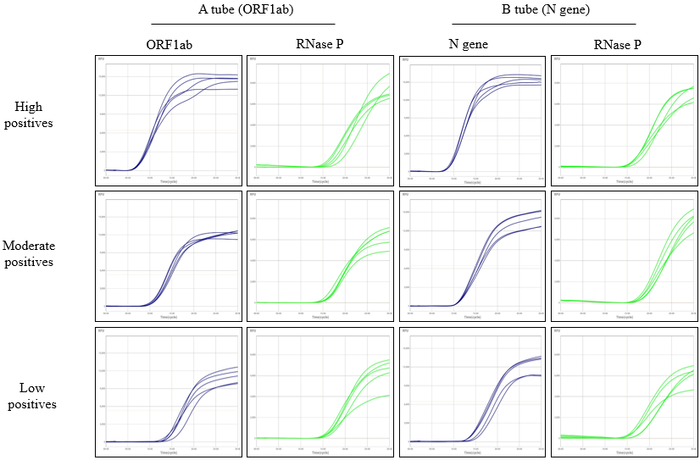
d)
