Supporting Information for
Pressure-induced liquid-liquid transition in a family of ionic materials
Z. Wojnarowska^{1*}, S. Cheng¹, M. Swadzba-Kwasny², S. McLaughlin,² Y. Delavoux,² M. Paluch¹
¹Institute of Physics, the University of Silesia in Katowice, Silesian Center for Education and Interdisciplinary Research, 75 Pułku Piechoty 1A, 41–500 Chorzów, Poland
² The QUILL Research Centre, School of Chemistry and Chemical Engineering, The Queen’s University of Belfast, David Keir Building, Stranmillis Rd, BT9 5AG, Belfast, NI, UK

Synthesis of examined systems.
Trihexyl(tetradecyl)phosphonium chloride, [P₆₆₆₁₄]Cl, was kindly provided by Solvay. Trihexyl(tetradecyl)phosphonium bis(oxolato)borate [P_{666,14}][BOB] was bought from Merck, and sodium tricyanomethanide was bought from TCI Chemicals. All other chemicals were purchased from Sigma-Aldrich and used as received.

[P_{666,14}][TFSI]. Trihexyl(tetradecyl)phosphonium chloride, [P₆₆₆,₁₄]Cl (0.010 mol eq.) and lithium bis(trifluoromethanesulfon)imide Li[TFSI] (0.013 mol eq.) were separately dissolved in 25 cm³ deionised water (total 50 cm³) and then combined in a round-bottomed flask (250 cm³), resulting in the formation of a biphasic liquid system; the mixture was left to react (1 h, room temperature, 600 rpm). The aqueous layer was separated, and the organic layer was collected and washed, firstly with deionised water (10 cm³) and then dichloromethane, DCM (10 cm³). Subsequent washes were performed with solution of Li[TFSI] in deionised water until no chloride could be detected with silver nitrate solution. Subsequently, DCM was removed via rotary evaporation (30 min, 35 °C) and the ionic liquid was dried under high vacuum (overnight, 70 °C, 10⁻² mbar). ¹H, ¹³C, ¹⁹F and ³¹P NMR spectra were recorded in d₆-DMSO solution.
¹H NMR (400 MHz, d₆ -DMSO) δ: 0.83-0.92 (m, 12H), 1.21-1.27 (m, 18H), 1.28-1.35 (m, 14H), 1.35-1.43 (m, 8H), 1.43-1.55 (m, 8H), 2.11-2.23 (m, 8H).
¹³C NMR (400 MHz, d₆ -DMSO) δ: 13.53, 13.64, 17.28, 17.76, 20.46, 20.50, 20.54, 21.75, 22.07, 28.08, 28.66, 28.74, 28.95, 29.04, 29.06, 29.09, 29.62, 29.77, 29.87, 30.02, 30.34, 31.32, 119.50 (q, CF₃).
¹⁹F NMR (400 MHz, d₆ -DMSO) δ: -79.00.
³¹P NMR (400 MHz, d₆ -DMSO) δ: 33.55.

[P_{666,14}][SCN]. Trihexyl(tetradcyl)phosphonium chloride [P₆₆₆,₁₄]Cl (0.010 mol eq.) and K[SCN] (0.013 mol eq.) were separately dissolved in 25 cm³ deionised water (total 50 cm³) and then combined in a round-bottomed flask (250 cm³), resulting in the formation of a biphasic liquid system; the mixture was left to react (1 h, room temperature, 600 rpm). The aqueous layer was separated, and the organic layer was collected and washed, firstly with deionised water (10 cm³) and then dichloromethane, DCM (10 cm³). Subsequent washes were performed with solution of K[SCN] in deionised water until no chloride could be detected with silver nitrate solution. Subsequently, DCM was removed via rotary evaporation (30 min, 35 °C) and the ionic liquid was dried under high vacuum (overnight, 70 °C, 10⁻² mbar). ¹H, ¹³C and ³¹P NMR spectra were recorded in d₆-DMSO solution.
¹H NMR (600 MHz, d₆ -DMSO) δ: 0.86-0.94 (m, 12H), 1.23-1.30 (m, 18H), 1.31-1.36 (m, 14H), 1.37-1.44 (m, 8H), 1.45-1.55 (m, 8H), 2.16-2.24 (m, 8H).
¹³C NMR (600 MHz, d₆ -DMSO) δ: 13.74, 13.80, 17.30, 17.59, 20.42, 20.48, 21.75, 22.04, 28.07, 28.63, 28.67, 28.94, 28.97, 29.01, 29.03, 29.03, 29.65, 29.73, 29.85, 29.95, 30.34, 31.25, 131.07.
³¹P NMR (600 MHz, d₆ -DMSO) δ: 33.67.

[P_{666,14}][TCM]. Trihexyl(tetradecyl)phosphonium chloride [P₆₆₆,₁₄]Cl (0.010 mol eq.) and sodium tricyanomethanide, Na[TCM] (0.013 mol eq.) were separately dissolved in 25 cm³ deionised water (total 50 cm³) and then combined in a round-bottomed flask (250 cm³), resulting in the formation of a biphasic liquid system; the mixture was left to react (1 h, room temperature, 600 rpm). The aqueous layer was separated, and the organic layer was collected and washed, firstly with deionised water (10 cm³) and then dichloromethane, DCM (10 cm³). Six subsequent washes were performed with solution of Na[TCM] in deionised water until no chloride could be detected with silver nitrate solution. Subsequently, DCM was removed via rotary evaporation (30 min, 35 °C) and the ionic liquid was dried under high vacuum (overnight, 70 °C, 10⁻² mbar). ¹H, ¹³C and ³¹P NMR spectra were recorded in d₆-DMSO solution.
¹H NMR (600 MHz, d₆ -DMSO) δ: 0.84-0.93 (m, 12H), 1.21-1.28 (m, 18H), 1.30-1.35 (m, 14H), 1.35-1.42 (m, 8H), 1.43-1.54 (m, 8H), 2.14-2.23 (m, 8H).
¹³C NMR (600 MHz, d₆ -DMSO) δ: 13.70, 13.76, 17.28, 17.69, 20.38, 20.45, 21.75, 21.98, 28.07, 28.61, 28.65, 28.91, 28.97, 29.01, 29.03, 29.05, 29.65, 29.71, 29.85, 29.95, 30.34, 31.20, 160.28.
³¹P NMR (600 MHz, d₆ -DMSO) δ: 33.67.

[P_{666,14}][BF₄]. Trihexyl(tetradecyl)phosphonium chloride [P₆₆₆,₁₄]Cl (0.010 mol eq.) and sodium tetrafluoroborate, Na[BF₄] (0.013 mol eq.) were separately dissolved in 25 cm³ deionised water (total 50 cm³) and then combined in a round-bottomed flask (250 cm³), resulting in the formation of a biphasic liquid system; the mixture was left to react (1 h, room temperature, 600 rpm). The aqueous layer was separated, and the organic layer was collected and washed, firstly with deionised water (10 cm³) and then dichloromethane, DCM (10 cm³). Subsequent washes were performed with solution of Na[BF₄] in deionised water until no chloride could be detected with silver nitrate solution. Subsequently, DCM was removed via rotary evaporation (30 min, 35 °C) and the ionic liquid was dried under high vacuum (overnight, 70 °C, 10⁻² mbar). ¹H, ¹³C, ¹¹B and ³¹P NMR spectra were recorded in d₆-DMSO solution.
¹H NMR (600 MHz, d₆ -DMSO) δ: 0.89-0.96 (m, 12H), 1.25-1.32 (m, 18H), 1.32-1.38 (m, 14H), 1.39-1.47 (m, 8H), 1.47-1.56 (m, 8H), 2.17-2.26 (m, 8H).
¹³C NMR (600 MHz, d₆ -DMSO) δ: 13.75, 13.83, 17.30, 17.61, 20.47, 20.50, 21.77, 22.06, 28.07, 28.63, 28.70, 28.94, 28.99, 29.01, 29.03, 29.05, 29.65, 29.75, 29.88, 29.98, 30.36, 31.28.
¹¹B NMR (600 MHz, d₆ -DMSO) δ: -1.26.
¹⁹F NMR (600 MHz, d₆ -DMSO) δ: -148.42.
³¹P NMR (600 MHz, d₆ -DMSO) δ: 33.70.
[P_{666,14}][TAU]. Trihexyl(tetradecyl)phosphonium chloride [P_{666,14}]Cl was converted to [P_{666,14}][OH] (solution in methanol) following a literature procedure. [P_{666,14}][TAU] was synthesised following a modified literature procedure. Taurine (0.012 mol eq.) was dissolved in 35 cm³ of deionised water and [P_{666,14}][OH] (0.015 mol eq., solution in methanol) was added. The solution was stirred for 2 h at ambient temperature and the water-methanol mixture was removed via rotary evaporation (3 h, 30-80 °C). Crude product was dissolved in 50 ml of dry acetonitrile and stored in the fridge (5 °C) overnight. The excess taurine crystallised and was filtered off. Acetonitrile was removed via rotary evaporation (30 min, 60 °C) and the ionic liquid was dried under high vacuum (overnight, 70 °C, 10⁻² mbar). ¹H, ¹³C, ¹¹B and ³¹P NMR spectra were recorded in d₆-DMSO solution.
¹H NMR (600 MHz, d₆ -DMSO) δ: 0.83-0.92 (m, 12H) 1.19-1.28 (m, 18H), 1.28-1.35 (m, 14H), 1.35-1.44 (m, 8H), 1.44-1.54 (m, 8H), 2.20-2.30 (m, 8H), 2.47-2.53 (t, 2H), 2.77-2.83 (t, 2H).
¹³C NMR (600 MHz, d₆ -DMSO) δ: 13.61, 13.66, 17.31, 17.63, 20.56, 20.58, 21.75, 22.03, 28.13, 28.68, 28.96, 28.98, 29.02, 29.04, 29.66, 29.76, 29.92, 30.02 30.37, 31.26, 38.52, 54.76.
³¹P NMR (600 MHz, d₆ -DMSO) δ: 33.53.
Prior to the measurements, the samples were dried under vacuum at 90 ℃ for 24h. The water content of the samples, detected using the Karl Fischer method, is around 500 and 300 ppm before and after drying, respectively.

Calorimetric data with different scanning rate
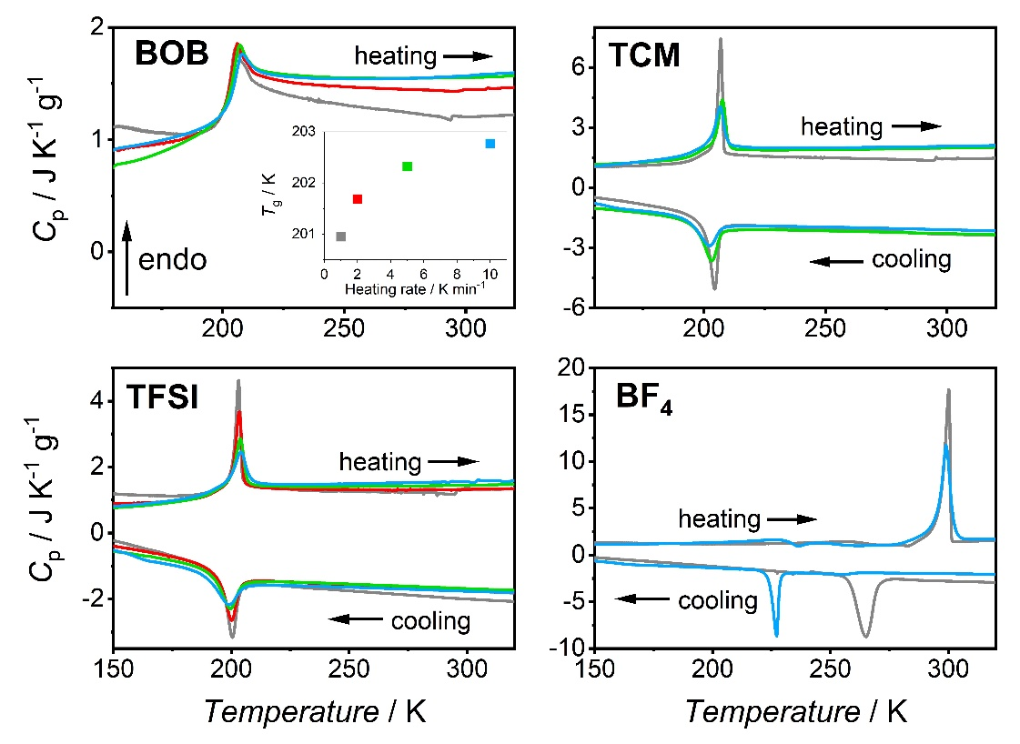
Figure S1. Heat capacity measured on different heating and cooling rate:10 (blue), 5 (green), 2 (red), and 1 (gray) K/min for [P_{666,14}]-based ionic liquids. Inset presents the change of glass transition temperature with the heating rate for [P_{666,14}][BOB].
Ambient pressure dielectric measurements
Figure S2. ε′ as a function of temperature at fix frequency (f=1MHz) during cooling (blue) and heating (red) with a rate of 1K/min for [P₆₆₆₁₄] [BOB], [P₆₆₆₁₄] [TCM], [P₆₆₆₁₄] [TFSI], and [P₆₆₆₁₄] [BF₄]. The light blue and light red curves in the graph of [P₆₆₆₁₄] [BF₄] denote the cooling and heating processes with a rate of 5K/min, respectively.
Figure S3. Stickel analysis of studied samples. Arrows indicate the LLT.
Figure S4. The dc-conductivity of [P_{666,14}]-based ionic liquids as a function of temperature.
Density results
Figure S5. Temperature dependence of specific volume for [P_{666,14}][TCM] and [P_{666,14}][TFSI]. The data for [P_{666,14}][TFSI] were taken from ref. .

J. L. Ferguson, J. D. Holbrey, S. Ng, N. V. Plechkova, K. R. Seddon, A. A. Tomaszowska and D. F. Wassell, Pure Appl. Chem., 2012, 84, 723–744
Brett F. Goodrich, Juan C. de la Fuente, Burcu E. Gurkan, Zulema K. Lopez, Erica A. Price, Yong Huang, and Joan F. Brennecke*, J. Phys. Chem. B, 115, 29, 9140–9150 (2011)
Klomfar, J.; Souckova, M.; Patek, J. Low Temperature Densities from (218 to 364) K and up to 50 MPa in Pressure and Surface Tension for Trihexyl(tetradecyl)phosphonium Bis(trifluoromethylsulfonyl)imide and Dicyanamide and 1‐Hexyl-3-methylimidazolium Hexafluorophosphate J. Chem. Eng. Data 59(7), 2263-2274, 2014

