Figure S1. Heatmap of the distribution of the thirty keystone species in the SCP co-occurrence network.
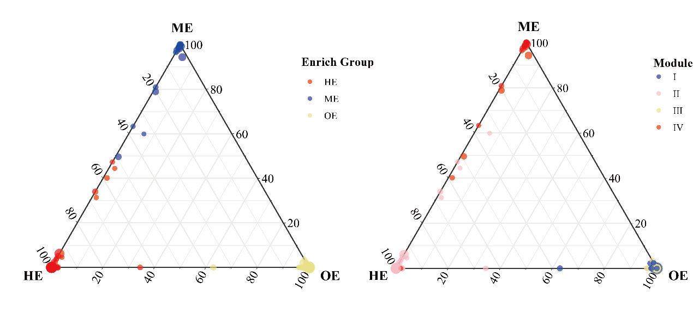
Figure S2. Ternary plots showing relative abundance of ASVs from modules I-VI corresponding to three eutrophication groups (HE, ME, and OE). Each dot represents one individual ASV, whose abundance was averaged over all samples in different groups.

