Additional file 2
Table S2. Yeast strains and plasmids used in this study
Yeast strains | Description | Source
S. cerevisiae strains
BY4742 | MATα HIS3 LEU2 LYS2 URA3 | Research Genetics
BY4742/pRS416 | BY4742 (pRS416) | This study
BY4742/IrrE | BY4742 (pRS416-HXT7p-IrrE-TEF1t) | This study
BY4742/I12 | BY4742 (pRS416-HXT7p-IrrEM74T, I103T, S133R, P162S, V204A, V299A, A300V-TEF1t) | This study
BY4742/I24 | BY4742 (pRS416-HXT7p-IrrE^{A52E, E119V, L160F, R244G} -TEF1t) | This study
BY4742/I37 | BY4742 (pRS416-HXT7p-IrrEA52E, L57P, L65P, E119V, L160F, M169V, R244G, E271K and Base 824 Deletion-TEF1t) | This study
M74T | BY4742 (pRS416-HXT7p-IrrE^{M74T} -TEF1t) | This study
I103T | BY4742 (pRS416-HXT7p-IrrE^{I103T}-TEF1t) | This study
S133R | BY4742 (pRS416-HXT7p-IrrE^{S133R} -TEF1t) | This study
P162S | BY4742 (pRS416-HXT7p-IrrE^{P162S} -TEF1t) | This study
V204A | BY4742 (pRS416-HXT7p-IrrE^{V204A} -TEF1t) | This study
V299A | BY4742 (pRS416-HXT7p-IrrE^{V299A} -TEF1t) | This study
A300V | BY4742 (pRS416-HXT7p-IrrE^{A300V}-TEF1t) | This study
A52E | BY4742 (pRS416-HXT7p-IrrE^{A52E}-TEF1t) | This study
E119V | BY4742 (pRS416-HXT7p-IrrE^{E119V}TEF1t) | This study
L160F | BY4742 (pRS416-HXT7p-IrrE^{L160F}-TEF1t) | This study
R244G | BY4742 (pRS416-HXT7p-IrrE^{R244G}-TEF1t) | This study
L57P | BY4742 (pRS416-HXT7p-IrrE^{L57P}-TEF1t) | This study
L65P | BY4742 (pRS416-HXT7p-IrrE^{L65P}-TEF1t) | This study
M169V | BY4742 (pRS416-HXT7p-IrrE^{M169V}-TEF1t) | This study
E271K | BY4742 (pRS416-HXT7p-IrrE^{E271K}-TEF1t) | This study
Base 824 Deletion | BY4742 (pRS416-HXT7p-IrrE^{Base 824 Deletion}-TEF1t) | This study
Table S3 Primers used in this work with endonuclease restriction sites underlined and italicized as essential.
Primer ID | Sequence (5’-3’)
HXT7p_F | CCCCCCGGGAGAAGGTTTTGGGACGCTC
HXT7p_R | CGGAATTCTTTTTGATTAAAATTAAAAAAACTTTTTG
TEF1t_F | ACGCGTCGACAAATAAGGAGATTGATAAGACTTTTC
TEF1t_R | CCCTCGAGGGCTAACTCTCAACAGACAACAAC
IrrE_F | CGGAATTCATGAAGGATGCTAATGAGAGTAAAT
IrrE_R | ACGCGTCGACTCAACGAGGTGGGAATGCC
74_F | ATTCTCTGACGGCCGGTGTT
74_R | AACACCGGCCGTCAGAGAAT
103_F | TATTCTGACCAACTCTGCGGC
103_R | GCCGCAGAGTTGGTCAGAATA
133_F | CCTGCTGAGAGACATCCACG
133_R | CGTGGATGTCTCTCAGCAGG
162_F | CCTCATGTCTGAGCCTGTA
162_R  204_F  204_R | TACAGGCTCAGACATGAGG  AAACCCCGGCTCCTGTTATCTAC  AGATAACAGGAGCCGGGGTTTG
299_F | GTCTCGTGGTATCGCTGCTG
299_R | CAGCAGCGATACCACGAGAC
300_F | TATCGTTGTTGTTAGCTTTG
300_R | CAAAGCTAACAACAACGATA
52_F | AGCGGCGAAGGAGCGTAT
52_R | ATACGCTCCTTCGCCGCT
119_F | CTCGCGCATGTAATCGGTC
119_R | GACCGATTACATGCGCGAG
160_F | GCAGCGATCTTCATGCC
160_R | GGCATGAAGATCGCTGC
244_F | TCTTCTTCTACCGGTGGTG
244_R | CACCACCGGTAGAAGAAGA
57_F | TGCGTGACCCGGCGGCAGCGTAC
57_R | ACGCTGCCGCCGGGTCACGCATAC
65_F | ACGTTGCGGCGCCCCCAGGT
65_R | ACCTGGGGGCGCCGCAACGTAC
169_F | TCGCGGAAGTGCTGGAGCGTTTTG
169_R | AAACGCTCCAGCACTTCCGC
271_F | ACCGGCATGAAAGTTCGTGAAG
271_R | TTCACGAACTTTCATGCCGG
824_F | TGGAAGTTCGTGAAGATCCTATGTTCCTTTC
824_R | AGGAACATAGGATCTTCACGAACTTCC

Table S4. Upregulated genes related to FAP stress response in the strain BY4742/IrrE.
Categories | Genes (Fold Change)
DNA repair | RAD52(3.21)、RAD51(2.22)、RAD14(2.19)、PSO2(2.01)、RAD33(2.08)
Transcription factors/ activators | YAP1(2.75)、CIN5(2.90)、RGM1(4.75)、RRN11(2.67)、MSS11(2.28)、TAF11(2.23)、HOT1(2.09)、RPI1(2.77)、MSA2(2.90)、HAA1(2.05)
membrane proteins | ATR1(2.88)、LSP1(3.97)、SEG1(2.25)、FMP45(7.20)、YNL194C(5.18)、PST2(2.59)、RTN2(7.41)、TFS1(4.29)、SRC1(3.00)、YME2(2.65)、OM45(2.60)、AIP1(2.49)、HEM15(2.98)、VID24(2.14)、COX14(2.95)、MRL1(2.56)、MCD4(2.19)、YTA12(2.05)、OM14(2.09)、ASI1(2.63)、UIP4(2.33)、TVP18(2.12)、PET111(2.49)、SAM37(2.16)、INP1(2.27)、IMP1(2.03)、LDS1(2.16)
transport proteins | AGP1(3.40)、GAP1(3.54)、PNS1(4.51)、TPO3(2.44)、TNA1(2.58)、MUP1(2.74)、MEP2(3.13)、MCH5(2.05)、FET4(2.34)、PTR2(2.23)、UBX2(2.29)
Ribosome proteins | MRPL3(2.85)、YML6(2.13)、MRPS17(2.33)、RSM7(2.89)、MRPL33(2.43)、RPL15B(2.19)、MRPS8(3.00)、TMA23(2.08)、MRPL19(2.18)、MRPL51(2.14)

Table S5. Upregulated genes related to FAP stress response in the strain BY4742/I24.
Categories | Genes (Fold Change)
permease | GNP1(3.24)、TPO3(3.12)、GAP1(3.35)、MUP1(3.09)、TPO2(3.97)、AGP1(2.64)、DIP5(2.35)、PUT4(2.23)
Translation initiation factor | TIF1(3.93)、TIF4631(2.49)、TIF11(2.42)、TIF3(2.23)、CDC33(2.35)、NIP1(2.54)、RPG1(2.39)、PRT1(2.09)、CLU1(2.46)、RLI1(2.20)、GCN3(2.09)
Transcription factors/  activators | MSN4(2.71)、MSN2(2.28)、PHD1(2.24)、MCM1(2.33)、RAP1(2.02) 1(2.09)、CLU1(2.46)、RLI1(2.20)、GCN3(2.09)
Membrane related | ELO3(3.42)、PMA1(2.56)、PMP1(3.35)

Figure S1
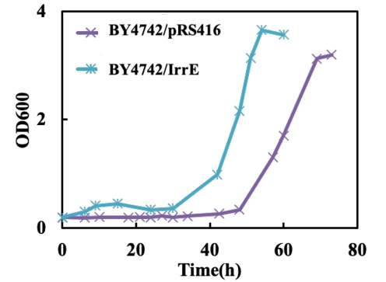
The growth behaviors of strain BY4742/pRS416 and BY4742/IrrE under acetic acid condition.

Figure S2
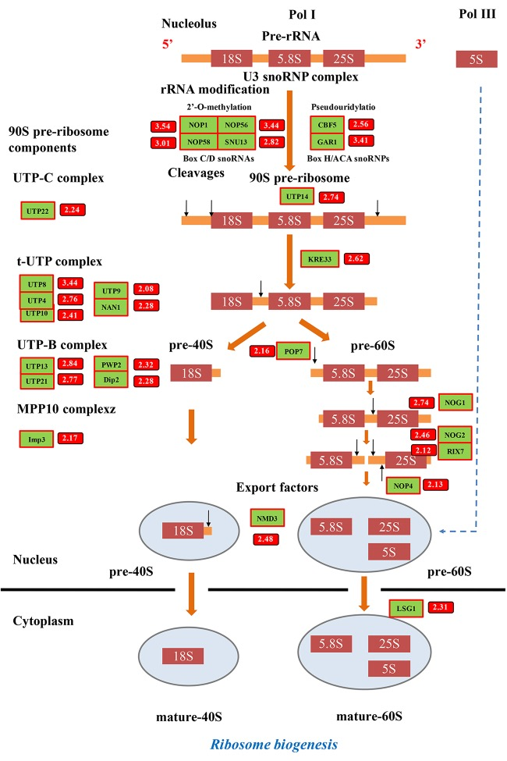
Transcriptional profiles of ribosome biogenesis by expressing I24. The strain BY4742/I24 and control strain BY4742/pRS416 were cultured in SC-Ura medium with FAP tolerance. Samples were taken in the middle of the lag phase. Box number exhibits transcriptional change, which is the foldchange of the transcriptional level of the strain BY4742/I24 to that of the control strain BY4742/pRS416. Upregulated genes were highlighted in red.

Figure S3
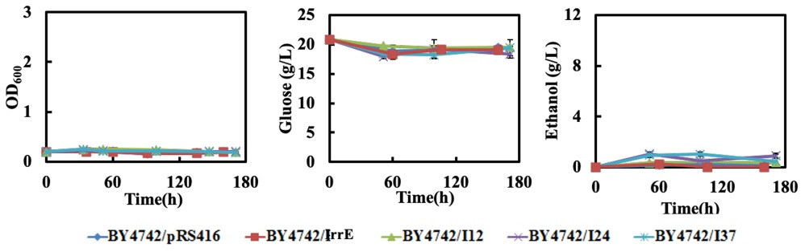
The growth behaviors, glucose consumption and ethanol production of strain BY4742/pRS416, BY4742/IrrE, BY4742/I12, BY4742/I24 and BY4742/I37 at 38 ºC in the presence of 0.8 g/L furfural, 3.0 g/L acetic acid and 0.3 g/L phenol.

Figure S4
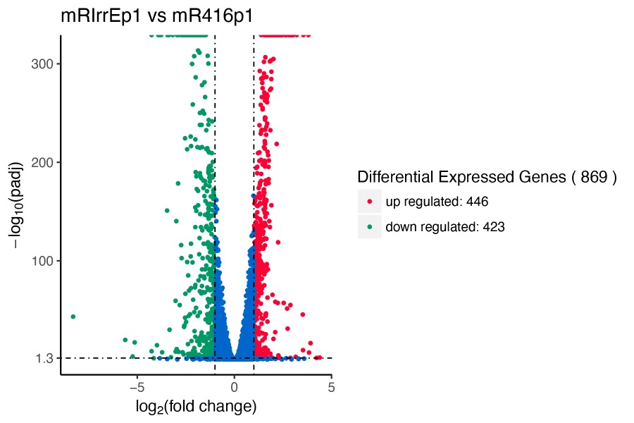
DEGs in the strain BY4742/IrrE in the presence of 0.8 g/L furfural, 3.0 g/L acetic acid and 0.3 g/L phenol. log₂foldchange>1.0 and p value<0.05

Figure S5
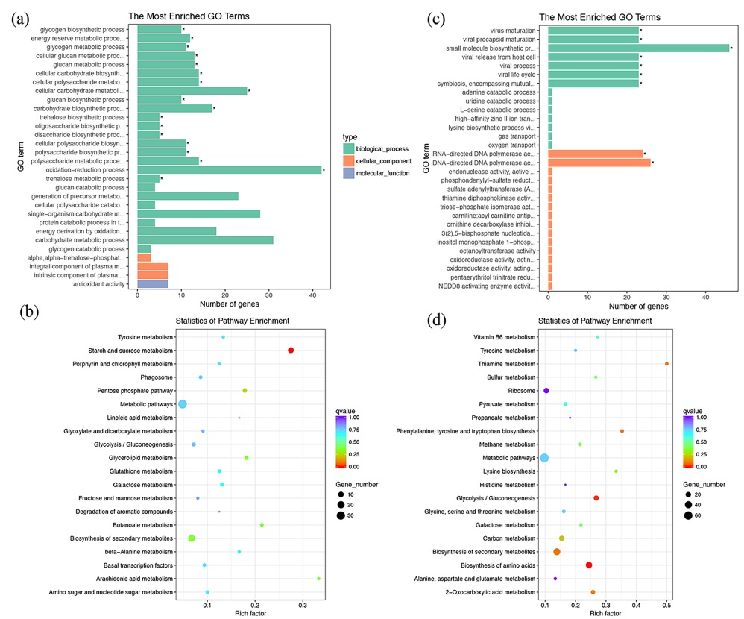
Representation of differentially expressed genes in selected Gene Ontology (GO) categories and KEGG pathways in the strain BY4742/IrrE after exposure to multiple inhibitors (0.8 g/L furfural, 3.0 g/L acetic acid and 0.3 g/L phenol) until the middle of the lag phase. (a) The most enriched GO terms of the upregulated genes. (b) The statistics of pathway enrichment of the upregulated genes. (c) The most enriched GO terms of the downregulated genes. (d) The statistics of pathway enrichment of the downregulated genes.

Figure S6
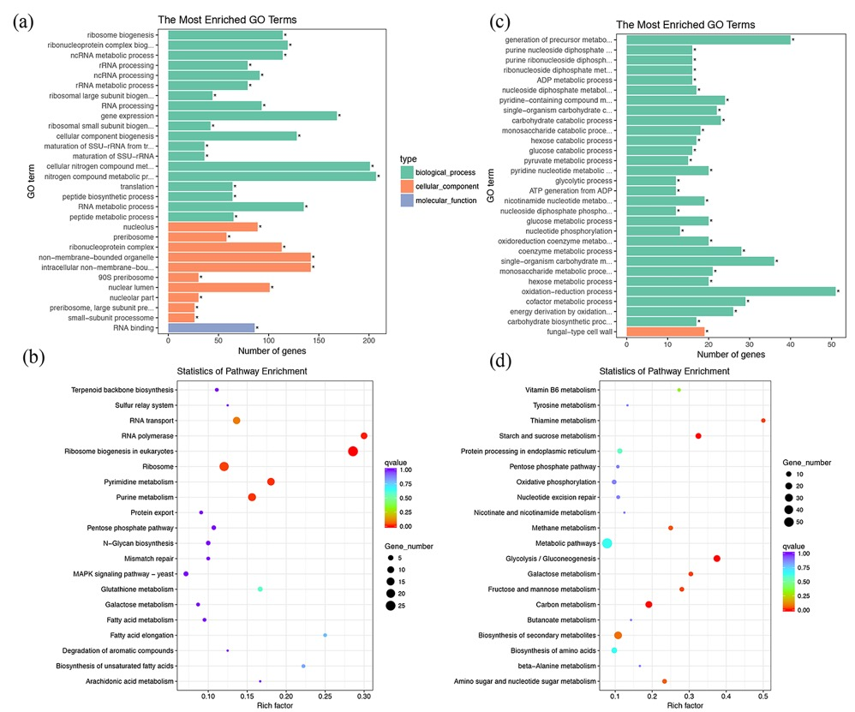
Representation of differentially expressed genes in selected Gene Ontology (GO) categories and KEGG pathways in the strain BY4742/I24 after exposure to multiple inhibitors (0.8 g/L furfural, 3.0 g/L acetic acid and 0.3 g/L phenol) until the middle of the lag phase. (a) The most enriched GO terms of the upregulated genes. (b) The statistics of pathway enrichment of the upregulated genes. (c) The most enriched GO terms of the downregulated genes. (d) The statistics of pathway enrichment of the downregulated genes.

Figure S7
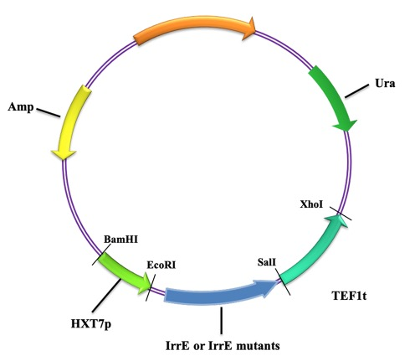
Plasmid map for plasmid pRS416-HXT7p-IrrE-TEF1t and IrrE library construction

