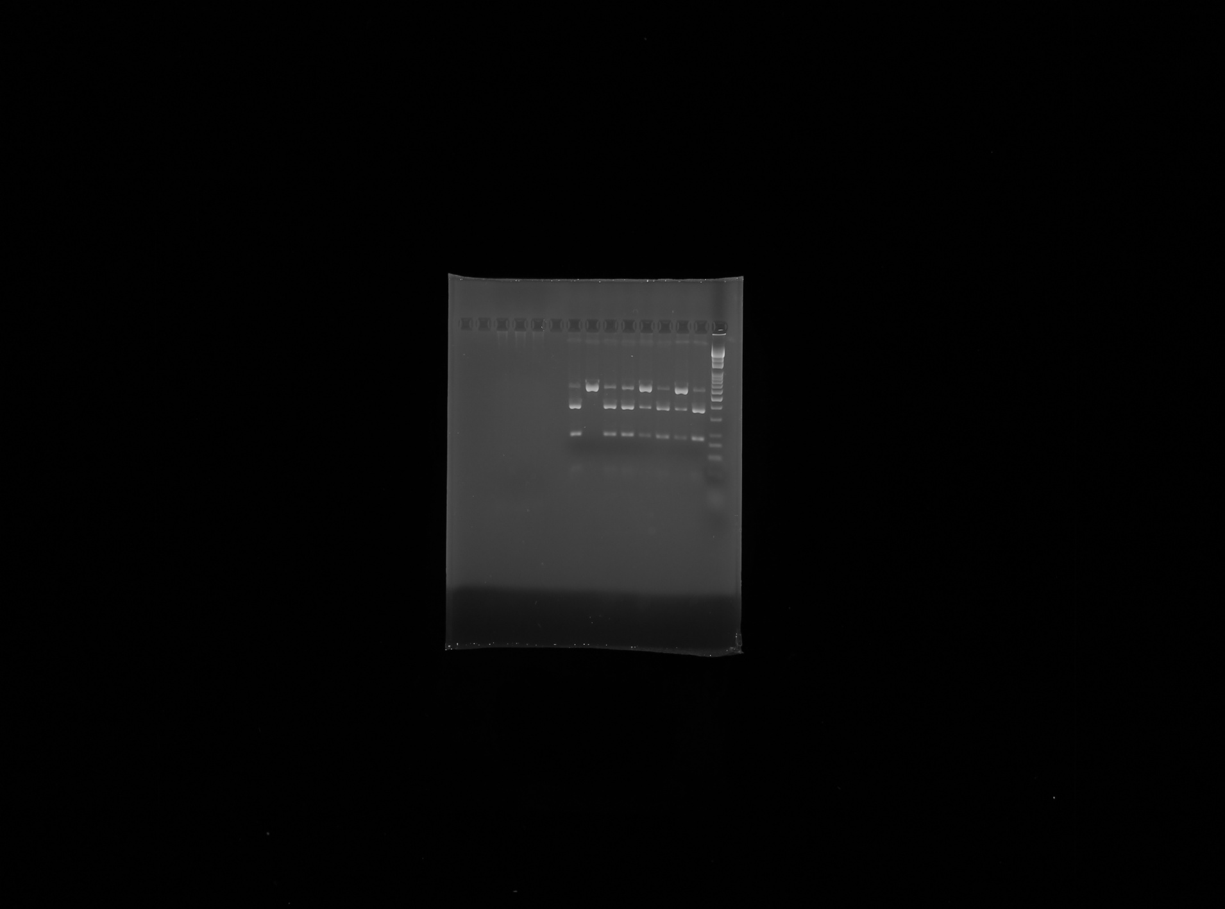
Pattern of 2% agarose gel electrophoresis of DNA samples for Arg389Gly-β₁AR polymorphism
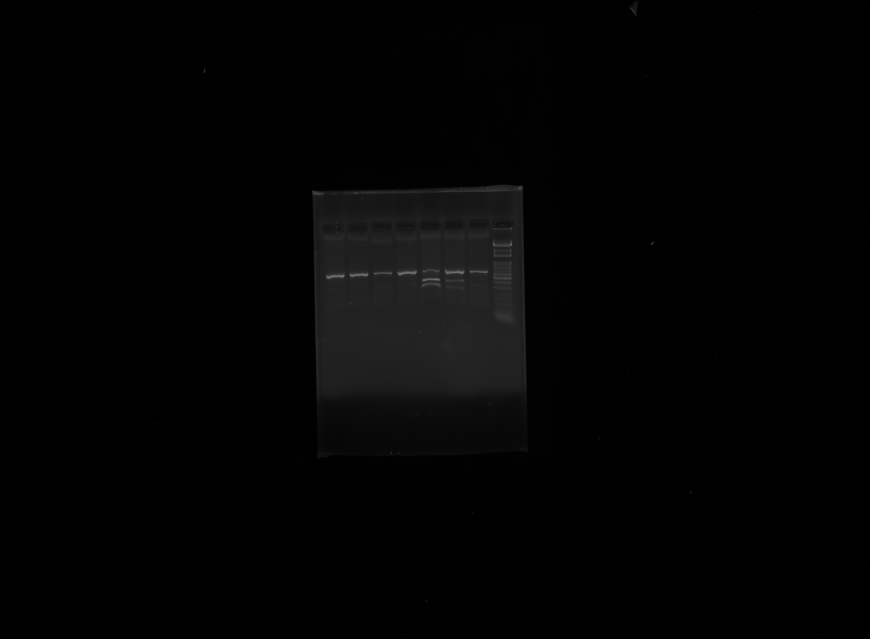
Pattern of 2% agarose gel electrophoresis of DNA samples for Ser49Gly-β₁AR polymorphism
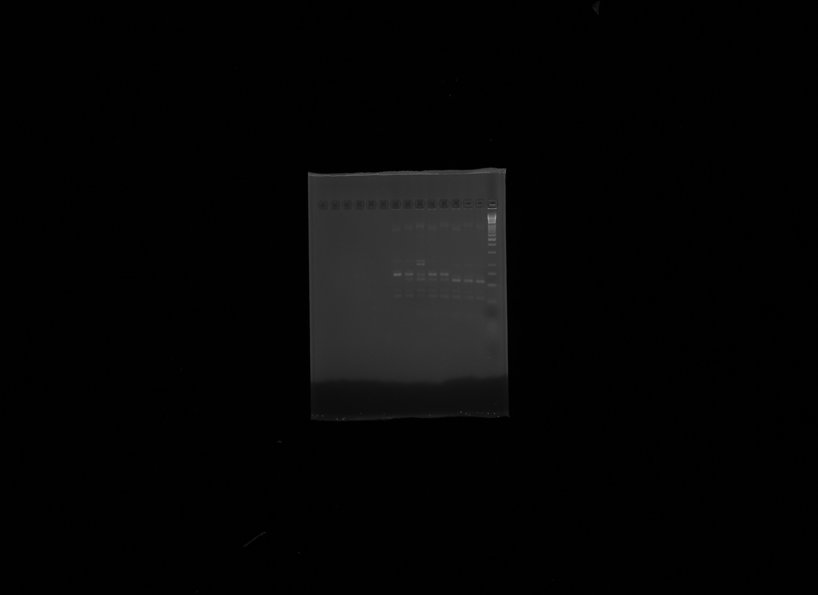
Pattern of 2% agarose gel electrophoresis of DNA samples for Arg16Gly-β₂AR polymorphism

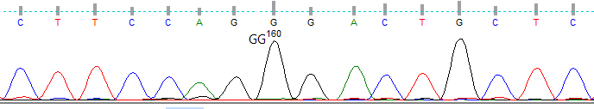

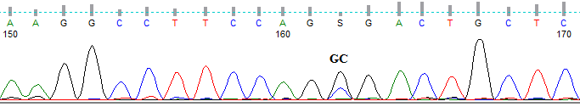

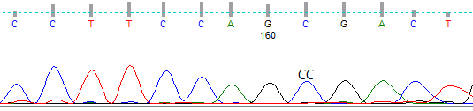

Sequence analysis of DNA samples for Arg389Gly-β₁AR

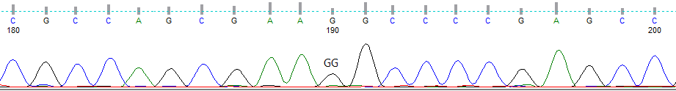

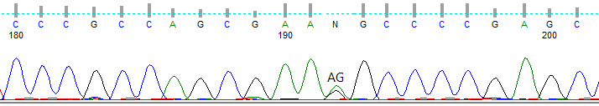

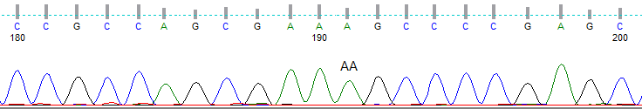

Sequence analysis of DNA samples for Ser49Gly-β₁AR

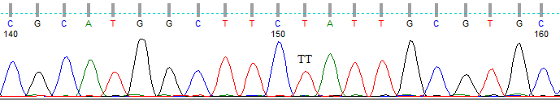

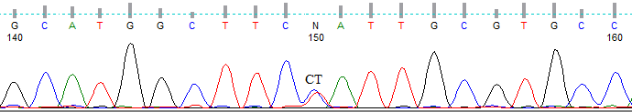

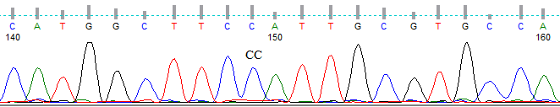

Sequence analysis of DNA samples for Arg16Gly-β₂AR

