Consent for Publication

Manuel Moya author of the manuscript ‘TRUNK FAT ESTIMATION ACCORDING TO GENDER IN CHILDHOOD THROUGH BASIC SOMATIC READINGS. An opportunity for improving girl’s evaluation’, gives full consent to WJP for its publication.
In agreement with this statement, I signed it on the 30th March 2021
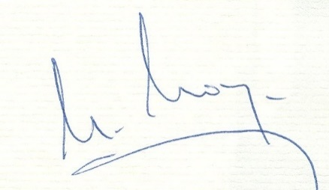
Manuel Moya
19359010W

Virginia Pérez-Fernández co-author of the manuscript ‘TRUNK FAT ESTIMATION ACCORDING TO GENDER IN CHILDHOOD THROUGH BASIC SOMATIC READINGS. An opportunity for improving girl’s evaluation’, gives full consent to WJP for its publication.
In agreement with this statement, I signed it on the 04 March 2021

PEREZ Digital signature of
FERNANDEZ PEREZ FERNANDEZ
VIRGINIA VIRGINIA- 34835975Z
34835975z Date: 2021. 03. 04
11:01: 24 +01’00’

