Supplementary Material

Figure S1
Figure S1. Location of the studied sites for nesting density and breeding success (red) of Bulwer’s petrel Bulweria bulwerii on Tenerife, Canary Islands, during 2017-2020 breeding seasons (see Table S1 for further details).

Figure S2
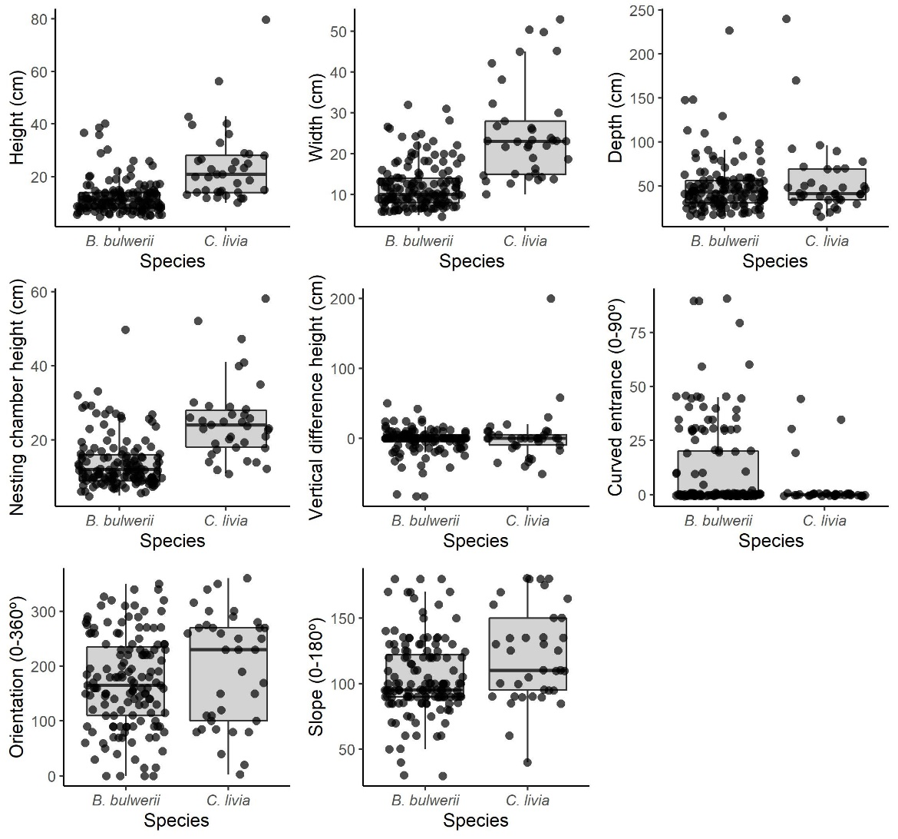
Figure S2. Comparison of eight variables describing nest features of Bulwer’s petrel Bulweria bulwerii and feral pigeon Columba livia on Tenerife, Canary Islands. Data have been jittered for a better visualization.

Figure S3
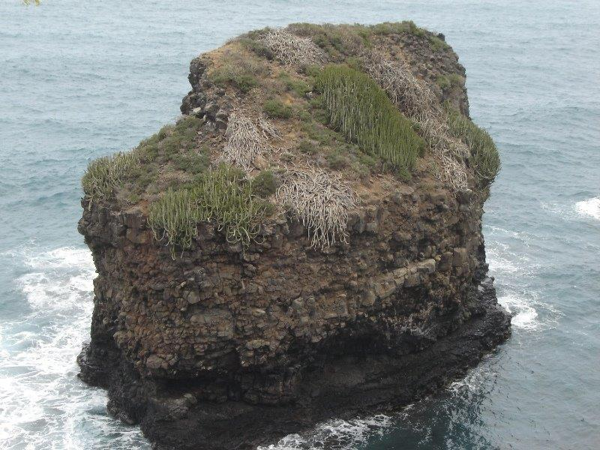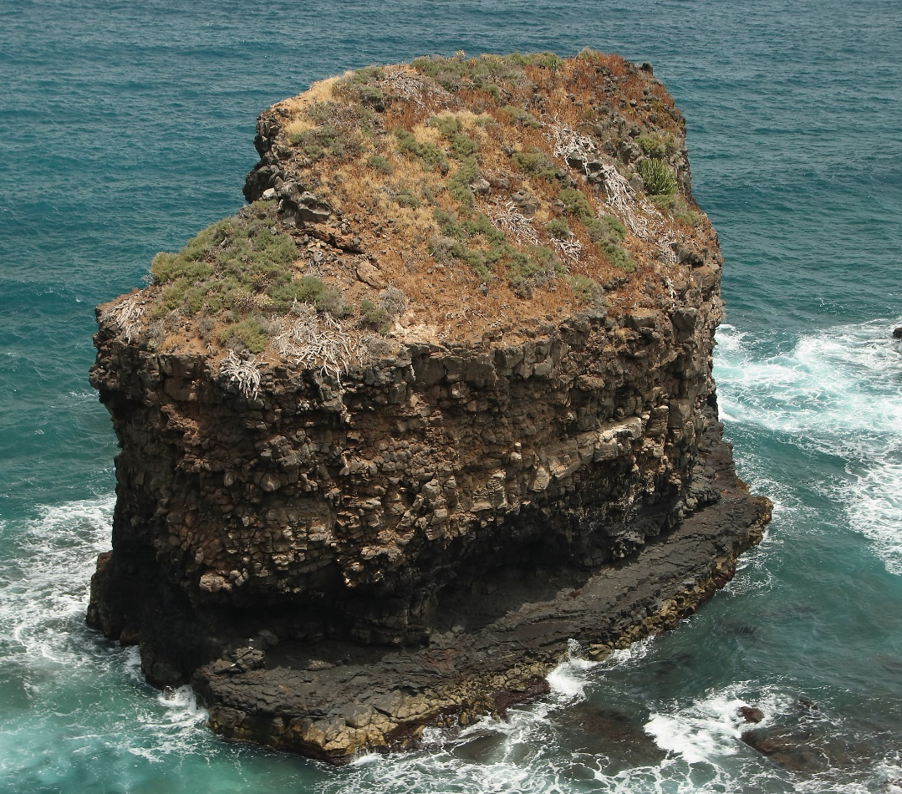
Figure S3. Photographs of Roque Grande (El Burgado, Los Realejos) taken in 2007 (top) and 2021 (bottom). Note the vegetation change. The number of Euphorbia canariensis have passed from nine large individuals in 2007 (top) to only one small individual in 2019 (bottom). Photo credit: José Miguel Martín Fariña (top) and Beneharo Rodríguez (bottom).

Table S1
Table S1. List of sites sampled for Bulwer’s petrel Bulweria bulwerii colonies on Tenerife, Canary Islands. Site id referred to figure S1. We provide habitat type (Island= main island; Rock = marine rock or stack), nest density of Bulwer’s petrel (number of nests/ha), abundance of Cory’s shearwaters Calonectris borealis (number of nests) and presence (1) or absence (0) of rock pigeons Columba livia, cats Felis catus or rats Rattus spp. ¹ Estimated using thermic monocular. S = South, E = East. Colonies where breeding success was studied are highlighted in red.
Id | Study site | Habitat | Nest Density | Calonectris  borealis | Columba  livia | Felis  catus | Rattus spp.
1 | Acantilado de Guaza1 | Island | 0.000 | 0 | 0 | 1 | 1
2 | Acantilado de Guaza2 | Island | 0.000 | 0 | 0 | 1 | 1
3 | Acantilado de Guaza3 | Island | 0.000 | 0 | 0 | 1 | 1
4 | Roque Callao Salvaje | Rock | 0.000 | 0 | 0 | 0 | 0
5 | Bahía Juan Lorenzo | Island | 0.000 | 0 | 0 | 1 | 1
6 | Acantilado de Isorana | Island | 0.000 | 0 | 0 | 1 | 1
7 | Punta de Sotavento | Island | 0.000 | 18 | 1 | 1 | 1
8 | Los Tiniques | Island | 0.000 | 76 | 1 | 1 | 1
9 | Roque La Hondura | Rock | 0.000 | 0 | 1 | 1 | 0
10 | Inmed. Galería Jurado | Island | 0.175 | 0 | 1 | 1 | 1
11 | Punta del Gigante | Island | 0.994 | 9 | 1 | 1 | 1
12 | Playa del Gigante | Island | 5.057 | 2 | 0 | 0 | 1
13 | La Jaqueta | Island | 1.988 | 2 | 1 | 0 | 1
14 | Los Pedrones | Island | 11.442 | 13 | 0 | 0 | 1
15 | Punta La Higuera | Island | 0.000 | 1 | 0 | 1 | 1
16 | Morro La Galera | Island | 0.395 | 0 | 0 | 0 | 1
17 | Juan López | Island | 0.126 | 0 | 0 | 1 | 1
18 | La Hábiga | Island | 0.000 | 0 | 0 | 0 | 1
19 | Teno Bajo | Island | 0.277 | 0 | 0 | 1 | 1
20 | La Tosquita | Island | 2.611 | 0 | 0 | 1 | 1
21 | La Puntilla | Rock | 0.000 | 0 | 1 | 0 | 0
22 | Roque Garachico | Rock | 3.965 | 32 | 1 | 0 | 0
23 | Roque Los Lagartos ¹ | Rock | 0.000 | 0 | 1 | 0 | 0
24 | Roque del Garajao ¹ | Rock | 6.568 | 0 | 0 | 0 | 0
25 | Roque La Coronela | Rock | 62.385 | 1 | 0 | 0 | 0
26 | Tasana | Island | 0.000 | 10 | 1 | 1 | 1
27 | Acantilados de La Guancha | Island | 0.090 | 31 | 0 | 1 | 1
28 | Roque Chico S. J. Rambla | Rock | 17.725 | 0 | 1 | 0 | 0
29 | Roque Grande S. J. Rambla | Rock | 13.961 | 0 | 1 | 0 | 0
30 | Roque Chico Burgado ¹ | Rock | 0.000 | 0 | 1 | 0 | 0
31 | Roque Grande Burgado ¹ | Rock | 0.000 | 0 | 1 | 0 | 0
32 | La Rapadura | Rock | 0.000 | 8 | 0 | 1 | 1
33 | Roque La Playa | Rock | 4.313 | 0 | 1 | 0 | 0
34 | Roque El Clavo | Rock | 8.256 | 0 | 1 | 0 | 0
35 | El Clavo-Risco Firme | Island | 2.110 | 0 | 0 | 1 | 1
36 | La Barranquera | Island | 0.147 | 0 | 0 | 1 | 1
37 | Roque La Fajana | Rock | 0.000 | 0 | 0 | 0 | 0
38 | Punta Salvaje | Island | 0.000 | 88 | 0 | 1 | 1
39 | Roque de Tierra Anaga (S) | Rock | 10.035 | 41 | 0 | 0 | 0
40 | Roque de Tierra Anaga (E) | Rock | 2.250 | 2 | 1 | 0 | 0
41 | Roque de Fuera Anaga | Rock | 3.335 | 213 | 0 | 0 | 0
42 | Punta El Jurado-Palmital | Island | 0.000 | 4 | 0 | 1 | 1
43 | Punta Salinas Anaga | Island | 0.000 | 33 | 0 | 1 | 1

Table S2
Table S2. Breeding success of Bulwer’s petrel Bulweria bulwerii in the studied colonies on Tenerife, Canary Islands, during three breeding seasons.
Id | Study site | Density of |  | Breeding success % (n)
 |  | Rats | Pigeons | 2018 | 2019 | 2020 | Total
14 | Los Pedrones | High | Absence | 53.8 (13) | 0 (7) | 0 (8) | 25.0 (28)
22 | Roque de Garachico | Absence | Low | 60.0 (25) | 61.5 (26) | 34.8 (23) | 52.7 (74)
25 | Roque La Coronela | Absence | Absence | 53.8 (13) | 52.9 (17) | 64.3 (14) | 56.8 (44)
28 | R. Chico S. J. Rambla | Absence | High | 71.4 (7) | 60.0 (5) | 100.0 (5) | 76.5 (17)
29 | R. Grande S. J. Rambla | Absence | High | 76.9 (13) | 60.0 (15) | 55.6 (18) | 63.0 (46)
 | Total |  |  | 62.0 (71) | 52.9 (70) | 47.1 (68) | 54.1 (209)

Table S3
Table S3. Physic characteristics of nest cavities used by Bulwer’s petrel Bulweria bulwerii and feral pigeon Columba livia on Tenerife, Canary Islands.
Variable | Bulwer’s petrel  (n = 139) | Feral pigeon  (n = 37) | Permutation test  p-value 99% CI
Nest type (%)
Rock crevice | 52.5 | 94.6
Soil crevice | 6.4 | 0
Burrow | 41.1 | 5.4
Height | 12.36 ± 6.57 | 24.08 ± 14.06 | < 0.001
Width | 12.22 ± 5.62 | 25.22 ± 11.66 | < 0.001
Depth | 48.50 ± 28.80 | 55.08 ± 42.46 | 0.670 - 0.694
Nesting chamber height | 13.78 ± 6.91 | 25.22 ± 10.85 | < 0.001
Vertical difference height | -2.78 ± 18.14 | 2.54 ± 38.86 | 0.920 - 0.933
Curved entrance | 11.85 ± 20.54 | 3.51 ± 10.66 | 0.005 - 0.009
Slope | 104.5 ± 29.0 | 121.4 ± 36.0 | 0.005 - 0.010
Nest material (%)
Yes | 42.1 | 100
No | 57.9 | 0

