Supplementary Tables
Supplementary Table 1. Details of sampling environmental conditions
Sample ID | Sample type | Detection time | Ambient temperature | Humidity | Sunlight (LUX) | Soil temperature | Sampling zone
LR-01 | Rock | 10:44 AM | 21.5 | 60 % | 256-260 | Nil | Outside cave
LS-01 | Soil |  |  |  | 256-261 | 18.5
LR-05 | Rock | 11:55 AM | 23.3 | 63 % | 0 | Nil | Inside cave
LS-05 | Soil |  |  |  | 0 | 18.3

LR-01, LS-01: outside the cave; LR-05, LS-05: inside the cave

Supplementary Table 2. Pearson’s correlation test against predominant bacteria phylum with environmental factors
Correlations
 |  | 1 | 2 | 3 | 4 | 5 | 6 | 7 | 8 | 9 | 10 | 11
1 | Planctomycetes
2 | Proteobacteria | 0.86
3 | Acidobacteria | -0.57 | -0.87
4 | Actinobacteria | -0.71 | -0.71 | 0.30
5 | Nitrospirae | 0.07 | -0.03 | 0.46 | -0.68
6 | Chloroflexi | -0.89 | -0.86 | 0.80 | 0.39 | 0.37
7 | Gemmatimonadetes | -0.83 | -0.86 | 0.86 | 0.32 | 0.46 | .99**
8 | Cyanobacteria | 0.77 | .98* | -0.95 | -0.58 | -0.19 | -0.85 | -0.88
9 | Temperature | 0.13 | -0.38 | 0.52 | 0.28 | -0.08 | -0.06 | 0.03 | -0.46
10 | Humidity | -0.91 | -0.89 | 0.54 | 0.93 | -0.38 | 0.70 | 0.64 | -0.78 | 0.19
11 | Sunlight | 0.91 | 0.89 | -0.54 | -0.93 | 0.39 | -0.70 | -0.64 | 0.78 | -0.19 | -1.00**
*. Correlation is significant at the 0.05 level (2-tailed).
**. Correlation is significant at the 0.01 level (2-tailed).

Supplementary Table 3. KEGG pathway normalized OTU reads for rock and soil samples collected outside and inside the cave.
Super pathway | Sub pathway | LR-01 | LS-01 | LR-05 | LS-05
Carbohydrate metabolism | Starch and sucrose metabolism | 0.0051 | 0.0082 | 0.0040 | 0.0062
 | Galactose metabolism | 0.0845 | 0.0731 | 0.0817 | 0.0809
 | Amino sugar and nucleotide sugar metabolism | 0.0004 | 0.0010 | 0.0004 | 0.0005
 | Fructose and mannose metabolism | 0.0003 | 0.0000 | 0.0000 | 0.0000
 | Pentose phosphate pathway | 0.0288 | 0.0162 | 0.0245 | 0.0245
 | Citrate cycle (TCA cycle) | 0.0420 | 0.0746 | 0.0685 | 0.0543
 | Ascorbate and aldarate metabolism | 0.0808 | 0.0700 | 0.0802 | 0.0791
Amino acid metabolism | Arginine and proline metabolism | 0.1093 | 0.0798 | 0.1075 | 0.1069
 | Phenylalanine metabolism | 0.0006 | 0.0021 | 0.0041 | 0.0014
 | Glycine, serine and threonine metabolism | 0.0499 | 0.0324 | 0.0368 | 0.0418
Other amino acid metabolism | Glutathione metabolism | 0.0014 | 0.0061 | 0.0045 | 0.0044
Lipid metabolism | Glycerophospholipid metabolism | 0.0047 | 0.0126 | 0.0037 | 0.0071
Xenobiotics biodegradation and metabolism | Bisphenol degradation | 0.0382 | 0.0321 | 0.0299 | 0.0359
 | Benzoate degradation | 0.0139 | 0.0163 | 0.0134 | 0.0136
Energy metabolism | Photosynthesis - antenna proteins | 0.0000 | 0.0000 | 0.0001 | 0.0000
 | Carbon fixation pathways in prokaryotes | 0.0027 | 0.0071 | 0.0044 | 0.0035
 | Methane metabolism | 0.0101 | 0.0135 | 0.0092 | 0.0054
Membrane transport | ABC transporters | 0.0319 | 0.0507 | 0.0282 | 0.0216

LR-01, LS-01: outside the cave; LR-05, LS-05: inside the cave

Supplementary Table 4. Primer information list.
Primer type | Primer name | Basepair sequence
Forward | 341F | CCTACGGGNGGCWGCAG
Reverse | 805R | GACTACHVGGGTATCTAATCC

Supplementary Figures
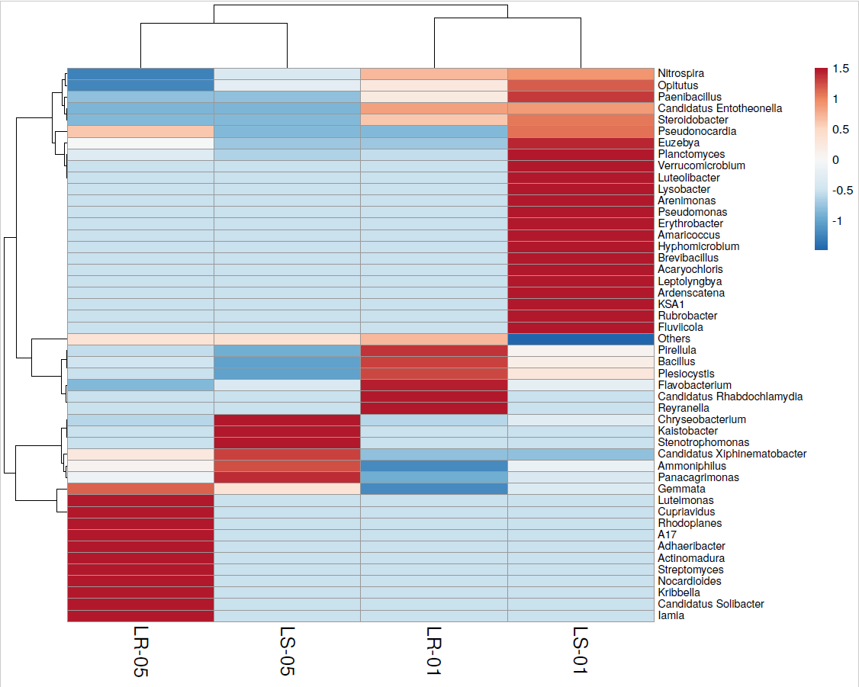

Supplementary Figure 1. Heatmap analysis with dendrogram plot at the genus level for all samples

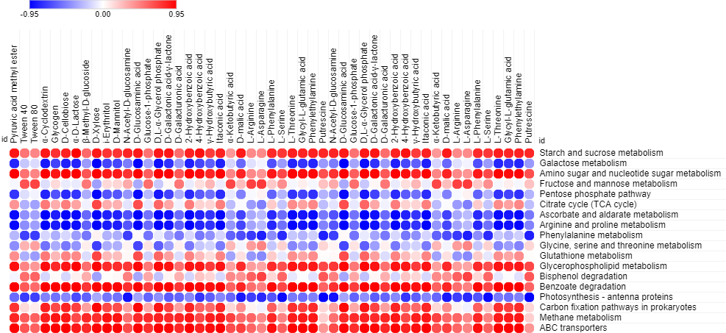

Supplementary Figure 2. Visualization of Pearson’s correlation statistical test with 31 Biolog EcoPlate™ carbon sources according to the functional KEGG pathway prediction data of the bacterial communities

