Supplementary data

Cellulase production by a newly isolated soil fungus Penicillium griseofulvum A2
Fachun Guan ¹, Jie Liu ², Jinling Cai ², Chunyan Qi ¹, Yanru Cui ^{1,} , Ligang Hou ^{1, *}, Xie Jiao ¹, Zhonghe Li ¹

- Jilin Academy of Agricultural Sciences, Changchun 130033, China.
- College of Chemical Engineering and Materials Science, Tianjin University of Science & Technology, Tianjin Key Laboratory of Brine Chemical Engineering and Resource Eco-utilization, Tianjin 300457, China.

- ITS sequence (MW874977)
TCCGAAGCTGTGGAAGGATCATTCGGGAGTGCGGGCCCCTCGGGGGCCAA
CCTCCCACCCGTGTTGCCCGAACCTATGTTGCCTCGGCGGGCCCCGCGCC
CGCCGACGGCCCCCCTGAACGCTGTCTGAAGTTGCAGTCTGAGACCTATA
ACGAAATTAGTTAAAACTTTCAACAACGGATCTCTTGGTTCCGGCATCGA
TGAAGAACGCAGCGAAATGCGATAACTAATGTGAATTGCAGAATTCAGTG
AATCATCGAGTCTTTGAACGCACATTGCGCCCTCTGGTATTCCGGAGGGC
ATGCCTGTCCGAGCGTCATTGCTGCCCTCAAGCCCGGCTTGTGTGTTGGG
CCCCGTCCCCCCCGCCGGGGGGACGGGCCCGAAAGGCAGCGGCGGCACCG
CGTCCGGTCCTCGAGCGTATGGGGCTTCGTCACCCGCTCTAGTAGGCCCG
GCCGGCGCCAGCCGACCCCCAACCTTTAATTATCTCAGGTTGACCTCGGA
TCAGGTAGGGATACCCGCTGAACTTAAGCATATCAATAAGGCGGAGGAAC

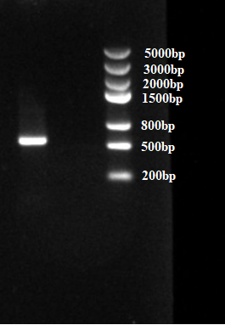
Figure 1. Agarose gel electrophoresis of Amplified ITS sequence.

Corresponding author: Jilin Academy of Agricultural Sciences, E-mail: 434965430@163.com (Yanru Cui) and houligang888@163.com (Ligang Hou).

