TableS1. The correlation matrix of 12 metal(loid)s in whole blood of COVID-19 patients.
 | Mg
Ca | -0.21
 | 0.0002 | Ca
Cr | -0.06 | 0.30 |  |  |  |  | < -0.4 |  | 0 ~ 0.2
 | 0.3173 | <0.0001 | Cr |  |  |  | -0.4 ~ -0.2 |  | 0.2 ~ 0.4
Mn | 0.32 | -0.25 | -0.15 |  |  |  | -0.2 ~ 0 |  | 0.4 ~ 0.6
 | <0.0001 | <0.0001 | 0.0081 | Mn |  |  |  |  | > 0.6
Fe | 0.55 | -0.59 | -0.35 | 0.51
 | <0.0001 | <0.0001 | <0.0001 | <0.0001 | Fe
Cu | -0.06 | 0.35 | 0.19 | -0.08 | -0.22
 | 0.3194 | <0.0001 | 0.0007 | 0.1811 | 0.0001 | Cu
Zn | 0.36 | -0.52 | -0.09 | 0.32 | 0.64 | -0.08
 | <0.0001 | <0.0001 | 0.1304 | <0.0001 | <0.0001 | 0.1432 | Zn
As | 0.24 | -0.30 | -0.30 | 0.37 | 0.50 | -0.20 | 0.30
 | <0.0001 | <0.0001 | <0.0001 | <0.0001 | <0.0001 | 0.0003 | <0.0001 | As
Cd | -0.09 | -0.01 | -0.05 | 0.13 | 0.01 | 0.11 | 0.08 | 0.01
 | 0.1312 | 0.8109 | 0.4083 | 0.0230 | 0.8718 | 0.0600 | 0.1757 | 0.9105 | Cd
Hg | 0.15 | -0.22 | -0.05 | 0.19 | 0.31 | 0.00 | 0.27 | 0.23 | -0.04
 | 0.0071 | 0.0002 | 0.3820 | 0.0010 | <0.0001 | 0.9753 | <0.0001 | <0.0001 | 0.4855 | Hg
Tl | 0.01 | -0.14 | -0.21 | 0.18 | 0.27 | -0.06 | 0.12 | 0.43 | 0.10 | 0.12
 | 0.8112 | 0.0159 | 0.0002 | 0.0018 | <0.0001 | 0.3329 | 0.0397 | <0.0001 | 0.0741 | 0.0386 | Tl
Pb | 0.22 | -0.15 | -0.14 | 0.17 | 0.32 | 0.13 | 0.26 | 0.21 | 0.32 | 0.09 | 0.12
 | 0.0001 | 0.0083 | 0.0131 | 0.0031 | <0.0001 | 0.0195 | <0.0001 | 0.0002 | <0.0001 | 0.1278 | 0.0415
Notes: correlation coefficients (CC, above) and p values (below). Abbreviations: Mg, magnesium; Ca, calcium; Cr, chromium; Mn, manganese; Fe, iron; Cu, copper; Zn, Zinc; As, arsenic; Cd, cadmium; Hg, mercury; Tl, thallium; Pb, lead.

Table S2. The Cut-off points of laboratory findings in COVID-19 patients by applying ROC
Parameter | Disease status |  |  |  |  |  | Outcome
 | Cut-off | Sensitivity | Specificity | AUC (95% CI) | P |  | Cut-off | Sensitivity | Specificity | AUC (95% CI) | P
Mg | 40.52 | 0.45 | 0.78 | 0.61 (0.54 - 0.67) | 0.002 |  | 35.95 | 0.87 | 0.33 | 0.53 (0.39 - 0.68) | 0.681
Ca | 68.00 | 0.53 | 0.80 | 0.66 (0.59 - 0.72) | < 0.001 |  | 62.91 | 0.73 | 0.47 | 0.56 (0.37 - 0.74) | 0.491
Cr | 1.03 | 0.51 | 0.82 | 0.68 (0.62 - 0.74) | < 0.001 |  | 1.32 | 0.67 | 0.83 | 0.77 (0.64 - 0.9) | 0.001
Mn | 10.98 | 0.72 | 0.58 | 0.68 (0.61 - 0.74) | < 0.001 |  | 10.90 | 0.48 | 0.67 | 0.53 (0.38 - 0.69) | 0.687
Fe | 376.67 | 0.81 | 0.55 | 0.73 (0.67 - 0.79) | < 0.001 |  | 343.25 | 0.69 | 0.53 | 0.56 (0.39 - 0.74) | 0.424
Cu | 823.98 | 0.78 | 0.47 | 0.65 (0.59 - 0.72) | < 0.001 |  | 1090.65 | 0.40 | 0.81 | 0.57 (0.4 - 0.74) | 0.392
Zn | 6.54 | 0.53 | 0.67 | 0.61 (0.55 - 0.68) | 0.001 |  | 5.46 | 1.00 | 0.22 | 0.55 (0.41 - 0.7) | 0.508
As | 1.24 | 0.76 | 0.63 | 0.74 (0.68 - 0.8) | < 0.001 |  | 0.96 | 0.70 | 0.80 | 0.75 (0.61 - 0.89) | 0.002
Cd | 0.61 | 0.65 | 0.42 | 0.52 (0.45 - 0.58) | 0.654 |  | 0.68 | 0.93 | 0.55 | 0.75 (0.63 - 0.87) | 0.002
Hg | 1.70 | 0.50 | 0.64 | 0.55 (0.48 - 0.62) | 0.122 |  | 1.62 | 0.60 | 0.64 | 0.61 (0.43 - 0.78) | 0.194
Tl | 0.05 | 0.52 | 0.82 | 0.67 (0.61 - 0.73) | < 0.001 |  | 0.06 | 0.15 | 0.93 | 0.53 (0.38 - 0.68) | 0.708
Pb | 11.24 | 0.59 | 0.61 | 0.59 (0.52 - 0.66) | 0.012 |  | 7.21 | 0.92 | 0.40 | 0.54 (0.33 - 0.74) | 0.647
Abbreviations: Mg, magnesium; Ca, calcium; Cr, chromium; Mn, manganese; Fe, iron; Cu, copper; Zn, Zinc; As, arsenic; Cd, cadmium; Hg, mercury; Tl, thallium; Pb, lead.

Supplementary Figures

Figure S1. Whole blood levels of 12 metal(loid)s in 306 COVID-19 patients between non-severe and severe group. Difference between non-severe and severe group were tested by using Mann-Whitney U test. Data are shown as median and interquartile range and were tested for significance at * p < 0.05. Gray dotted line and dashed line represented normal lower and upper limit, respectively. Abbreviations: Mg, magnesium; Ca, calcium; Cr, chromium; Mn, manganese; Fe, iron; Cu, copper; Zn, zinc; As, arsenic; Cd, cadmium; Hg, mercury; Tl, thallium; Pb, lead.

Figure S2. Whole blood levels of 12 metal(loid)s in the severe patients with COVID-19 between deceased and recovered group. Difference between deceased and recovered group were tested by using Mann-Whitney U test. Data are shown as median and interquartile range and were tested for significance at * p < 0.05. Gray dotted line and dashed line represented normal lower and upper limit, respectively. Abbreviations: Mg, magnesium; Ca, calcium; Cr, chromium; Mn, manganese; Fe, iron; Cu, copper; Zn, zinc; As, arsenic; Cd, cadmium; Hg, mercury; Tl, thallium; Pb, lead.

Figure S1
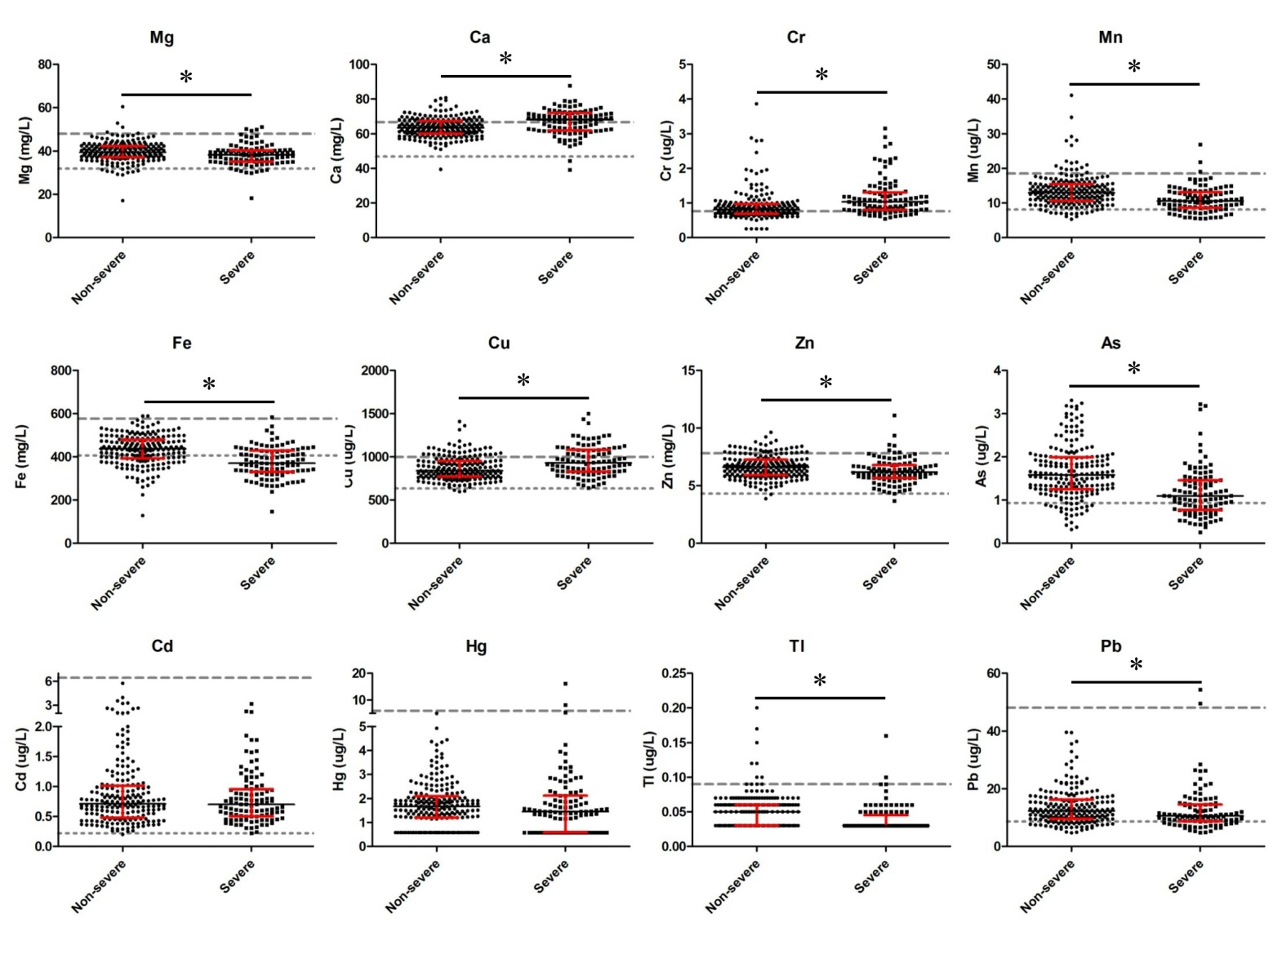
Figure S2
