Supplementary Information for paper
An ultra-low magnetic field thermal demagnetizer for high-precision paleomagnetism
Huafeng Qin¹, Xiang Zhao^{1，2}, Shuangchi Liu¹, Greig A. Paterson^{3,4}, Zhaoxia Jiang^{1,5}, Shuhui Cai¹, Jinhua Li³, Qingsong Liu^{1,6}, Rixiang Zhu¹
¹ State Key Laboratory of Lithospheric Evolution, Institute of Geology and Geophysics, Chinese Academy of Sciences, Beijing 100029, China
² Research School of Earth Sciences, Australian National University, Canberra, ACT 2601, Australia
³Key Laboratory of Earth and Planetary Physics, Institute of Geology and Geophysics, Chinese Academy of Sciences, Beijing 100029, China
⁴ Department of Earth, Ocean and Ecological Sciences, University of Liverpool, Liverpool L69 7ZE, UK
⁵ Key Laboratory of Submarine Geosciences and Prospecting Techniques, Ministry of Education, and College of Marine Geosciences, Ocean University of China, 266100 Qingdao, P.R. China
⁶ Department of Marine Science and Engineering, Southern University of Science and Technology, Shenzhen 518055, China

- Specimen description and thermal demagnetization of TRM
To verify the thermal demagnetization performance of our new furnace, we explored the thermal demagnetization behavior of synthetic hematite specimens. Hematite specimens synthesized in the lab were chosen to avoid potential thermochemical changes during multiple heatings. The particles of hematite are cubic and with a broadly uniform size distribution with an average length and width of 570 nm and 545 nm, respectively. In addition, the weak magnetizations of hematite are suitable for checking the effects of weak background fields.
Eight synthetic specimens were prepared by mixing hematite with quartz sand (5 g), Kaolinite (5 g) into 20 ml deionized water in water. The mixtures were then loaded into ceramic boxes (2×2×2 cm) and allowed to dry and consolidate in ambient atmosphere Five of the specimens contained more hematite were classified as strong specimens (D2-1, 2, 4-6), and the other three contained less hematite are classified as weak specimens (D2-7,8,12).
To investigate if these demagnetization experiments are influenced by undesirable magnetic fields from the furnace, we adopt a different style of thermal demagnetization procedure. Progressive thermal demagnetization of TRM was carried out to identify the unblocking temperature spectrum of the studied specimens. A full TRM was acquired by cooling specimens from 700°C in the presence of a 30 µT field using the MMTD-SC paleointensity furnace, then progressive thermal demagnetization was performed by removing the applied field. The amplitudes of the TRMs range from 1.13×10⁻⁶ Am² to 0.65×10⁻⁶ Am² for strongly magnetic specimens and from 1.52×10⁻⁷ Am² to 1.88×10⁻⁷ Am² for weakly magnetic specimens. Subsequently, specimens were subject to stepwise progressive thermal demagnetization up to 700°C in our new furnace.
During demagnetization we used temperature intervals of 100°C below 500°C and 10°C above 600°C. After each heating and cooling step, remanences were measured. The results are shown in Figure S1. The intensities of remanent magnetization of all specimens did not change significantly until 600°C and began to reduce rapidly above 640°C (Figure S1a-e), which indicates the distribution of unblocking temperatures is relatively narrow and is consistent with narrow size distribution of hematite. For the weak specimens, there are small inflection around 580-600°C which indicate that these samples could have a small amount of magnetite. The inflection also presents in strong specimens as well, but the signal is buried by the relatively strong total magnetization. We note that two specimens (D2-1, D2-2), which were placed on the door side of the furnace, are complete demagnetization at 680°C, but other specimens are demagnetized by the 670°C step. This is possibly caused by thermal gradients in the sample zone.
Orthogonal projection diagrams (Zijderveld 1967) indicate that the directions shift a little at low temperatures, but this is likely due to measurement errors and manual handling of the specimens between steps. The magnetic moments of terminal demagnetization steps are less than one percent of initial total TRM and lie close to the origin of the plots (the inserts in Figure S1).
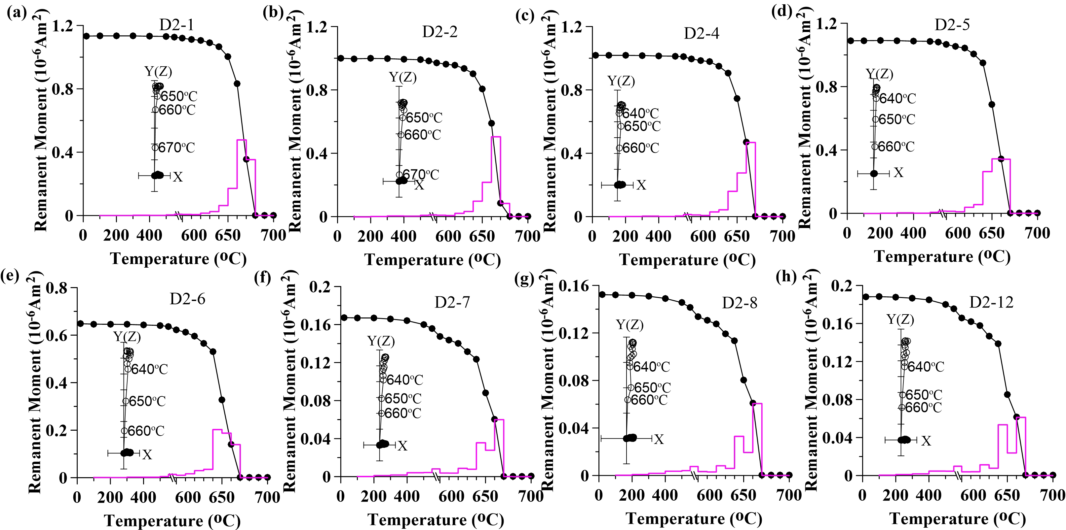
Figure S1. Thermal demagnetization curve (black symbol and line) and corresponding orthogonal plot (inserts) of progressive thermal demagnetization of TRM (30 μT, 700°C) of synthetic specimens. Solid (open) circles indicate projection on the horizontal (vertical) plane in orthogonal plot. The numbers close to the symbols for the vertical plane projections indicate the level of stepwise demagnetization. The purple line is the demagnetization proportion of individual temperature range.

- Repeated progressive thermal demagnetization behavior for new furnaces
The repeated thermal demagnetization experiment is carried out after the specimens were heated up to 700°C for complete demagnetization. We aimed to keep specimens in the same angle and position while placing them on the sample holder during heating and cooling in the furnace. Since the magnetic moments are relatively weak, the sample holder of the cryogenic magnetometer was cleaned before each measurement. The measurements were repeated twice and the drift value was kept less than 5.0×10⁻¹¹Am².
The experimental results are shown in Figure S2. The initial moments range from 6.5×10⁻¹¹Am² to 2.8×10⁻¹⁰Am² for strong specimens and from 2.5×10⁻¹¹Am² to 9.4×10⁻¹¹Am² for weak specimens. These are about 0.02-0.05% of the 30 µT TRM. These experiments also confirm that the specimens have relatively stable (within the limits of noise) moments below 640°C. The magnetic moments and directions of all specimens clearly change in the 650-700ºC temperature interval, indicating that the new thermal demagnetizer is affected by field noise. We note, however, that the changes in the magnetic moments are very low relative to total TRM. Some of the magnetic moments do not always increase, but also decrease (e.g., Figure S2a, b). It is possible due to the superimposed remanence caused by the noise field is limited and opposite to the previous remanence direction.
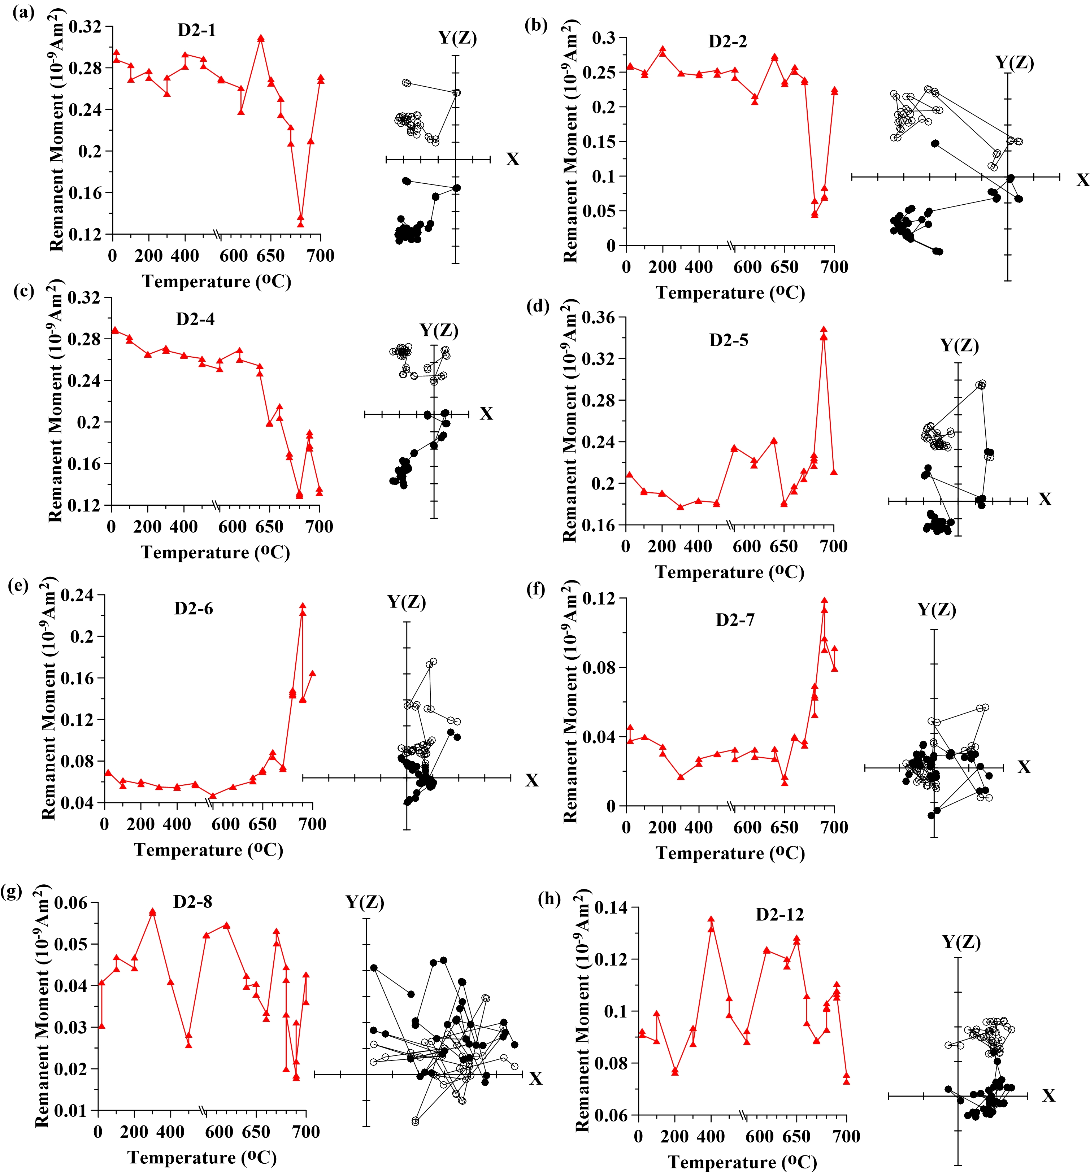
Figure S2. The thermal demagnetization curve (red symbol and line, left) and corresponding orthogonal plot (right) of repeated progressive thermal demagnetization of the synthetic hematite specimens. Solid (open) circles indicate projection on the horizontal (vertical) plane.

