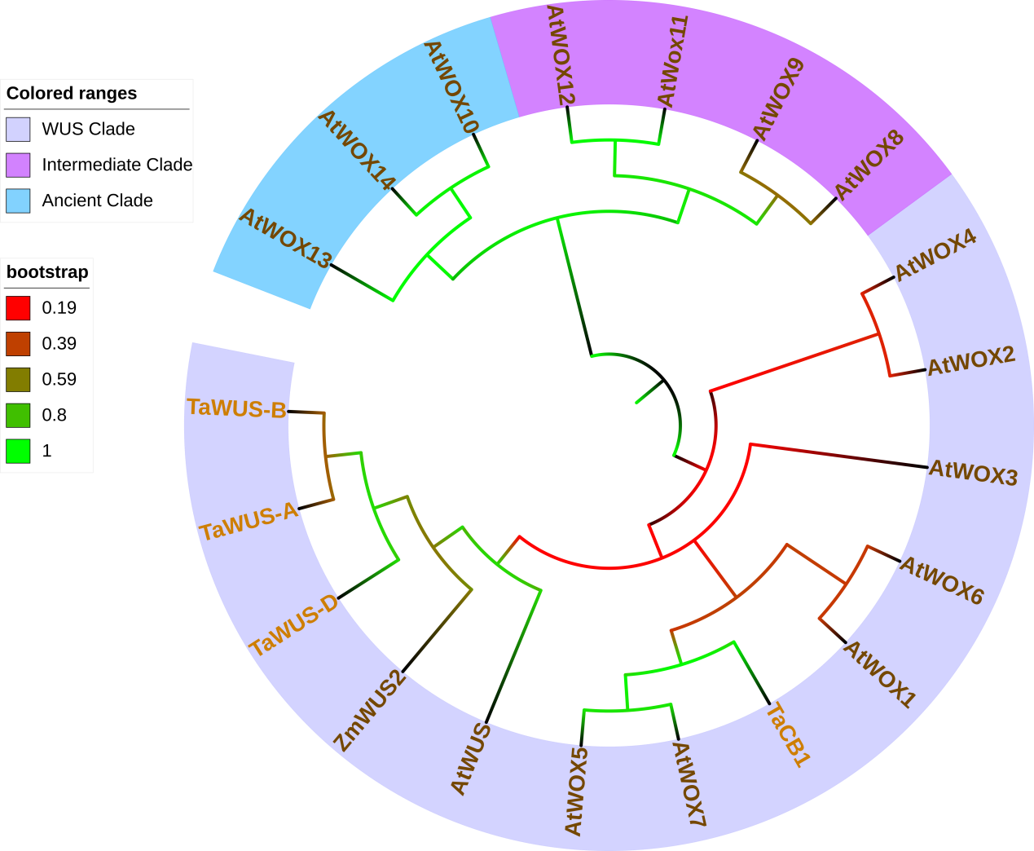
Extended data Fig. 1 Phylogenetic relationships among TaCB1 and TaCB2 proteins from wheat, and WOX proteins from Arabidopsis.
Phylogenetic tree was constructed based on the sequences of TaCB1 and TaCB2 proteins in wheat and WOX proteins in Arabidopsis by the MEGA X using the neighbor-joining approach with 1000 bootstrap replicates. Scale plate and legend in left displayed tree scale and bootstrap value.
AtWUS: NP_565429; AtWOX1: NP_188428; AtWOX2: NP_200742; AtWOX3: NP_180429; AtWOX4: NP_175145; AtWOX5: NP_187735; AtWOX6: NP_565263; AtWOX7: NP_196196; AtWOX8: NP_199410; AtWOX9: NP_180944; AtWOX10: NP_173494; AtWOX11: NP_187016; AtWOX12: NP_197283; AtWOX13: NP_195280; AtWOX14: NP_173493. TaCB1: MN412513; TaWUS-A: MW452946; TaWUS-B: MW452947; TaWUS-A: MW452945.

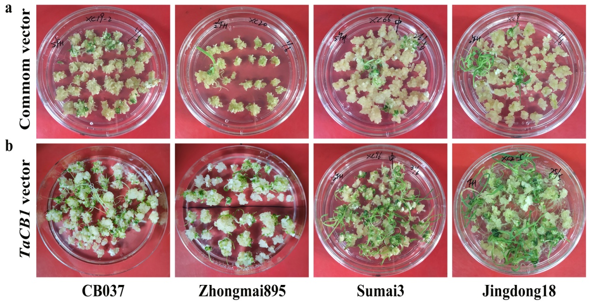
Extended data Fig. 2 Shoot regeneration of the immature embryos of different wheat genotypes promoted by the TaCB1 gene.
a: Shoot regeneration of the wheat embryos transformed with common vectors. b: Shoot regeneration of the wheat embryos transformed with TaCB1 gene containing vector.

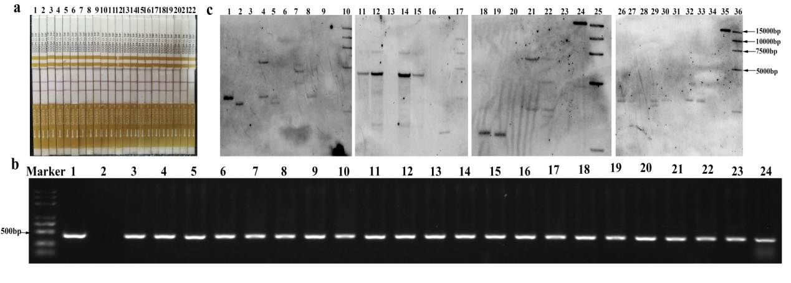

Extended data Fig. 3. Detection of transgenic wheat plants by QuickStix Kit, PCR and Southern blot.
a: QuickStix Kit assay for the Bar protein; 1-21: transgenic plants; 22: the wild-type Fielder. b: PCR detection for Bar gene; 1: plasmid of TaCB1 vector; 2: the wild-type Fielder; 3-24: transgenic plants. c: Southern blot assay for Bar gene; 1-2: transgenic plants of Zhengmai9023; 3: Zhengmai9023; 4-5: transgenic plants of Jimai22; 6: Jimai22; 7-8: transgenic plants of Xinong 979; 9: Xinong979; 11-12: transgenic plants of Aikang58; 13: Aikang 58; 14-15: transgenic plants of Jing 411; 16: Jing411; 18-19: transgenic plants of Zhoumai18; 20: Zhoumai18; 21-22: transgenic plants of Sumai3; 23: Sumai 3; 26-27: transgenic plants of Zhengmai7698; 28: Zhengmai7698; 29-30: transgenic plants of Kenong199; 31: Kenong199; 32-33: transgenic plants of Yangmai16; 33: Yangmai16; 24 and 35: plasmid of TaCB1 vector; 10, 17, 25 and 36: DL15000 DNA marker.

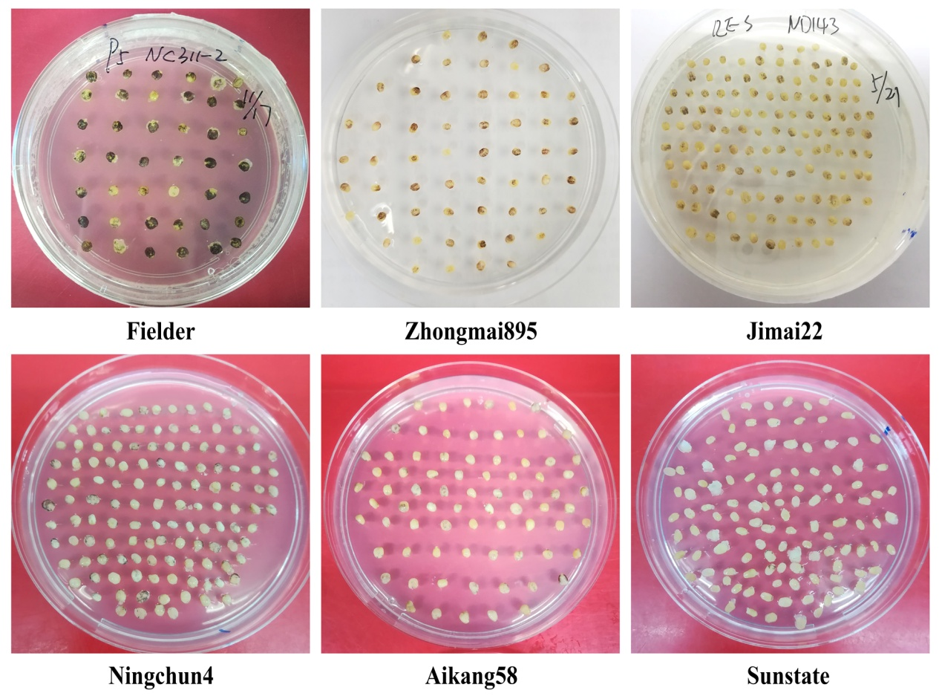
Extended data Fig. 4 Comparison of the transient infection efficiency of different wheat varieties by expressing anthocyanin biosysthesis genes ZmR and ZmC1 as visible marker.

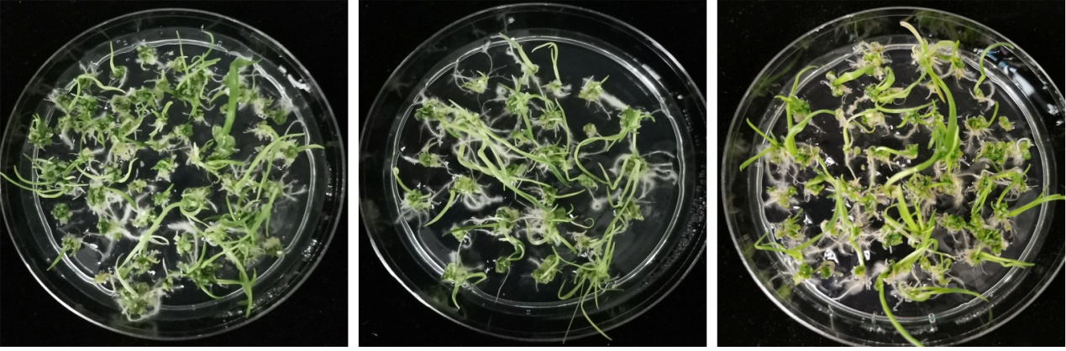
Extended data Fig. 5 Normal growth of the regeneration shoots derived from a transformed immature embryo on the premise of TaCB1 gene in three experiment repeats.

Supplementary Table 1 Summary of information on the TaCB1 and TaCB2 genes identified in this study.
Gene | Species | mRNA length (bp) | Protein length (aa) | GenBank ID
TaCB1 | T. aestivum | 633 | 210 | MN412513
TaCB1-1 | T. aestivum | 633 | 210 | MN412514
TaCB1-2 | T. aestivum | 639 | 212 | MN412515
AsCB1-1 | Ae. speltoides | 624 | 207 | MN412510
AsCB1-2 | Ae. speltoides | 630 | 209 | MN412511
AsCB1-3 | Ae. speltoides | 630 | 209 | MN412512
TmCB1-1 | T. monococcum | 639 | 212 | MN412516
TmCB1-2 | T. monococcum | 630 | 209 | MN412517
TmCB1-3 | T. monococcum | 627 | 208 | MN412518
TaWUS-A | T. aestivum | 927 | 308 | MW452946
TaWUS-B | T. aestivum | 921 | 306 | MW452947
TaWUS-D | T. aestivum | 927 | 308 | MW452945

Supplementary Table 2 The detailed transformation results of 29 wheat genotypes with TaCB1 and common vectors.
Genotypes |  | The common vector |  |  |  |  |  |  |  | The TaCB1 vector
 |  | No. of explants transformed | No. of experiments | Positive plants | Transformation efficiency (%) |  |  | No. of explants transformed | No. of experiments |  | Positive plants | Transformation efficiency (%)
B037 | 1198 |  | 17 | 478 | 39.9 |  |  | 341 | 4 |  | 338 | 96.2
Fielder | 2322 |  | 32 | 1045 | 45.0 |  |  | 3290 | 39 |  | 3108 | 94.5
Zhoumai18 | 2029 |  | 23 | 240 | 11.8 |  |  | 981 | 15 |  | 908 | 92.6
Zhengmai1342 | 166 |  | 2 | 9 | 5.4 |  |  | 1056 | 10 |  | 924 | 87.5
Bs366 | 272 |  | 3 | 0 | 0 |  |  | 266 | 3 |  | 222 | 83.5
Zhongmai895 | 510 |  | 5 | 30 | 5.9 |  |  | 571 | 7 |  | 472 | 82.7
Ji5265 | 948 |  | 12 | 123 | 13.0 |  |  | 99 | 2 |  | 80 | 80.8
Yangmai16 | 688 |  | 7 | 43 | 9.3 |  |  | 2009 | 19 |  | 1622 | 80.7
Jingdong18 | 504 |  | 6 | 72 | 14.3 |  |  | 1966 | 18 |  | 1570 | 79.8
Kenong199 | 1781 |  | 18 | 315 | 17.7 |  |  | 1069 | 11 |  | 809 | 75.7
Yangmai58 | 40 |  | 1 | 3 | 7.5 |  |  | 123 | 1 |  | 90 | 73.2
Xinchun9 | 165 |  | 2 | 22 | 13.3 |  |  | 147 | 2 |  | 106 | 72.1
Lunxuan987 | 503 |  | 6 | 27 | 5.4 |  |  | 508 | 6 |  | 336 | 68.5
PM97033 | 94 |  | 1 | 14 | 14.9 |  |  | 197 | 3 |  | 129 | 65.4
Zhengmai7698 | 2196 |  | 24 | 229 | 10.4 |  |  | 1108 | 13 |  | 682 | 61.6
Zhengmai1860 | 938 |  | 11 | 101 | 10.8 |  |  | 975 | 10 |  | 580 | 59.5
Sumai3 | 150 |  | 2 | 4 | 2.67 |  |  | 662 | 7 |  | 380 | 57.4
Jimai22 | 701 |  | 7 | 41 | 5.8 |  |  | 5459 | 69 |  | 3023 | 55.4
Zhengmai9023 | 60 |  | 1 | 7 | 11.7 |  |  | 232 | 5 |  | 74 | 31.8
Ningchun4 | 136 |  | 2 | 0 | 0 |  |  | 441 | 4 |  | 129 | 29.3
AiKang58 | 434 |  | 5 | 0 | 0 |  |  | 142 | 2 |  | 31 | 21.8
Jing411 | 377 |  | 3 | 8 | 2.1 |  |  | 388 | 6 |  | 68 | 17.5
Xinong979 | 144 |  | 2 | 0 | 0 |  |  | 245 | 3 |  | 41 | 16.7
Sunstate | 113 |  | 1 | 0 | 0 |  |  | 374 | 4 |  | 34 | 9.1
Zhengmai6694 | - |  | - | - | - |  |  | 1008 | 13 |  | 986 | 97.8
Zhengmai9170 | - |  | - | - | - |  |  | 450 | 5 |  | 412 | 91.6
Zhongmai175 | - |  | - | - | - |  |  | 374 |  |  | 236 | 63.1
Luohanmai | - |  | - | - | - |  |  | 237 | 3 |  | 41 | 17.3
Cang6005 | - |  | - | - | - |  |  | 131 | 2 |  | 8 | 6.1

-: no data.

Supplementary Table 3 Main botanic and agronomic characters of the transgenic wheat plants overexpressing TaCB1.
 | Plant height (cm) | Stem diameter (mm) | Leaf width (cm) | Leaf length (cm) | Leaf area (cm²) | Chlorophyll content | Grain number per spike | Thousand grain weight (g) | Grain length (mm) | Grain width (mm) | Length-width ratio
Fielder-TaCB1 | 86.49±2.99 | 4.21±0.21 | 2.67±0.21 | 18.40±1.08 | 35.27±7.08 | 48.24±1.56 | 46.60±5.96 | 42.61±2.12 | 6.17±0.11 | 3.13±0.08 | 1.98±0.02
Fielder-WT | 90.69±2.29 | 3.54±0.04 | 1.90±0.03 | 19.72±0.43 | 27.76±1.31 | 48.03±1.32 | 48.55±6.95 | 41.31±1.29 | 6.10±0.08 | 3.07±0.04 | 2.00±0.04

