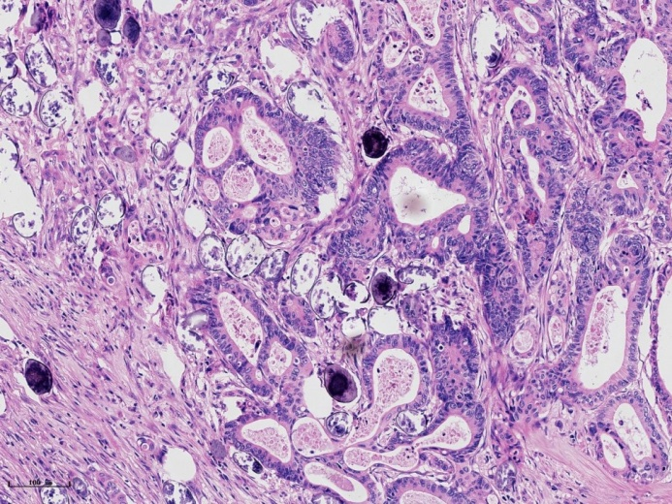
Sup Fig.1. Typical sample of schistosomiasis-associated colorectal cancer, the red arrows indicate schistosome ova (HE, ×100)
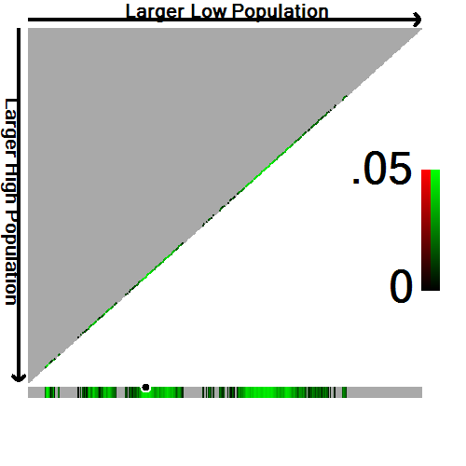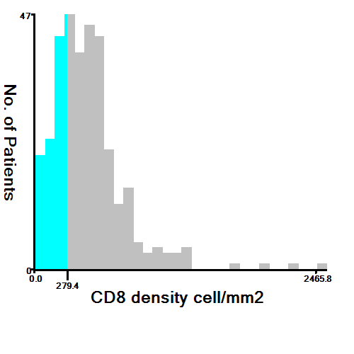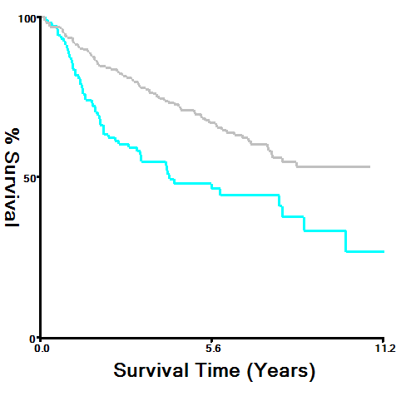
Sup Fig. 2. Determination of cut-off values of CD8 density of TMAs and survival analyses. X-tile analysis of OS was performed using patients’ data collected from the pathological system and Qingpu District Center for Disease Control and Prevention to determine the optimal cut-off value for CD8 density. The optimal cut-off values highlighted by the black circles in left panels are shown in histograms of the entire cohort (middle panels), and Kaplan-Meier plots are displayed in right panels. P values were determined by using the cut-off values defined in training sets and applying them to validation sets. The optimal cut-off value for CD8 density was 279.4 (χ2 = 15.538, P = 0.0029).

Supplementary Table 1. Univariate and multivariate analysis for overall survival in CRC-S setand CRC-NS set
Variables |  | CRC-S set |  |  | CRC-NS set
 |  | P | HR(95%CI) |  | P | HR(95%CI)
Univariate analysis
Age (＜60ys) |  | 0.232 | 21.827(0.139-3436.270) |  | 0.122 | 1.454(0.905-2.336)
Gender (male) |  | 0.307 | 1.311(0.779-2.207) |  | 0.017 | 1.780(1.110-2.853)
Tumor size(5cm) |  | 0.320 | 1.282(0.786-2.089) |  | 0.591 | 0.886(0.569-1.378)
Tumor site
Rectum |  |  | Refer |  |  | Refer
Left colon |  | 0.484 | 1.263(0.657-2.427) |  | 0.672 | 0.889 (0.515-1.534)
Right colon |  | 0.130 | 1.631 (0.865-3.076) |  | 0.054 | 0.590 (0.344-1.010)
Pathological T stage |  | 0.087 | 1.851(0.915-3.747) |  | ＜0.001 | 3.363(1.620-6.980)
Lymph node metastasis |  | ＜0.001 | 3.552 (2.141-5.894) |  | ＜0.001 | 2.447 (1.573-3.807)
TNM stage |  | ＜0.001 | 4.219(2.497-7.128) |  | ＜0.001 | 2.764(1.259-3.206)
Differentiation |  | 0.054 | 1.668(0.991-2.809) |  | 0.003 | 2.009(0.991-2.809)
Vessel invasion |  | 0.275 | 1.321 (0.801-2.180) |  | ＜0.001 | 2.816 (1.808-4.385)
Nerve invasion |  | 0.206 | 1.727 (0.741-4.024) |  | 0.319 | 1.424 (0.710-2.857)
Lymph nodes positive for CRC |  | ＜0.001 | 4.138(2.205-7.769) |  | ＜0.001 | 3.973(2.359-6.692)
Colonic perforation |  | 0.500 | 0.506(0.070-3.657) |  | 0.763 | 1.194(0.377-3.786)
Tumor budding |  | 0.318 | 1.311(0.771-2.229) |  | ＜0.001 | 2.411(1.453-3.999)
Schistosomiasis |  | 0.474 | 1.225(0.703-2.132) |  | — | —
Ulceration |  | 0.212 | 0.725(0.437-1.201) |  | 0.744 | 1.077(0.691-1.676)
Histological type |  | 0.345 | 0.685(0.312-1.503) |  | 0.364 | 1.343(0.710-2.538)
CD8 density |  | ＜0.001 | 0.412(0.239-0.711) |  | 0.002 | 0.459(0.283-0.745)
Multivariate analysis
Gender |  | — | — |  | 0.028 | 1.740(1.062-2.852)
Pathological T stage |  | — | — |  | 0.046 | 2.182(1.015-4.688)
TNM stage |  | ＜0.001 | 3.250(1.836-5.755) |  | 0.036 | 1.729(1.035-2.887)
Differentiation |  | — | —
Schistosomiasis |  | — | — |  | — | —
Vessel invasion |  | — | — |  | 0.080 | 1.549(0.950-2.526)
Lymph nodes positive for CRC |  | 0.027 | 2.106(1.086-4.084) |  | 0.033 | 1.935(1.056-3.545)
CD8 density |  | 0.045 | 0.592(0.337-1.039) |  | 0.037 | 0.574(0.341-0.966)
—:Data is non-significant ; Abbreviation: CI=confidence interval; HR=Hazard ratio; P < 0.05 was defined as the criterion for variable deletion when performing backward stepwise selection

